

Certificate of Donation

$25.00

Young Life Summer Camp

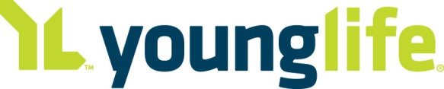 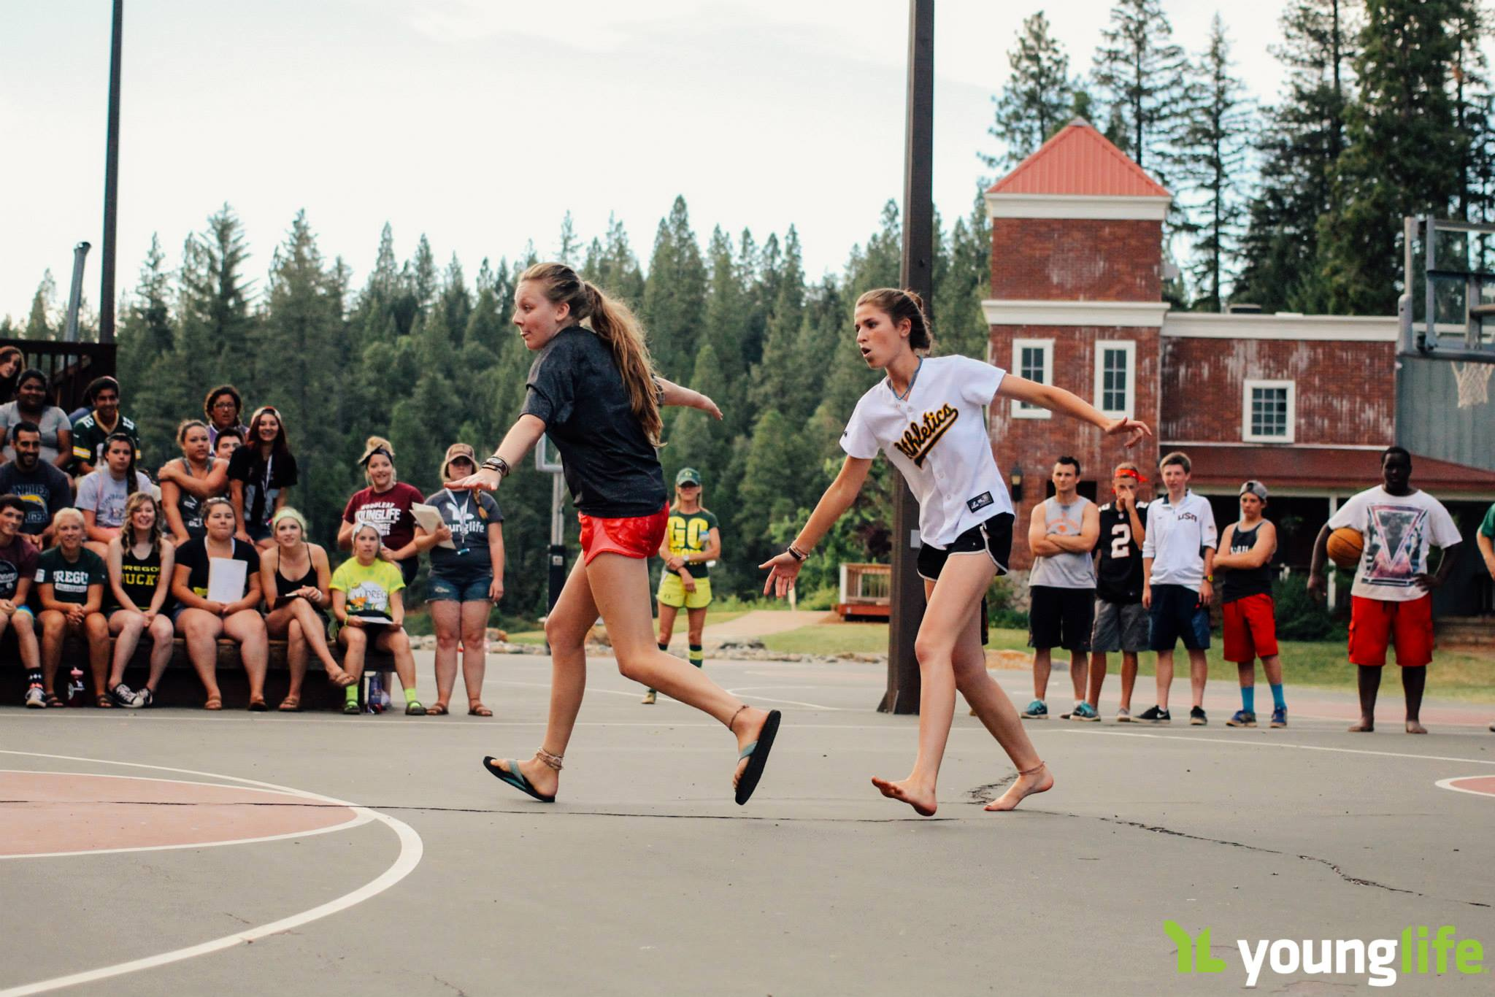 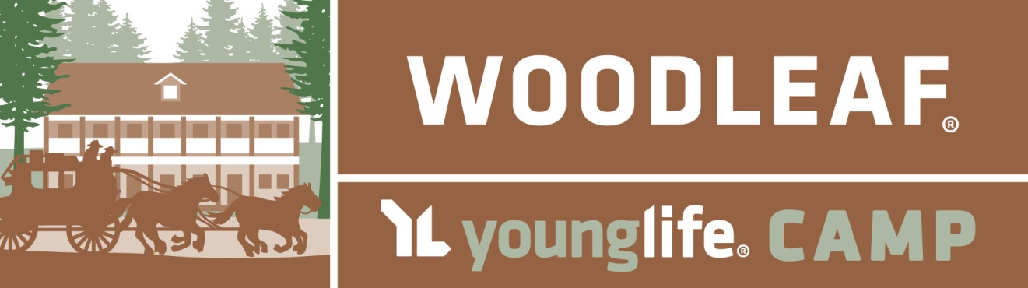

With a simple purchase of this $25 Certificate, You Can Sponsor

_________________ to go to Woodleaf Camp on July 17-23, 2016!

(Camper’s Name)

Purchased By: _____________________________ Date: ______________________________