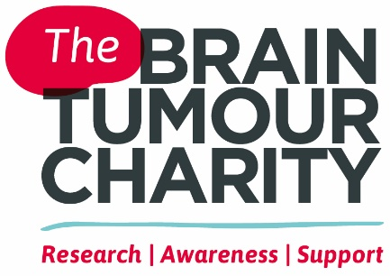
Gift Aid certificate
  - Thank you for choosing to make a donation to
The Brain Tumour Charity in support of our work.
  - Your donation is worth so much more to us when it is Gift Aided.
Please complete this form and return it to us at:
Hartshead House, 61-65 Victoria Road, Farnborough, Hampshire GU14 7PA.

Brain tumours are the largest cancer killer of children and adults under 40,
yet they receive less than 2% of funding on cancer research and survival
times have improved little over the last 40 years.
The Brain Tumour Charity is at the forefront of the fight to defeat brain tumours,
making a difference every day to the lives of people with a brain tumour and their
families. It funds pioneering research to increase survival, raises awareness of
the symptoms and effects of brain tumours and provides support for everyone
affected to improve quality of life.
The Charity’s goals are to double survival within 10 years in the UK and
to halve the negative impact that brain tumours have on quality of life.
Find out more at: thebraintumourcharity.org
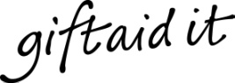 | - Please Gift Aid your donation so we can claim Gift Aid tax  relief of 25p on every pound you give at no extra cost to you.

My details (this must be your home address)
Name:
Address:
Postcode:
Tel: |  |  | Email:
When you submit this form, you agree to us recording your details on our secure database, so we can provide you with the best possible service every time you contact us and allow us to keep you up-to-date on our work. Your details will be kept securely and only shared with trusted suppliers who enable
us to deliver our work, for example, distribution of our newsletter. We never sell or swap your details with any third parties, including charities. If at any stage you do not want to hear from us, you can email enquiries@thebraintumourcharity.org, call us on 01252 749990 or write to us at the address above.

Gift Aid declaration
I confirm that I am a UK Income or Capital Gains taxpayer. I have read this statement and want the charity named above to reclaim tax on my donations. I understand that I must pay an amount of Income Tax and/or Capital Gains Tax in the tax year at least equal to the amount of tax that all the charities and Community Amateur Sports Clubs I donate to will reclaim on my gifts for that tax year. I understand that other taxes such as VAT and Council Tax do not qualify. I understand the charity will reclaim 25p of tax on every £1 that I have given.
☐ I agree that The Brain Tumour Charity can claim Gift Aid on all donations I have paid in the last four years and all donations I make from the date of this declaration until I notify you otherwise.
Signature: |  |  |  |  | Date:

Please notify us if you:
- Want to cancel your Gift Aid declaration
- Change your name or home address
- No longer pay sufficient tax on your income and/or capital gains.
If you pay Income Tax at the higher or additional rate and want to receive the additional tax relief due to you, you must include all your Gift Aid donations on your Self-Assessment tax return or ask HM Revenue and Customs to adjust your
tax code.
If you have any queries please get in touch: donations@thebraintumourcharity.org / 01252 749043

