Template: Marketing Automation program

Project name: [project name]
Program objective: [objective]
Program KPIs: [KPIs]
Program reviewers: [reviewers]

Critical deadlines: [any deadlines, such as trade show, etc.]

Program elements: [3rd party ads, social media etc., which needs to be tracked]

Target Audience: [US customer list]

Email From address: [standard]
Email From name: [standard]

Any tests:

Test description

Additional notes:

Notes

Campaign flow:
Date […]
Date […]
Email 2
Same email
Different Subject
Sent to people who did not fill the form
Email 1

Landing Page 1

Thanks Email 1
Thanks Page 1

Naming Conventions
Naming conventions can be used for any internal assets and organization of the material within marketing automation system or any internal asset management system.
[project name]
Emails:
Email 1: [name of the asset]
Email 2: [name of the asset]
Thank You email: [name of the asset]

Landing pages:
Landing page 1: [name of the asset]
Landing page URL: [landing page URL]

Thank You page 1: [name of the asset]
Thank You page URL: [landing page URL]

Landing page location (marketing automation, or internal server, any specifics)

Form:
Form 1: [name of the asset]

Subjects, META, Tests
Tests: Subject line test for email 1

Email Subjects:
Email 1 A: [Subject line]
Email 1 B: [Subject line]

Email 2: [Subject line]
Thank You email: [Subject line]

Landing Pages:
Landing page 1 - Title: [Title]
Landing page 1 - Description: [Title]

Thank You page 1 - Title: [Title]

Email 1
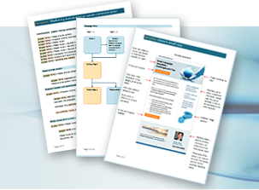
Online Marketing Moment
3 Email Campaign Templates
Plus Template Tricks and Tips

Image of 3 Email templates
Please select visually interesting parts of the templates to include into the image

Download templates

What are challenges of international email marketing templates?
Is it time for mobile first templates, or responsive templates?
What type of agency should be designing and developing email templates?
Ah! You just sent all your requirements for a new campaign to your automation agency or internal resources and forgot a couple of points. Again.
What if you could use a template that includes a collective wisdom of several marketers and a handy checklist?
Download templates for your next campaign:
- Automated campaign template with a check list of critical items
(best practices, translation ease, etc.)
- Campaign review list your stakeholders
will find easy to follow
- Word document template anybody can use for internal emails

Image related to questions, confusion, etc.

Download templates

Primary call to action URL [http://onlinemarketingmoment.wordpress.com/templates/ ]

Recovery pane: [standard]
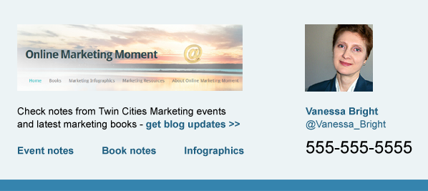
Link tagging:
(Link tagging can be used for additional analytics, such as query string data collected in the form or detecting which exactly link was clicked if marketing automation system does not do it automatically)

Logo top: [tag]
Title: [tag]
Button top: [tag]
Button bottom: [tag]
Q-international: [tag]
Q-mobile: [tag]
Q-agency: [tag]

Landing Page 1
Download FREE Templates
Get Templates
FORM
Online Marketing Moment

3 Email Campaign Templates
Plus Template Tips and Tricks

Save time while working on your next marketing automation campaign or a simple email with helpful templates.

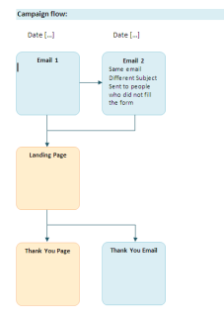
Marketing Automation campaign template (Word)
- Campaign flow layout
- Campaign element checklist
- Form checklist

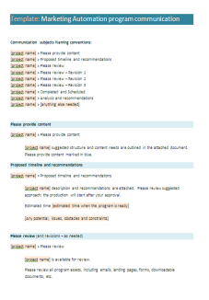
Marketing Automation project communications (Word)
- Naming conventions
- Stakeholder checklist
- Emails to copy-paste

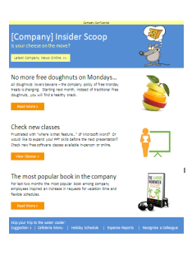
Internal Word to Outlook email template (Word)
- Modifiable template sample
- Process explanation
- Troubleshooting points

Form 1
Form Fields
(Listing of all form fields desired)
[First Name]
[Last Name]
[Email]
[Company]
[Title]
[Country]
[….]

Hidden Fields
[Original Lead Source]
[Most Recent Lead Source]

Does the contact need to be classified as part of a certain business unit?
Does the contact need to be assigned to a specific interest?

Form Button
[Get Templates]

Form Processing Steps
[Redirect to the Thank You page]
[Send Thank You Email]

Does the contact need to be assigned to a specific welcome or nurturing program?
Does the contact need to be assigned to any custom subscription process based on the country?

Thank You Page 1
Online Marketing Moment
Thank you!
3 Email Campaign Templates

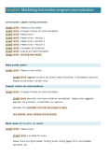
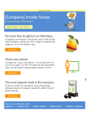
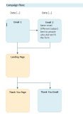
Marketing Automation project communications (Word)
Marketing Automation campaign template (Word)
Internal Word to Outlook email template (Word)
Share Templates with a colleague

Check these 3 Email Campaign Templates – [shortened link to the primary landing page with a tag]

You might also find useful…
[Secondary call(s) to action]

Social Media Sharing (if appropriate)
Thank You Email 1 (content is similar to the Thank You page)
Online Marketing Moment

Your 3 Email Campaign Templates

Thank you for requesting 3 Email Campaign Templates!

Marketing Automation project communications (Word)
Marketing Automation campaign template (Word)
Internal Word to Outlook email template (Word)
Share Templates with a colleague

Check these 3 Email Campaign Templates – [shortened link to the primary landing page with a tag]

You might also find useful…
[Secondary call(s) to action]

Social Media Sharing (if appropriate)

General Campaign Checklist
- Analytics
  - Web Analytics setup on the landing pages
  - Any additional analytics for email (Litmus, etc.)
  - Any query string tracking
- Campaign automatic reports
  - Who needs to receive daily/weekly/etc. campaign automatic reports?
  - Naming conventions for the campaign automated reports email
  - Any additional shared mailboxes (check if shared mailboxes are receiving the reports, which could be external emails)

Find more templates: http://onlinemarketingmoment.wordpress.com/templates/
I am happy to make corrections and improve templates based on your recommendations!
Vanessa Bright @Vanessa_Bright Vanessa.L.Bright@gmail.com

