2013-14
HISD Career Pathways Program

Time Tracking Tool
User Manual

Table of Contents
Introduction to Time Tracking 3
Benefits of Time Tracking 3
Time Tracking Expectations 3
Accessing the Time Tracking Tool 4
Submitting an Activity 5
Reviewing Previously Submitted Activities 11
Using Time Tracking Data during Check-ins with Principals 12
Appendix A: Time Tracking Template 13
Appendix B: Examples of Activities 14

Introduction to Time Tracking
Congratulations on being selected for a Career Pathways teacher leadership role! In order to ensure that we can adequately study the effect of Teacher Leaders and make Career Pathways a successful and sustainable program, you as a teacher leader are responsible for reporting accurate data about how you are spending your time in your role. The success of Career Pathways depends on learning which activities have the most impact on teacher effectiveness and student learning.
As part of your role, you will report how you spend your time as a teacher leader every two weeks. Each month we will share reports with you and your principal with high-level campus trends of how teacher leaders are spending their time. These may also include average number of hours per week spent on specific activities and total time spent with specific teachers.
Information collected and reported about how you are spending your time will NOT be used to assess your performance in the role. You will only be held accountable for completing the time tracking process. However, this information may be used to refine role responsibilities for this and future years of the Career Pathways program.

Benefits of Time Tracking

Time tracking will benefit you in the following ways:

First, your time tracking submissions will help you and your principal ensure that your time is spent improving instruction, not completing paperwork or other administrative activities.

Second, this information will help you and your principal reflect on how you are spending your time and work together to determine if adjustments need to be made to how you are spending your time.

Lastly, providing this information is your chance to shape the future of your leadership role and the Career Pathways program. You will be providing critical data to the Career Pathways team in order to gauge the impact of specific activities so that roles and the program can be improved over time.

Time Tracking Expectations
You will begin tracking your time on Monday, October 21 and will continue through Sunday, March 30. Data from your time tracking submissions will be downloaded every two weeks.
Submission Deadlines
November | December | January | February | March
Nov. 3  Nov. 17 | Dec. 8  Dec. 22 | Jan. 19  Feb. 2 | Feb. 16  Mar. 2 | Mar. 16  Mar. 30
To ensure your time is being tracked as accurately as possible, you should log your time as activities are being completed. Please do not wait until the end of the two-week data collection period to submit your activities. Not only is it more cumbersome to input all activities at once, it may also compromise the accuracy of the time tracking data. In addition, if you do not submit any activities, it will appear in the monthly campus report that you completed 0 hours of work.
To make it as easy as possible on you, we have chosen a time tracking tool that can be accessed on your smartphones. This way you can track activities in the moment as you complete them. If you don’t have a smartphone, or would just prefer to write down activities as they are completed, we have provided a paper template on page 13 of this manual. (Please note that the paper template will only be used to track activities. You will still be required to submit activities via the online time tracking tool.)
You should only track activities related to your Career Pathways leadership role. Do not track activities related to your regular classroom duties or related to another leadership position that you hold.
Please be honest and accurate with your submissions. There is no standard expectation for how many hours per week you are spending on leadership activities. If you do not complete activities in your teacher leadership role for several days, that is completely fine.

Accessing the Time Tracking Tool
We worked hard to ensure that the online time tracking tool is fast and easy for you to access. You can easily log into the time tracking tool from any computer (on any network) using the following website: http://hisdeffectiveteachers.org/timetracking. This website can also be accessed from the web browser on your smartphone.
- Click on the link to the time tracking tool. You will be redirected to the log-in page.

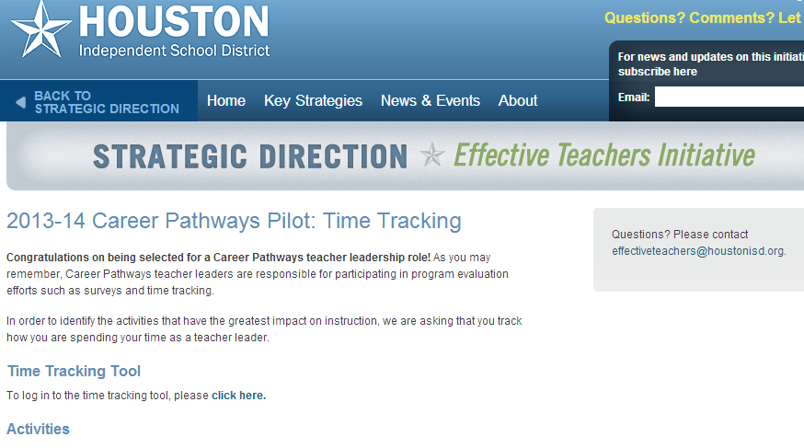
- A username and password will be emailed to you prior to start of time tracking. You will enter this username and password and click the Log In button.
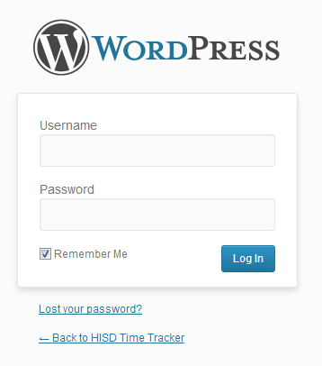

Submitting an Activity
After logging in, your name and email address will automatically appear on the time tracking form. You will need to select from drop-down menus or manually enter the remaining information.
- First, select your campus.
- Second, select the date and start and end times of the activity.
- Then select the activity you completed.
  - There are seven categories of activities and an “Other” category. If you are unsure of how to code your time, click on the link to detailed descriptions of activities. You will be redirected to a page on the Effective Teachers Initiative website. You can also find examples of activities on page 14 of this user manual.
  - Please note that these categories are very comprehensive, so you should only use the “Other” category in the rarest cases.
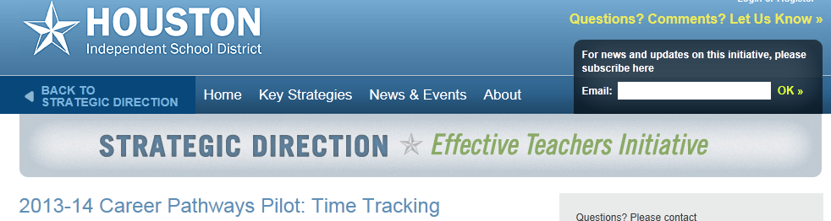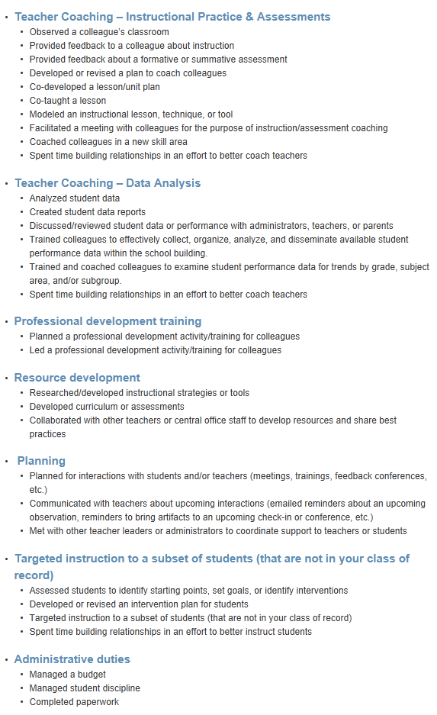
- Next, select whether you worked with an individual, with a group, or by yourself.
  - If you select “with an individual teacher or administrator,” the employee roster for your campus will appear. Select the name of the individual you worked with.
    - If you do not recognize any of the employees on the list, please make sure you selected the correct campus at the top of the form.
    - If you do not see the name of the individual you worked with, select “with a group of teachers, administrators, and/or parents” and follow the instructions for entering a teacher’s name.

  - If you select “with group of teachers/administrators/parents” or “with students” a comment box will appear. You will need to write the first and last names of individuals in that group. Write the names as “last name, first name.” Do not write “Mr.” or “Mrs.”

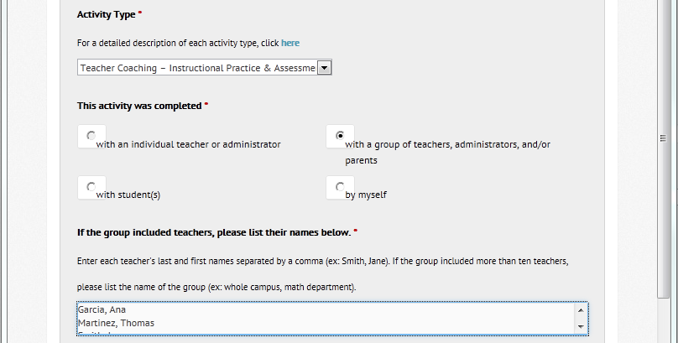
  - If you select “by myself” you will not need to select or enter any additional information.

- You have the option of entering notes about the activity, which may be useful when reviewing activities with your principal. Entering notes is not required.
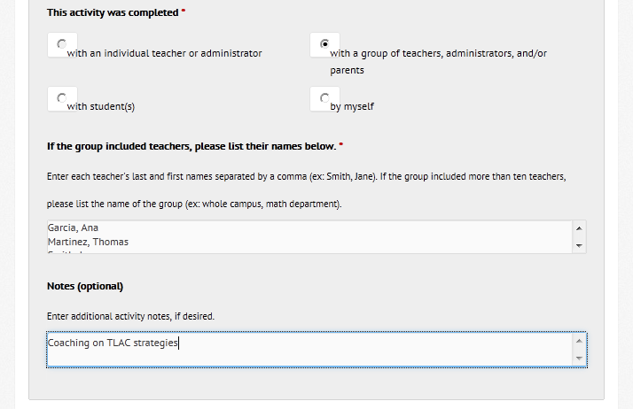

- Finally, click the “Submit” button in the Verification section of the form.
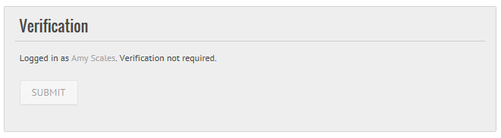

- You will be redirected to a screen confirming your information. You will also receive an email confirming that your activity was submitted. If you do not see the confirmation screen or you do not receive the confirmation email, there was an error with your entry and you will need to resubmit.
- On the confirmation screen you have the option of submitting another entry or viewing previous entries.
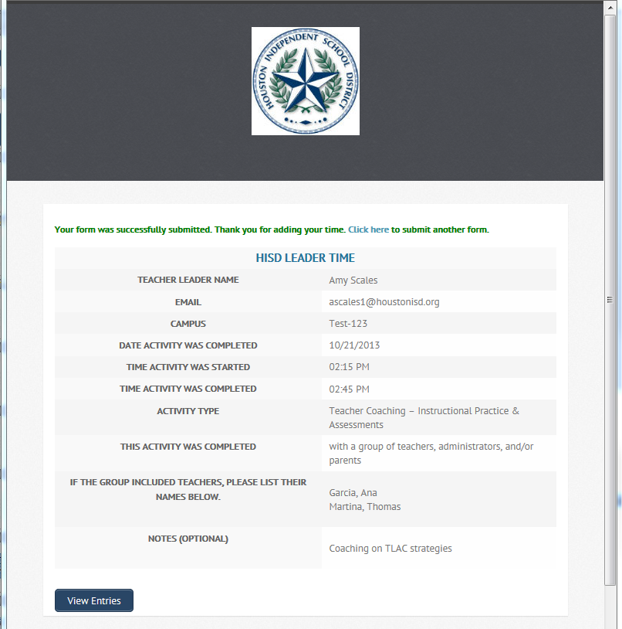

Reviewing Previously Submitted Activities
- To view previous entries, click on the “View Entries” button at the bottom of the submission form or at the bottom confirmation screen.
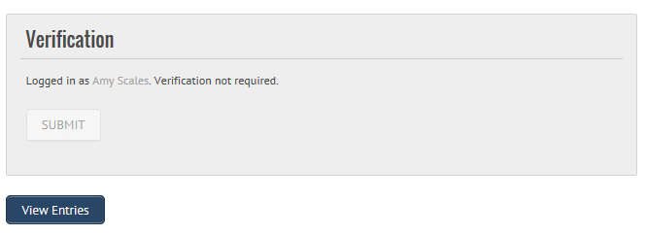
- You will be redirected to a new screen.
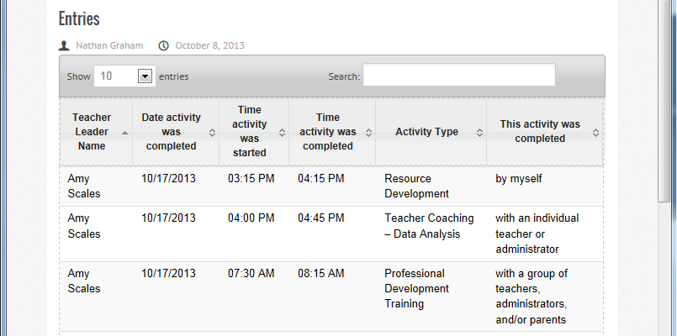
04:00 PM
- You can search previous submissions by date, by activity type, or by whether the activity was completed alone, with individuals, or with a group.
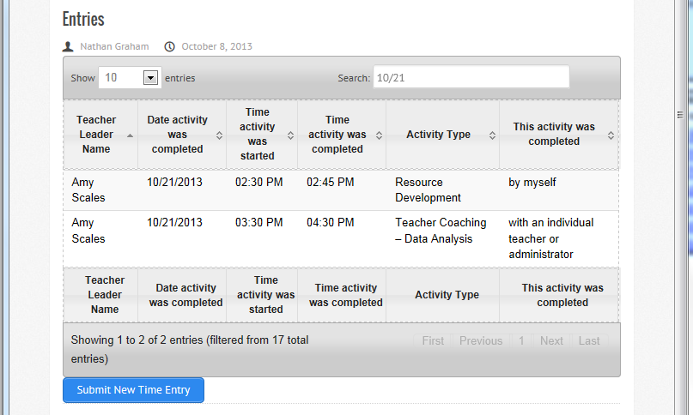

Using Time Tracking Data during Check-ins with Principals
During ongoing check-ins with your principal, you should share your previous time tracking submissions. This will help the two of you see which activities you are spending the most time on and which teachers you are spending the most time with. You and your principal may decide that your time should be spent differently.
You should also review the monthly campus reports with your principal. The campus reports may reveal that one teacher is receiving support from several teacher leaders, but another teacher who is struggling is receiving no support at all. Or, you might notice that all but one grade level team is receiving support. This information will help you and your principal redirect time and resources to fill in these gaps.
Data from previous submissions and monthly reports will also help you and your principal determine if your workload is sustainable, or if adjustments are needed.

Appendix A: Time Tracking Template
If you prefer to write down your activities and submit them online at the end of the day, this template may help you track in real time the activities you are completing. YOU WILL NOT SUBMIT THIS PAGE. Only activities submitted via the online time tracking tool will be accepted.
Teacher Leader: ______________________________________________________
Activity Date | Start Time | End Time | Coaching Activity* | This activity was completed | Name(s) of Individual(s)
☐With an individual teacher/administrator
☐With a group of teachers/administrators/parents
☐With students ☐By myself
☐With an individual teacher/administrator
☐With a group of teachers/administrators/parents
☐With students ☐By myself
☐With an individual teacher/administrator
☐With a group of teachers/administrators/parents
☐With students ☐By myself
☐With an individual teacher/administrator
☐With a group of teachers/administrators/parents
☐With students ☐By myself
☐With an individual teacher/administrator
☐With a group of teachers/administrators/parents
☐With students ☐By myself
☐With an individual teacher/administrator
☐With a group of teachers/administrators/parents
☐With students ☐By myself
☐With an individual teacher/administrator
☐With a group of teachers/administrators/parents
☐By myself
☐With an individual teacher/administrator
☐With a group of teachers/administrators/parents
☐With students ☐By myself

Appendix B: Examples of Activities
If you are wondering how your time should be coded, here are some examples of what should go under each type of activity. Categories of activities and the examples that fall under each were derived from activities listed in role descriptions.
- Teacher Coaching – Instructional Practice & Assessments
  - Observed a colleague’s classroom
  - Provided feedback to a colleague about instruction
  - Provided feedback about a formative or summative assessment
  - Developed or revised a plan to coach colleagues
  - Co-developed a lesson/unit plan
  - Co-taught a lesson
  - Modeled an instructional lesson, technique, or tool
  - Facilitated a meeting with colleagues for the purpose of instruction/assessment coaching
  - Coached colleagues in a new skill area
  - Spent time building relationships in an effort to better coach teachers
- Teacher Coaching – Data Analysis
  - Analyzed student data
  - Created student data reports
  - Discussed/reviewed student data or performance with administrators, teachers, or parents
  - Trained colleagues to effectively collect, organize, analyze, and disseminate available student performance data within the school building.
  - Trained and coached colleagues to examine student performance data for trends by grade, subject area, and/or subgroup.
  - Spent time building relationships in an effort to better coach teachers
- Professional development training
  - Planned a professional development activity/training for colleagues
  - Led a professional development activity/training for colleagues
- Resource development
  - Researched/developed instructional strategies or tools
  - Developed curriculum or assessments
  - Collaborated with other teachers or central office staff to develop resources and share best practices
- Planning
  - Planned for interactions with students and/or teachers (meetings, trainings, feedback conferences, etc.)
  - Communicated with teachers about upcoming interactions (emailed reminders about an upcoming observation, reminders to bring artifacts to an upcoming check-in or conference, etc.)
  - Met with other teacher leaders or administrators to coordinate support to teachers or students
- Targeted instruction to a subset of students (that are not in your class of record)
  - Assessed students to identify starting points, set goals, or identify interventions
  - Developed or revised an intervention plan for students
  - Targeted instruction to a subset of students (that are not in your class of record)
  - Spent time building relationships in an effort to better instruct students
- Administrative duties
  - Managed a budget
  - Managed student discipline
  - Completed paperwork

