******************************************************************
These areas are project specific and they are indicated to assist the Engineer to find them.
******************************************************************
ORANGE COUNTY UTILITIES

Consultant Firm
Proposal for Project

Project Purpose
The purpose of the project is to replace and upgrade the existing water mains, which are constructed of material that does not comply with the current Orange County Utilities (OCU) standards and / or undersized. This will improve water pressure, insure adequate fire protection, and improve service reliability in the project area.

In addition, wastewater collection system inspection data will be acquired to provide data necessary to make informed decisions concerning rehabilitation and/or replacement of existing wastewater collection system and force mains in the project area.

Description of Project
Services will be provided to accomplish the following in the Rio Pinar Area:

Potable Water System: Replace and upgrade approximately forty-three thousand nine hundred linear feet (43,900 LF) of AC pipes, PVC pipes smaller than 4-inch diameter and 4-inch PVC pipes located in places other than cul-de-sacs.

Wastewater Gravity System: Inspection and evaluation of approximately eighty nine thousand linear feet (89,000 LF) of the existing gravity system. The portions of the gravity system that need rehabilitation or replacement shall be described in the preliminary design report.

Scope of Work

Engineering services shall provide design drawings and specifications that meet or exceed the requirements of Utilities’ Standards and Construction Specifications Manual (Manual) and insure the proposed gravity system, water main, reclaimed water main and force main, and pump station are within the right-of-way, easement, or site boundaries. The following tasks will be performed as part of the work:
- Task 100 Preliminary Engineering;
- Task 200 Surveying;
- Task 300 Geotechnical Investigation;
- Task 400 Ecological Investigation;
- Task 500 Construction Documents;
- Task 600 Public Relations: Community Meeting/Public Notification-Flier Production and Mailing Procedure;
- Task 700 Bidding Assistance; and
- Task 800 Construction Administration Services.

TASK 100 - Preliminary Engineering

The purpose of the preliminary engineering phase is to present project completion alternatives to Utilities in a manner that will allow Utilities to make an informed decision as to how the project shall proceed. Minimal survey services will be performed during the Preliminary Engineering unless approved by the Utilities Project Manager.

Subtask 110 Data Collection
- Kick-off meeting
- Collect and review all available information such as records, maps, aerials, surveys, easements, ROW records, plans, record drawings, soils investigation reports, privately owned utility system data, zoning classification, building codes and standards that may be pertinent to execution of the Project. Review all requirements of all agencies having jurisdiction over the Project. Collect and review any other information that may have a bearing and impact on the planning, design, approval, permitting, construction or operation of the Project.
- Evaluate existing conditions along the proposed pipe installation route by site visitation. Consider current field conditions and any proposed site improvements and/or changes that may impact the project and recommended location of the proposed pipeline.
- Meet with Utilities prior to any inspection work to establish communications and coordination for televising gravity mains, manhole inspections, and smoke testing. The Engineer shall summarize the meeting field inspection procedures, evaluation methodology, and reporting formats. The inspection data submittals and PDR spread sheet shall conform to Utilities requirements set during this meeting.

Subtask 120 Gravity Main Inspections
1. Cleaning and CCTV Inspections
- Cleaning and CCTV inspections shall be completed and shall conform the procedures established in CIP Standard Specifications Section 02761 Cleaning Sanitary Sewer Systems and Section 02762 Televising Sanitary Systems. It is recognized that there are some conditions such as broken pipe and major blockages that prevent cleaning from being accomplished or where additional damage would result if cleaning were attempted or continued. Should such conditions be encountered, those specific manhole sections will not be required to be cleaned. The Engineer will review CCTV data collected for quality assurance.
- Furnish materials, equipment, supplies, traffic control and personnel to perform the complete inspection.
- Remove and dispose of debris at an approved site.
- Repair and replace existing structures or property, public or private, disturbed by Contractor’s employees or activities.
- Take precautions to prevent damage to sewer lines and causing of service line backups due to pipe cleaning or CCTV operations.
2. CCTV inspection submittals shall be bound and include (1) a printed and electronic Microsoft Office Excel data spread sheets of what is included in the submittal, (2) printed color copies of the reports, (3) DVDs, and (4) a pertinent GIS map.
- Microsoft Office Excel spread sheet shall be in the required Utilities format provided by Utilities.
- The printed color copies of the reports shall be in the same order as the DVD.
- DVDs or portable hard drive should include the line segments with the DVD numbers and manholes identified by Utilities asset numbers.
- GIS map will include project area inspected with recommended R/R the pipe segments with the DVD number as well as Utilities manhole asset numbers
- CCTV inspection data shall be PACP compliant in submitted in a PACP compliant database.
- All electronic files shall be named in accordance with the naming conventions described in CIP Standard Specifications Section 02762 Televising Sanitary Systems.
- The following deliverables shall be submitted on DVDs or portable hard drive at the completion of CCTV inspection for each service subarea:
  - Inspection videos saved in MPEG format or Windows Media video format (one video file per pipe reach), named in accordance with CIP Standard Specifications Section 02762 Televising Sanitary Systems.
  - Electronic version (.pdf) of the pipe inspection reports as described in CIP Standard Specifications Section 02762 Televising Sanitary Systems.
  - PACP export pipe inspection database (.mdb)
  - Inspection digital photographs shall be embedded in the PDF reports.
  - GIS Map depicting area inspected, inspection status, R/R recommendations, asset identification numbers and mark ups
  - QA/QC report

Subtask 130 Manhole Inspections
- Gravity sanitary sewer manhole inspections will be inspected within the project area and any evidence of surface depressions or line breaks will be documented prior to CCTV inspection. The pipes entering and leaving the manhole will be compared to GIS maps. Any corrections to the GIS maps will be identified during the inspections.
- Manhole inspections shall be completed and conform the procedures as established in CIP Standard Specifications Section 02764 Inspection of Existing Manholes. Manhole inspections shall include the following type of information:
  - The casting/cone condition and manhole cover will be evaluated;
  - Manhole walls will be checked for integrity and signs of root intrusion, deterioration of mortar joints, loose or missing bricks, signs of surcharge level, etc;
  - Sewer lines entering and leaving the manhole will be inspected to determine the manhole-line condition and establish if any manhole settlement has separated or sheared pipelines; and
  - Silt deposition that reduces flow capacity will be noted and silt depth recorded. Observed defects (root intrusion, cracked pipe, obstructions, etc.) will be documented.
3. Manhole inspection submittals shall be bound and include (1) a printed and electronic Microsoft Office Excel data spread sheets of the submittal contents, (2) printed color copies of the reports, (3) DVDs, and (4) a pertinent GIS map. The following submittals are required for manhole inspections:
- Manhole inspection forms, including OCU manhole identification numbers, component observations, manhole inspection details for defect and image references, connecting pipe details, and manhole plan view sketch.
- NASSCO MACP compliant database populated with inspection data.
- GIS maps showing inspected manholes and labeled with OCU manhole asset numbers with reference to each service subarea report.
- Digital photographs as specified in Section 02764 Inspection of Existing Manholes
  - All image references shall adequately capture the manhole conditions and details of defects showing area image, internal image, manhole defect image, connecting pipe image.
  - All digital photographs shall be referenced on the manhole inspection form and electronic spreadsheet/database.
  - Submit Image References in JPEG format and Defect Field Data Sheet and Sketches in PDF format.
- All electronic files shall be named in accordance with the naming conventions described in CIP Standard Specifications Section 02764 Inspection of Existing Manholes.

Subtask 140 Smoke Testing
1. Smoke Testing shall comply with the attached smoke testing specification and guidance document as established in CIP Standard Specifications Section 02765 Smoke Testing Wastewater Collection Systems.
2. Smoke testing submittals shall be bound and include (1) a printed and electronic Microsoft Office Excel data spread sheets of the submittal contents, (2) printed color copies of the reports, (3) DVDs, and (4) a pertinent GIS map. The following submittals are required for smoke testing:
- Microsoft Office Excel spread sheet shall be in the format provided.
- The printed color copies of the reports shall be in the same order as the DVD.
- GIS map will include the pipe segments with the DVD number as well as Utilities manhole asset numbers depicting inspected gravity system in each project area, smoke testing results, and preliminary repair recommendations.
- Smoke Testing Data Sheets to include OCU Asset Identification Numbers.
- Populate smoke testing data in database format provided by Utilities
- Common descriptions of defects shall utilize the MACP defect codes.
- Submit Image References in JPEG format and Defect Field Data Sheet and Sketches in PDF format.
- All electronic files shall be named in accordance with the naming conventions described in CIP Standard Specifications Section 02765 Sanitary Sewer and Manhole Smoke Testing.

Subtask 150 Preliminary Engineering Report
- Prepare a preliminary layout of the proposed construction alignment of the water, wastewater and/or reclaimed water mains which indicates all major conflicts with existing utilities and all areas where special construction techniques must be considered. Additionally, present any other pertinent information necessary for Utilities to evaluate the proposed alignment.
- Provide a schematic map showing the project limits for utility improvements and project area for the proposed gravity and water system improvements.
- The CCTV inspection of the gravity mains, manhole inspections, and smoke testing data shall be reviewed and analyzed, and R/R recommendations will be formulated utilizing Utilities database and reporting formats for main line CCTV inspections, manhole inspections, and smoke testing results are required.
- Provide GIS Maps depicting base map, project area, inspected wastewater gravity system, water distribution system, defect color codes and legends, and R/R recommendations.
- Tabulation of pipe segments, manholes, service laterals, and smoke testing data and R/R recommendations utilizing Utilities asset identification and data formats.
- Prepare a preliminary estimate of probable construction costs for the Project based on the preliminary alignment drawings.
- Prepare a bound “Preliminary Design Report” which presents the findings and conclusions that resulted from the Preliminary Engineering effort. At a minimum, include illustrative sketches/plans (pipe alignment lay-out), permit requirements, future plans of other utilities and agencies that may affect Project (if applicable) and the conclusions and recommendations concerning further execution of the Project.
- Submit six (6) copies of the draft “Preliminary Design Report” to Utilities. Meet with Utilities to discuss and revise in accordance with the comments from Utilities. Submit two (2) hard copies and a digital copy as a single PDF of the final “Preliminary Design Report”.

TASK 200 – Survey

The majority of the survey services shall be performed during the Subtask 510 – 60% Level of Completion. Survey services shall provide Utilities with sufficient data to ascertain that the proposed water, wastewater, and/or reclaimed water main is within the existing and/or proposed right of way, easement or site boundary and as indicated on the construction drawings. Surveyor shall monument and provides coordinates for existing or proposed rights-of-way, easements, and sites.

1. Horizontal and Vertical Controls:
- Vertical control data shall be based on the North American Vertical Datum 1988. Benchmark(s) shall be provided for each of the Design Drawings.
- The horizontal control data shall be relative to the Florida State Plane Coordinate system, East Zone, North American Datum of 1983/1990 adjustment.
2. Rights-of-Way, Easements, and Pump Station Sites: Any survey of rights-of-ways, easements, and pump station sites shall meet or exceed Chapter 5J-17 FAC “Minimum Technical Standards” or the requirements of the following Table 1 Minimum Survey Accuracies, whichever is more stringent. The survey of easements shall be as surveyed as boundary surveys. Sketches of description for acquisition of easements or fee simple parcels by Utilities shall meet the County’s Real Estate Management Division requirements. This includes meeting the requirements of ALTA/ACSM Land Title Survey Standards and the survey being certified to the County and its title insurance company.
  - Perform topographic survey of the proposed construction corridor and existing utility tie-in locations for preparation of the construction drawings. Obtain title information pertaining to existing easements and/or deeded right of way and related pertinent right of way maps, maintenance maps, plats and similar documents. Existing underground utilities flagged by the respective utility owners shall be located by the survey. Existing wetlands boundaries flagged by others shall be located by the survey.
  - All proposed UTILITY easements and tracts shall be shown with dimensions and offsets tied to the baseline of the design survey.
  - Found or set monuments for existing right-of-ways, easements, or pump station sites shall be adequately depicted on the survey.
  - Determine by excavation the horizontal and vertical location of existing pipes at proposed “tie-in” locations (number of tie-in locations to be determined by engineer after consultation with Utilities), existing utilities at proposed utility crossings, and all utilities along the proposed pipe within the existing right-of-ways within 10’ from either side of the centerline of the proposed pipe at minimum intervals of 200’.
  - Conventional surveying of the control and baseline points shall maintain a minimum positional reliability of 1:10,000 feet relative to the nearest geodetic control station. All baseline control traverses shall be tied to a least two existing horizontal controls of second order class I or higher standards or a control established by the County.
  - Prepare a survey control drawing for the baseline horizontal and vertical controls. A table shall provide state plane coordinates with elevations (x, y, z) at all changes in baseline direction. Baseline turning points shall be labeled on the design drawings to identify these points referenced in the survey control drawing table. The table shall include the type of monument set. Iron pins are required when setting the baseline in easements or rights-of-way without pavement. The survey control drawing shall state what datums were used to set the baseline controls. Two horizontal and vertical datums are required for horizontal and vertical controls. The Surveyor’s name, registration number, and the date the survey was performed shall be labeled on the survey control drawing.
  - Baselines shall be parallel to the right-of-way and monumented at the beginning and end of the project and at all changes in direction.
  - Enough corners shall be found to determine the right-of-ways and these monuments shall be indicated on the survey.
  - GPS surveyed control baselines shall meet these post processed GPS survey specifications using the kinematic survey method. Kinematic GPS surveys make use of two or more GPS units. At least one GPS unit is set up over a known (reference) station and remains stationary, while other (rover) GPS units are moved from station to station. These surveys can be either continuous or “stop and go”. Stop and go station observation periods are of short duration, typically under two minutes.
- Minimum number of reference stations to control the project is 3rd order or better
- Minimum number of check stations is 2
- Maximum distance between the survey project boundary and the network reference control stations is 6 miles.
- Maximum PDOP during station occupation is 5.
- Minimum observation time on station is 5 epochs
- Minimum number of satellites observed simultaneously at all stations is 5 (100% of time)
- Maximum epoch interval for data sampling is 1 to 15 seconds
- Minimum satellite mask angle above the horizon is 10 degrees. During office processing, start with a 15 degree mask.
  - Existing and proposed easements and pump station site corners shall be surveyed as boundary surveys and monumented.
  - Survey Map Report: A Survey Map Report shall be prepared. At a minimum, the Survey Map Report shall identify real estate title information used, measurements and computations made, accuracies obtained for the survey traverse, rights-of-way, easements, and pump station site boundaries, information obtained from surveying, possible boundary issues, and obstructions within the easements. The Report shall also describe the positional accurancy for the control points and bench mark elevations that were used.
  - Survey data shall include but not be limited to the following:
- Survey control drawing for the baseline horizontal and vertical controls
- Electronic files of data collected, control, title search of public records, last deeds of records or other data utilized in the survey effort.
- Survey Map Report
- Submit three [3] certified copies of the Easement Boundary Surveys and a certified survey control drawing. A single PDF file for all surveys.
  - The Surveyor shall be totally responsible for the QA/QC process of their services.
Table 1
Minimum Survey Accuracies Per Asset
(Proposed and Existing Water, Wastewater, Reclaimed Water)

Asset/Location | Horizontal Accuracy (feet) | Elevation Accuracy (feet) | Location: horizontal center and vertical top, unless otherwise specified
Baseline Control Locational Accuracy | 0.01 | 0.01 | Point
Property and Easement Corners | * | N/A | Survey Monuments
Hydrants | 0.1 | N/A | Operating Nut
Blow off Valves | 0.1 | N/A | Valve Enclosure
Air Release Valves | 0.1 | N/A | Valve Enclosure
Master Meters | 0.1 | N/A | Register
Meter Box or Curb Stop if box does not exist | 0.1 | N/A | Top of Meter Box
Well | 0.1 | 0.1 | Top of well
Clean-out | 0.1 | N/A | Top of Clean-out
Pump Station | 0.1 | 0.01 | Top Center of Wet Well and Pipe Inverts
Manholes | 0.1 | 0.01 | Top Center of Cover and pipe inverts
Manhole | 0.1 | 0.01 | Pipe Inverts
System Valves | 0.1 | 0.1 | Operating Nut and Valve Body
Fittings and end of the pipe if plugged. | 0.1 | 0.1 | Top of Fitting
Piping at 100’ max intervals | 0.1 | 0.1 | Top of Pipe
Restrained Pipe | 0.1 | N/A | Limits
Connections | 0.1 | 0.01 | Pipe Invert
Bore & Jack Casing | 0.1 | 0.1 | Top of Casing at Limits of Casing
Directional Drilling | 0.1 | 0.1 | Top of connection fitting for the beginning and end of HDPE or PVC pipe
Existing Orange County Utilities Water, Wastewater, and Reclaimed Water Main Crossings | 0.1 | 0.1 | Top of pipe or top and center of structure
* Shall conform to the requirements of the “Chapter 5J-17,”Minimum Technical Standards”, FAC” for a boundary survey and certified by a Surveyor.

TASK 300 - Geotechnical Investigation

Perform a geotechnical investigation to facilitate design of the proposed main and construction of the Project. The results of the geotechnical investigation shall be summarized in a report that includes at a minimum the following.
- Soil boring logs and classifications
- Existing groundwater levels and estimated seasonal high levels
- Pipe trench preparation and backfill recommendations
- Possible ground water contamination - Any potential sources of ground water contamination from sources along the pipe route, such as gasoline stations, shall be checked for FDEP violations and noted in the report.
5. If the project requires dewatering for the installation of piping, Geotech shall perform ground water sampling, testing results analyzed and recommendation provided in the report. Engineer shall perform groundwater sampling at potential contamination locations along the pipe route and at a maximum distance of everything 1,000’. Water samples shall be provided to a lab for analyzing for the water quality parameters specified in the FDEP Generic Permit for the Discharge of Produced Ground Water from any Non-contaminated Site Activity, per Chapter 62-621, paragraph 62-621.300(2), F.A.C. (see www.dep.state.fl.us/Water/wastewater/iw/docs/62-621.300_2.pdf). Should the results of the water analysis exceed the allowable levels of the specified parameters (see Table 2, Screening Values for Discharge of Produced Ground Water), the Engineer shall address the remedy.

Table 2
Screening Values for Discharge of Produced Ground Water

Parameter | Fresh Waters | Coastal Waters
Total Organic Carbon (TOC) | 10.0 mg/l | 10.0 mg/l
pH, standard units | 6.0-8.5 | 6.5-8.5
Total Recoverable Mercury | 0.012 μg/l | 0.025 μg/l
Total Recoverable Cadmium | 9.3 μg/l | 9.3 μg/l
Total Recoverable Copper | 2.9 μg/l | 2.9 μg/l
Total Recoverable Lead | 0.03 mg/l | 5.6 μg/l
Total Recoverable Zinc | 86.0 μg/l | 86.0 μg/l
Total Recoverable Chromium (Hex.) | 11.0 μg/l | 50.0 μg/l
Benzene | 1.0 μg/l | 1.0 μg/l
Naphthalene | 100.0 μg/l | 100.0 μg/l

6. Other concerns as appropriate to perform the Project.

Submit the report to Utilities and include an unbound copy with the unbound technical specifications submitted for bidding purposes.

TASK 400 – ECOLOGICAL INVESTIGATION

- Provide ecological consulting services to insure compliance with any permitting requirements of the Florida Department of Environmental Protection, South Florida Water Management District, Florida Fish and Wildlife Conservation Commission, the Orange County Environmental Protection Division and other governmental agencies as applicable.
- Identify existing wetlands; perform corridor assessment to evaluate existence of threatened and endangered species and quality of potentially jurisdictional wetlands.
- Request and conduct site reviews with governmental agencies for wetlands determination
- Prepare reports and permit applications related to ecological conditions at the Project, determine mitigation requirements and alternatives if applicable
- Provide other biological and ecological support data as necessary in order to represent Utilities’ interest with governmental agencies

TASK 500 - Construction Documents

The construction documents shall be complete and meet all requirements for construction contract competitive bid formulation and subsequent construction of the Project. All documents shall comply with the current requirements of the Manual. Provide quality assurance and "constructability" review prior to all submittals to Utilities. Design services will include 60%, 90%, and 100% document submittals, survey, geotechnical investigation, ecological investigation, and permitting.

Subtask 510 – 60% Level of Completion

Shall be defined as a complete set (all sheets that will be in the bid package) of plan and profile drawings indicating all survey and topographic information, all existing utility locations, all main connections, all applicable construction details and a preliminary draft of all sections of the technical specifications, and an opinion of the probable construction cost. If in the opinion of the project manager (PM) the 60% level of completion is not met, the submittal shall be resubmitted. In this case the reason will be provided by the PM for the resubmittal.

- Submit seven (7) printed sets and a digital copy as a single PDF file of construction drawings and technical specifications.
- The Surveyor shall be totally responsible for the QA/QC process of their services. Survey data shall include but not be limited to the following:
  - Survey control drawing for the baseline horizontal and vertical controls
  - Electronic files of data collected, control, title search of public records, last deeds of records or other data utilized in the survey effort.
  - Survey Map Report
  - Submit three [3] certified copies of the Easement Boundary Surveys and a certified survey control drawing. A single PDF file for all surveys.
- Prepare a survey control drawing for the baseline horizontal and vertical controls. A table shall provide state plane coordinates with elevations (x, y, z) at all changes in baseline direction. The table shall include the type of monument set. Iron pins are required when setting the baseline in easements or rights-of-way without pavement. The survey control drawing shall state what datums were used to set the baseline controls. Two horizontal and vertical datums are required for horizontal and vertical controls. The Surveyor’s name, registration number, and the date the survey was performed shall be labeled on the survey control drawing.
- Baselines shall be shown on the design drawings sufficiently for the contractor to establish his work. Baseline turning points shall be labeled on the design drawings to identify these points referenced in the survey control drawing table.
- Baselines shall be established parallel with the road right-of-way and easement boundaries. Stations and offsets from the baseline to the proposed mains shall be shown.
- Boundary surveys shall be shown in the design drawings.
- Found or set monuments for existing right-of-ways, easements, or pump station sites shall be adequately depicted on the design drawings.
6. Prepare design drawings to include all required plan and profile views and all necessary construction details and notes. Prepare the technical specifications for the project manual.
7. All existing utilities shall be shown on the plans in accordance with the CI/ASCE 38-02, ASCE Standard Guideline for the Collection and Depiction of Existing Subsurface Utility Data. Existing utilities shall be identified with a utility quality level by an appropriate abbreviation and legend. In addition, place the Drawing note, index notes, legend and abbreviations, and a horizontal and vertical data table in accordance with CI/ASCE 38-02 Utility Quality Level Information Index on the plan and profile drawings (see Tables 3, 4, and 5).

NOTE: This drawing was prepared in conformance with ASCE standard CE/ASCE 38-02” American Society of Civil Engineers Standard Guideline for the Collection and Depiction of Existing Subsurface Utility Data”.

Table 3

CI / ASCE 3802 Subsurface Utility Quality Level Index

- Quality Level A (QLA): Utility information which has been visually verified, survey located (both horizontally and vertically) and accurately reduced onto these drawings. This is typically shown as a HV verification excavation hole.
- Quality Level B (QLB): Utility information derived by marking the approximate surface horizontal location of utility using electronic methods. Marking is subsequently field survey located and accurately reduced onto these drawings.
- Quality Level C (QLC): Utility information obtained as below for quality level D, plotted to correlate with surface utility features which have been field verified, survey located and accurately reduced onto these drawings. Included in this category are aerial utility information and utility depictions, which in the professional opinion of the subsurface utility engineer, represent the most probable approximate horizontal location, type and / or existence of a utility.
- Quality Level D (QLD): Utility information plotted on the drawing based solely on record information, individual recollections or the existence of utility service. It shall be noted that all information shown (other than at test hole locations, see QLA above) with reference to a utilities size, capacity, material composition, condition or service status shall be considered QLD even though the utility may be plotted and labeled QLC or QLB.

Table 4

LEGEND AND ABBREVATIONS

QLB = Quality Level B
QLC = Quality Level C
QLD = Quality Level D
--WM-- = Water Main
--SAN-- = Sanitary Sewer
CO = San. Clean-Out
--FM-- = WW Force Main
--RWM-- = Reclaimed WM
--UT-- = Buried Telephone
--OH TEL = Overhead Telephone
--UFOC-- = Buried Fiber Optic Cable
--UE-- = Buried Elect. Cable
--OH ELEC-- = Overhead Elect. Cable

Table 5

Utility Quality Level A
Horizontal and Vertical Data Example

Location ID | Horizontal Coordinates | Elevation (ft) | Utility Owner | Size & Material
HV-1 | N 1363520 E 2221723 | 110 | Florida Gas | 2" galv
HV-2 | N 1363521 E 2221724 | 108 | AT&T | 1" cable
HV-3 | N 1363520 E 2221727 | 106 | OCU | 6" PVC
Survey field work for HV locations was performed on “date”

The date of the field work shall be depicted with the Subsurface Utility Data. Failure to properly locate utility quality level A utilities may require the Engineer to pay all incidental costs for moving the proposed pipe(s) as a result from existing utility location errors shown on the plans or the lack thereof. Utility quality level A locations and attribute information are required for existing utilities named as follows:
- all utilities along the proposed pipe within 10’ from either side of the centerline of the proposed pipe at minimum intervals of 100’,
- proposed pipe crossings of existing utilities, and
- proposed pipe connections to existing utilities
8. Present verification that Sunshine One was notified.
- Utilities listed with match design ticket provided by SSOCOF One Call.
- Copies of letters to utilities sent requesting markups
- Follow-up with utilities that did not respond by date requested verified
9. A physical walk-through of the proposed pipe(s) route shall be made by the Orange County Utilities construction inspector, PM, and the Engineer prior to the 60% review meeting.
  - The Engineer shall include in the Construction Document Technical Specifications the current Section 01720, Project Record Documents and Survey, (Utilities’ CIP General Requirements specification) and if applicable, Section 01516, Collection System Bypass.
  - Design drawings and specifications shall be in accordance with the Manual. Any modifications to the Manual’s Standard Drawings shall be noted.
  - Provide the Engineer’s Estimate of Probable Cost.
  - Meet with Utilities to discuss the 60% submittal, prepare a written list of Utilities comments, submit to Utilities for verification and subsequently revise the construction documents per Utilities’ comments.
14. Coordinate with the Orange County Public Works Department (Public Works). Submit one (1) printed set of 60% construction drawings as a separate submittal package with cover letter for review and comment to each:
- Manager of Development Engineering Division
- Manager of Highway Construction Division
- Manager of Stormwater Management Division
- Manager of Public Works Engineering Division
- Manager of Traffic Engineering Division
- Manager of Roads and Drainage Division
- Manager of Transportation Planning Division
  - Incorporate Public Works comments into the drawings and specifications after approval by the PM. An email shall be submitted by the Engineer verifying whether each of the preceding Public Works Divisions have reviewed and commented on the Drawings.

Subtask 520 - 90% Level of Completion

Shall be defined as a complete set the construction drawings and technical specifications including the Bid Schedule that will allow the Project to be bid, the entire Utilities’ 60% review comments were addressed, and an opinion of the probable construction cost. If in the opinion of the PM the 90% level of completion is not met, the submittal shall be resubmitted. In this case the reason will be provided by the PM for the resubmittal.

- Submit seven (7) printed sets and a digital copy as a single PDF file of construction drawings and technical specifications.
- The Engineer shall indicate fittings on the construction plans for pipe deflections. PVC pipe shall be designed with no pipe deflections and shall have fittings for all bends.
- An electronic blank file of the Record Drawing Asset Attribute Data Table (see Table 6) in Excel format will be provided by Utilities to the Engineer upon request.
- Identify all assets on the drawings with a unique numbering procedure. The first two digits shall be the drawing sheet number followed by a dash. The next number is the number of the asset. Utility assets and infrastructural features shall be labeled on the PLANS with unique identification numbers in order to create a link between the PLANS and the As-Built Asset Attribute Data Table. All columns other than the columns labeled “Utilities Asset Number”, “Easting”, “Northing”, and “Elevations” are to be filled in on the current electronic blank Asset Attribute Data Table in Excel format. The project assets include all of the applicable assets listed in Table 1 Minimum Survey Accuracies per Asset (Water, Wastewater, Reclaimed Water and Existing). These include, but are not limited to, baseline control locational accuracy, property and easement corners, fire hydrants, blow-off valves, air release valves, meters, meter box, clean-outs, pump stations (public and private), grease interceptors, manholes, system valves, fittings, piping at 100’ maximum intervals, bore and jack casing, and directional drilling beginning and end.
- Provide the Engineer’s Estimate of Probable Cost.
- The Engineer shall prepare and submit a QA/QC engineering review checklist. The Engineer shall be totally responsible for the QA/QC process of their services.
- Meet with Utilities to discuss the 90% submittal, prepare a written list of Utilities’ comments and submit to Utilities.
- Permitting
  - Prepare and submit all required Project related permit applications and supporting documentation necessary to obtain required permits for construction and operation of the Project from all applicable agencies (Florida Department of Environmental Protection, Florida Department of Transportation, County Public Works Department, County Building Department, Water Management Districts, Railroad, etc.) with jurisdiction over the Project.
  - Respond to all requests for additional information from permitting agencies.
  - All permit fees are to be included in the engineering fee compensation. Utilities will reimburse permit fees paid by the Engineer.
- Red-line a set of plans showing Utilities 90% review comments. Red-line and flag each page of the specification showing Utilities’ 90% review comments.
8. Submit the red-lined documents to the PM for their submittal to Utilities’ Design Review Group (DRG). Do not make changes to the project documents until instructed by the PM. The DRG will perform a final review. Any final comments will be transmitted by Utilities’ PM to the Engineer. Incorporate all final comments into the drawings and specifications.

Table 6
Record Drawing Asset Attribute Data Table
Recommended for ease of coordination between the Engineer and the Contractor’s As-built Surveyor for calculating deflections from surveyed coordinates and elevations that each utility pipe have a unique asset ID (top of pipe shots and fittings) numbered sequentially along the pipe run (including changes in direction) from start to finish of the pipe. Then branches and services of the same utility type can be numbered. It is recommended that each utility (water, wastewater or reclaimed water) numbering format be distinguishable from the other. This will allow organization and convenient sorting after the individual asset table worksheet tabs are combined in the spreadsheet program prior to copying and pasting to the deflection table spreadsheet.

General Information Worksheet
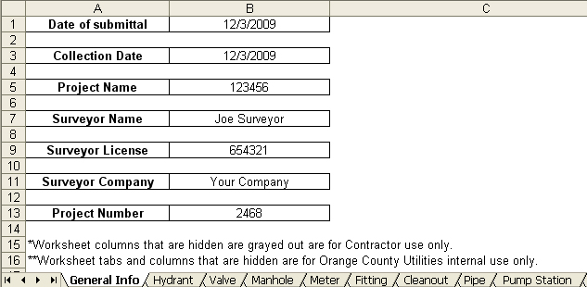

Cleanout Worksheet
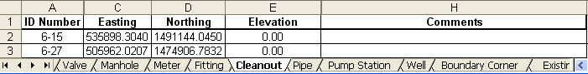

Existing Orange County Utility Crossing Worksheet
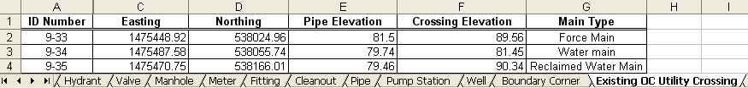

Fitting Worksheet
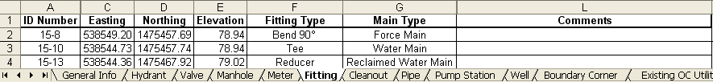

Hydrant Worksheet
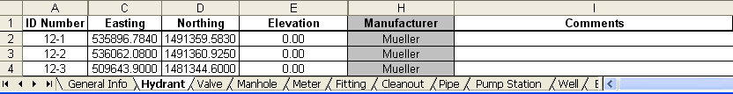

Manhole Worksheet
Meter Worksheet
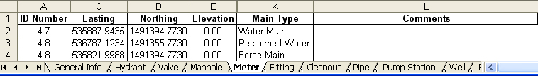

Monitoring Well Worksheet
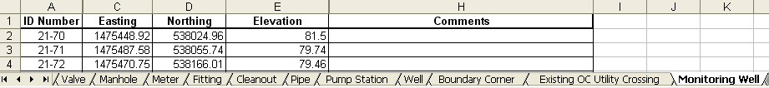

Pipe Worksheet

Property & Easement Corner Worksheet
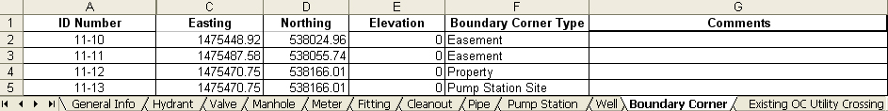

Pump Station Worksheet
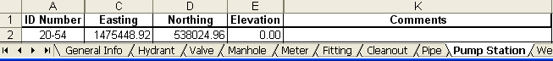

Valve Worksheet
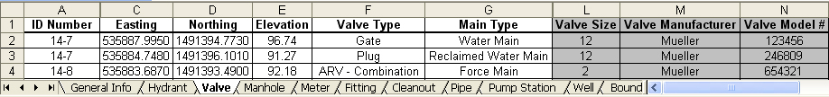

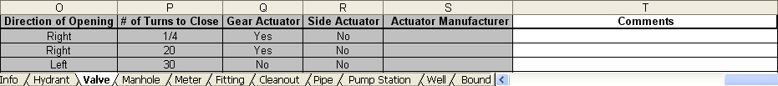

Well Worksheet
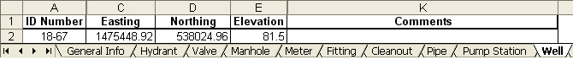

Subtask 530 - 100% Level of Completion

Shall be defined as a complete set the construction drawings and technical specifications including the Bid Schedule that will allow the Project to be bid and all of Utilities’ 90% review comments were addressed.

- Submit three (3) hard copy sets of 100% complete construction drawings and technical specifications.
- Submit one (1) set of 100% complete construction drawings to Utilities’ GIS Section to assign asset numbers.
- Submit a copy of the drawings and specifications in electronic format as .pdf documents on a CD.
- Submit a copy of the drawings in electronic AutoCAD format (.dxf or .dwg) and a copy of the Specifications in Microsoft Word  format on a CD
- Prepare and provide the Engineer’s Estimate of Probable Cost, signed and sealed by a State of Florida Registered Professional Engineer.
.
TASK 600 - Public Relations: Community Meeting/Public Notification-Flier Production and Mailing Procedure

1. Following the 90% level of completion and before advertising for construction bids, the Engineer shall prepare and conduct a pre-construction community meeting to discuss the proposed construction with the affected community.
- PM establishes date for the community meeting and coordinates with District Commissioner’s Office.
- Engineer identifies a location (typically an Orange County public school) for the community meeting that is in proximity of the proposed construction, and provides location to PM.
- Engineer identifies properties adjacent to or affected by proposed construction utilizing County Buffer Notification Criteria or instructions from PM and obtains property owner’s mailing address. Engineer develops mailing list and provides a copy upon request to the PM.
- Obtain the Community Meeting Notice guidelines and coordinate with the PM to determine the design and contents of the notice, number of notices to be printed and the property mailing addresses. The notice shall include the anticipated construction start date.
- Engineer coordinates with PM to develop a color, computer generated, 8½ x 11-inch size community meeting notice with location map utilizing Word™ and based on OCU guidelines.
- PM sends draft notice to Department Public Information Officer (PIO) for review and final approval by Department Director. PIO requires 10 working days from receipt of draft notice for approvals.
- PM has Engineer make any changes required by the PIO and Engineer sends final notice to the PM to obtain final approvals.
- All notices shall meet the requirements set by the County, Utilities and the Orange County Public Notification Task Force.
- Printing
- Fliers shall be printed on white glossy recycled 8 ½ x 11-inch paper
- Stock shall be a minimum of 60lb weight. And printing shall utilize the four-color process paper.
- Property owners should receive notice two (2) weeks prior to the meeting.
- Engineer mails Utilities approved community meeting notice.
- Construction projects that are 1 year or more in duration, a notice shall be sent to the subject property owners every 6 months and provide the status of the project.
- Additional notices may be needed if an urgent or emergency situation arises on the project where public notification is warranted

TASK 700 - BIDDING ASSISTANCE

      - Within 30 days before the project is advertised to be bid, revisit any easements containing proposed pipes to determine if any protected animals (gopher turtles, eagles, etc.) have inhabited the area.
      - Create construction drawings and specifications for bidding and ePlan™ distribution by the Orange County Contracts and Purchasing (Purchasing) Division. Construction drawings and specifications shall be formatted as .pdf documents and furnished to Purchasing on CD. Furnish five (5) copies of the CD containing the .pdf documents.
      - Furnish fifteen (15) sets of 24-inch by 36-inch size hard copy construction drawings, one (1) unbound, single page-sided, set of technical specifications with Index of Specification Sections and an Index of Construction Drawings, the Bid Schedule and any Special Provisions to Purchasing for use during the bidding process.
      - Attend a pre-bid conference scheduled by Utilities.
      - Consider written questions from bidders related to the Project and prepare all addenda as required to interpret, clarify or expand the Bidding Documents. Submit addenda to Utilities in a timely manner that allows reception of addenda by all bidders no later than a minimum of three (3) days prior to bid opening date.
      - Prepare a tabulation of all bids received in spreadsheet format and provide a digital copy, review and evaluate the apparent three (3) lowest bidders unit prices, experience and references and make recommendations to Utilities regarding the award of the construction contract.

TASK 800 - Construction Administration

Utilities’ Construction Division provides construction inspection. All instructions to the Contractor(s) shall be issued through Utilities. The Engineer shall:
- Modify bidding documents, if required, and obtain all County/Purchasing required and contractor executed documents; provide the County ten (10) full size and five (5) half-size hard copy sets of the “Conformed” construction drawings and fifteen (15) complete, bound Project Manuals (collectively referred to as the conformed Contract Documents) for Utilities’ use during the construction phase of the Project.
- Conformed Construction Documents
- Add the asset numbers assigned by Utilities’ GIS Section to the applicable assets on the drawings.
- Submit one (1) certified, full size, hard copy sets of Conformed Construction Documents signed and sealed by the Engineer.
- Submit digital Conformed Drawings in AutoCAD (dxf or dwg) format.
- Preconstruction Conference
- Plan, organize and conduct a pre-construction conference; distribute Conformed Contract Documents, take meeting minutes and distribute written minutes to all attendees.
- Provide a digital version of the conformed construction drawings in AutoCAD format (.dxf or .dwg) to the Contractor. Provide an electronic copy of an Excel™ workbook to the Contractor for the As-Built Asset Attribute Data Tables. The full Asset Attribute Data Table, as shown on the PLANS, shall be provided in excel format to the contractor once the PLANS have been approved.
- Review shop drawings and product submittals for conformance with the Contract Documents.
- Provide clarifications, interpretation of the specifications, sketches and drawings to resolve actual field conflicts encountered and provide consultation and advice during the construction process, as requested by Utilities.
- Attend monthly construction progress meetings, take meeting minutes and distribute minutes to all attendees. Concurrently on the day of the monthly construction progress meeting, observe the construction of the Project and discuss any concerns with Utilities.
- The Engineer shall review at construction progress meetings the progressive As-Built Drawings. Review the Contractor Surveyor’s Record Drawing Asset Attribute Data Table (see Table 6). If applicable, the Engineer shall prepare and up-date Gravity Main Table (see Table 7) and Pipe Deflection Table (see Table 8) to determine if the constructed improvements meet the Engineer’s design intent.
- The Utilities Construction Division executes change orders. If requested by Utilities, evaluate requests for changes in contract price and time made by the Contractor.
- Conduct substantial and final completion inspections of Project and prepare appropriate “punch lists”.
- Prepare necessary documents and submit the Project certification of completion and any necessary partial certifications to the FDEP to obtain all approvals for release of the water main, force main, gravity main, and reclaimed water main for use and including, but not limited, to partial Record Drawings.
- Projects that have an estimated construction cost of $6 million shall utilize Primavera Contract Manager Version 12.1 or current version hosted and managed on Utilities’s server for all documentation and correspondence throughout Construction.
- All project correspondence and documentation including but not limited to requests for information, notices, change orders / change management, noncompliance notices, notice of claims, requests for clarification, updates, meeting minutes, shop drawing transmittals, clarifications, shop drawing comments, letters, memo’s, etc shall be created and managed in Primavera Contract Manager.
- The use of emails as project correspondence and documentation between the Contractor and Engineer is unacceptable and shall be considered noncompliant.
- Record Drawings
- The Engineer shall develop the Record Drawings from the As-built Drawings of the construction supplied by the construction contractor. The Record Drawings shall incorporate all partial clearance information. The Engineer shall indicate substantive deviations from the original design documents and certify whether the deviations are such that the original engineering design intent has or has not been “materially” accomplished by the finished construction. The Engineer shall fully and completely delineate the scope of the Engineer’s work on all Record Documents and what services were performed by the Engineer upon which the certification is based. The accuracy of the location information is to be based upon the Contractors surveyor’s As-Built Asset Attribute Data Table.
- The Record Drawings shall be a compiled representation of the constructed project; shall contain a listing of the sources and the basis of information used in the preparation of the Record Drawings; shall contain a certification that they are believed to be correct to the best of the Engineer’s knowledge and that the drawings meet the design intent including, but not limited to, the location of the installed assets (gravity main slopes, if applicable), and degree of pipe deflections.
- The Record Drawings shall contain the As-Built Asset Attribute Table that was certified by the Contractor’s surveyor and the gravity main and pipe deflection tables.
- The Engineer shall submit three (3) certified, full size, hard copy sets of Record Drawings, signed and sealed by the Engineer of Record and containing appropriate notes or disclosures accompanying the certification that state the Engineer’s determination that such modifications do or do not “materially” affect the permitted design. Exclusions are not permitted.
- The Engineer shall submit a scanned digital version of the certified, hard copy Record Drawing in Adobe Acrobat protected document file (pdf) format and comprised of the tagged information file (tif) format.
- Electronic Record Drawings shall be signed and sealed by the Engineer of Record by creating a “signature” file in accordance with Chapter 61G15-23.003, FAC.

Table 7
Gravity Main Table

Downstream |  | Upstream |  | As- Built Length (ft) | Design Slope | As-Built Slope | Constructed Allowable Slope
Manhole Number | As-Built Invert Elev. | Manhole Number | As-Built Invert Elev.
TABLE 8
PIPE DEFLECTION TABLE EXAMPLE
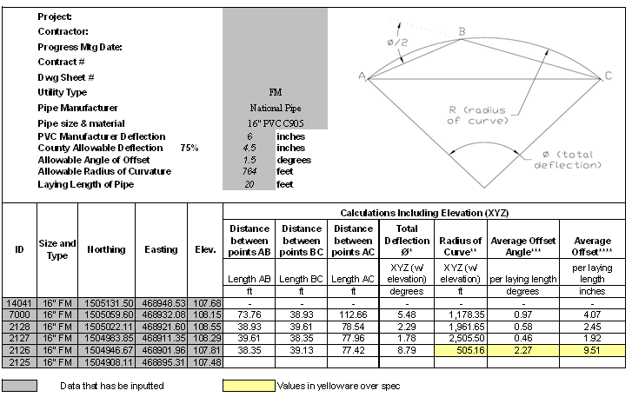
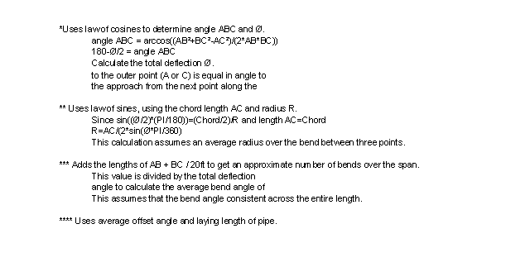
FOR A RFP - DELETE THE REMAINDER

ORGANIZATIONAL CHART

The proposal shall contain a chart that depicts the organizational hierarchy of the project team. The chart shall contain names, position title and responsibility of each team member of the primary firm, the name of all sub-consultant firms and depict the flow of communication and responsibility for task performance. An expanded organizational chart may be requested once an engineering firm is selected to perform the Project.

SCHEDULE
The work effort described herein will be completed within ? months in accordance with the proposed schedule provided as Exhibit A.
The proposal shall contain a schedule for accomplishment of the Project that reflects the proposed elapsed time in days for completion of the preliminary engineering phase, the design phase, the bidding phase and the construction of the Project. The schedule shall identify and address accomplishment of each major milestone enumerated in the previous SCOPE OF WORK. Assume a County review time of two (2) weeks for each submittal.
The schedule will reflect the proposed elapsed time in days that the engineer will require for accomplishing the task, the estimated bidding duration and the construction time. The duration of activities controlled by the County may be estimated and included in the schedule.

COMPENSATION

Engineer will perform the services described herein for a not to exceed fee of $XXXXX in accordance with Contract Y10-XXX. A cost breakdown is provided in the attached Exhibit B.
The fee is separated into the following headings and work items are described on each corresponding line:
Task 100 Preliminary Engineering;
Task 200 Surveying with the following breakdown of the scope of work:
- Vertical control
- Horizontal control
- Baseline traverse
- Right-of-way
- Easement acquisition related work
- Fee Simple property acquisition related work
- Topography
- Subsurface geotechnical test hole location
- Pipe crossings/conflict location
- Wetlands boundary survey and staking
- Legal descriptions and sketches
- Other specific task pertinent to the particular project;
Task 300 Geotechnical Investigation;
Task 400 Ecological Investigation;
Task 500 Construction Documents with the following headings:
- Subtask 510 – 60% Level of Completion
  - Identify components
- Subtask 520 – 90% Level of Completion
  - Identify components
  - Permitting
- Subtask 530 – 100% Level of Completion
  - Identify components
Task 600 Public Relations: Community Meeting/Public Notification-Flier Production and Mailing Procedure;
Task 700 Bidding Assistance; and
Task 800 Construction Administration Services.
    - Identify components
- Gravity Main Table (see Table 5) and Pipe Deflection Table (see Table 6)

Fee direct costs can be determined by examination of the area of the project utilizing tax maps, etc.

M/WBE PARTICIPATION

Total MBE percentage for this authorization is ZZ.ZZ%. XXXX, an MBE firm, and YYYYY, an MBE firm, will be involved in this project. XXXX’s fee total is not to exceed fee of $XX,XXX.XX, and XXXX’s total not to exceed fee is $YY,YYY.YY.

PROCEEDING WITH TASKS

A kick-off meeting shall be scheduled at the outset of the work for this Task Authorization. Each of the tasks listed below shall be authorized individually by the PM before proceeding to the next task.
Task 100 Preliminary Engineering;
Task 200 Surveying;
Task 300 Geotechnical Investigation;
Task 400 Ecological Investigation;
Task 500 Construction Documents:
- Subtask 510 – 60% Level of Completion
- Subtask 520 – 90% Level of Completion
- Subtask 530 – 100% Level of Completion

Engineering Consultant
Invoicing Format and Procedures

Invoices for services by the Engineer shall provide a narrative describing the activities being performed, date range as well as the project specific duties / tasks performed by each person billed to the County.
Engineer shall utilize the following format and procedures. Invoice submittals that do not meet the following format, will be disapproved and returned to the consultant. If you have any questions concerning your invoice submittal, please contact the PM.
1. Invoice Format
- Invoices shall be submitted to:
Orange County Utilities
Attn: Manager, Fiscal Services Division
9150 Curry Ford Road
Orlando, Florida 32825
- A transmittal letter shall be included with the invoice. Faxed invoices are not acceptable.
- Invoice shall have the current date of submittal and not backdated.
- Invoice shall have the billing period stated; for example: “For services provided from May 1, 2009 to June 1, 2009”.
- If the invoice is a re-submittal of a previously submitted invoice, the invoice shall have the words “Revised” and/or “Re-submitted” followed by the date of re-submittal.
- Invoices shall be consecutively numbered, starting with Invoice No. 1, followed by the Purchase Order Number and the Project Name; for example: “Invoice No 1-PO C9680002; Hemple Avenue Force Main Project”.
- Invoices shall have a complete listing of tasks that are identical to the listing of tasks in the approved scope of work. Each task breakdown shall include the total task dollar amount and the dollar amount for that billing period with an itemization of hours by discipline and dollar amount by discipline. The sum of the dollar totals for each task shall be equal to the fee amount.
- A complete description of the provided services shall be included with the invoice.
- All sub-consultant costs and all direct cost shall be presented as a separate itemization.
- All sub-consultant and direct costs shall include back-up documentation that clearly indicates incremental cost amounts.
2. Invoice Processing Procedures
- OCUD Fiscal Services Division will mathematically review invoice, verify documentation and submit to Engineering Division with their payment recommendation.
- The Engineering Division’s Project Manager will review invoice in regards to amount billed versus services received and either approve or disapprove invoice.
- Disapproved invoices are returned to Fiscal Services Division for return to Consultant.
D. Approved invoices are sent to Engineering Division Manager for final approval and returned to Fiscal Services Division, which initiates the payment procedure through the Contracts and Purchasing Department. The Orange County Comptrollers Office issues checks.

