UV Curable Screen Inks Color Chart
1400 Series, 1600 Series, 1800 Series, 1900 Series, N3100 Series, 3400 Series, 3600 Series, 3800 Series, 3900 Series, 4000 Series, 4100 Series, 4200 Series
The UV Ink Color Chart is representative of the colors available in all Nazdar UV ink series; however, some colors are not available in all ink series. Check the specific product pages for specific ink series color availability.

PANTONE® Base Colors
The 60 and 360 Series colors are highly concentrated versions of the base colors used to simulate the PANTONE Color Specifier 1000. The higher pigment concentration of the 60 Series provides stronger colors, greater opacity and easier color matching. The 360 Series provides intense colors, expanded color palette and special colors, including metallics, pearls, and transparents. 360 colors contain no white in the individual ink color. This allows a larger range of colors and transparents to be matched, including metallics and pearls.
Consult the Nazdar UV Screen Inks Color Simulation Formula Guide for the PANTONE MATCHING SYSTEM® to match formulas to specific PANTONE colors.
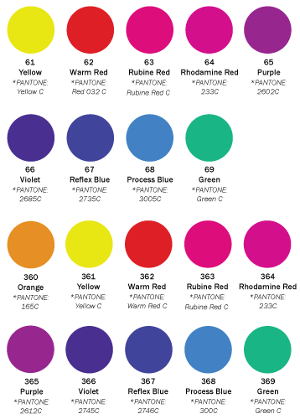

Standard Printing Colors
These bold and durable colors offer exceptional printing performance. The standard printing colors provide excellent flow characteristics and are ready to print from the container.
Fluorescent colors are available upon request in select ink series.
