Conventional Screen Inks Color Chart
The Conventional Screen Inks Color Chart is representative of colors available in several Nazdar Conventional ink series; however, some colors are not available in all ink series. Check the individual series product pages for specific color availability.
5100 Series, 6100 Series, 7200 Series, 7900 Series, 8400 Series, 8800 Series, 8900 Series, 9600 Series, 9700 Series, 9800 Series, ADE Series, PP Series, S2 Series

PANTONE® Base Colors
The 60 and 360 Series colors are highly concentrated versions of the base colors used to simulate the PANTONE® Color Specifier 1000. The higher pigment concentration of the 60 Series provides stronger colors, greater opacity and easier color matching. The 360 Series provides intense colors, expanded color palette and special colors, including metallics, pearlescents, and transparents.
Consult the Nazdar Conventional Screen Inks Color Simulation Formula Guide for the PANTONE MATCHING SYSTEM® to match formulas to specific PANTONE colors.
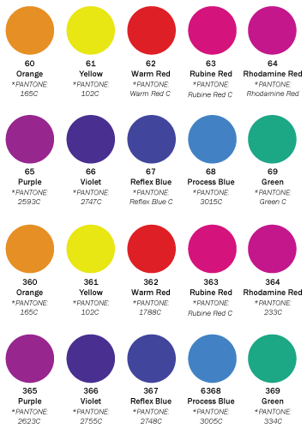

Standard Printing Colors
These bold and durable colors offer exceptional printing performance. The standard printing colors provide excellent flow characteristics and are ready to print from the container.
Fluorescent colors are available upon request in select ink series.
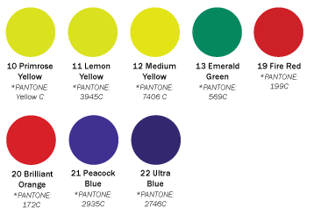
Toners
These remarkably clean single pigment toners are formulated with transparent pigments specially selected for their superior exterior performance. Single pigment toners can be used to enhance color matching and may be let down with 26 Mixing Clear to achieve various transparent shades. Special transparent colors are available upon request.
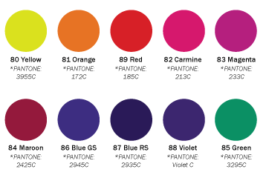
Halftone Colors
The primary subtractive colors used for full color reproduction with halftone art are based on SWOP color standards for color hue and density and are used in guiding color standards for commercial proofing systems. A halftone black supplements the four color system. Halftone extender base can be used with any of these colors to reduce the density of the color.
