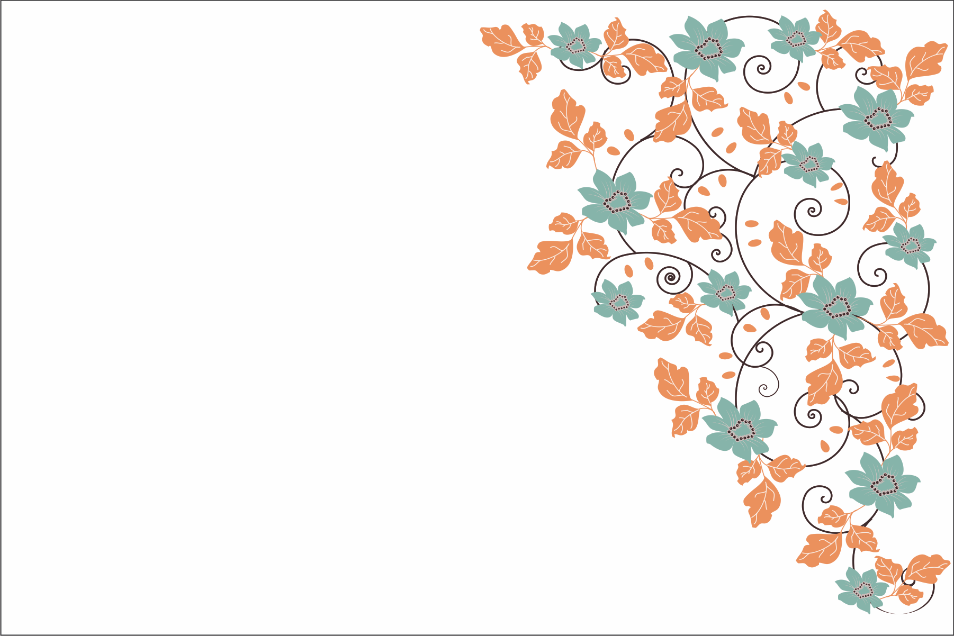

Please join us on our upcoming get together

Holiday party.

Monday 10th, 2015

At 198-GW-XYZ

You are invited