Morse Code Practical

Information – Communication increased more rapidly over long distances with the discovery of electric current by Volta in 1799. The first messages sent and received using electric current came in 1836 when Sir Charles Wheatsone invented the electric telegraph that could move pointers in railway signalling. A year later Samuel Morse, an American devised a much simpler system. He devised a code that could send messages by opening and closing a switch. The pulses of electricity produced made dots and dashes on a strip of paper at the other end.
Later in 1876 communication technology went further in transmitting voice through telegraph wires and so the invention of the telephone by Alexander Graham Bell was created.

Aim: to create and interpret a morse code message.

Equipment: Power supply, Light globe, switch, 3 connecting leads

Method:

- Connect the circuit up as shown in diagram.
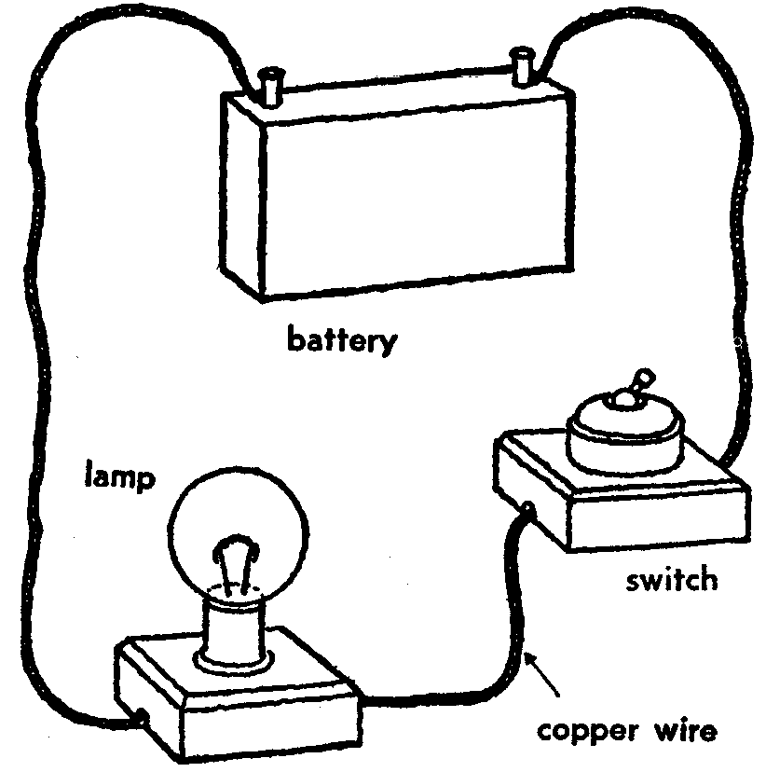

- Connect to power supply on DC at D setting. Make sure your globe is working.
- Write a short message down and use the morse code key to translate it.
- Tap the message out slowly on your circuit and get your partner to take down the message, than translate it.
- Switch roles and repeat the process

Results: Translated message.
Discussion/Conclusion: What were the difficulties in sending and receiving morse code messages?

Morse Code Alphabet

Rules:
A dash lasts as long as three dots
A space as long as one dot is left between each pulse
A space as long as one dash is left between each letter of a word
A space as long as 5 dots is left between each word of a sentence.

A .-  B -...  C -.-.  D -..  E .  F ..-.  G --.  H ....  I ..  J .---  K -.-  L .-..  M -- | N -.  O ---  P .--.  Q --.-  R .-.  S ...  T -  U ..-  V ...-  W .--  X -..-  Y -.--  Z --.. | 0 -----  1 .----  2 ..---  3 ...--  4 ....-  5 .....  6 -....  7 --...  8 ---..  9 ----.  Fullstop .-.-.-  Comma --..--  Query ..--..

