***Grow Baby Grow***

# **Content Standard(s)**

**Goal.** The student will demonstrate the ability to investigate exponential, logarithmic, and logistic functions and solve real-world problems, both with and without the use of technology.

**Objectives:** The student will be able to:

Sketch and analyze exponential functions and their transformations.

Sketch and analyze logarithmic functions and their transformations.

Sketch and analyze logistic functions.

Compare and contrast the exponential and logistic models.

MP1: Make sense of problems and persevere in solving them.

MP3: Construct viable arguments and critique the reasoning of others.

MP4: Model with mathematics.

MP5: Use appropriate tools strategically.

MP7: Look for and make use of structure.

*Mathematical Analysis Honors, Unit 5*

# **The Task**

The growth of an average male is shown in the growth chart below. A local pediatrician would like a model to calculate the average height of his male patients for any age in months. Use the data to determine a model of best fit for the pediatrician. Defend your choice of model mathematically.

|  |  |
| --- | --- |
| **Age (in months)** | **50th Percentile Stature (in centimeters)** |
| 24 | 86.4522 |
| 36.5 | 95.27359 |
| 48.5 | 102.5105 |
| 60.5 | 109.1751 |
| 72.5 | 115.6609 |
| 84.5 | 122.0305 |
| 96.5 | 128.1237 |
| 108.5 | 133.7345 |
| 120.5 | 138.8234 |
| 132.5 | 143.7304 |
| 144.5 | 149.3088 |
| 156.5 | 156.4099 |
| 168.5 | 164.1418 |
| 180.5 | 170.1393 |
| 192.5 | 173.6101 |
| 204.5 | 175.341 |
| 216.5 | 176.185 |
| 228.5 | 176.6179 |
| 240 | 176.8492 |

<http://www.cdc.gov/growthcharts/html_charts/statage.htm>

# **Facilitator Notes**

1. Students should have access to graphing calculators to enter data and calculate regression equations. Check their stat plots, residual plots and look for evidence of MP4 and MP5.
2. The use of student groups of four will allow for debate as to which model fits the situation. (Look for evidence of MP3.)
3. Students’ answers may vary for Follow-Up Question #2. Discuss whether the quadratic model is appropriate, and the idea of restricting domain. (Look for evidence of MP1, MP3, and MP7.)
4. Students learned about residuals in Algebra I and Algebra II.

# **Follow-Up Questions**

1. Based on the model chosen, what is the “limit to growth” in centimeters for the average male? Is there evidence of this value in the model?
2. Have you calculated a quadratic regression for this data? Could this be a good model for the pediatrician? Why or why not?
3. Is there any other information the pediatrician could provide to match a model more closely to the data? Explain.

# **Solutions**

Exponential Model

Logistics Model

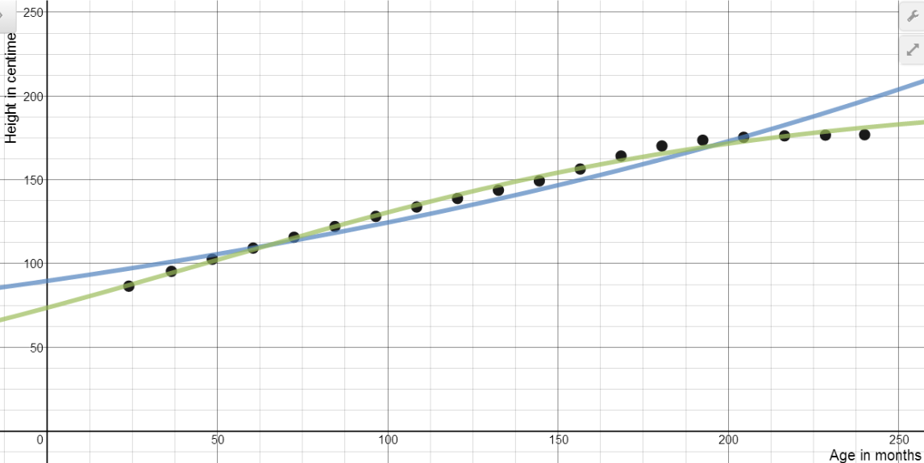

Quadratic Model

Logarithmic Model

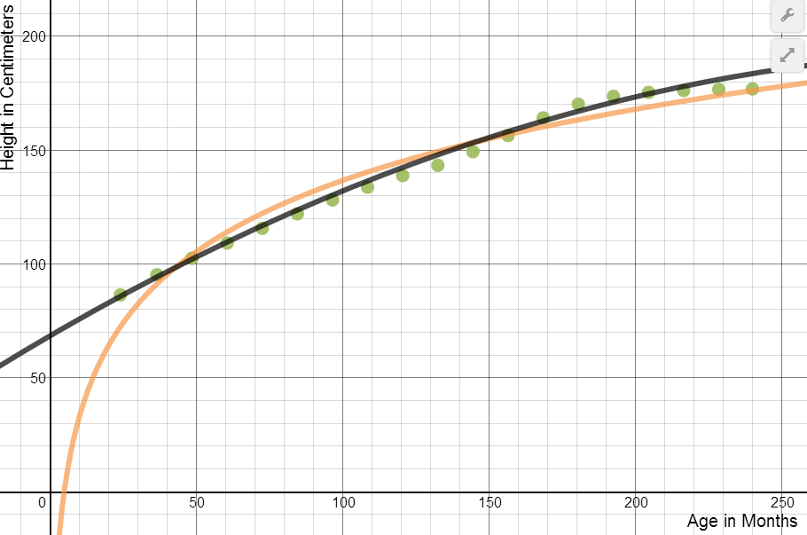

Exponential Model: 

Exponential Residuals

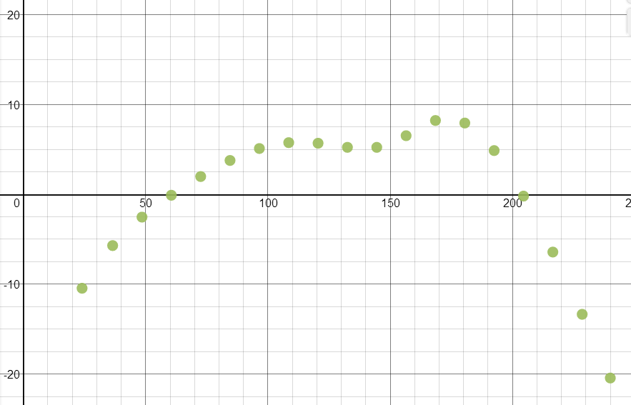

Logistics Model: 

Logistics Residuals

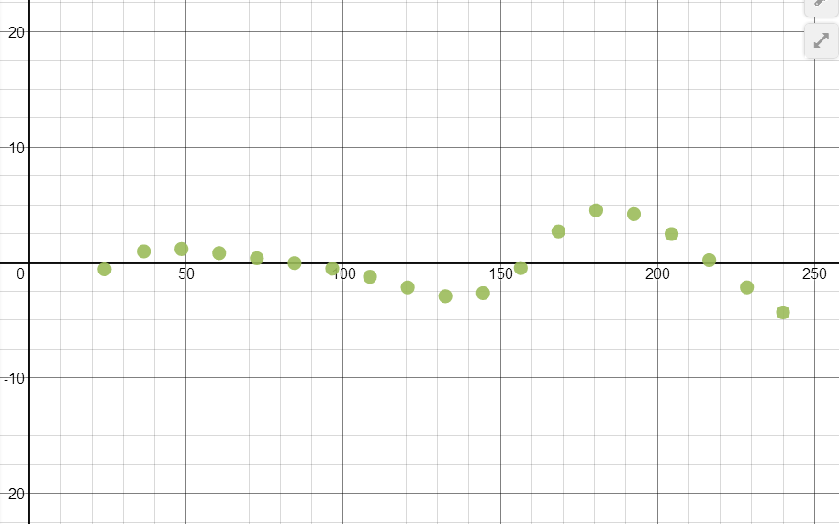

Logarithmic Model: 

Logarithmic Residuals

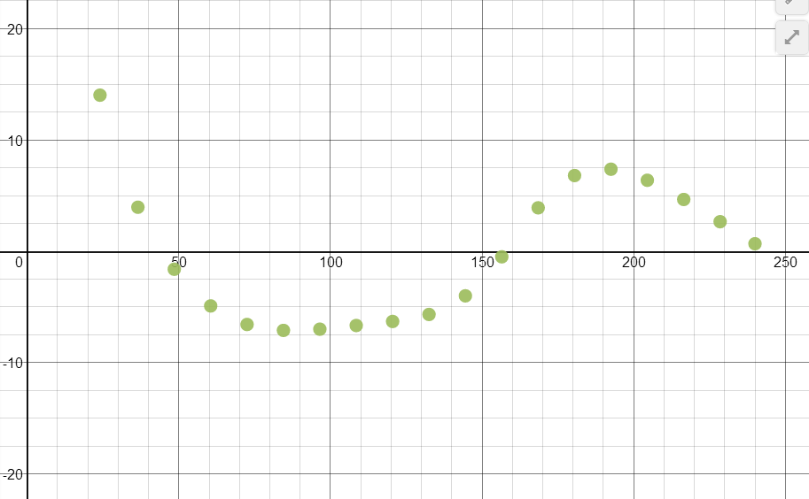

Quadratic Model: 

Quadratic Residuals

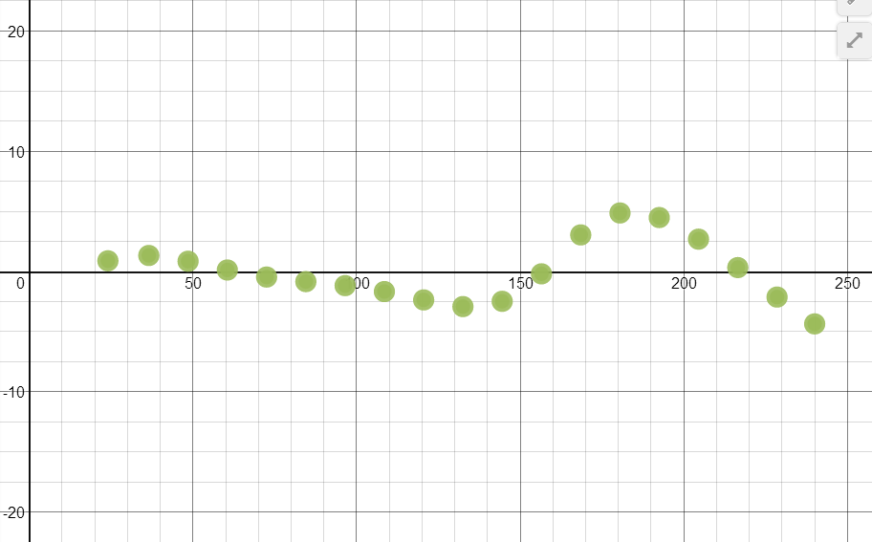

Answers may vary. Sample solutions:

Based on the models and residuals graphed above, the logistics model is best. It slows in growth as the ages reaches 240 months (20 years) just as a man’s height will reach a maximum around that time. The residuals graph is very close to the *x*-axis.

The quadratic model is a good choice for the pediatrician as it is a good fit for the data. However, the domain would need to be restricted at 240 months. A man’s height will not reach a maximum and then decrease. It would be appropriate for interpolation of data only. The residuals graph is very close to the *x*-axis.

Quadratic Model

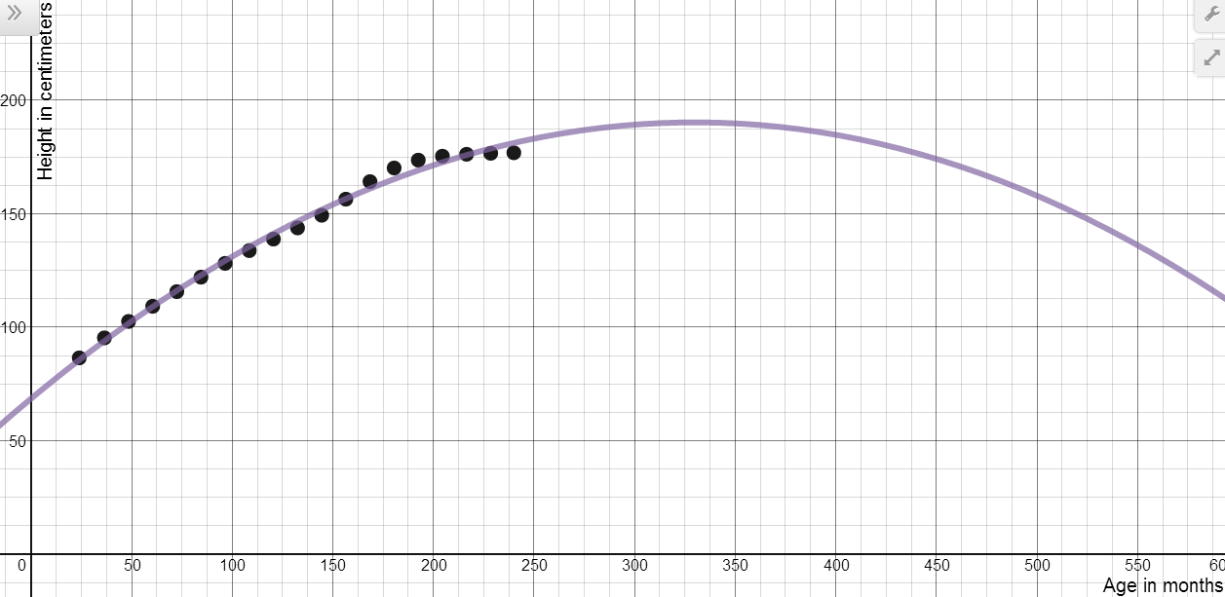

**Follow Up Questions:**

1. The limit to growth in the logistics model is approximately 199.720 centimeters. This can be estimated using the graph of the model or using the table on the graphing calculator. The limit to growth is found in the numerator of the logistics model.
2. Quadratic Model: 

Answers may vary. See graph of quadratic model above. Sample solutions:

The quadratic model is a good choice for the pediatrician as it is a good fit for the data. However, the domain would need to be restricted at 240 months. A man’s height will not reach a maximum and then decrease. It would be appropriate for interpolation of data only.  
  
The quadratic model is not a good choice for the pediatrician as it will reach a maximum height and then decrease in height as the man gets older.

3. Answers may vary. Sample solution:

If the pediatrician includes data from birth and 12.5 months a model may be more accurate.