Loss Database Technical Overview Sheet
This technical overview sheet accompanies the JRC report on “Recording Disaster Losses: Recommendations for a European Approach” (http://publications.jrc.ec.europa.eu/repository/handle/111111111/29296) and aims to collect information on existing or planned loss databases in a systematic and comparable manner in support of a technical meeting on 15 November 2013. For more information please contact Tom De Groeve, Joint Research Centre of the European Commission (tom.de-groeve@jrc.ec.europa.eu).

Purpose of loss database (See Chapter 3)
Applications and use | Scale and scope | Data assessment
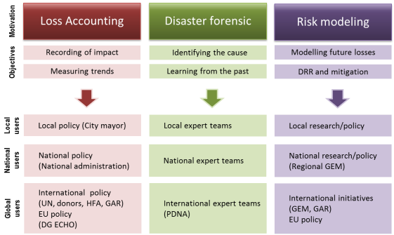  For which applications is the database designed?  ☒ Loss accounting: Click here to enter text.  ☐ Disaster Forensics: Click here to enter text.  ☐ Risk modelling: Click here to enter text.  Who are the main users (ministry, policy, sector)?  Click here to enter text.  Are you systematically sharing loss data with other organisations?  ☐No ☐With UN ☐With EU ☐With other org’s  What format or standard is used? (e.g. Excel, SQL, XML)  Click here to enter text. | 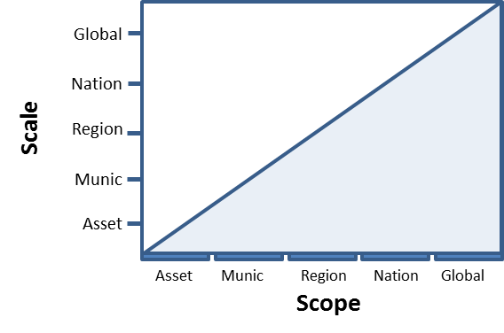  At what scale (precision) are you recording data?  ☐Asset ☐Municipal ☐Regional ☐Nat ☐Global  What is the scope or coverage of your database?  ☐Asset ☐Municipal ☐Regional ☐Nat ☐Global  What hazard types are covered?  ☐All hazards  ☐A single hazard: Click here to enter text.  ☐Multiple: Click here to enter text.  Time period covered  ☐Historical records (From/to: 19xx-20xx)  ☐Continuously updated and sustainable  ☐Sustainability not guaranteed | Mandated organisation to collect data  Click here to enter text.  ☐Mandated ☐Academic/Project ☐Private  What techniques are used to record loss data?  ☐Desk research (media, government reports)  ☐(Sectorial) field assessment teams  ☐Official reporting mechanism (e.g. insurance claims or police reports)  ☐Remote sensing  Other: Click here to enter text.  Do you have well-defined entry criteria? Which?  Click here to enter text.  Is there a quality assurance process?  ☐Systematically ☐Ad hoc ☐No  Language(s): Click here to enter text.
Comments: Click here to enter text.

External references: identifiers ☐ Considered / important
Do you refer to external database(s), and if yes, which one(s)? |  | If yes, how do you ensure correct relationships?
☐Hazard database (e.g. USGS catalogue of earthquakes)  Click here to enter text.  ☐Exposed element database (e.g. cadastre, asset database)  Click here to enter text.  ☐Loss data (e.g. surveys, forensic study, assessment report)  Click here to enter text.  ☐The database is independent. There are no links with other databases |  | ☐Manual selection of corresponding records ☐Automatic selection
 |  | ☐Mandatory (in workflow) ☐Optional (only done when possible)
☐We store the corresponding record identifier of external database
☐External database uses our record identifier
☐Use of common identifier (e.g. GLIDE number)
☐Other
Comments: Click here to enter text.
Uncertainty handling ☐ Considered / important
Do you handle uncertainty or missing data explicitly in the database? | Do you handle uncertainty by referring to an external database? |  | If yes, how do you handle uncertainty or missing data?
☐Narrative, description
☐Qualitative (e.g. high, low) or Flag (e.g. exact, estimated, uncertain)
☐Quantitative metric (e.g. ±5km), range (min-max), statistic (e.g. st.dev.)
☐Probabilistic (e.g. PDF)
☐Storing multiple values, estimates or versions
☐Fixed conversion rules (e.g. 1 family = 4 persons; several buildings = 10)
☐Other, specify:
e.g. assign to smallest administrative area containing the hazard

☐No, or only in narrative  ☐For all fields  ☐For most value fields  ☐Only for key fields:  Click here to enter text. | ☐Hazard database (e.g. USGS catalogue of earthquakes)  ☐Affected element database (e.g. cadastre, asset database)  ☐Loss data (e.g. surveys, forensic study, assessment report)
Comments: Click here to enter text.

Hazard (See Table 1) ☒ Considered with Click here to enter text. fields in the database
Geographical location of hazard | Temporal information of hazard | Hazard event classification
How is location recorded in the database?  ☒Country (ISO3)  ☐Subnational unit(s)  ☐Point (lat/lon)  ☐Footprint (poly)  Which standards are used?  e.g. ISO3, NUTS, LAU2, INSPIRE, WGS84, UN GeoOntology | How is time recorded in the database?  ☒Date and time  ☐Period (from – to)  ☐Month only (for uncertain beginning/ending)  ☐Spatio-temporal dynamic information | Which standard are you using?  ☐CRED/MunichRe/IRDR standard  ☐INSPIRE HazardCategoryValue  ☐Other (standard internal or external list)  ☐None (free text, optional)
 | Event type specific attributes | Hazard event identification
 | ☐All hazard data is recorded in the database  ☐Some key data is recorded in the database  ☐Reference to external hazard database | Do you group records by hazard event?  ☒Yes, using internal event identifier  ☐Yes, linked to external event databases (e.g. GLIDE)  ☐No, only individual loss records
Comments: Click here to enter text.
Loss indicators (See Tables 2,4-6) ☒ Considered with Click here to enter text. fields in the database
Damage / loss categories (Table 2) | Loss indicators for population (Table 6) |  | Loss indicators for property (Tables 4,5)
What are you recording?  ☒Direct damage / people directly affected  ☐Indirect loss / damage  ☐Total loss / damage  ☒Tangible (economic loss and people affected)  ☐Intangible (loss of future usage, cultural, env.)  For property, are you recording  ☐Physical damage  ☒Monetary loss | Do you break down affected population by  ☐Killed ☐Missing ☐Injured  ☐Evacuated ☐Displaced ☐Homeless  ☐Victims ☐Affected ☐Total  Based on standard or methodology:  ☐UNDP/UNISDR (DesInventar)  ☐EM-DAT  ☐Internal  ☐Other: Click here to enter text. |  | Do you record damage or losses (monetary value)?  ☐Damage only; losses are calculated outside of db  ☐Losses  ☐Damage and losses  Do you record damage / losses (Table 5)  ☐At asset level (individual buildings)  ☐For groups of buildings (e.g. total for city)  Do you break down losses per sector (Table 4)  ☐per sector  ☐per loss owner (who bears the loss)  ☐Other: Click here to enter text.
Comments: Click here to enter text.
Affected element (See Tables 1,3,4) ☒ Considered with Click here to enter text. fields in the database
Geographical location of assets / losses | Population (killed, injured, displaced, etc.) |  | Property (damaged or destroyed)
Is location recorded separately for affected elements?  ☒No, only the hazard is georeferenced  ☐ Country (ISO3), Subnational unit(s)  ☐Point (lat/lon)  ☐Footprint (poly) | Do you break down population by (see Table 3)  ☐Age, Gender, Marital status, Education, etc.  ☐Risk category (e.g. ECLAC method)  Based on standard:  ☐ECLAC  ☐Other: Click here to enter text. |  | Do you break down property by (see Table 3)  ☐Buildings versus Civil works (e.g. energy lines)  ☐Crops / Moveable property (e.g. cars)  ☐Structural properties (e.g. material, age, stories)  ☐Classification (standard based)  Based on standard:  ☐EuroStat CC  ☐HAZUS  ☐Syner-G  ☐Other: Click here to enter text.
 | Sectorial |  | Loss ownership
 | Do you group affected elements by sector (e.g. energy, health, transport, residential)  ☐Sectorial approach like ECLAC and Solidarity Fund  ☐Mapped to national governmental departments  ☐Other  ☐No |  | Do you record who bears the loss in case of damage?  ☐Systematically ☐Ad hoc ☐No  Do you include these groups?  ☐Public ☐Individual / business ☐Insurance
Comments: Click here to enter text.

