Clinical Case Study Poster Presentations:

Clinical Case Abstract Submission Information
Your clinical case abstract should include a synopsis of your case which includes the history and physical exam of the case to be discussed, an outline of the differential diagnosis, Test and Results, Final/ Working Diagnosis, and Treatment/ Outcomes as it pertains to the case. It is recommended that the necessary data (i.e. EKG, X-rays, ECHOs, etc) be included.

ABSTRACT DEADLINE: 5 pm, February 14, 2014
ALL ABSTRACTS will be published in the International Journal of Exercise Science

Abstract Formatting Guidelines
Abstracts are limited to one typed page. The abstract should be formatted using Microsoft word (.doc format) using the template provided on the TACSM website (www.tacsm.org → Student Corner → Abstract Template). All Clinical Case Abstract submissions must include the following elements:

- Descriptive title
- Authors of Project (including post-nominals – M.S. Ph.D., FACSM, etc)
- Institutional affiliation of all authors
- Classification of First Author (undergraduate, masters, doctoral or PIT)
- Abstract (not to exceed 400 words). If you chose to include a table or figure, please make sure that the abstract length is kept to one page
- Role the First Author played on the project
- If this abstract has been submitted national ACSM, indicate who is first author of that abstract.
Note: Abstracts not meeting these guidelines will be rejected for presentation and publication.
Follow these steps to submit an abstract:

- Direct your Web Browser to: http://digitalcommons.wku.edu/ijesab.
- Click on “Submit Article” on the right side tool bar.
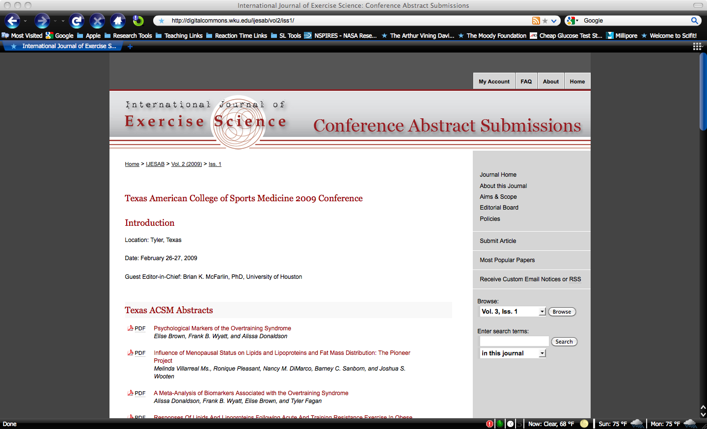

- Create an account (this is free). Note: If you created an account last year, you can use the same account.
- Login to your account.
- Review the Guidelines for the Submission Process and press “continue” button.
- Accept the “Article Submission Agreement.”
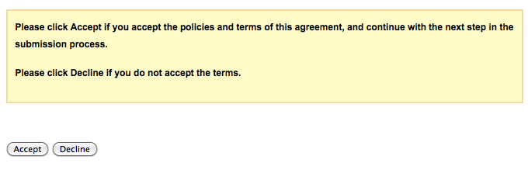

- Add Author Information (you will have to add each author separately). Take care in entering all authors’ names/email addresses and proofread for errors before proceeding!

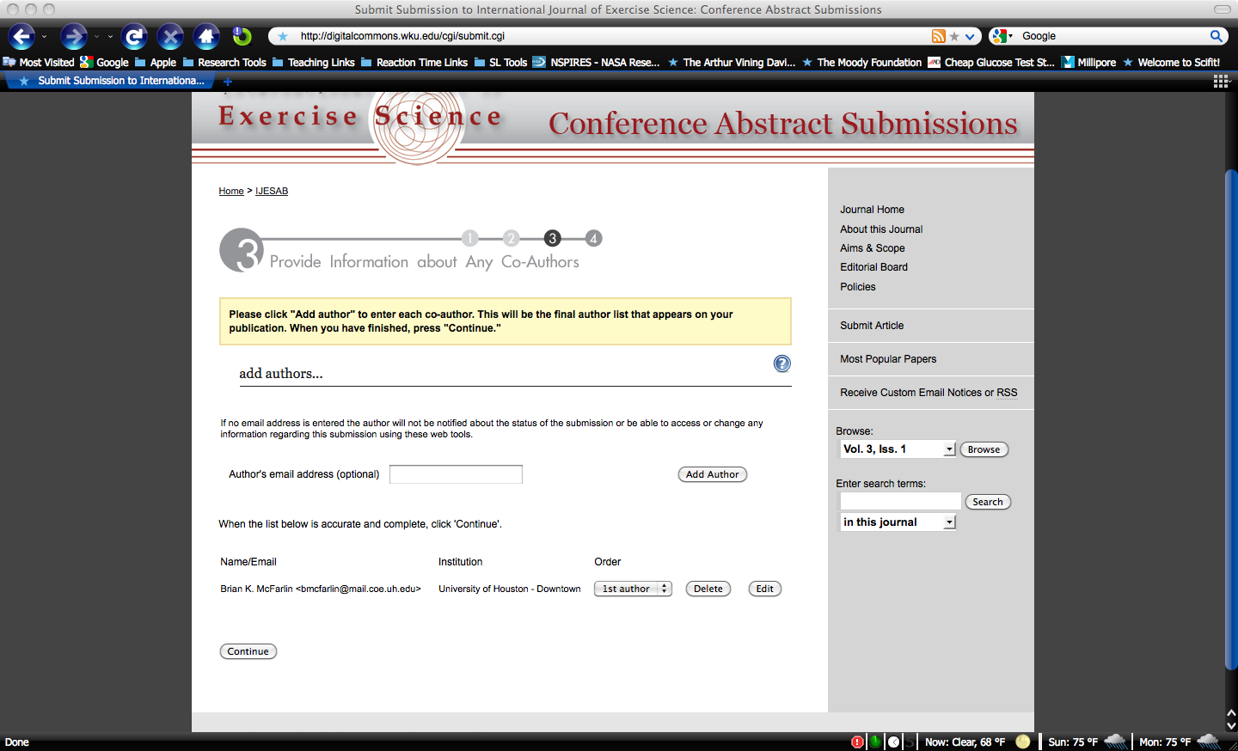

- After you have entered your information, under the “type of submission” option select “TACSM Abstract.”

- Upload a copy of your abstract in MS word format (please refer to TACSM template mentioned above).

- If you encounter any problems during the submission process, please email Dr. Brian McFarlin (Brian.Mcfarlin@unt.edu )
- Note: All abstracts are accepted, but please have your faculty supervisor review your abstract before you submit it, especially if this is the first time you have submitted an abstract. You may submit the same abstract for TACSM and National ACSM. This is an excellent chance to practice your presentation since you will get a lot of interaction with TACSM members and the judges will also ask you to explain your work.
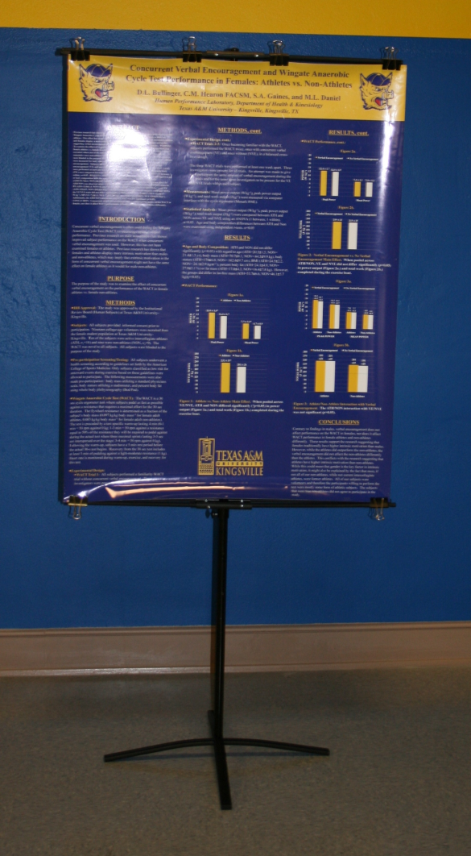
Poster Formatting Guidelines-
TACSM requires all posters to be in portrait format. Adherence to this requirement is essential because the poster standards cannot accommodate posters that are not in this format (see picture to left). Posters must be formatted to a size of 48” high (top-to-bottom) x 36” wide (right-to-left). The poster must be printed on a single sheet of paper. Many universities offer this service and if your university does not, then you can contact a local FedEx Kinko’s or other print shop. NOTE: Failure to comply with these preparation guidelines will result your poster not being displayed.
↑
48”
↓

Clinical case poster format
Every clinical case poster presented at TACSM should include at least the following elements:
- Descriptive Title with the
  - area of injury and, chronic condition, or disease
  - sport or activity where applicable
- Author Block (all authors should be listed, including professors)
- Institution(s)
- Short Introduction (limited to one paragraph)
- History: medical and symptom
- Physical exam findings
- Differential Diagnoses
- Test and results(should include figures and/or tables)
- Final working diagnosis and discussion

