Nicholas E. Davies Enterprise Award of Excellence
Case Study Template
Revised – January 2015

The focus of the Davies Award of Excellence is to demonstrate the use of health IT to improve outcomes. In order to be Davies worthy, case studies must present the problem that the organization intended to solve; identify the design, implementation, and governance strategies; provide qualitative and quantitative data demonstrating improved outcomes for patients provide an overview of both capital costs and operational costs for each initiative; and provide actionable and replicable lessons learned. The following template will assist you with compiling the critical data required for
As your organization prepares to resubmit the case studies, please do not hesitate to contact Jonathan French at should you have any questions.
*Standards for Quality Improvement Reporting Excellence [SQUIRE Methodology]
The application submission form was developed from the SQUIRE methodology The use of SQUIRE can be leveraged as a tool in the design of a project. The SQUIRE Guidelines help authors write usable articles about quality improvement/performance improvement in healthcare so that their findings can be easily discovered and widely disseminated, thus spreading improvement work to a broader population.

The following journals support the SQUIRE guidelines: American Journal of Nursing, Annals of Internal Medicine, British Medical Journal, Canadian Journal of Diabetes, Implementation Science, Joint Commission Journal on Quality and Patient Safety, Journal of General Internal Medicine, Journal of Nursing Care Quality, Quality & Safety in Health Care.

The Davies Organizational Committee modified the SQUIRE methodology with the intent to capture from applicants how health IT impacted patient safety and quality outcomes.

Menu Case Study Development
Candidates are required to submit four menu case studies demonstrating how the enterprise is utilizing health information technology as a tool to change clinical workflows and positively impact the quality of patient care. Each case study is intended to be a blueprint for success that other organizations can follow to improve care outcomes. The maximum length of each case study is 8 pages (not including the cover page and executive summary.) Each case study must demonstrate:
- Identification of a specific local clinical problem.
- A replicable and actionable description of the IT selection process, the workflow development process, and the anticipated outcome.
- A step by step description of how health IT changed and intervened in clinical workflows.
- A narrative supporting 12 months of both quantitative process improvement data and outcomes improvement data demonstrating sustainable quality improvement. Provide a description of the feedback loop used to evaluate success, and share the change management strategy for making changes to workflow.
- Actionable and replicable lessons learned.
- Case study specific capital and operational expenses, and resulting hard return on investment and “soft ROI” from clinical improvements and cost avoidance.
Executive Summary
Your cover page should feature an executive summary providing the following:
- Title of the Case Study
- Name, Organization, Location, and Primary and Secondary Points of Contact
- Executive Summary Highlighting:
  - The local clinical problem
  - The IT/IT-enabled solution
  - A Summary of the Resulting Clinical Improvement (include data-points.)

Local Problem (Suggested Length- ½ a page)
Provide the business case, utilizing pre-implementation of IT and workflow data, to identify the clinical and/or financial problem that your organization selected an IT enabled solution to improve upon.
It is critical to provide a baseline data point. The Value Derived section should provide data demonstrating that this local problem has been sustainably improved.
Example:
“XXX began a process of looking at quality data in early 2011 shortly after our EMR implementation. We determined that at baseline only 56% of our patient population had received a pneumonia vaccination. This percentage did not seem to significantly improve over the course of fiscal year 2012. To address this, XXX set a goal during fiscal year 2013 to increase the percentage of our patient population age 65 and older who had been vaccinated against pneumonia.”

Design and Implementation (Suggested Length- 1 page)
- Describe the selection process of the IT solution highlighted.
- Describe the process for the development of the workflow supported by IT.
- Identify how clinicians and end-users were incorporated into the development of the workflow.
- Conclude with identifying the intended outcome of the project.

Utilizing flowcharts and graphics to help demonstrate project design is encouraged. Here is an example from former winners:
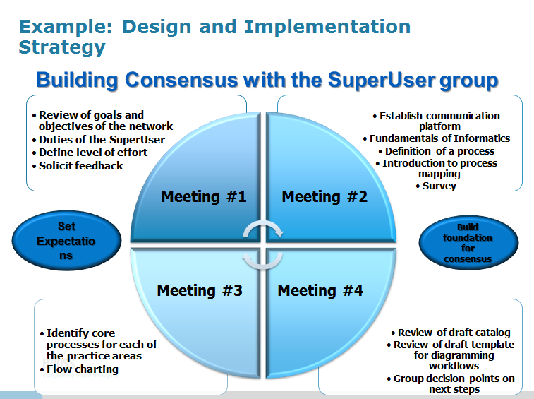

How Health IT Was Utilized (Suggested Length-2 Pages)
Detail the workflow utilized for improving the clinical workflow used to address the local problem highlighted in the opening section. Mix narrative and images to create a replicable blueprint that another organization can follow.
Step 1: Provide narrative describing the clinical workflow, and provide a flow chart detailing the step by step workflow process.
Examples:
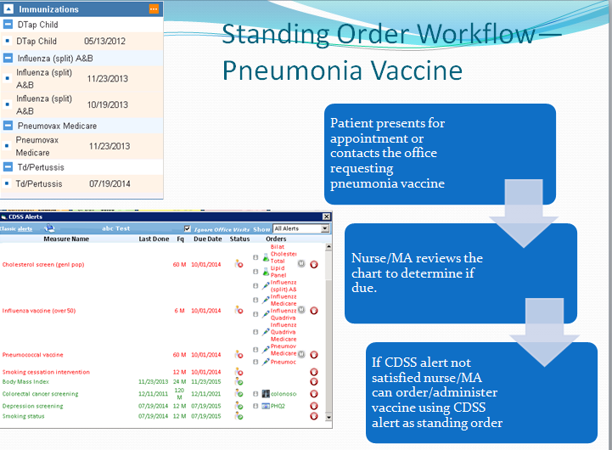
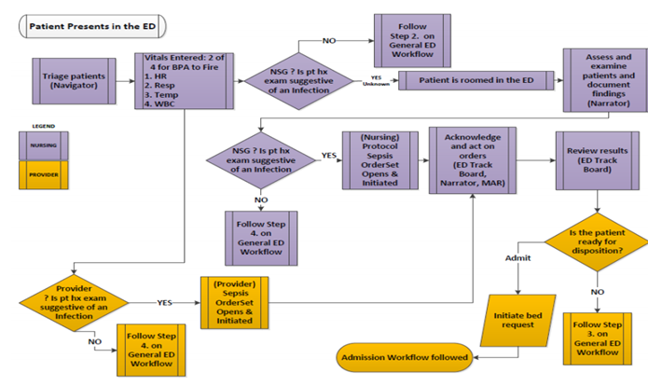

Step 2: Identify the points in the workflow where IT is utilized. Describe the intervention/solution/application/software/tool. Provide a screen shot. Describe how the IT intervention is used as part of the workflow.
Example:
The patient type (i.e. medical, surgical, etc.) is chosen by the provider or predetermined by the system based on the admitting information. In the example below, the patient is already in the highest risk category, so there is no need for the provider to identify additional risk factors. Relative and absolute contraindications to pharmacologic treatment are indicated by the provider.
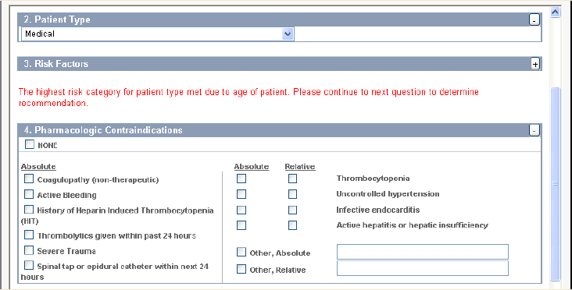

Value Derived (Suggested Length-2 Pages)
Value Derived is the most critical component of the case study as it requires data demonstrating improvement in clinical process and outcomes. There are four key components to a successful Value Derived presentation.
- Provide a narrative specifically identifying causation for your data. If it is unclear that IT was a critical component in improving your organizations process, the case study will not move forward.

- Provide a minimum of 12 months of post implementation data that demonstrates improved adherence to clinical best practice. Examples include Meaningful Use quality measures, Joint Commission measures, etc.
This data should be trended out, and spikes or drops in performance need to be explained.

- Provide a minimum of 12 months of post implementation outcomes data demonstrating that improved adherence to clinical best practice as result of IT utilization and improved workflow have positively impacted patient outcomes. An improved outcome answers the question “did the patient population get better as result of the workflow highlighted?” Examples of metrics include:
- Lowered Mortality, Length of Stay
- Lowered Readmissions
- Improved Health Outcomes (Lowered Morbidity)
- Reduction in Hospital Acquired Infections, Adverse Events, Medication Errors, etc.
Data should be trended, and show causation. Here is an example where an applicant provides process improvement data (improved successful medication scan rates) and then provides outcomes data demonstrating a reduction in medication errors.
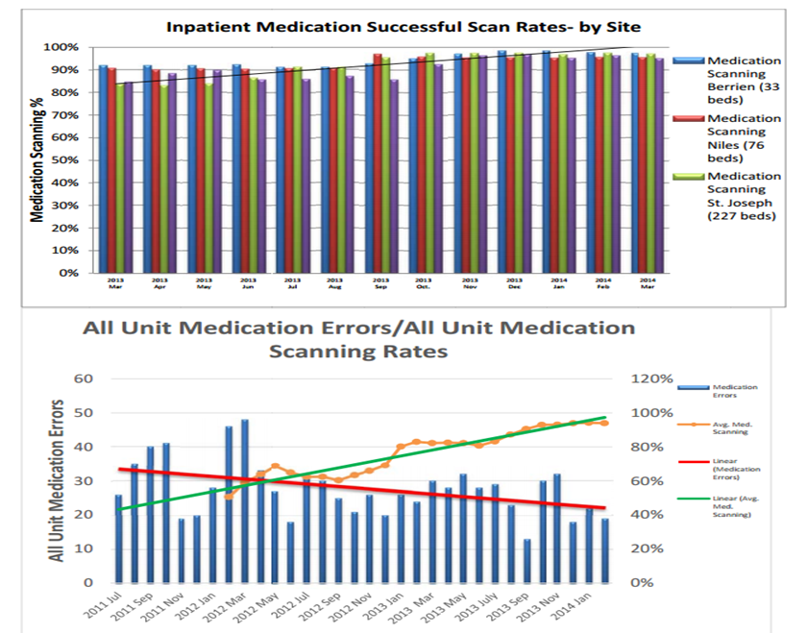

- Identify the workflow and IT tools utilized to measure improvement and analyze how to continue to improve process.

Lessons Learned (Suggested Length- 1 page)
Provide actionable and replicable lessons learned, including cause and solutions for failures. Identify critical root causes for success. Identify barriers and solutions that would be critical for another organization to replicate your success. Provide data where appropriate.
Example:

“Many clinicians thought the flowsheet data was too prescribed, and that interventions identified may not be appropriate in all cases. In some instances, nurses called a “code blue” for a patient with a high MEWS score, even though the patient did not meet the criteria for a code blue. XXX added language to the flowsheet group, indicating they were guidelines and should not replace a nurse’s clinical thinking and assessment of a patient’s needs. We also created additional guidance on how to manage patients within the MEWS framework.”

Financial Considerations (Suggested Length- 1 page)

In order for other organizations to replicate the IT implementation, provide the following information.
- Detail initial capital investment costs, including hardware, software, interfaces, staffing, training etc.
- Detail on-going operational costs, such as software updates, training, and new interfaces.
- Detail any new revenue streams or cost savings as result of the initiative, including
  - Pay for Performance Contracting
  - Patient Centered Medical Home
  - Incentives from participation in an ACO
- Cite any “soft ROI,” specifically cost avoidance as result of clinical improvements. Use peer reviewed studies that determine an average cost per episode of care (the Agency for Healthcare Research and Quality has excellent examples.)

Example of How to Present Cost Information:
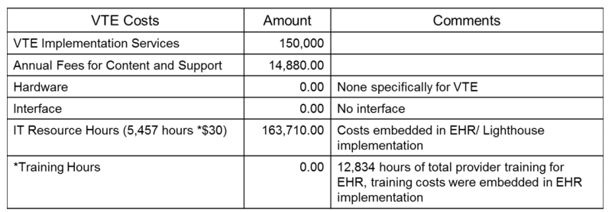

Example of How to Present ROI

