STRATEGIC ACCOUNT
PLAN TEMPLATE

"By failing to prepare, you are preparing to fail."
-Benjamin Franklin

“If I had eight hours to chop down a tree, I'd spend six hours sharpening my ax.”
-Abraham Lincoln

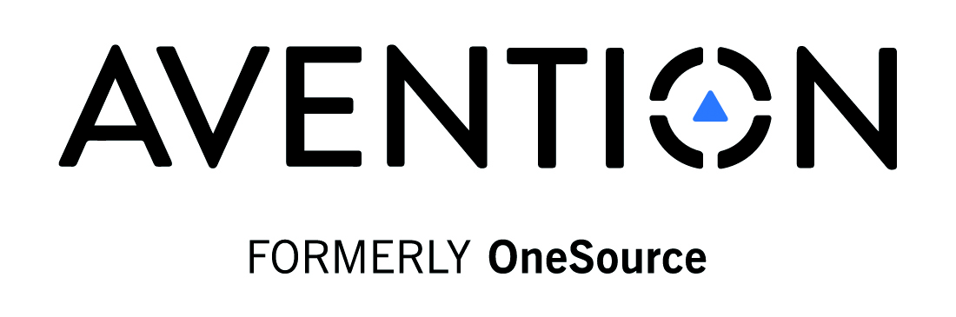
Table of Contents

Contents
Executive Summary 3
Account Information 4
Business & Industry Summary 4
Business & Industry Summary – CONT. 6
Accounts Key Competitors 7
Product & Solution Alignment 8
Embedded Information Technology Architectures 8
All Current And Planned Projects 9
CURRENT Projects and Evaluations 9
FUTURE Projects and Evaluations 10
Sales Opportunity Pipeline And Forecast 10
Current Proposals on the Table 10
Contract Information 11
Relevant Success Stories And Case Studies 11
Relevant Industry Insights Or Initiatives 12
Relationships 12
Organizational Charts 13
Voice of the Customer 14
Strategic Relationship Assessment 14
Partner Analysis 15
Activities, Tasks and Events 17
Contact Avention 19

Executive Summary

Account Name: | Date:

The Strategic Account Plan is designed to help the account management team effectively prepare and stay focused on the customer’s business objectives and goals to ensure they achieve the planned results, create a consistent experience for the customer, and ultimately identify how they can make a positive impact on the customer’s business.

This is your opportunity to write a one-page short summary of the past, current, and forecasted situation in the account.

How are they currently using your products? How are they using your competitor’s products? And, how is their growth going to affect usage of your product?

Account Information
Who is the Chief Information Officer and what is his/her background?

Current team, roles, and contact information

NAME | ROLE/TITLE | PHONE | EMAIL

Business & Industry Summary

What business is this company in? Annual revenues, market size? Key divisions? Locations?

Current Industry Trends
(E.g. If the company is in the business of moving freight, how are increased fuel costs going to affect their business and their need for your product?)

Key points from the latest earnings call?
(E.g. executive management changes, economic conditions, merger & acquisitions, security breaches, new investments, etc.)

Business & Industry Summary – CONT.

 |  | Current FY Ends |  | Month/Year
Financial Information | FY4 | FY3 | FY2 | FY1 | Current FY
Revenue
Net Income
Growth Rate

Major Subsidiaries and/or Divisions
Subsidiary Name
Location
Information on Subsidiary

Subsidiary Name
Location
Information on Subsidiary

Annual Report Highlights – What are the key business issues, challenges, drivers, initiatives from the annual report, news articles or other documents?

Significant Developments (past 12 months) – Major achievements or setbacks, changes in management and changes in the competition?
SALES TRIGGER EVENTS

Accounts Key Competitors

Their top three competitors | #1  (Name of company) | #2  (Name of company) | #3  (Name of company)
Revenue
Net Income
Growth Rate

List below your customer’s top three competitors and the specific areas they compete in. What are the strengths and weaknesses of each competitor and how does your customer sell against them?

Competitor #1
(Name of Company)

Competitor #2
(Name of Company)

Competitor #3
(Name of Company)

Key Value Proposition to the Customer – Elevator Pitch

Product & Solution Alignment

Line of Business – Division – Subsidiary | Product – Solution | Sales Revenue

Embedded Information Technology Architectures

TECHNOLOGY | VENDOR | VENDOR | VENDOR
ERP
CRM
SCM
PLM
Email Servers
ILM
Info Security
Network Operations
Data Warehouse
HRMS
Manufacturing Systems
Planning Systems
Data Center Consolidation
Virtualization
Business Intelligence
Operating Systems
Web Servers
Disaster Recovery
Outsourcing
Mainframes
Other 1
Other 2
Other 3

Data Center Locations (Domestic & International)

Address and Country
Address and Country
Address and Country
Address and Country

All Current And Planned Projects

What projects are currently in progress or may be planned in the near term (six months) that may assist or hinder forecasted Sales Opportunities? (E.g. Six Sigma, outsourcing, ERP implementation, internal audit, etc)

CURRENT Projects and Evaluations

Project Name / Vendor Partner | Decision Maker | Time Frame | Budget Approval Status

FUTURE Projects and Evaluations
Project Name / Vendor Partner | Decision Maker | Time Frame | Budget Approval Status

Sales Opportunity Pipeline And Forecast

Current Proposals on the Table
Product, Service, Solution | Proposal Amount | Expected Revenue | % Close | Close Date
 |  |  |  | 0-30 Days
 |  |  |  | 30-60 Days
 |  |  |  | 60-90 Days
 |  |  |  | 90+ Days

Contract Information
(Internal and Domestic) Policies for all affected locations around the globe – ATTACH RELEVANT DOCUMENTS

How does the customer make IT purchasing decisions? | ( )Central ( )Regional ( )Local
What is the company culture? (are decisions made at the divisional level or is it centralized?)
Product Pricing
Services & Education Pricing
Support Pricing
What level of support does the customer receive?
FY__ SPEND
FY__ SPEND
FY__ SPEND
What is the impact on channel partners (OEM, DISTRIBUTOR, VAR, RESELLER)

Relevant Success Stories And Case Studies
Are there any success stories or case studies that you need to know about and reference with your customer?

VENDOR NAME | AREAS OF SUCCESS/RESULTS | HOW CAN YOU USE THIS INFO?

Relevant Industry Insights Or Initiatives
Is there any industry research from Gartner, Forrester, IDC, etc., that would interest your customer?

What industry or initiatives are relevant to this account? (industry, technology, application, service, etc.) | How is it applicable? Who in the account would care about it?

Relationships
Who are the key Decision Makers (DECM), Recommenders (RECM), Influencers (INFL), and Champions (CHMP) in the account?

Customer Contact Name | Role – DECM, RECM, INFL, CHMPO | Friend or Foe? | Weight in Decision Process (1-10)

Organizational Charts
Attach an organizational diagram mapping the relationships of the executives including the politics of the account. Office of the CEO and his/her direct reports.
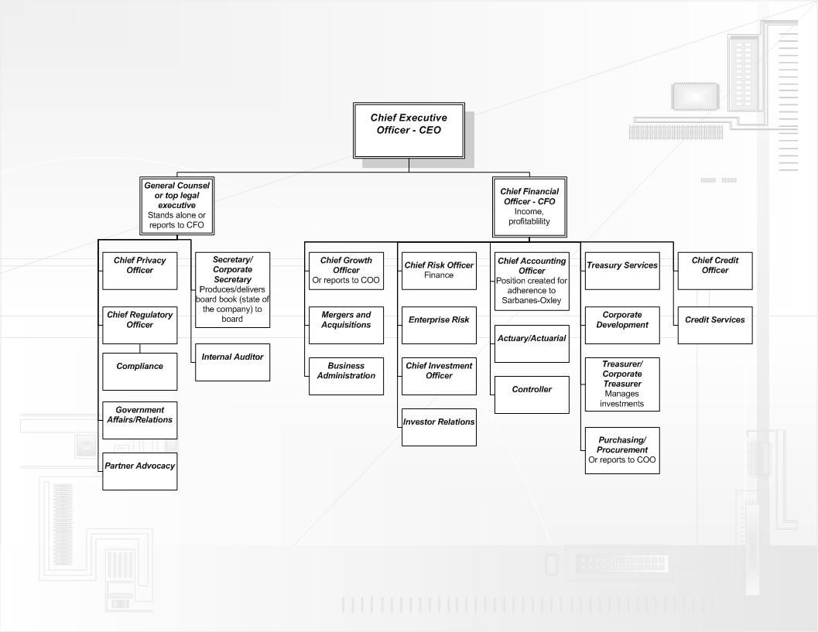
(SAMPLE ORG CHART)

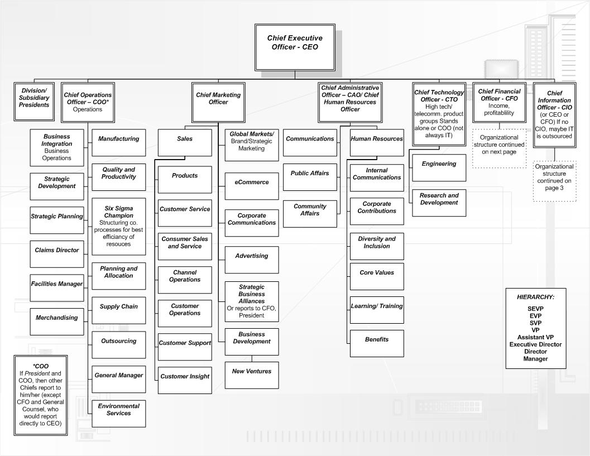

Voice of the Customer
Questions to ask your customer…

How do you define a strategic relationship? And how do you compare to your partners? How do you measure a successful partnership?
Given your three to five year goal of XYZ, what do you need to do to become a strategic partner?
What outside influence will affect your future?

What is the biggest challenge you’re facing today?

What is your expected market?

Who is your primary competitor?

What would be the most effective way for you to impact your strategic decision?
How does your corporate culture affect the way you make decisions?

What do you perceive are our weaknesses as a vendor?

Why aren’t we doing what you’d like us to do?

Strategic Relationship Assessment

This section will help you analyze the customer’s relationships with other third parties including technology, business, financial, consulting, auditor, market research, and other significant influential parties.

Current and Potential Strategic Relationships with Partners | Why should the customer invest in building a stronger relationship with them? | Why shouldn’t the customer continue to invest in building a stronger relationship with them?
Strategic Supplier A
(Company name here)

Strategic Supplier B
(Company name here)

Partner Analysis
This section will help you analyze which of the above partners will be in a position to help you in the account. This section is intended to reflect the perspectives of the partners, not your own.

Partner | Status +/- | Areas of joint value | Why should we partner with them? | Why shouldn’t we partner with them?

The section is intended to outline all of the internal goals, objectives, and action items you may want to include in a customer-facing document.

GOALS: What are the six month to one year goals for the account and the one year to three year goals for the account in the following areas:
 | Three months to one year | One year to three years
Relationships Goal:

Revenue Goal:

Customer Success Goal:

OBJECTIVES: What specific objectives need to be achieved to meet the goals outlined. The objectives must be SPECIFIC, MEASUREABLE, ATTAINABLE, REALISTIC, and TIMEBOUND (SMART). (e.g. participate in customer planning sessions, customer invited to join advisory board, speaking engagements at a conference, replace other competitors or partners, etc.)
Objective: | Completed by date:
Relationship Goal – a Partner Objective or a series of partner objectives should be included in all plans to fulfill the short- term and long- term goals of the partnership
Objective | By:
Objective | By:
Objective | By:
REVENUE GOAL:

Objective: | By:
Objective: | By:
Objective: | By:
CUSTOMER SUCCESS GOAL:

Objective: | By:
Objective: | By:
Objective: | By:

Activities, Tasks and Events
What are the Activities, Tasks, and Events that need to occur to meet the above Objectives? 30-, 60-, 90- day plan. Complete each Objective below with as much detail as possible.

OBJECTIVE:
Activities, Tasks, and Events | Customer Contact | Your Responsibility | Date | Status

OBJECTIVE:
Activities, Tasks, and Events | Customer Contact | Your Responsibility | Date | Status

OBJECTIVE:
Activities, Tasks, and Events | Customer Contact | Your Responsibility | Date | Status

OBJECTIVE:
Activities, Tasks, and Events | Customer Contact | Your Responsibility | Date | Status

OBJECTIVE:
Activities, Tasks, and Events | Customer Contact | Your Responsibility | Date | Status

OBJECTIVE:
Activities, Tasks, and Events | Customer Contact | Your Responsibility | Date | Status

OBJECTIVE:
Activities, Tasks, and Events | Customer Contact | Your Responsibility | Date | Status

OBJECTIVE:
Activities, Tasks, and Events | Customer Contact | Your Responsibility | Date | Status

Contact Avention
Avention, Inc., formerly OneSource Information Services, provides real-time, actionable B2B data from the world’s most comprehensive database to deliver 21st century business information solutions. Avention empowers sales, marketing and research professionals with the best global B2B data available and leverages that data with its cutting-edge software. Visit www.avention.com and follow us on Twitter @AventionInc.

