OBJECTIVE

Determine if the market for shelter and rebuilding materials in Capiz & Iloilo districts can supply rebuilding needs and is functioning at a level that could support an IRC cash or voucher intervention.

METHODS

Coco lumber, corrugated, galvanized iron sheeting (CGI) and crosscut saws were used as proxy items to assess market functionality. The assessment team investigated the markets for these three items using market mapping analysis and key informant interviews. Due to time limitations locations were purposively sampled from the areas where the IRC intends to intervene and market actors were selected conveniently for interviews. The number of interviews conducted for each type of informant are displayed below.

Wholesalers | Retailer: Large Hardware | Retailer: Small Hardware | Chainsaw Operator | End User
1 | 5 | 4 | 2 | 2

RESULTS

Market assessment teams visited five Municipalities (Roxas City, Iloilo City, Ma-Ayon, San Donisio & Sara). Retailers were interviewed in each Municipality’s Poblacion, two chainsaw operators were interviewed in two separate Barangays (Ilyad and Bagakai) within the Municipalities of Ma-Ayon and San Donisio and end users of lumber were interviewed in the Barangays of Bagakai and Ilyad. Retailers spoken with included both large (5) and small (5) hardware stores. It is understood by the assessment team that hardware stores must be licensed and are only located in market centers such as Municipality Poblacions. A wholesaler in Roxas city was also visited.

One retailer explained the cycle of construction and input prices in Panay, noting that there is typically very little construction during the rainy season (June – December) and prices drop. Most construction occurs during the summer months (March – May) and prices typically rise as a result.

The large hardware store assessed in Ma-Ayon sourced their materials from both Roxas and Iloilo, while the small retailers in the same Municipality relied solely on suppliers in Roxas. Hardware stores in San Donisio and Sara were supplied by wholesalers in Iloilo. Customers of these hardware stores were the end users, as these hardware stores did not act as wholesalers for smaller markets. The two large retailers visited in Iloilo City source their materials from Manila or Cebu.

Crosscut Saws
Current prices ranged from P55 at a small retailer in Sara to P400 at a small retailer in a San Donisio. Retailers were either unable to predict prices four weeks in the future or assumed that they would remain static.

Current stocks of crosscut saws ranged from one at a small hardware in San Donisio to 25 at a large retailer in Sara. Future stocks were unknown, though all retailers stated that this was entirely demand dependent. The small and large hardware stores interviewed do not keep large stocks of saws, because demand is low. This is a common household item, so people are not buying these regularly – people already have them and they keep them/they last for a long time.

However, four of the six retailers that the saws that they typically sell were currently out of stock. A large hardware retailer in Ma-Ayon stated that they could not find a supplier to purchase from in order to restock, while other retailers stated that they would be able to replenish their stock in anywhere from one day to one week.

Cross-cut saws were also available from stalls in Sara’s market. Many vendors were selling saws and other tools (i.e. hammers, tape measures). However, PBSP staff noted that these were poor quality items, sold without receipts and by unregistered vendors.

Coconut Lumber
No lumber was found for sale in retail stores in either Sara or Ma-Ayon. A large hardware store in Sara used to have a warehouse with lumber pre-typhoon, but it was damaged by the storm. Lumber was available for sale from retailers, wholesalers and chainsaw operators in all other locations.

Prices for lumber are displayed in the table below:

 | Coconut | Mahogany | Chiminia
Chainsaw Operators | 10-12/bd. ft. | P19/bd. ft | P19/bd. ft
Small Hardware – San Donisio | P16/bd. ft. | - | -
Roxas Wholesaler | P16/bd. ft. | P25/bd. ft | P28/bd. ft.

The chainsaw operator interviewed in Ma-Ayon (an inland location where coco trees do not grow) did not work with coco lumber and only worked as clients placed orders with him. He expressed concern over his lack of capital to create stock ahead of orders. In San Donisio, the assessment team spoke with both a small hardware store and a chainsaw operator that kept stock of lumber. While he had no warehouse, the chainsaw operator had a current stock of 20,000 board feet. The store owner had 20 pieces each of several different sizes in stock and reported that his maximum capacity would be to stock 30-40 each pieces of different sizes. The wholesaler in Roxas had capacity for 6000 board feet in assorted sizes, but had a stock out at the time of the assessment.

While the wholesaler and retailer expressed concern over ability to maintain stock, the chainsaw operators did not cite any difficulties or problems in meeting demand since the storm. Chainsaw operators generally cut timber on-demand from either retailers, middlemen selling timber to retailers, or from individuals purchasing timber from them directly.

All sellers of lumber have seen an increase in demand since the typhoon. The small hardware store in San Donisio noted up to a 300% increase, with people now buying 10-20 pieces of wood where they used to buy 4-5. This hardware store received its stock from the three chainsaw operators in the area, while this store was the only buyer for the chainsaw operator interviewed. The Roxas wholesaler sourced their lumber from two agents that worked directly with chainsaw operators, one of whom was in Aklan, the other in Pilar.

Two end users of lumber were interviewed during the assessment. In San Donisio, the home owner needed to rebuild a 16’ x 18’ house. He would source his lumber from a chainsaw operator and he remarked that the P10,000 planned support from the government (DSWD) for housing reconstruction would not be enough to rebuild his house with coco lumber, but P50,000 would suffice for concrete construction. In Ma-Ayon, the homeowner interviewed would need 300 board feet of lumber to rebuild his home and he noted a preference for mahogany wood over coco lumber.
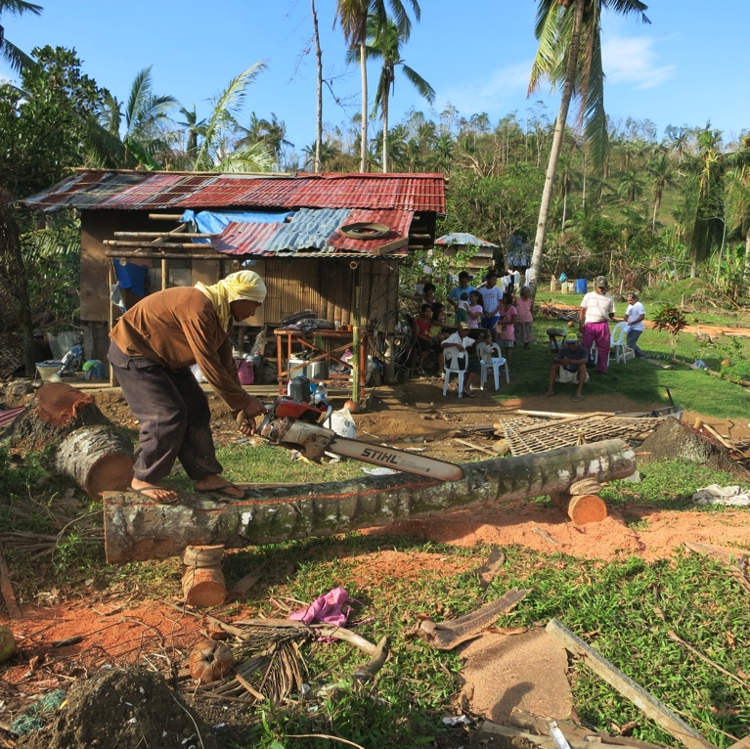
Corrugated Galvanized Iron Sheeting
All retailers, plus the wholesaler in Roxas, sold CGI. This wholesaler sourced their CGI from manufacturers in Manila and Cebu and reported a two-week lead time on deliveries. They have been placing orders every other day, but there can be issues with ships being overloaded with cargo and the materials being offloaded and delayed.

Hardware stores were selling from as few as 10-20 sheets in a week to the large hardware retailer in Ma-Ayon reporting the sale of thousands of sheets in the last week. Most vendors are unsure of their sales volume four weeks into the future, though the wholesaler expressed hope that it would slow down by January.

Prices were not reported consistently, but tended to range from P100 to P400 per sheets, with the sheets being various sizes. Six of the nine assessed vendors reported price increases since Yolanda, specifically citing increased demand as the cause. Three retailers has stock-outs, while two vendors, including the wholesaler, only had the smallest thickness available. Of the six vendors expressing supply concerns, five, including the wholesaler, were due to delays from their supplier, while one (large hardware – Ma-Ayon) was due to regulations limiting the load capacity of trucks.

Warehouse storage capacity also varied, with one large hardware retailer in Ma-Ayon reporting capacity of 300,000 sheets, while the wholesaler in Roxas reported that they could support 500 sheets of each size, though maybe more. The small hardware stores were limited to several hundred sheets, while the large hardware stores could store stock in the thousands.

Most vendors agreed that price competition exists and there appears to be sufficient competition among actors.

SUMMARY:
- Despite the large increase in need for construction materials, suppliers do not appear to be ramping up purchases or anticipating increased demand. The major constraints on suppliers re-stocking or increasing stock is a lack of understanding how the situation will develop.
- Overall, while demand for construction items has increased since Typhoon Yolanda, it appears that this demand has not increased at a high level yet. A lack of household purchasing power is likely the reason for the relatively low demand from suppliers despite the overwhelming need for construction.
- Stock-outs are a concern, particularly for corrugated sheeting. Further interviews with wholesalers in Cebu and Manila are needed to determine what is constraining the flow of goods to retail outlets in the affected areas.
- Where housing construction is dependent on coconut lumber, there may be a bottleneck in the supply chain due to the limited number of chainsaw operators. Lumber retailers are already reporting difficulty sourcing coconut timber, while chainsaw operators are experiencing increased demand.
- Many stores have sold out of hand tools, such as cross-cut saws, and have 1-2 week lead times to restock.

RECOMMENDATIONS
- Undertake further interviews with wholesalers in Manila, Cebu, and Iloilo to better understand the constraints on the supply market for key construction items. Retailers and wholesalers claim to be able to restock with a two-weeks lead time, but this needs to be confirmed with suppliers in Cebu and Manila to confirm that the supply chain is indeed intact.
- Voucher systems may be an appropriate way to delivery shelter materials to affected households, if distributors in Manila and Cebu can increase supply to wholesalers and retailers in Panay. Several retailers discussed their experiences with previous voucher responses to typhoons and were overall acceptable of a voucher approach, but expressed concern with delays in payment. Additionally, vouchers may be a good tool to address the following constraints to the shelter market:
  - Inability of market actors to predict demand - Low household purchasing power after the storm, coupled with potential large-scale shelter material distributions by response agencies may be limiting retailers and wholesalers from stocking-up on key items.
  - Enable retailers to place orders with chainsaw operators, so operators can plan in advance their supply and better organize their capital requirements (such as arranging in advance for trees, etc.)
- Recommend undertaking further structured conversations with suppliers to gauge willingness to increase stock of construction materials if they were guaranteed sales through a voucher program.
- Any cash or voucher programs for construction materials will have to maintain strong communication with retailers/wholesalers, and ensure that the market actors have sufficient lead time (at least two weeks) to increase supply of goods to avoid stock-outs and price increases. The key will be maintaining strong and transparent communication with voucher recipients and stores alike.

