THE UNIVERSITY OF NORTH CAROLINA
APPENDIX A: NOTIFICATION OF INTENT TO PLAN A NEW BACCALAUREATE OR MASTER’S PROGRAM

 | Date: | November 10, 2011

Constituent Institution: |  | East Carolina University
School/College: | Harriot College of Arts and Sciences |  | Department: |  | Geography

Program Identification:
CIP Discipline Specialty Title: | City/Urban, Community and Regional Planning
CIP Discipline Specialty Code: |  | 04.0301 |  |  | Level: B |  |  |  |  | M | XX |  | I
Exact Title of the Proposed Degree: |  |  | Master of Community Planning
Exact Degree Abbreviation (e.g., BS, BA, MA, MS, CAS) |  |  |  | MCP
Does the proposed program constitute a substantive change as defined by SACS? |  |  |  |  |  |  |  |  |  | Yes |  |  | No | XX
a) Is it at a more advanced level than those previously authorized? |  |  |  |  |  |  |  |  |  | Yes |  |  | No | XX
b) Is the proposed program in a new discipline division? |  |  |  |  |  |  |  |  |  | Yes |  |  | No | XX

Approximate date for submitting the request to establish proposal (must be within one year of date of submission of notification of intent to plan): | Spring 2013
Proposed date to establish degree (month and year): (Date can be no sooner than six months after the date of notification of intent to plan and must allow at least three months for review of the request to establish, once submitted). | August 2013

1. Describe the proposed new degree program. The description should include
a) a brief description of the program and a statement of educational objectives
b) the relationship of the proposed new program to the institutional mission and how the program fits into the institution’s strategic plan and its response to UNC Tomorrow
c) the relationship of the proposed new program to other existing programs at the institution
d) special features or conditions that make the institution a desirable, unique, or appropriate place to initiate such a degree program. (please see attached description)

2. List all other public and private institutions of higher education in North Carolina currently operating programs similar to the proposed new degree program. University of North Carolina, Chapel Hill (also see attachment)

3. Estimate the number of students that would be enrolled in the program during the first year of operation.
Full-time | 10 | Part-time | 4

4. If there are plans to offer the program away from campus during the first year of operation: Not applicable
a) briefly describe these plans, including potential sites and possible method(s) of delivering instruction.
b) indicate any similar programs being offered off-campus in North Carolina by other institutions (public or private).
c) estimate the number of students that would be enrolled in the program during the first year of operation:
Full-time | 0 | Part-time | 0

5. List the names, titles, e-mail addresses, and telephone numbers of the person(s) responsible for planning the proposed program. Jerry Weitz, Associate Professor and Director, 252-328-6579, weitzj@ecu.edu; Burrell Montz, Professor and Chair, 252-328-6230, montzb@ecu.edu.

The intent to plan a new program has been reviewed and approved by the appropriate campus committees and authorities.

Chancellor: |  | Date:

- DESCRIPTION OF THE PROPOSED NEW DEGREE PROGRAM

A master’s degree in planning is in most instances considered the minimum credential required to enter the planning profession. In most areas of the U.S., an undergraduate degree in planning is usually not enough in the professional labor market. Those applicants for planning jobs who do not have a master’s degree in planning are disadvantaged in most job markets in the U.S., which tends to explain why there are some 90 accredited graduate planning programs but only 14 accredited undergraduate planning programs in the U.S.

Opportunities for graduate planning study are undersupplied in North Carolina, with only one such accredited graduate program in the state, a program which has had to turn away hundreds of applicants in recent years. Approving our proposed program will bring North Carolina closer into alignment with other growing Southern coastal states that have two or more graduate planning programs.

- Brief Description of the Program

The master of community planning degree program will teach planning as a field of professional practice rather than just as a subject interest. ECU’s master of community planning degree program will adhere to curriculum requirements established by the Planning Accreditation Board (PAB) in “The Accreditation Document: Criteria and Procedures of the Planning Accreditation Program” (2006). We will seek accreditation of the degree program with (PAB) as soon as we have graduated 25 students. For accredited programs, two years of full-time study or the equivalent are required for students for whom the graduate degree constitutes the first professional degree in planning. Based on that requirement, a review of the requirements for accreditation, and degree program requirements for other accredited master of planning degree programs (see Table A-1 in an appendix to this report), we propose a 48 semester hour program which is clearly the norm. As shown in Table A-1, the vast majority of program on semester systems require 48 hours, with several programs requiring considerably more than the norm and only a handful of programs requiring less than 48 hours. The course work will consist of six core courses (18 hours) and ten courses (30 hours) of electives.

The curriculum will be designed with environmental planning and “sustainability” as principal features of the graduate program, although neither term will appear in the title of the degree. The proposed master of community planning degree program will initially offer two areas of concentration: (1) community planning; and (2) environmental and coastal planning. Although at the outset we will offer only these two areas of concentration, there is substantial potential to expand concentration areas in conjunction with other colleges, schools and units at East Carolina University. As just one example, there are good prospects for collaboration with the health sciences (e.g., public health) at ECU, since there is a clear trend toward integrating public health objectives into planning (and there are increasing funding opportunities to support such research and practice).

Requirements for the graduate degree program in planning will differ from typical research degree requirements. Instead of a master’s thesis, our program will require a practice project or practice paper. Such a curriculum requirement is typical of a graduate planning degree. An internship will be optional (credit given) but not required.

Our target for the program is the unfilled demand for graduate planning study generated by traditional students who want to study in the state of North Carolina but are unable to because there is only one (very competitive) program in state, UNC-Chapel Hill. See the following diagram which projects our first-year degree program enrollment by type of student. We recognize that some of that demand may very well come from our own traditional students graduating with a BS in urban and regional planning degree, as a sizable proportion of whom immediately pursue a graduate degree in planning upon completing their undergraduate degree.To that point, we will explore the prospects for “advanced standing” of our undergraduate planning majors so that our undergraduate planning students have the option of enrolling in the graduate planning degree program and completing it in less than two full-time years of study. The following chart illustrates our projection for students in the first year of program operation.

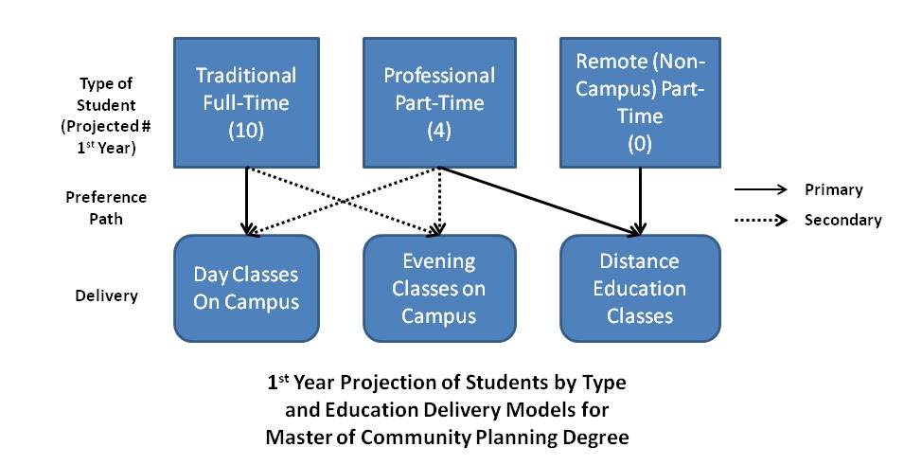

Initially, we see the need to deliver the program with our target audience of full-time, traditional students in mind. However, we are also cognizant of a more limited demand from working professional planners in the region; as some of the letters of support appended to this report indicate, there is some demand from alumni of ECU’s urban and regional planning program to return and study part-time for a master of community planning degree. In that light, we anticipate the need to provide one or more distance education opportunities each semester and also schedule one or more courses for evening hours, in order for working students in the region to enroll in the program. However, students will not be able to complete the graduate planning degree program with distance education classes only.

- Statement of Educational Objectives

Program objectives include but are not limited to the following. We will:

- Satisfy increasing needs for skilled, knowledgeable, and qualified planning practitioners.
- Play a leading role in transforming the economy and developing community in the eastern North Carolina region, consistent with strategic plans of the university system and East Carolina University.
- Advance the science and art of planning for sustainable environments.
- Meet and exceed accreditation criteria for the master of community planning degree program while maintaining our existing accredited undergraduate planning program.
- Maintain a diverse and productive research program.
- Seek and maintain partnerships with the School of City and Regional Planning at the University of North Carolina – Chapel Hill (the first and only current graduate degree program in planning) and other allied programs, centers, and institutes in the North Carolina University System.

Student educational objectives include but are not limited to the following. We will:

- Prepare students to become skilled practitioners in the planning profession.
- Instill leadership qualities so that many of our planning program graduates will go on to become planning directors.
- Prepare students to understand and serve a diverse, multicultural society.
- Provide a service learning orientation to the program’s practice requirements.
- Provide a strong foundation for those students who wish to pursue a Ph.D. degree in planning or related fields.

- Relationship to Institutional Mission

The proposed graduate planning degree will further the mission of the university system as articulated by UNC Tomorrow (2007) in at least eight distinct ways:

- Underserved regions and disadvantaged populations. The proposed master’s degree is consistent with major finding 4.2, which suggests that the university system should increase higher education access to underserved regions and disadvantaged populations. The only current graduate degree program in planning in North Carolina is UNC – Chapel Hill; it takes students nationally and internationally and does not fully serve the needs for graduate planning degrees in the state. In addition to serving the state’s population as a whole, the proposed graduate degree in planning at ECU will be particularly accessible to the underserved eastern North Carolina region. The region has a comparatively higher poverty rate and larger numbers of disadvantaged populations than other parts of the state. The UNC system is more likely to attain its objective of increasing the educational attainment of underrepresented populations, especially African-American males (Finding 4.2.5), by authorizing a graduate planning degree at East Carolina University, since the only graduate planning degree in the system now cannot provide sufficient opportunities.

- Economic transformation and community development. Establishment of a master of community planning degree at ECU will also advance Finding 4.4. Because the planning profession is centrally concerned with economic and community development, ECU’s graduate planning degree will increase prospects that the university will engage in economic transformation and community development in the eastern North Carolina region. Approval of the graduate planning degree will directly implement finding 4.4.1, which emphasizes that the university system should “increase its capacity and commitment to respond to and lead economic transformation and community development.” The graduate planning degree will emphasize a curriculum that is consistent with rural needs, thereby directly addressing finding 4.4.2.

- Inclusive discussions of community issues. Many of the issues faced in communities are addressed by planners. The planning profession emphasizes and ensures community participation in all planning efforts. Ethical foundations of the planning profession emphasize the need to serve disadvantaged populations. By the very nature of the subject matter, then, the graduate community planning degree at ECU will help the university system facilitate “inclusive” discussions about important community issues in the eastern North Carolina region and the state, consistent with finding 4.4.5.

- Environmental sustainability. The UNC Tomorrow Report also suggests that the system should “embrace environmental sustainability as a core value” (4.6.1). Environmental planning is the strength of ECU’s planning program, and ECU more generally has a strong ecological, coastal, and sustainable future focus. The planning program, housed within ECU’s Geography Department, is well positioned to demonstrate the long-range, spatial implications of policy and development on the environment. No other department or program is more centrally concerned with environmental sustainability. Although the graduate degree in city and regional planning at UNC-Chapel Hill is also centrally concerned with sustainability, a graduate planning degree at ECU will allow the university system to advance its emphasis on environmental sustainability in the coastal and eastern North Carolina regions of the state, in addition to bolstering sustainability advancement opportunities statewide. The report (finding 4.6.2) goes further to suggest that the university system “leverage its existing research expertise to address critical environmental and energy issues.” The graduate planning degree will directly implement this finding by increasing the depth, level, and quality of planning research focused on energy and the environment, a strong suit of ECU’s planning program.

- Community awareness. The planning profession is more engaged than most others with the public. Public participation, as practiced by planners, is a continuous process of educating the public and increasing community awareness. The new program will be consistent with the university system’s desire to increase community awareness of environmental and sustainability issues (finding 4.6.3).

- Regional connections. Major finding 4.7 of the report suggests that the system should become “more directly engaged with and connected to” the people of North Carolina and its regions. The graduate planning degree at ECU will provide discrete, important opportunities to connect the institution with the eastern North Carolina region and beyond, because it will incorporate a practicum (i.e., planning studio) requirement and emphasize “service learning” in the immediate region.

- Efficient use of available resources. Because the urban and regional planning program already exists, it will be an efficient use of existing resources to offer a graduate degree in addition to an undergraduate degree in planning. Hence, the graduate degree proposal is consistent with finding 5.6 which emphasizes efficient use of existing resources in fulfilling the university system’s mission.

- Interdisciplinary collaboration. A number of collaborative efforts spring forth from a central concern about planning issues. The planning profession is by its very nature interdisciplinary, in that planning considers the interrelationships among human, social, economic, political, and other functions and processes. Because the Urban and Regional Planning Program is housed in the Geography Department, it can leverage the expertise within the department, including land use, cultural resources and atmospheric science to create unique opportunities for students and the region. Therefore, the graduate degree in planning at ECU will advance the goal of encouraging and facilitating interdisciplinary collaboration among the system’s institutions (finding 5.7), and among colleges and programs within ECU itself.

Response to UNC Tomorrow. ECU responded to the UNC Tomorrow Report with a 25-page report of its own. In that response, ECU recognizes unique and special responsibilities with regard to rural areas and underserved populations. No other program at ECU has greater potential for ECU to fulfill the “special responsibility for community and economic development in the east” than a graduate planning program, since professional planners are centrally concerned with and charged to advance community and economic development. In that same document ECU articulates a commitment that it will “expand and apply its expertise, research and outreach functions to address regional and wider-scale challenges and to support public and private sector decision-makers in such areas as the economy, environment, and energy and water, among others.” Planners are centrally concerned with these critical issues, and the master of community planning program provides a premier venue for ECU to meet the commitment it has articulated in its response.

Mission and Strategic Plan. East Carolina University’s mission, approved by the UNC Board of Governors on November 13, 2009, is to serve as a national model for public service and regional transformation by (among others): “creating a strong, sustainable future for eastern North Carolina through education, research, innovation, investment, and outreach…” The mission also includes an effort to improve “quality of life.” The strategic plan, ECU Tomorrow: A Vision for Leadership and Service, is consistent with and reinforces the mission statement. Strategic directions of ECU include, among others, training and preparing leaders, promoting economic prosperity in the east, and improving quality of life.

The master’s degree in community planning will advance these causes. Planning by its very nature is focused on the future, and our program will emphasize sustainability. The new degree will lead to more attention focused on pressing community issues and problems in the eastern North Carolina region. The graduate degree program will also increase opportunities to provide outreach to stakeholders in the East Carolina region through high-quality, practical, applied course projects.

The planning profession is more centrally and comprehensively focused on improving quality of life than any other profession. Planners are adept at defining and implementing benchmarks for (and indicators of) quality of life. The new degree program will assist the institution in attaining its mission of regional transformation, as applied planning projects will focus on economic development and improving quality of life in the region. The master’s degree in community planning will advance ECU’s ability to produce community leaders. Students with master’s degrees in planning are much more likely to become directors of planning and community development departments. Furthermore, it is not uncommon for planners, due to their generalized training (but also with a specialty), to assume higher level administrative positions in government.

- Relationship to Existing Programs at ECU

We have identified the following similar graduate Degree Programs at East Carolina University:

- Geography with concentration in planning. The Geography Department at ECU provides a master’s degree in geography with a concentration in planning. The concentration requires 15 hours. To the extent that graduate students of the ECU geography department concentrating in planning are more interested in a master of planning degree, there is potential for some competition for enrollment within the geography department. Some students will want the master of community planning degree and others will prefer a geography degree because of the different opportunities each provides. We believe the potential competition will not be significant, since the graduate planning program is contemplated as a professional degree instead of a research-related degree. If the master of community planning degree program also had a thesis option, it would likely be more directly competitive with the Geography Department’s master’s degree in geography with a concentration in planning. From another perspective, the master of community planning degree program will strengthen the geography department’s existing graduate program by offering a wider range of graduate courses for students concentrating in planning from which to choose.

- Public administration with concentration in planning. The Political Science Department at ECU offers a master of public administration degree with a concentration in planning. For a planning emphasis, students must complete 15 hours of electives approved jointly by the graduate coordinator of the urban and regional planning program and the director of the MPA program. To the extent that graduate students of the ECU MPA program concentrating in planning are more interested in a master of planning degree, there is potential for some competition for enrollment within the political science department. We believe the potential competition is relatively insignificant, however, because the degrees offer different professional opportunities. Furthermore, we have obtained a letter of support from ECU’s political science department which houses the MPA degree program. Like with the master of geography program, the MPA program director views the graduate planning degree as beneficial in making additional courses available to MPA students.

- Technology with concentration in environmental planning. ECU’s College of Technology and Computer Science offers a master of science in technology with a concentration in environmental planning and development. It requires 30 hours, of which 18 are in the concentration area. The environmental planning and development concentration is described in the graduate catalog as providing “courses serving the needs of students to provide training that will equip the student to work in the coastal regions across the nation, developing sustainable building and hazard mitigation codes as well as maximizing the recreational opportunities while minimizing the impact on the environment.” Because students in that program are interested in technology, that degree option is thus not considered to be directly competitive with the proposed degree.

- Sustainable tourism. ECU also offers a master of science degree in sustainable tourism. It is managed by the Center for Sustainable Tourism with oversight from an interdisciplinary faculty advisory committee. The sustainable tourism degree is designed for individuals interested in the tourism profession with a focus on sustainability as it applies to economic success, social and cultural vitality, environmental conservation, and long term health. The MS in sustainable tourism prepares students for managerial or regulatory positions in the profession. The degree program requires a minimum of 33 (thesis) to 36 (non-thesis) semester hours. Due to this program’s specialization in economic development, it is not considered to be in competition with the proposed graduate planning degree program.

The proposed master of community planning degree program will complement existing centers, offices, and initiatives of East Carolina University.

- Center for Natural Hazards Research. This Center focuses on hurricane, tornado, flooding and erosion hazards as they affect eastern North Carolina and the United States. This center is highly complementary in terms of the proposed graduate planning degree.

- Center for Geographic Information Sciences. This center provides faculty and students who provide support for geospatial research and projects. It is complementary to the proposed program because many graduate planning projects make use of geospatial data. This center is especially important in terms of recruiting planning students who are interested in spatial aspects of planning, such as land use and environmental planning.

- Center for Sustainable Tourism. The master’s degree in community planning would complement, not conflict with, graduate studies in this Center.

- Coastal Studies Institute. The UNC Coastal Studies Institute located in Manteo on Roanoke Island was formed in 2003 as an inter-university research institute. It focuses on the unique history, culture and environment of the maritime counties of North Carolina. It represents another opportunity for collaboration with the proposed degree program.

- Institute for Coastal Science & Policy. This center was established in 2007 to initiate, promote, and coordinate interdisciplinary research on all aspects of riverine, estuarine, coastal, and shallow marine environments. It is another major asset in terms of potential complementary connections with the proposed graduate planning degree.

- Coastal Water Resources Center. This center addresses the threat to economic development posed by issues of fresh water availability arising from natural trends (e.g., drought, saltwater intrusion, depletion of aquifers) and from inappropriate resource management (e.g., inefficient uses, pollution, pricing, lack of basin management schemes). The master of community planning degree program will advance prospects for participation in this center by attracting additional graduate students with the new degree.

- Center for Diversity and Inequality Research. This center is housed in the Department of Sociology and studies social diversity and inequality in Eastern North Carolina with research focusing on underserved populations. Because planning is especially concerned with disadvantaged populations, there will be alignment between the graduate planning degree program and this center.

- Intergenerational Center. The mission of the Center is to lead in neighborhood revitalization in the West Greenville community. Planning is centrally concerned with neighborhood revitalization, and the graduate degree program will therefore provide students who can assist with research at this center.

- Renaissance of Downtown Greenville. This objective of ECU will be further realized with graduate planning students and research projects that can be directed toward maintaining a healthy downtown Greenville, consistent with this existing initiative.

- Special Features and Conditions Making the Program Desirable, Unique, and/or Appropriate

Response to Demand

The most common entry credential into the field of professional planning practice is a master’s degree in planning. Increasing competition for jobs in the planning profession suggest that job applicants without a master’s degree (all other things being equal) may be at a disadvantage. A recent (2010) salary survey by the American Planning Association substantiates this point. Almost two-thirds (64 percent) of 11,136 full time planners responding to the question, “in what field is your highest degree?” indicated that they held a master’s degree. A master’s degree in urban planning led that list of responses, constituting 44 percent of total respondents. A bachelor’s degree in planning constituted only 10 percent of the total responses.

A master of community planning degree program is essential to meet the demand for professional planners in North Carolina. The only current program offering such an accredited degree in the state is the University of North Carolina at Chapel Hill, and as noted in greater detail in the following section (see #2, “similar programs”), that program has literally turned away hundreds of applicants. Graduate planning students at UNC-Chapel Hill are drawn nationally and internationally; it therefore does not begin to satisfy the interest in and demand for graduate planning degrees in North Carolina. This leaves a huge void that needs filling, and the proposed degree program at East Carolina University will help meet that demand.

East Carolina University’s proposed program will also meet a new type of need that is similarly unfilled by the only graduate planning program in the state: evening and distance education classes for planning professionals. By offering evening and distance education options, our program will make graduate planning study accessible to a new segment of professionals. ECU’s Master of Business Administration (MBA) and Education programs, which are flourishing, are evidence of the new demand created by distance education-delivered programs.

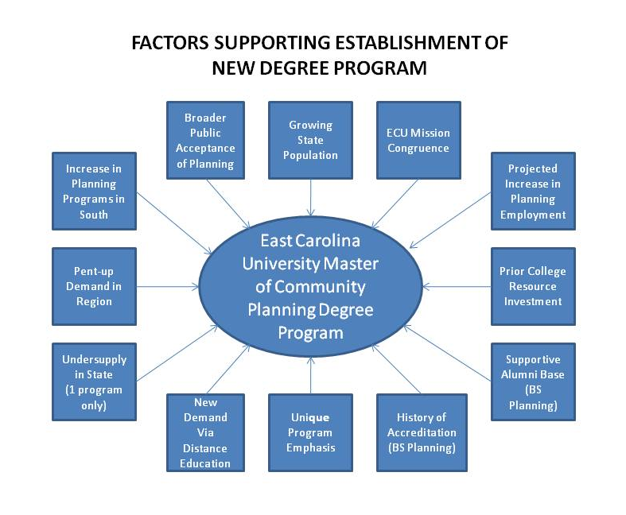
Trend Toward More Planning Schools in the South

Our proposal is consistent with a trend in southern coastal states toward more numerous graduate planning programs. Virginia has three accredited graduate planning programs, and Alabama has two. Georgia currently only has one accredited graduate planning program but the University of Georgia in 2009 established a master of environmental planning and design degree and will likely pursue accreditation; furthermore, Savannah State University (coastal region) now offers a master of science degree in urban studies and planning (not accredited). Similarly, Florida now has three accredited graduate planning programs. Approval of a second graduate planning degree program in North Carolina would simply begin to bring our state into alignment with other growing southern coastal states which have university systems that have already responded to the growing demand for graduate planning study.

Desirability

The occupational outlook for urban and regional planners is favorable and positive during the next several years, as indicated in the following table. Local governments constitute more than one-half of the total employment of urban and regional planners, and more than one-half of planning jobs added during the decade from 2008 to 2018 will be with local governments.

U.S. Occupational Outlook, Urban and Regional Planners, 2008-2018

 | 2008 | 2018 | 2008-2018  Absolute Change | 2008-2018  Percent Change
Total Employment | 38,400 | 45,700 | +7,300 | +19.02%
Local Government Employment | 25,400 | 29,200 | +3,800 | +14.95%

Source: U.S. Bureau of Labor Statistics. 2009. 2008-18 National Employment Matrix, 19-3051 Urban and regional planners

ECU’s urban and regional planning program has been successful in placing those holding undergraduate urban and regional planning degrees in professional positions in eastern North Carolina and elsewhere. To a large extent, however, the successful placement of new professionals with an undergraduate planning degree from ECU has depended on a strong network of ECU alumni with undergraduate planning degrees. Also, ECU’s planning undergraduates are working primarily in the Eastern North Carolina region, which is relatively rural and less affluent. Salaries paid to professional planners tend to reflect these realities. For these reasons, professional planning jobs in our region do not tend to attract extensive competition from applicants with graduate degrees in planning. Nonetheless, that situation is changing. Competition for planning jobs is increasing, and a master’s degree is considered a prerequisite in some regions of the U.S. in order to be competitive. It also appears from the American Planning Association’s 2010 salary survey that, nationally, professionals with master’s degrees in fields other than planning (public administration, geography, etc.) collectively hold more professional positions than professionals with undergraduate degrees in planning.

Uniqueness and Geographic Appropriateness

While our program will produce practitioners ready to work in any region of the U.S. and at any scale of urbanization (large central city, urban county, etc.), we will emphasize rural and small town planning appropriate to our region. That emphasis will distinguish our program from UNC-Chapel Hill’s graduate program in city and regional planning. The degree title will be “master of community planning” rather than master of urban (or city) and regional planning. We intend to tailor the program’s curriculum so that it produces practitioners appropriately skilled to work in local governments in rural, eastern North Carolina. While we believe that strategically we must maintain a delivery system appropriate for traditional, full-time students, we intend to provide enough evening and distance education course offerings to draw existing planning professionals in the region to study without conflicting with normal business hours.
Public and Private Institutions of Higher Education in North Carolina Currently Operating Programs Similar to the Proposed New Degree Program

There is only one master’s degree in planning offered in the state, by UNC Chapel Hill. There are three other UNC campuses in addition to ECU that offer a master’s degree in geography with some type of concentration in planning, but none of them constitutes a professional planning degree program. There is one planning certificate offered by Appalachian State University. After reviewing the website of North Carolina Independent Colleges and Universities website, few if any of the private colleges and universities offer any master’s degree programs, and only one (Duke) crosses over in terms of subject matters (policy). Further details are provided below.

  - University of North Carolina at Chapel Hill

The Department of City and Regional Planning at the University of North Carolina at Chapel Hill provides a Master’s Degree in City and Regional Planning. It was initiated in 1946 and is accredited with the Planning Accreditation Board (PAB). The degree requires 51 hours to complete, and students can concentrate studies in the following areas: community development, design and preservation, economic development, land use and environmental planning, and transportation planning. According to the department’s website, “sustainable development is the overarching concept for these specializations.” UNC’s is the only accredited master of planning program in North Carolina. For the 2010 year, this degree program received 235 applications and only enrolled 40 (17%) (see Table below).

University of North Carolina at Chapel Hill
Applications and Enrollment for Master of City and Regional Planning Degree, 2009-2010

Year | Applied | Accepted | % Total Applied | Enrolled | % of Total Applied
August 2009 | 195 | 101 | 51.8% | 55 | 28.2%
Sept. 2010 | 235 | 71 | 30.2% | 40 | 17.0%

Source: Association of Collegiate Schools of Planning. 2009. Guide to Undergraduate and Graduate Education in Urban and Regional Planning, 15th Edition, p. 223.

Statistics are not currently available regarding the number of applicants residing in state and out of state. However, it is evident from the data above that there is a significant number (164) of applicants to UNC’s master of city and regional planning program who are not accepted. While we cannot determine the actual number of North Carolina residents in the applicant pool, the application, acceptance, and enrollment figures in the table represent significant interest in the master of planning degree in North Carolina. In short, UNC does not and cannot meet the in-state demands for master’s degrees in planning.

A master of planning degree at East Carolina University would be poised to capture a share of the unfulfilled demand exhibited in the Table above (applicants to UNC) because of demand and interest for the degree program in eastern and coastal North Carolina. Also, new demand will be created geographically in the eastern North Carolina region because such students would not otherwise be able to get a master of planning degree unless the new program is established.

The source of data shown in the Table (Association of Collegiate Schools of Planning) also reports that, of a student body of 107 in the master of city and regional planning program in 2009-2010, 83.2 percent were White and only 5 percent (6 students) were African American. A master of planning degree at East Carolina University would be poised to capture a share of demand for the master of planning degree within North Carolina from African American students.

A master of planning degree at East Carolina University will not compete with UNC Chapel Hill’s program for students, as UNC will continue to function as one of the leading accredited programs in the nation. The program at ECU will emphasize coastal environments and rural and small town communities rather than city and regional planning. Another key distinction between ECU’s proposed master of planning program and UNC’s is the host college and department – the planning program at ECU is housed in the geography department and will emphasize physical and environmental planning, compared to a greater emphasis placed on policy at UNC.

  - University of North Carolina at Charlotte

UNC Charlotte’s Department of Geography and Earth Sciences offers a master of arts degree in geography with concentrations in location analysis, urban-regional analysis, and transportation studies. An alternative to these concentrations is a community planning “track,” which requires 36 semester hours to complete, including 21 hours of core planning-related courses, 9 hours of electives, and 6 hours in a capstone research project.

UNC Charlotte’s College of Arts and Architecture also offers a Master of Urban Design degree, which does not compete because it draws students more interested in working in applied design professions. Neither of these programs in Charlotte is considered to be directly competitive with a graduate planning degree in Greenville, NC.

  - University of North Carolina at Greensboro

The Department of Geography at UNC Greensboro offers a master of arts in applied geography. That degree program has an urban planning and economic development concentration which requires 15 hours. If it competes with anything at ECU, it would be the master’s degree in geography with a concentration in planning, since it is not a planning degree.

  - Appalachian State University

Appalachian State University’s Department of Geography and Planning offers a Master of Arts Degree in Geography with a concentration in planning and also a Post-Baccalaureate Certificate (non-degree program) in planning. The graduate planning certificate requires 18 hours of course work. Neither the concentration nor the certificate program are directly competitive with the proposed master of community planning degree at East Carolina University.

  - Duke University

The Sanford School of Public Policy offers a master of public policy degree. Concentrations of the program include global policy, social policy, and health policy. Since it does not emphasize government, it is not considered to be a competitor with ECU’s planning degree.

Appended Letters of Support

Craven County, North Carolina
Rivers and Associates, Inc.
Holland Consulting Planners, Inc.
North Carolina Chapter of the American Planning Association
Master of Public Administration Program, Political Science Dept., ECU
Appalachian State University, Department of Geography and Planning
ECU Collaborative Team Letter of Support

Table A-1
Credit Hour Requirements for Graduate Planning Programs
On Semester Systems

University | Graduate Planning Degree Title | Hours Required
Harvard University | Master in Urban Planning | 80
University of Illinois at Urbana-Champaign | Master of Urban Planning | 64
Columbia University | Master of Science in Urban Planning | 60
Cornell University | Master of Regional Planning | 60
Hunter College, City University of New York | Master of Urban and Regional Planning | 60
New York University | Master of Urban Planning | 60
Pratt Institute | Master of Science in City and Regional Planning | 60
University of Illinois at Chicago | Master of Urban Planning and Policy | 60
University of Pennsylvania | Master of City Planning | 57
Clemson University | Master of City and Regional Planning | 56
Georgia Institute of Technology | Master of City and Regional Planning | 55
University at Buffalo, State University of New York | Master of Urban Planning | 52
University of Florida | Master of Arts In Urban and Regional Planning | 52
Morgan State University | Master of City and Regional Planning | 51
The University of North Carolina at Chapel Hill | Master of City & Regional Planning | 51
University of Colorado Denver | Master of Urban and Regional Planning | 51
University of Oklahoma | Master of Regional and City Planning | 48-50
Massachusetts Institute of Technology | Master in City Planning | 50
University of Iowa | Master of Arts or Master of Science in Urban and Regional Planning | 50
University of New Mexico | Master of Community and Regional Planning | 50
University of Virginia | Master of Urban & Environmental Planning | 50
University of Arizona | Master of Science in Planning | 49
Cleveland State University | Master of Urban Planning, Design and Development | 48
Florida Atlantic University | Master of Urban and Regional Planning | 48
Florida State University | Master of Science in Planning | 48
Iowa State University | Master of Community and Regional Planning | 48
Kansas State University | Master of Regional and Community Planning | 48
Michigan State University | Master in Urban and Regional Planning | 48
Rutgers, The State University of New Jersey | Master of City and Regional Planning | 48
San Jose State University | Master of Urban Planning | 48
Texas A & M University | Master of Urban Planning | 48
Texas Southern University | Master of Urban Planning and Environmental Policy | 48
The University of Texas at Arlington | Master of City and Regional Planning | 48
The University of Texas at Austin | Master of Science in Community and Regional Planning | 48
University at Albany, State University of New York | Master of Regional Planning | 48
University of California, Berkeley | Master of City Planning | 48
University of Kansas | Master of Urban Planning | 48
University of Maryland at College Park | Master of Community Planning | 48
University of Massachusetts at Amherst | Master of Regional Planning | 48
University of Memphis | Master of City and Regional Planning | 48
University of Michigan | Master of Urban Planning | 48
University of Minnesota | Master of Urban and Regional Planning | 48
University of Nebraska-Lincoln | Master of Community and Regional Planning | 48
University of Puerto Rico | Master in Planning | 48
University of Southern California | Master of Planning | 48
University of Wisconsin - Milwaukee | Master of Urban Planning | 48
Virginia Commonwealth University | Master of Urban and Regional Planning | 48
Virginia Polytechnic Institute & State University | Master of Urban and Regional Planning | 48
Wayne State University | Master of Urban Planning | 48
Arizona State University | Master of Urban and Environmental Planning | 47
Alabama A & M University | Master of Urban and Regional Planning | 46
Auburn University | Master of Community Planning | 45
University of New Orleans | Master of Urban and Regional Planning | 45
Temple University | Master of Science in Community and Regional Planning | 45
University of Wisconsin - Madison | Master of Science in Urban and Regional Planning | 45
University of Hawaii at Manoa | Master of Urban and Regional Planning | 42
Ball State University | Master of Urban and Regional Planning | 36

Source: Planning Accreditation Board, unpublished spreadsheet for 2009.

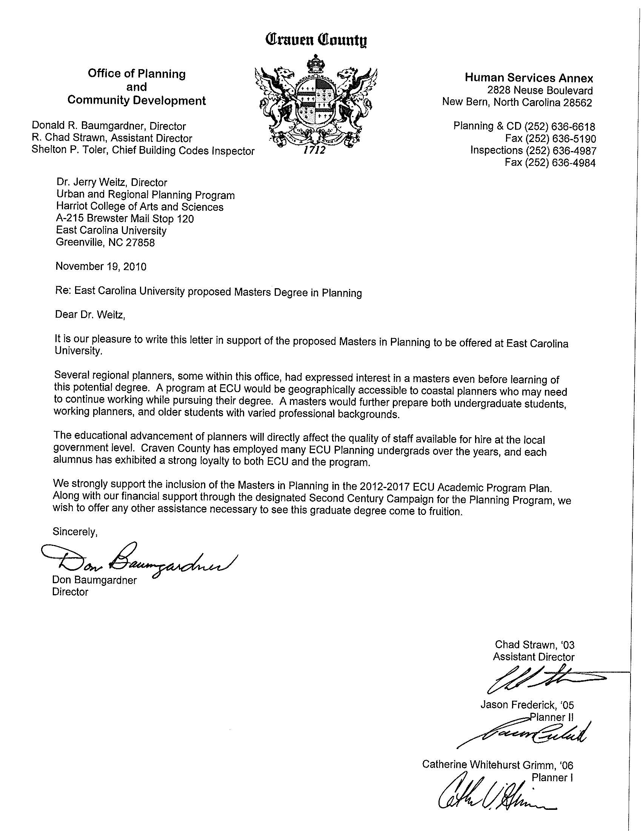
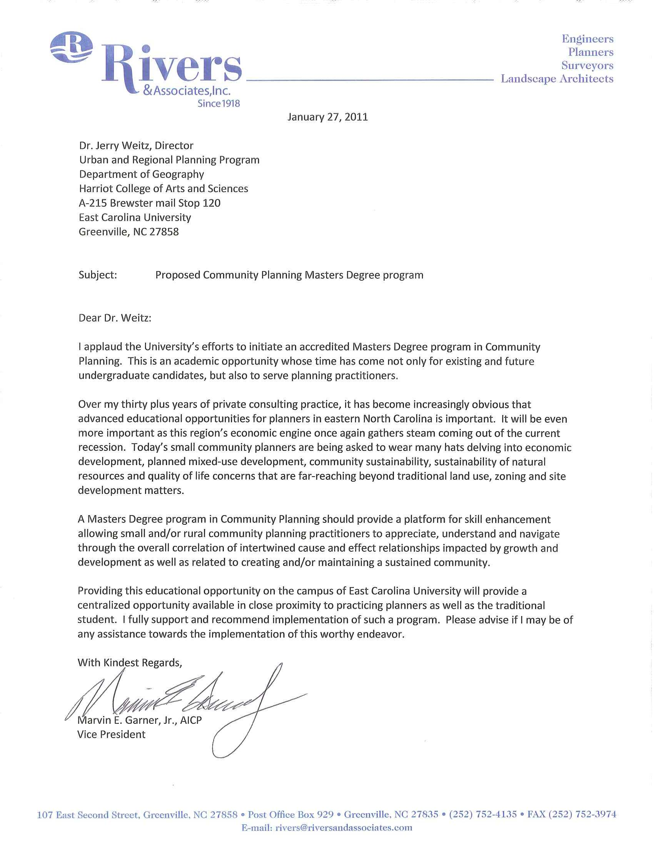
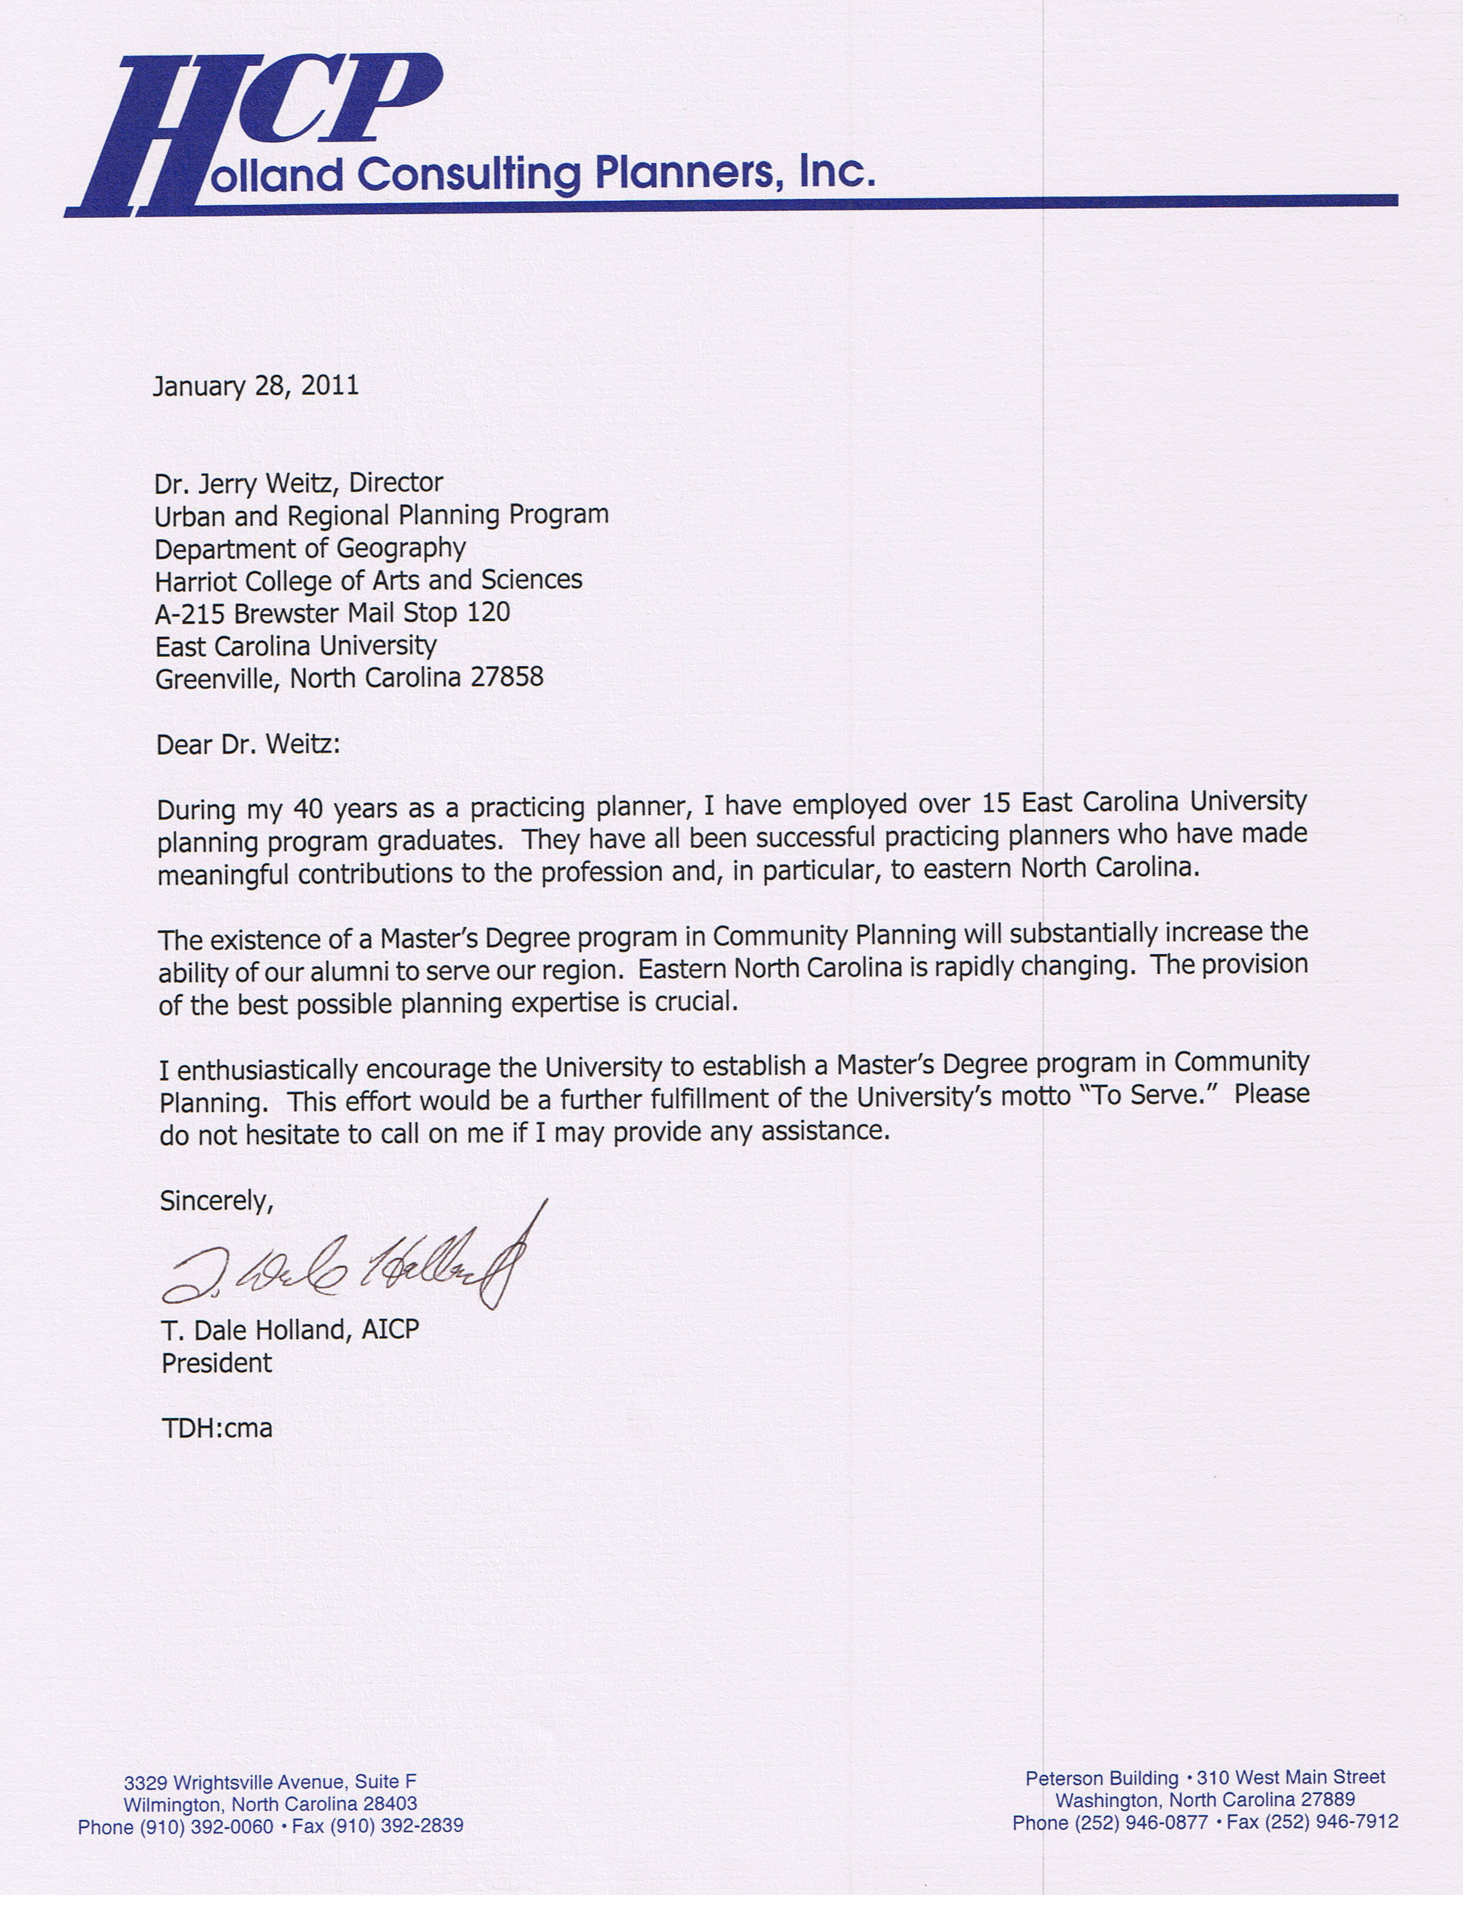
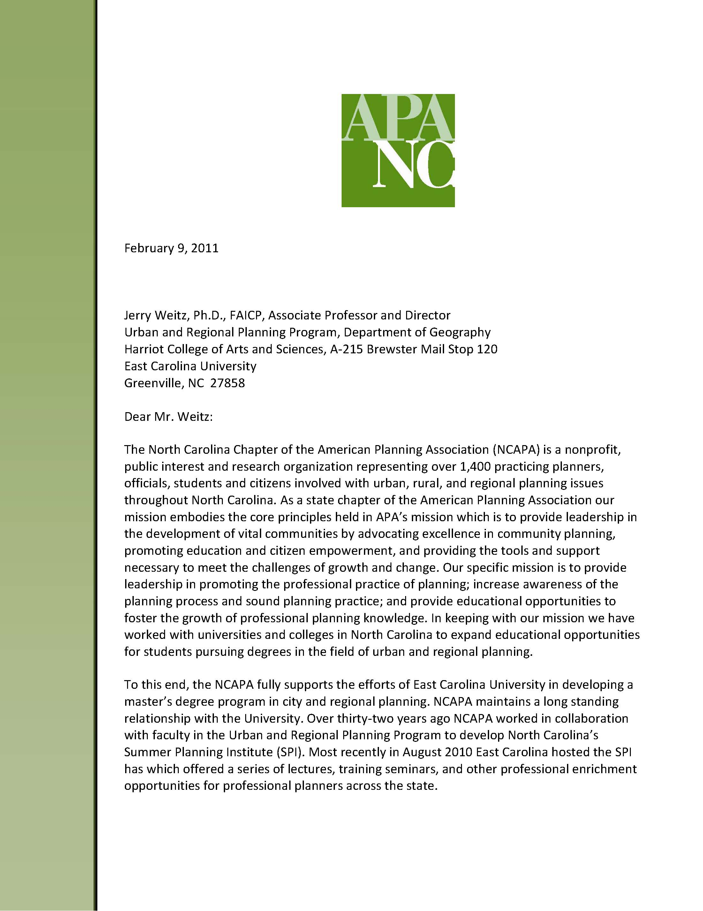
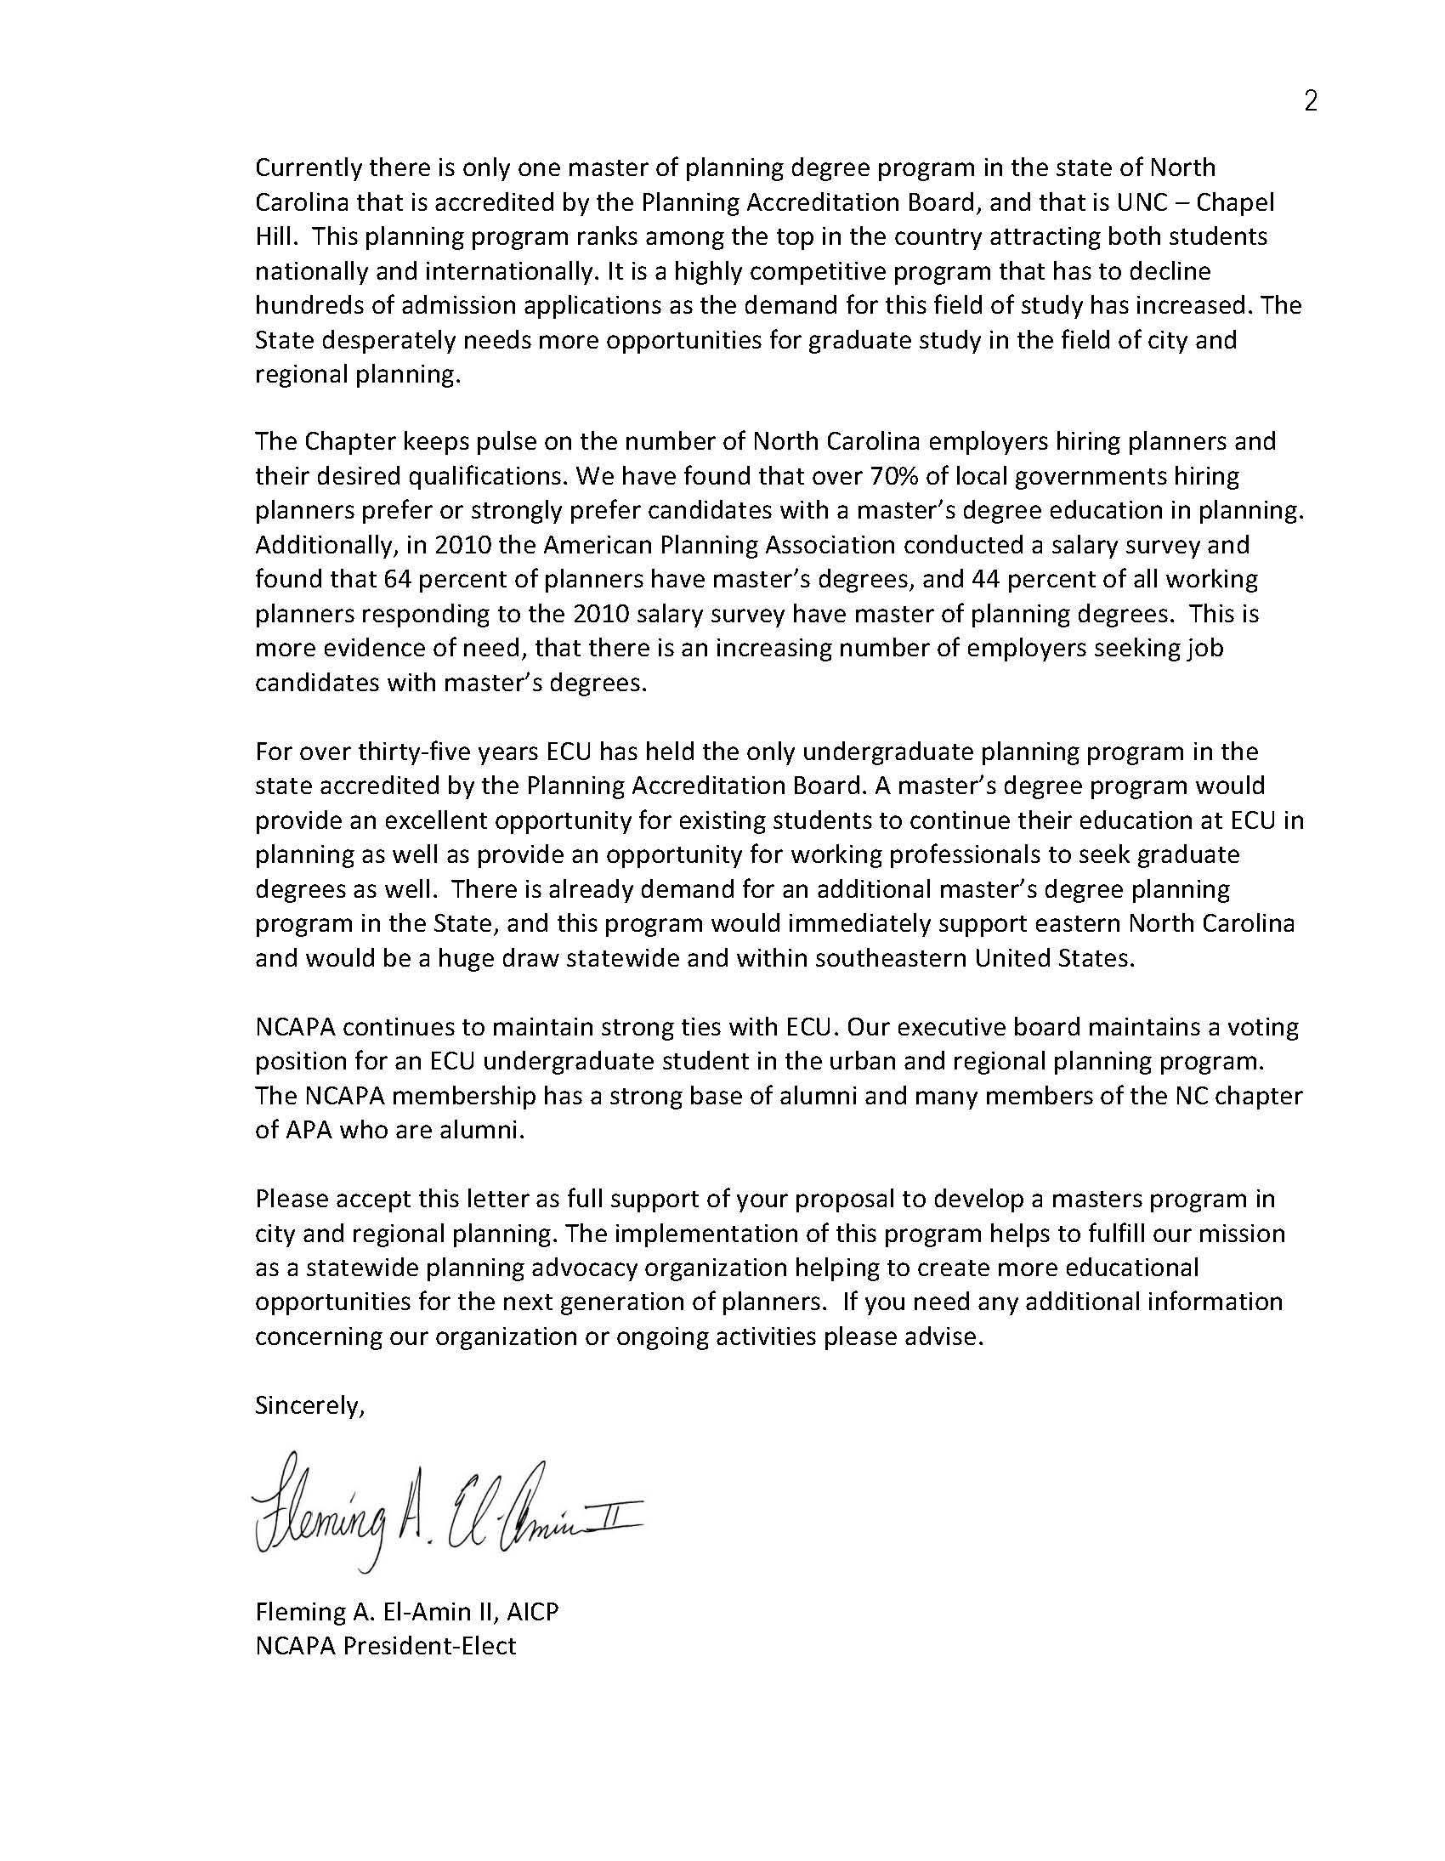
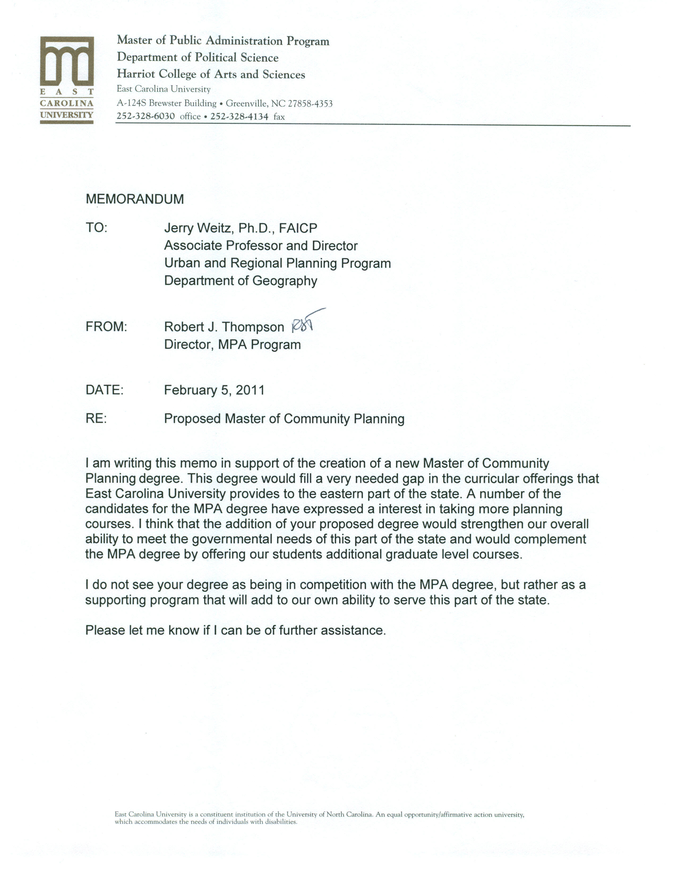
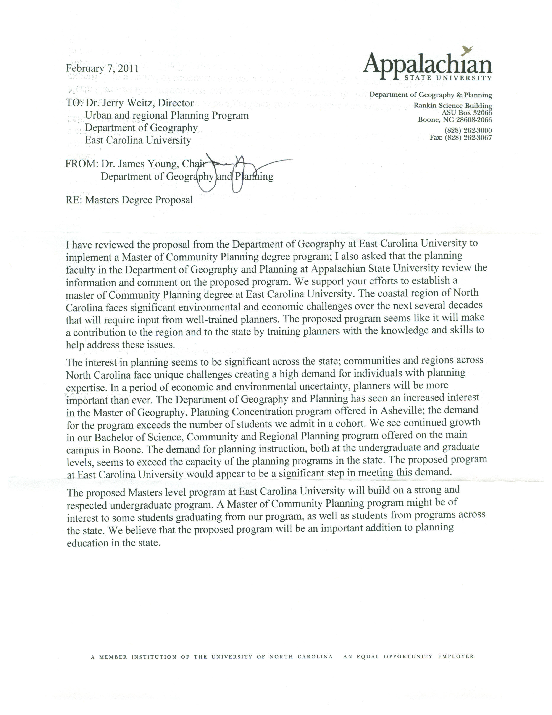
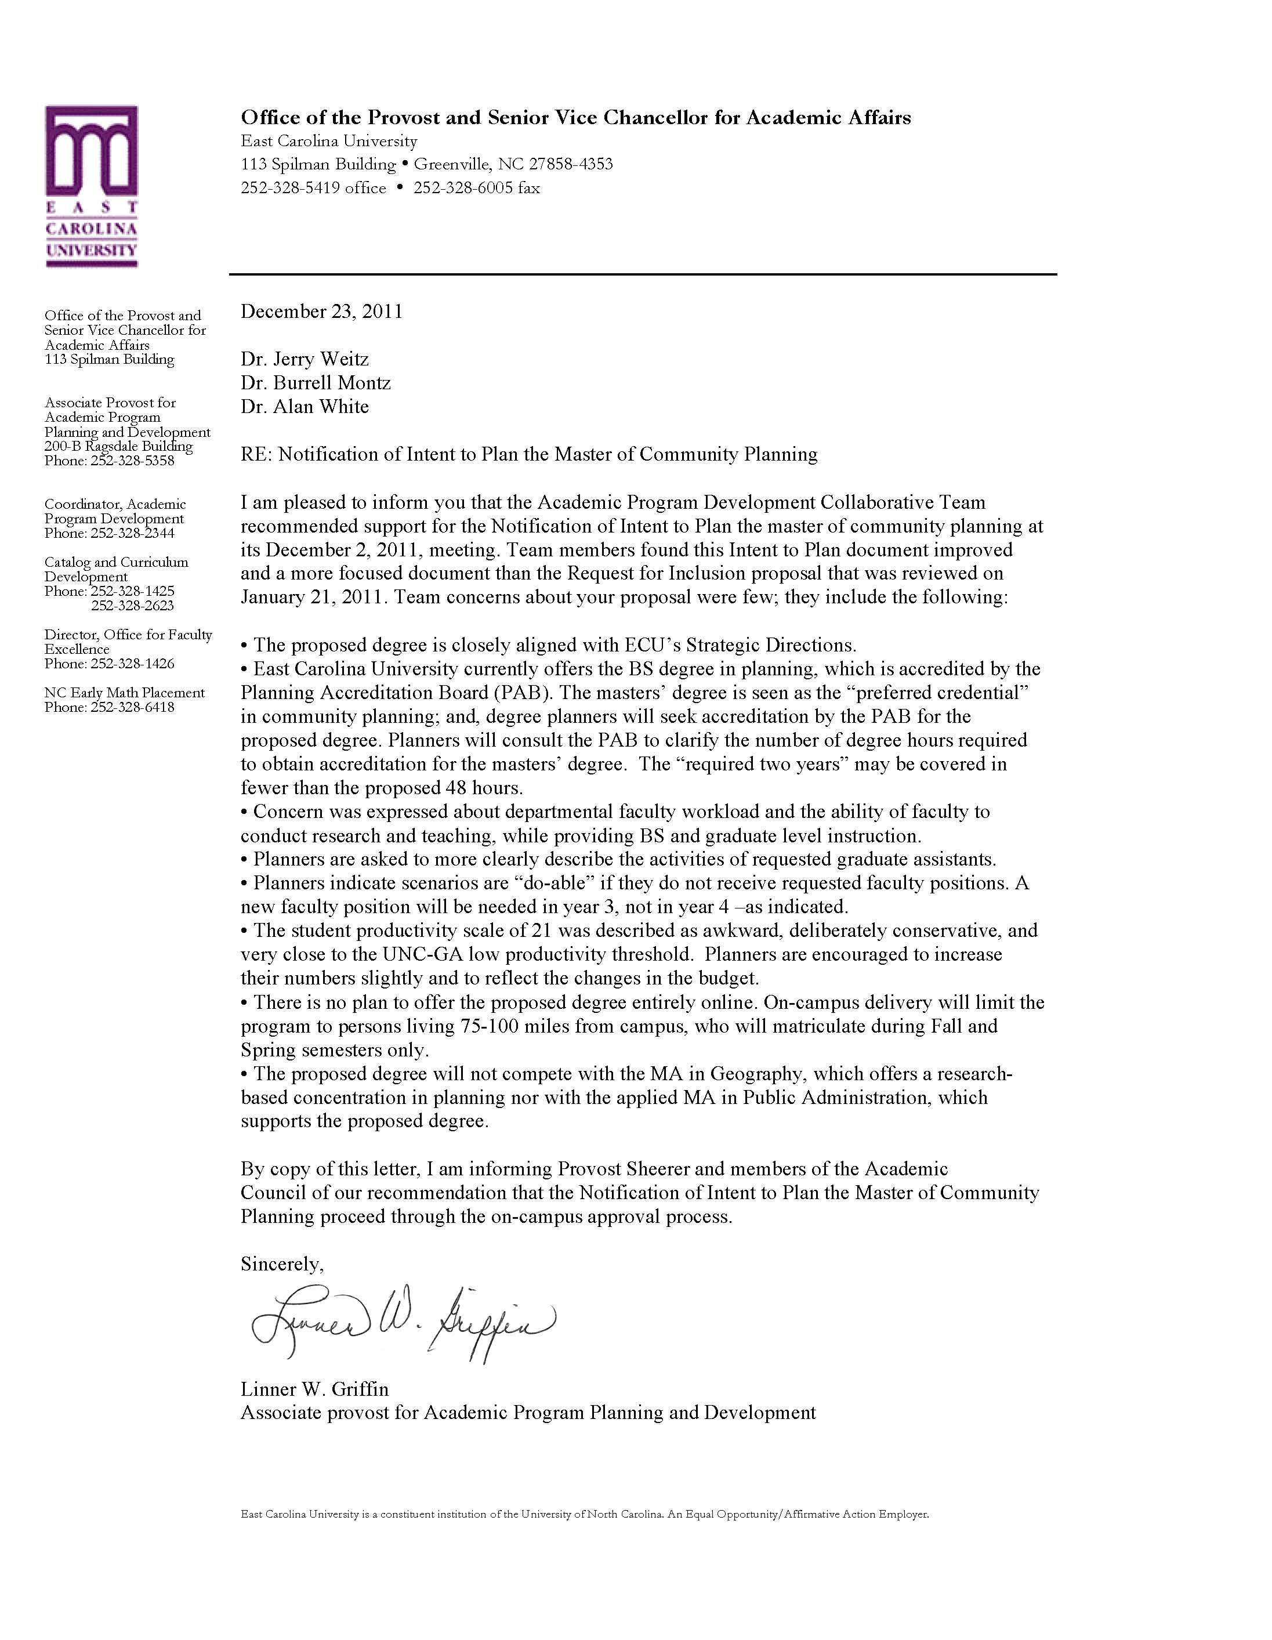

Degree planners contacted the Planning Accreditation Board on December 5, 2011, in an effort to explain the variation in accredited graduate planning program requirements for total semester hours. Shonah Merits, Executive Director of PAB, replied that the PAB has no “data point as a requirement regarding credit hours” and that “not all programs calculate hours the same.” Also, Ms. Merits supplied an unpublished worksheet showing hours required for graduate planning degree programs on the semester system.
U.S. Department of Health and Human Services, Centers for Disease Control and Prevention, has grants available and are soliciting proposals for “Health Impact Assessments to Foster Healthy Community Design.” Prior to those grant funding opportunities, there have been significant research efforts funded through foundations which have aimed at linking public health and planning. This represents a trend that will undoubtedly continue and presents an opportunity for specialized study within the proposed graduate planning program.
We identified 12 universities that offer both the undergraduate degree and graduate degree in planning. We inquired about whether they have an “advanced standing” provision for undergraduate students to continue in the graduate program. We received replies from California State University – Pomona, the University of Virginia, and Ohio State University. We also determined that such an advanced standing model is permissible under the Planning Accreditation Board’s requirements. Based on the three responses received, it appears customary to allow undergraduate planning students with high grade point averages in their senior year to be approved for enrollment and to complete the graduate planning degree with approximately one year of additional study beyond their undergraduate degree. Such an advanced standing opportunity for our undergraduate students thus offers considerable potential for student enrollments in our proposed graduate planning program, given that many of our students go directly into graduate planning school.
American Institute of Certified Planners (AICP) Code of Ethics and Professional Conduct, Adopted March 19, 2005, Effective June 1, 2005, Revised October 3, 2009, Part “A: Principles to Which We Aspire,” Paragraph 1, “Our Overall Responsibility to the Public,” paragraph “f” reads: “We shall seek social justice by working to expand choice and opportunity for all persons, recognizing a special responsibility to plan for the needs of the disadvantaged and to promote racial and economic integration. We shall urge the alteration of policies, institutions, and decisions that oppose such needs.”
East Carolina University, UNC Tomorrow Response Phase I Report, May 1, 2008.
http://www. ncicu.org/member.html

