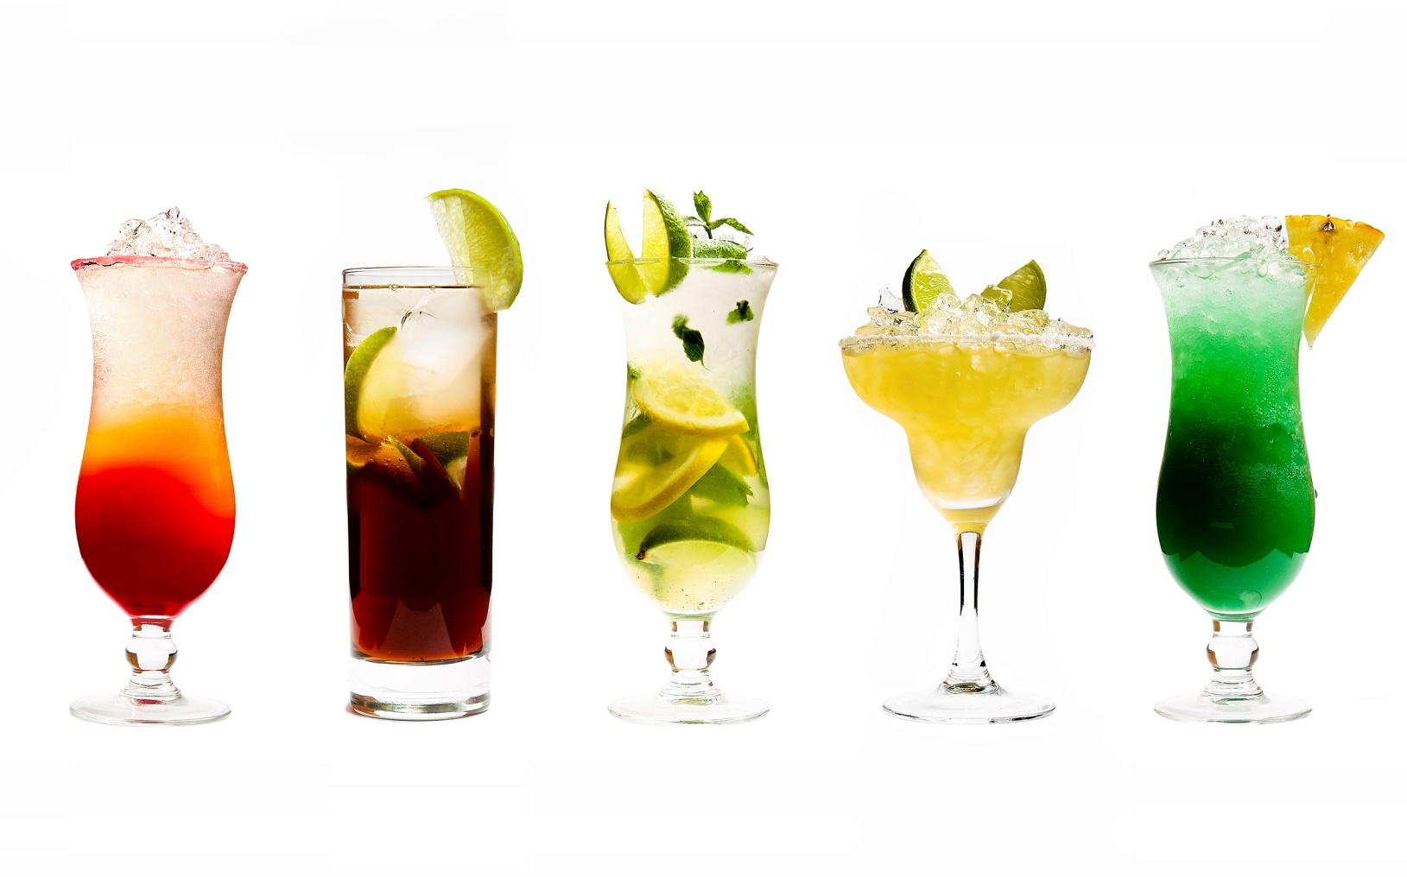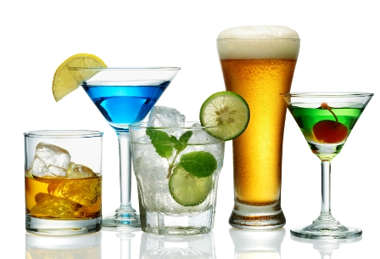

**APPETIZERS**

Crispy Hot Wings (10) – Bleu Cheese and Celery 10

Water Grille Cheese Dip – Tortilla Chips 7

Cilantro & Green Chili Calamari – Candied Jalapeno Cream 12

Cheese Fries 6

Pico De Gallo & Tortilla Chips 6

Black Bean & Cheese Quesadillas – Fresh Salsa and Sour Cream 9

**SOUPS**

Please ask your server about daily soup selections

Soup Sampler 6

**RAW BAR**

Sesame Sashimi (Hawaii) 12

Oysters on the Half Shell (Louisiana) each 1

Citrus Steamed Clams (Florida) 1/2lb. 8

White Wine Steamed Mussels (Marine) 1/2lb. 8

Chilled Shrimp Cocktail (Texas)

**SANDWICHES**

All Served with Chips and a Pickle Spear; add Batter Dipped Fries 2

Smoked Turkey Club 8

Angus Cheese Burger 8

Corned Beef Reuben 8

Grilled Ham and Swiss Melt 8

Southern Fried Chicken Sandwich 8

Water Grille Salmon Cake 8

Fried Bologna and Cheddar 8

BAR MENU