Spreadsheet Management with the new Office

Spreadsheets and databases (known as end-user computing (EUC) applications) are extraordinarily powerful tools that enable users to store, analyze, and manipulate data efficiently. They have become ubiquitous in firms for a wide range of activities from financial reporting to securities trading to risk analysis.

Unfortunately, this ease of use often causes EUCs to proliferate beyond the reach of governance rules and IT administrators. EUC applications may be designed, developed, tested, and used by a small group or even an individual, and they are often created in response to an immediate need without formal requirements or management approval. However, the data they provide is used to create reports and make business-critical decisions. Even if the data and outputs in an EUC are correct, versions may not be refreshed in step with one another, leading to multiple views of key performance indicators instead of a unified understanding of a company’s numbers and health.

The results can be dire. Erroneous, incomplete, or fraudulent EUCs can subject companies to unwanted attention from auditors and regulators and result in noncompliance with regulations promulgated by Sarbanes-Oxley 404, the National Association of Insurance Commissioners Model Audit Rule, the Office of the Comptroller of the Currency, the Financial Services Authority, Solvency II, Basel II, and MFID. Companies may even experience significant financial losses.

The reality is that companies may have hundreds or thousands of EUCs lurking in SharePoint or on file shares. Without the right technology, administrators and compliance officers have no efficient means of finding and managing EUCs, and users lack the tools to maximize their value without creating unnecessary business risk. Formerly, organizations needing Microsoft Office EUC discovery, auditing, and management capabilities needed to use costly third-party solutions. In 2011, Microsoft acquired Prodiance, a leading provider of EUC control solutions. This strategic acquisition means organizations now have access to a comprehensive EUC management toolset, integrated with Excel and SharePoint and directly supported by Microsoft. With these offerings, organizations can empower users while reducing the risk inherent in unmanaged EUCs—all with technology that is familiar and integrated with Microsoft Office.

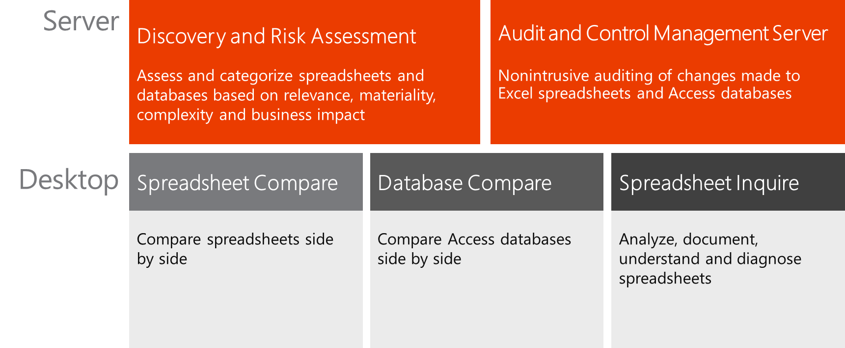

Automating Discovery, Inventory, and Risk Assessment

Discovery and Risk Assessment
For many companies, the first challenge in corralling EUCs is finding them. One of the key difficulties presented by EUCs is that they can be stored virtually anywhere—on SharePoint sites, file shares, and even PCs. Many organizations have little insight into the sheer number of EUCs in use, let alone how many versions of each exist, which files are business-critical, and the levels of risk represented by each one. Even for companies with formal rules concerning EUCs, attempting to manually discover, inventory, and manage them consistently can be difficult or impossible, and linked files are often missed.

Discovery and Risk Assessment gives companies an easy-to-use, comprehensive way to discover and evaluate EUCs. It scans network shares and SharePoint document libraries automatically or on demand, creating an inventory of files. Each EUC is analyzed and assigned a risk level based on complexity measures and business impact, which can be tailored to the needs of the organization.

Discovery and Risk Assessment helps organizations categorize spreadsheets and Access databases based on robust, highly configurable rules that enable the evaluation of materiality, complexity, use, and other company-specific parameters. Spreadsheet content and structure are evaluated, along with linked spreadsheets and queries to external data. The tool uses a template-based approach that helps organizations get started quickly while enabling fine-tuned control for a range of corporate governance needs.

In organizations where EUCs are used, management of EUCs is an ongoing process, not a steady state. Discovery and Risk Assessment is designed with this in mind; it can run on a scheduled basis to find, incorporate, and assess spreadsheets and databases created by users day after day.

Automating the Spreadsheet and EUC Management Life Cycle

Audit and Control Management Server
Along with the ability to maintain a detailed, up-to-date inventory and assessment, organizations need a way to manage the actual content and functionality of EUCs. To accomplish this, once EUCs have been discovered, they can be placed under the control of Audit and Control Management (ACM) Server.

By remotely monitoring files on corporate file shares and SharePoint document libraries, ACM Server captures a cell-level audit trail of changes to EUCs. This, in turn, supports change control and versioning. ACM Server is a web-based application that is transparent to users. The administrative user interface of ACM Server is very similar to SharePoint, making it easier for administrators to learn and use.

When users update EUCs, ACM Server automatically saves that version of the file and tracks what changes the user has made since the prior version. With ACM Server, an administrator can see, for example, that a formula in a spreadsheet has been modified, who modified it, and what the previous values were. It maintains a version history to enable historical comparisons of EUC versions and the ability to revert files that have been corrupted with errors or unauthorized changes.
ACM Server was designed in close partnership with leading tax and audit firms to satisfy mandates for SOX 404, the NAIC Model Audit Rule, OCC, FSA, Solvency II, Basel II, and MiFID. As such, the application supports all recommended controls including change control, access control, version control, analytics, backup and archiving, security and data integrity, and segregation of duties. The result is that your mission-critical EUCs are managed with the highest level of integrity and trust throughout their life cycle.

With ACM Server, organizations can greatly reduce the complexity of managing EUCs and detect errors or fraud before they cause financial losses. In tandem with Discovery and Risk Assessment, they can greatly reduce the time and expense associated with audits.

Accelerating EUC Review and Approval

Spreadsheet Compare and Database Compare
Server-based discovery, auditing, and change management tools empower administrators and compliance officers to manage EUCs across the organization. Users need ways to ensure the quality and consistency of the EUCs they rely on. Manually tracking and managing changes to shared EUCs can be difficult and time consuming. With more-complex EUCs, even the most diligent manual comparison can easily miss a change that has significant consequences for the organization. Spreadsheet Compare and Database Compare are fast, feature-rich, easy-to-use applications that give users instant and comprehensive insight into the differences between EUC versions.

Spreadsheet Compare and Access Database Compare are standalone applications that come with Office Professional Plus 2013 or Office 365 ProPlus. Spreadsheet Compare can be accessed through the “Inquire” add-in in Excel. Both applications enable users to graphically compare two files. For spreadsheets, these include formulas, errors, calculated values, links, data connections, structural changes, formatting, and names. For Access databases, changes highlighted include tables, queries, modules, macros, reports, pages, and forms. Spreadsheet Compare automatically detects when rows and/or columns have been inserted or deleted and realigns rows for more-efficient comparisons. Both applications enable line-by-line comparisons of macros and VBA code. Comparison results can be exported to Excel for reporting or further analysis.

Automating Diagnostics, Error Checking, and Optimization

Spreadsheet Inquire
Organizations relying on spreadsheets for financial calculations, business analysis, and other mission-critical tasks need to know that their models are error-free. Spreadsheet Inquire, included with Office 2013 Professional Plus and Office 365 ProPlus, enables users to easily perform diagnostics, error checking, and optimization from Office Excel 2013 without specialized expertise. The tool can analyze workbooks, cells, and cell dependencies. Over 40 diagnostics are included such as formula errors, inconsistent formulas, invisible cells, hidden rows and columns, very hidden worksheets (hidden by macros), formulas referencing hidden or blank cells, formulas returning text, duplicate formulas, cells with conditional formatting or validation logic, warnings, and more. The results of such an analysis can be documented in a separate workbook and submitted with comments by end users. Whether analyzing existing spreadsheets or creating new ones, Spreadsheet Inquire helps users build quality into the models they rely on for important business functions.

Complete EUC Risk Management with the new Office
EUCs are a crucial part of a wide range of business activities, yet if unmanaged, they create significant financial, operational, legal, and compliance risk. Now, Microsoft offers a comprehensive suite of tools for discovering, managing, auditing, and validating EUCs. Organizations can get the full power of EUCs while minimizing enterprise risk. Users are empowered to implement robust quality assurance procedures, while administrators get company-wide visibility and control. Whether a company is beginning to get a handle on EUCs or wants to move from a third-party solution to one that is integrated with Microsoft Office, these new tools will help reduce costs, streamline business processes, and minimize business risks.

Businesses face mounting compliance challenges given increasing volumes of data, rapidly advancing technology, and ever-more-stringent regulations. That is why powerful, easy-to-use compliance tools are built into the new Office—and EUC controls are only part of the story. For example, SharePoint now supports robust enterprise content management as well as unified eDiscovery across SharePoint, Exchange, and Lync from a web-based console. Exchange offers immutable, in-place archiving that helps organizations simultaneously reduce the cost and complexity of managing archives while improving experiences for IT and users. Together, these and other capabilities of the new Office help organizations meet today’s compliance challenges with tools that work together seamlessly and help everyone in an organization manage risk.

How to Get It
Tool | Installed on server | Part of Office Professional Plus 2013 | Notes
Discovery and Risk Assessment | X |  | Requires ACM Server
ACM Server | X |  | Additional SharePoint ECAL license required. Runs on a stand-alone server
Spreadsheet Compare |  | X | Standalone application also accessible via Inquire tab in Excel 2013 (when enabled) as “Compare files”
Database Compare |  | X | Standalone application
Spreadsheet Inquire |  | X | Accessible via Excel 2013 add-in enabled in Excel Options menu

