PM Lite 2.0

Process Documentation

Version: 2.0 • February 27, 2015

Section 1. PM Lite 2.0

1.1 Description
PM Lite (Project Management Lite) is a project management process made up of tools, templates, and best practices that empowers its users to be more efficient and effective in project delivery regardless of project size or complexity.
In PM Lite’s most recent release (PM Lite 2.0) DIR’s PPMO simplified Project Management Institutes (PMI) project management processes facilitating a “liter”, and easy to use, toolset that aligns to a global standard.
The Program and Portfolio Management Office (PPMO) at DIR have created the PM Lite process to help enable state and local entities to achieve their core missions through successful project delivery. PM Lite is an optional process. Using these tools and templates can help your organization achieve project consistency, standardization, and project success.

1.2 Uses
Anyone formulating and running a project can use these tools, templates, processes and best practices. The PM Lite process, can be used to manage projects regardless of project size, complexity, project type, or methodology.¹

Section 2. PM Lite 2.0 Templates
Template Name | Version | File Format | Description/Purpose | Project Phase
*Business Case | 2.0 | .doc | The Business Case defines the business need along with the necessary information, from a business standpoint, to determine whether or not the project is worth the required investment. It demonstrates alignment to business and strategic objectives and is used to prioritize the project among other project demands. | Portfolio Review (Pre-Initiation)
*Project Charter | 2.0 | .doc | The Project Charter officially authorizes the project and allocates resources. The chartering process forms the project core team and officially kicks off the project. | Initiation
Project Management Plan | 1.0 | .doc | The Project Management Plan defines "how" the project is executed, monitored and controlled, and closed. | Planning
*Project Schedule | 1.0 | .mpp  -OR-  .xlsx | The Project Schedule is a Microsoft schedule, it is created to help plan and track important dates within the project. | Planning
Requirements Document | 2.0 | .xlsx | The Requirements Document details specific project and product requirements that must be met to satisfy the business objectives. | Planning
Milestone Timeline | 2.0 | .vsd | The Milestone Timeline is used as a “visual” representation of the schedule for key project deliverables and milestones. The Milestone Timeline is beneficial for presenting a visual schedule for the project. | Planning
*Project Register | 2.0 | .xlsx | The Project Register is a tool that can be used to capture and track key project information, making it easier to monitor, control, and track project details throughout the life of the project. | Monitor & Control
Project Meeting Notes | 2.0 | .doc | The Project Meeting Notes Template is used to document and communicate notes for all project meetings. | Monitor & Control
Project Status Report | 2.0 | .doc | The Status Report is utilized for communicating the overall health of the project to the core team and key project stakeholders to keep everyone abreast of project progress. | Monitor & Control
Project Change Request | 2.0 | .doc | The Project Change Request (PCR) is used by the Project Manager to request a change to the project scope, schedule, costs, project milestones and/or deliverables. | Monitor & Control
*Lessons Learned | 2.0 | .doc | The Lessons Learned document is used to identify and preserve the lessons learned on each project. The purpose of this document is to help the project team share knowledge gained from the experience. A successful Lessons Learned program will help project teams repeat desirable outcomes and avoid undesirable outcomes. | Closure
*Project Closure | 2.0 | .xlsx | The Project Closure document formalizes the completion of the project. | Closure
*These templates are highly recommended when using PM Lite, regardless of project size or complexity.¹

Section 3. PM Lite 2.0 Process
The PM Lite 2.0 Process has five core phases and one pre-process phase. The five phases represent a typical project life-cycle. They include initiation, planning, executing, monitoring and controlling, and closure. The diagram below identifies which templates are typically created and/or completed during each phase of the project lifecycle.
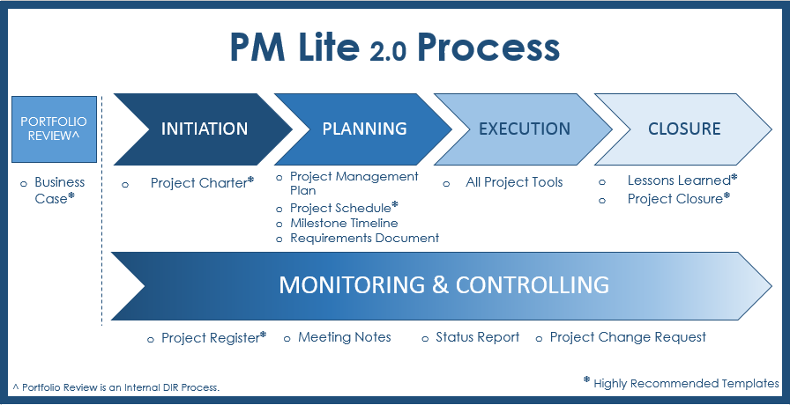

3.1 Portfolio Review (Pre-Initiation)
The Portfolio Review is a DIR internal process for prioritizing, aligning, and evaluating project requests. When the business idea is submitted by the Project Sponsor, the Portfolio Review Board reviews and assigns the project to a Project Manager based on prioritization and strategic alignment.

3.1.1 Business Case
- The Project Sponsor or Business Owner submits this template. This template will address the business issue and the expected business outcome as well as the key resources necessary for the project. It is defines how the project will align to the goals of the agency and/or state.

3.2 Initiation
The Initiation Phase reviews the business idea and turns it into a formal project.

3.2.1 Key Activities:
- Review Lessons Learned from similar projects
- Identify project risks and constraints
- Define expected outcomes and key milestones
- Define high-level scope, schedule, and costs
- Identify Stakeholders
- Identify Resources
- Schedule Project Kickoff
- Define project roles and responsibilities

3.2.2 Project Charter
- The Charter is where you will define a project scope, create an estimated timeline, and establish a project budget. Once this document has been completed and approved, the Initiation Phase closes and the project moves into the Planning Phase.

3.3 Planning
The Planning Phase develops the approach and schedule for delivering the project. The triple constraint (Scope, Schedule, and Cost) is finalized in the Planning Phase. The project team is formalized and the communications plan and project deliverables are identified.

3.3.1 Key Activities:
- Finalize the project goals/scope
- Identify project/product requirements and project metrics and key performance indicators
- Develop the project schedule & high-level milestones
- Assign project tasks
- Solidify the project team
- Develop Project Plan, including Communications Plan for Stakeholders

3.3.2 Project Schedule
- The Project Schedule Template is pre-configured to align to standard Project Management life cycle processes. There are two versions of the PM Lite 2.0 Project Schedule Template. One is a MS Project and the other an Excel spreadsheet. Pick the tool that works best for your project and organization. The project schedule allows you to plug in dates, resources, and budget information. Once populated with dates and resources, key performance indicators (KPIs) such as schedule variance and % complete, can then help track the project performance.

3.3.3 Requirements Document
- This template provides a mechanism to track product/project deliverables against requirements to ensure business and product requirements are met.

3.3.4 Milestone Timeline
- A Milestone Timeline can be created using MS Visio, a diagramming application. Once a project schedule is created the key deliverables and milestones should be mapped and aligned to the “visual” milestone timeline according to when they will occur in the project.

3.3.5 Project Management Plan
- This template lays out a plan and strategy for “how” the project will be executed. The Project Charter defines the “what” while the Project Management Plan defines the “how”.

3.4 Execution
In the Execution Phase, the project plan is worked, the project deliverables are completed, and the project is implemented or “goes live.” The Execution Phase is where the work defined in the Project Charter is performed to satisfy the project objectives.

3.4.1 Key Activities:
- Execute the project plan
- Maintain project communications
- Manage quality of deliverables
- All project tools and templates should be used as appropriate to ensure on time project delivery

3.4.2 Templates
All PM Lite 2.0 tools and templates can be used during this phase.

3.5 Monitoring & Controlling
The Monitoring & Controlling Phase of the project is an overarching phase that commences in the Initiation Phase and extends through Project Closure. Templates included in the Monitoring & Controlling phase include reporting, tracking, and communication tools to ensure successful project delivery.

3.5.1 Key Activities:
- Track project status
- Track and communicate project activities
- Monitor project health and status
- Measure/monitor & report project key performance indicators

3.5.2 Project Register
- The Project Register can be used to track action items, decisions, deliverables, risks, issues, stakeholder contact information, and more.

3.5.3 Meeting Notes
- The Meeting Notes Template is meant to be utilized at all project meetings to document the meeting agenda, action items, decisions made in the meeting, who attended the meeting and scheduling the next meeting.

3.5.4 Status Report
- The Status Report communicates key performance indicators (KPIs), key project dates, and key risks/issues related to the project in order to keep all project players equally informed.

3.5.5 Project Change Request (PCR)
- Use this form to document major changes in the project that impact scope, schedule, costs, quality, or key project performance and health. This form should NOT be used to manage daily operational project management, project monitoring and control activities, as doing so will add significant overhead to the project management activities.

3.6 Closure
In the Project Closure Phase, the project artifacts are archived in the project repository, the project activities are completed, and the project transitions to operational status.

3.6.1 Key Activities:
- Transition project
- Close the project
- Archive project artifacts
- Document lessons learned
- Perform Customer Satisfaction Survey

3.6.2 Lessons Learned
- Populate the Lessons Learned document using Project Register information and any other pertinent project artifacts, as well as project team feedback obtained from any lessons learned brainstorming.

3.6.3 Project Closure
- The Project Closure Template documents confirmation that all in scope business objectives have been met and necessary project items have been finalized. This includes making sure all listed project deliverables have been completed and project documentation saved in suitable shared storage. This template also allows you to document how outstanding actions/issues are to be handled.

Section 4. PM Lite Process Best Practices
- PM Lite 2.0 Best Practice. For process and template best practices see the PM Lite 2.0 Best Practice document.

Section 5. Feedback
If you have any questions on PM Lite or on project management practices, please contact DIR’s PPMO at ppmo@dir.texas.gov.

PM Lite does NOT supersede the Texas Project Delivery Framework.
PM Lite 2.0 is based on Project Management Institute (PMI) five process groups as defined in the Project Management Body of Knowledge (PMBOK).

