Product Brochure
www.fcesoftware.com
(734) 904-1895



Our primary focus is to assist physicians and therapists in the objective evaluation of functional abilities by developing, providing and supporting our industry-leading FCE software and instrumentation.  While the Arcon FCE system uses state-of-the-art, automated evaluation tools, it is important to remember that the key to every FCE system is the software used to collect, process and summarize your data.  We guarantee our FCE software to be:  - Easy to use.  - Widely accepted by insurance companies, physicians and other referral sources.  - Easy to store and edit all data.  - Intuitive, with menus and help screens describing tests, protocols, system calibration and set-up.  - Complete, automated FCE reports in Microsoft Word with clearly presented data, pictures and summary.  The Arcon FCE software is the culmination of 25 years of development and refinement. Its performance is robust and reliable and provides a superior clinical tool to enhance your practice.  We have the largest installed customer base, with almost 1,000 clinics across North America, employing our evaluation software and hardware.  Our functional evaluation software and testing protocols have been designed with the help of Physical Therapists, Occupational Therapists, Exercise Physiologists, and Kinesiologists, as well as Physicians engaged in Occupational and Physical Medicine.  The Arcon FCE methodology and reports are accepted by disability evaluators and insurance companies as an industry standard. | The Arcon system includes:  * Computerized grip and pinch dynamometers.  * Isometric testing unit (ISTU) with dynamic  lifting shelf attachment.  * Upper extremity strength testing attachment.  * Electronic goniometer.  * Dual range of motion inclinometers.  * MTM dexterity boards.  * Computerized wireless heart rate monitor.  Testing protocols include:  * Grip and pinch strength with reliability and comparison to norms.  * Whole Body Isometric & Dynamic lifting.  * Isometric testing for upper and lower extremities.  * Range of motion testing.  * Dexterity testing.  * Movement, balance and postural tolerance.  * Aerobic capacity testing.
  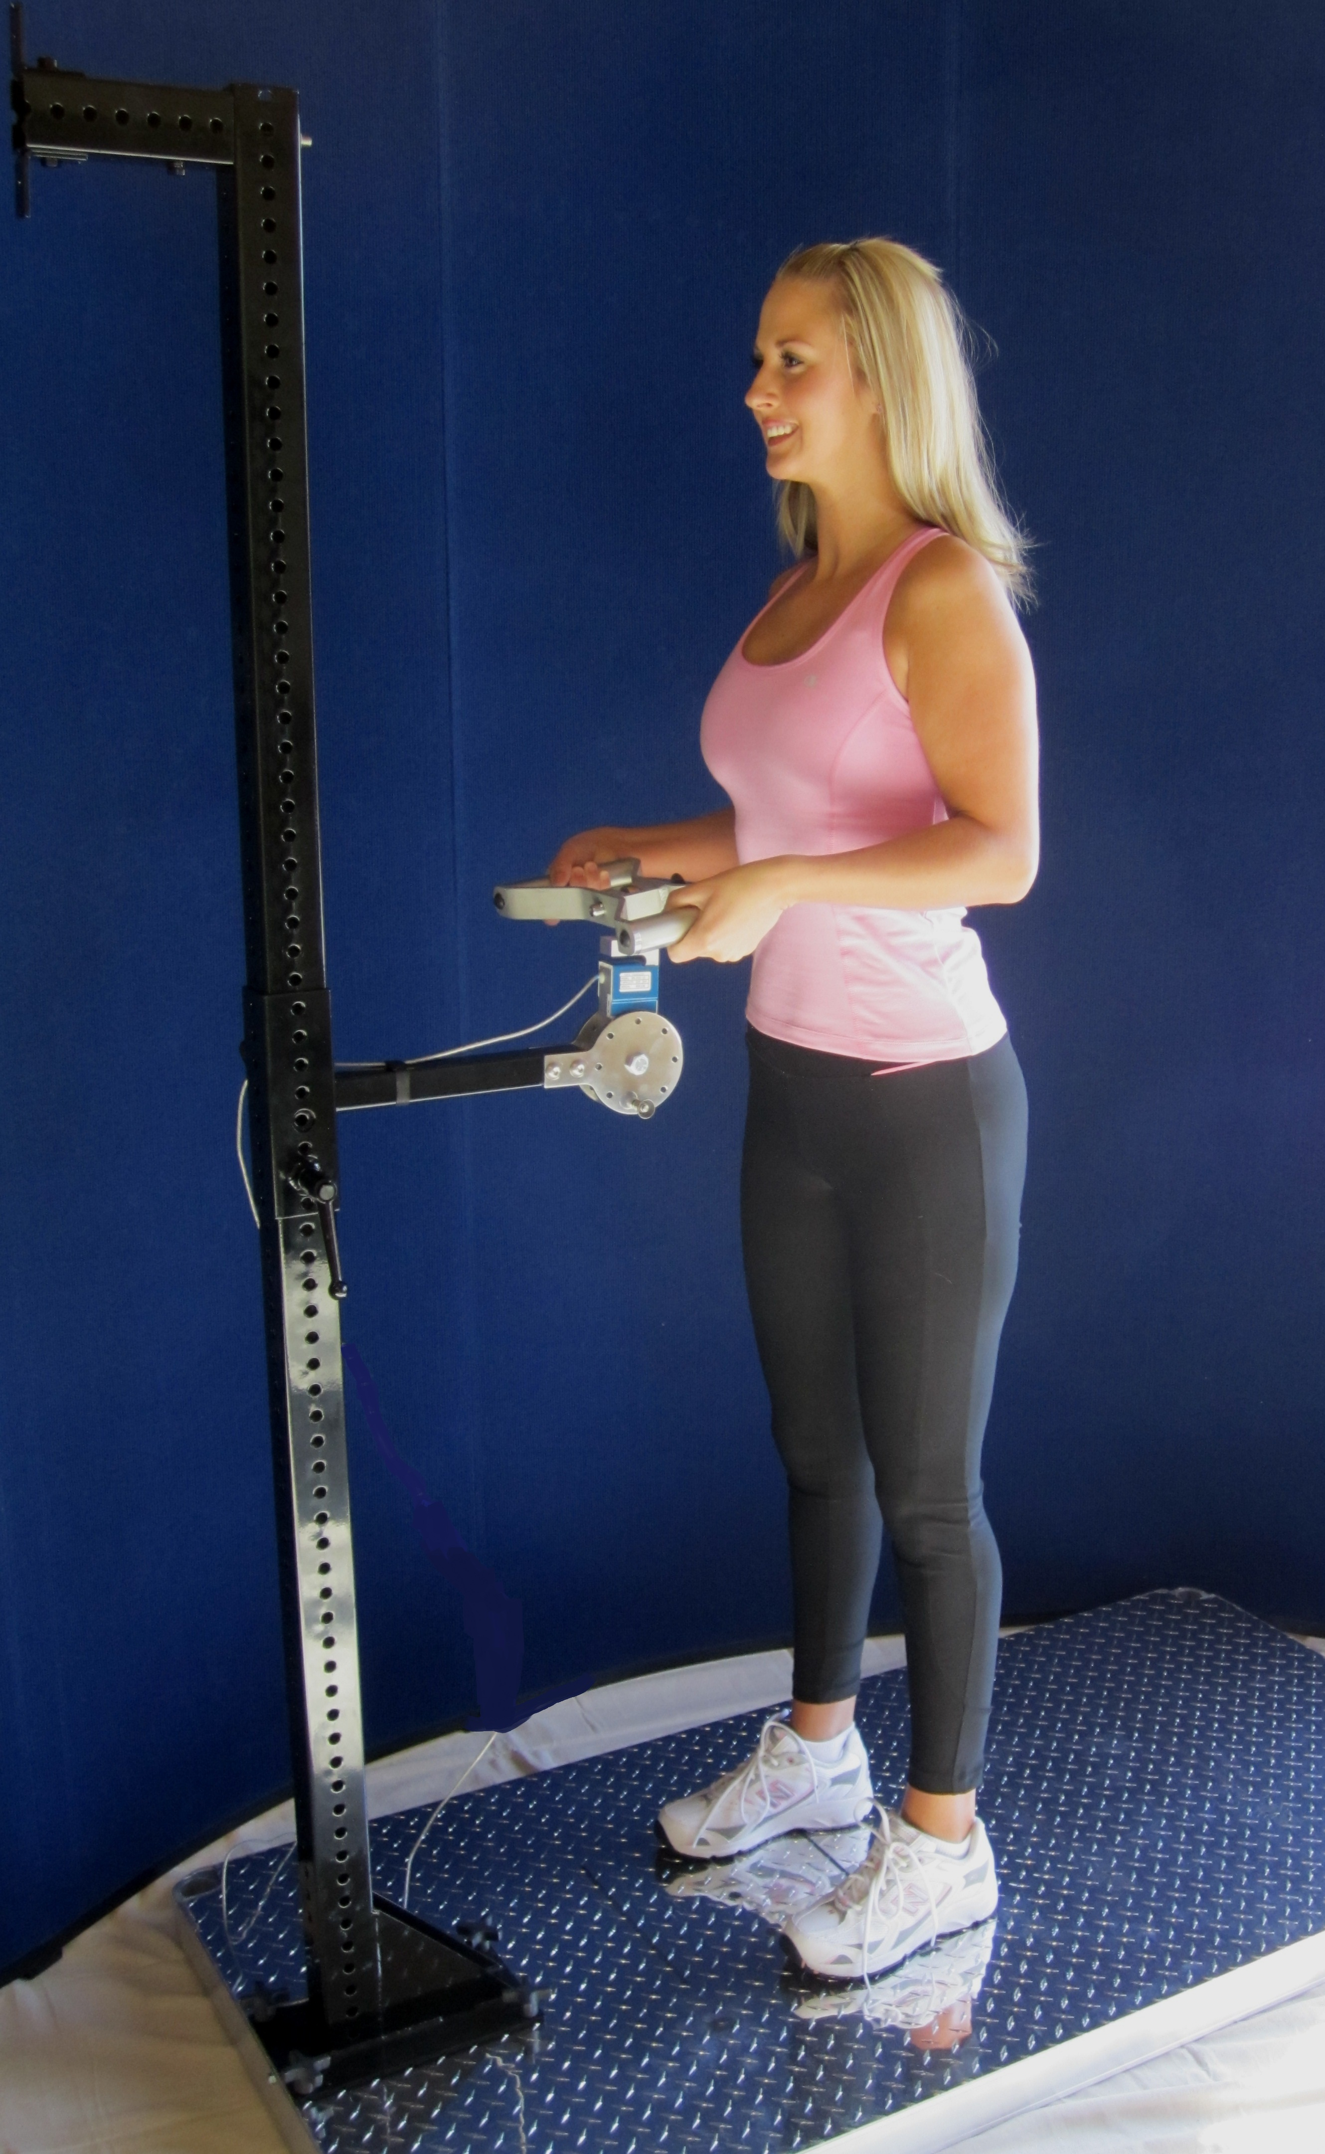
ARCON Functional Evaluation System
The ARCON system is a user-friendly tool to help clinicians perform Functional Capacity Evaluations (FCEs) in a simple, accurate and consistent manner. The system produces high quality evaluations by combining three critical components: the evaluation Tools (hardware and software), the evaluation Protocol and a Competent Trained Evaluator. These components work together to assure easily understood, reliable and legally defensible results.
The Tools:
The ARCON system is designed to collect objective information about a client’s physical abilities. The FCE software and hardware augment a clinician’s skills by streamlining the cumbersome and time consuming tasks of data collection and report generation, so that the evaluator can focus on the assessment itself. The system tools perform real time measurement of functional strength, movement and postural activities while also recording heart rate. The system takes care of stepping through the proper sequence of activities and automatically saves the data for each task, along with any observations that the clinician may wish to add.
The ARCON system substantially reduces measurement and calculation errors. Each instrument is controlled and monitored by the FCE software, resulting in a high degree of accuracy. Strength measurements are accurate to the nearest pound or to 1% of full scale. Angle measurements (goniometer and inclinometers) are accurate to the nearest degree. The ARCON software includes calibration procedures for each instrument, and has an internal check to ensure that calibration is verified or performed on at least on a bi-monthly basis. The evaluator is alerted if measured values are unusually high or low so that equipment problems, while rare, can be quickly detected. By comparison, typical manual FCE systems may only have their tools calibrated once a year or less.

Upon completion of the FCE, the ARCON software automatically generates a finished report in a matter of minutes. The results of the evaluation are presented in a clear and concise manner, and all measurements, graphs, scores, clinical observations, and computed ability levels are accurately transcribed. Since all supporting data is saved in the ARCON system, it is a simple matter to revise a report should additional information become available.
The Protocol:
The ARCON FCE protocol is based on published peer-reviewed research. The component functional tests have been selected based on input from physicians, physical and occupational therapists, exercise physiologists, nurse case managers and vocational professionals. The protocol is designed to provide a comprehensive assessment of the client's functional abilities. A typical evaluation takes approximately 4 hours, and is comprised of a variety of components that objectively predict a client’s specific physical abilities over the course of an 8-hour day. While the ARCON system allows clinicians flexibility in the selection of component tests, a typical FCE includes the following sections.
Intake Interview: The intake interview is an opportunity for the evaluator to describe the functional evaluation procedure and to identify expectations through the use of an informed consent document. It is also an opportunity to develop a rapport with the client and allay any fears associated with functional testing. During this component of testing the client has an opportunity to tell his or her story. Often times this is the first opportunity that the client has had to describe the injury or illness process fully and how it has impacted both work and activities of daily living. The evaluator is able to collect the client's perception of current capabilities and compare those to demonstrated functional abilities observed later during the evaluation. The evaluator is also able to measure tolerance for sustained sitting during this time.
Musculoskeletal Screen: The client undergoes a brief general screen of functional movement as well as an optional diagnostic specific assessment of injured areas. Range of motion, strength, stability, sensation and other diagnosis specific testing can be correlated with demonstrated functional abilities performed later in the evaluation for consistency. The screen confirms diagnostic criteria, ensures that the client is safe to proceed with more physically demanding portions of the exam and identifies specific deficits. Also during this component of the evaluation, grip and pinch strength data is collected. This data is compared to population norms based on gender and age, and is also is used in determining the client’s reliability of effort.

Strength Testing: Whole body lifting, pushing, pulling and carrying capacity is measured both statically and dynamically. Static (isometric) testing is an excellent tool for quickly and safely assessing maximum strength in various work postures. Dynamic lifting is performed utilizing the PILE protocol (Progressive Isoinertial Lifting Evaluation) and has application for both occasional and frequent demand levels of work. Heart rates are measured during static and dynamic lifting, and provide physiological evidence of exertion (reliability of effort) by the client during these tasks. Strength abilities are rated using the standard categories defined in the Dictionary of Occupational Titles published by the U.S. Department of Labor.
Functional Abilities: The ARCON protocol uses Methods-Time-Measurement (MTM) testing to measure a client’s abilities in activities that involve movement, dexterity and/or postural tolerance. MTM utilizes the Industrial Standard (IS) criterion as an objective basis for rating ability levels. The Industrial Standard is defined as the time it takes an average worker (male or female), between 18 and 65 with average skills, to perform a task at a rate that he or she can maintain over an 8-hour workday with appropriate allowance for rest, and without undue stress or fatigue. This method of rating functional abilities is based on an extensive body of research published over the past 70 years. Some functional evaluation systems rely on clinical observation of functional tasks, with the rating of a client's ability based on the evaluator's clinical judgment. With MTM testing, the client’s ability for each of the functional activities is objectively obtained through direct measurement. ARCON MTM results are reliable, valid and not influenced by evaluator judgment or bias.
Cardiovascular Assessment: Another component used to predict a client’s ability to perform work is aerobic capacity. Studies suggest that workers can sustain an energy expenditure rate of 33% of maximum aerobic capacity (VO2 max) over an 8-hour day. The Arcon system offers three sub-maximal aerobic tests that predict VO2 max, and thus sustained work capacity. The Canadian Aerobic Fitness Test and the YMCA Step Test are both simple step tests that can quickly and safely predict aerobic capacity, while the Single Stage Treadmill Test uses a motorized treadmill that some clients find easier to tolerate than a step test. When a client has a job with a significant energy demand, the results of a cardiovascular assessment will indicate if he or she is capable of meeting that demand upon return to work.
Reliability of Effort: Essential to every FCE is an objective assessment of the reliability of effort demonstrated by the client during the evaluation. It is also important to identify symptom complaints and/or behaviors that are inconsistent or exaggerated when compared to objective evidence. Reliability is determined based on evidence collected over the entire evaluation and not simply the results a single test. Observed behaviors are compared and contrasted to the client's perception of abilities and self-reported symptoms. The ARCON system calculates up to 70 independent measures of reliability over the course of an evaluation. These include a statistical consistency of effort and movement, heart rate responses to exertion, quality and speed of movement patterns, force curve analysis and distraction techniques such as isometric horizontal strength changes, rapid exchange grip testing and Waddell’s non-organic signs.

The ARCON FCE system includes instructions for each task as well as suggestions for verbal cues that can be used during testing. Each individual component of the ARCON protocol is well supported with peer reviewed literature.
Competent Trained Evaluator:
Ultimately, the results of the functional evaluation hinge on the correct performance and interpretation of the testing protocol. Each ARCON evaluator is a highly trained clinical professional. These professionals may come from a variety of different backgrounds and include Physicians, Chiropractors, Physical and Occupational Therapists, Exercise Physiologists, Kinesiologists and Athletic Trainers. Each evaluator receives extensive training in the technical operation of the equipment. As an additional quality assurance check, ARCON will optionally perform a quality over read for the first few functional evaluations performed by new evaluators. This includes a technical review to ensure testing was performed to protocol standards and a clinical over read to ensure that the report answers referral questions and data supports the evaluator's conclusions. Evaluators also have a technical support staff available to assist them with any questions before, during and after the evaluation.
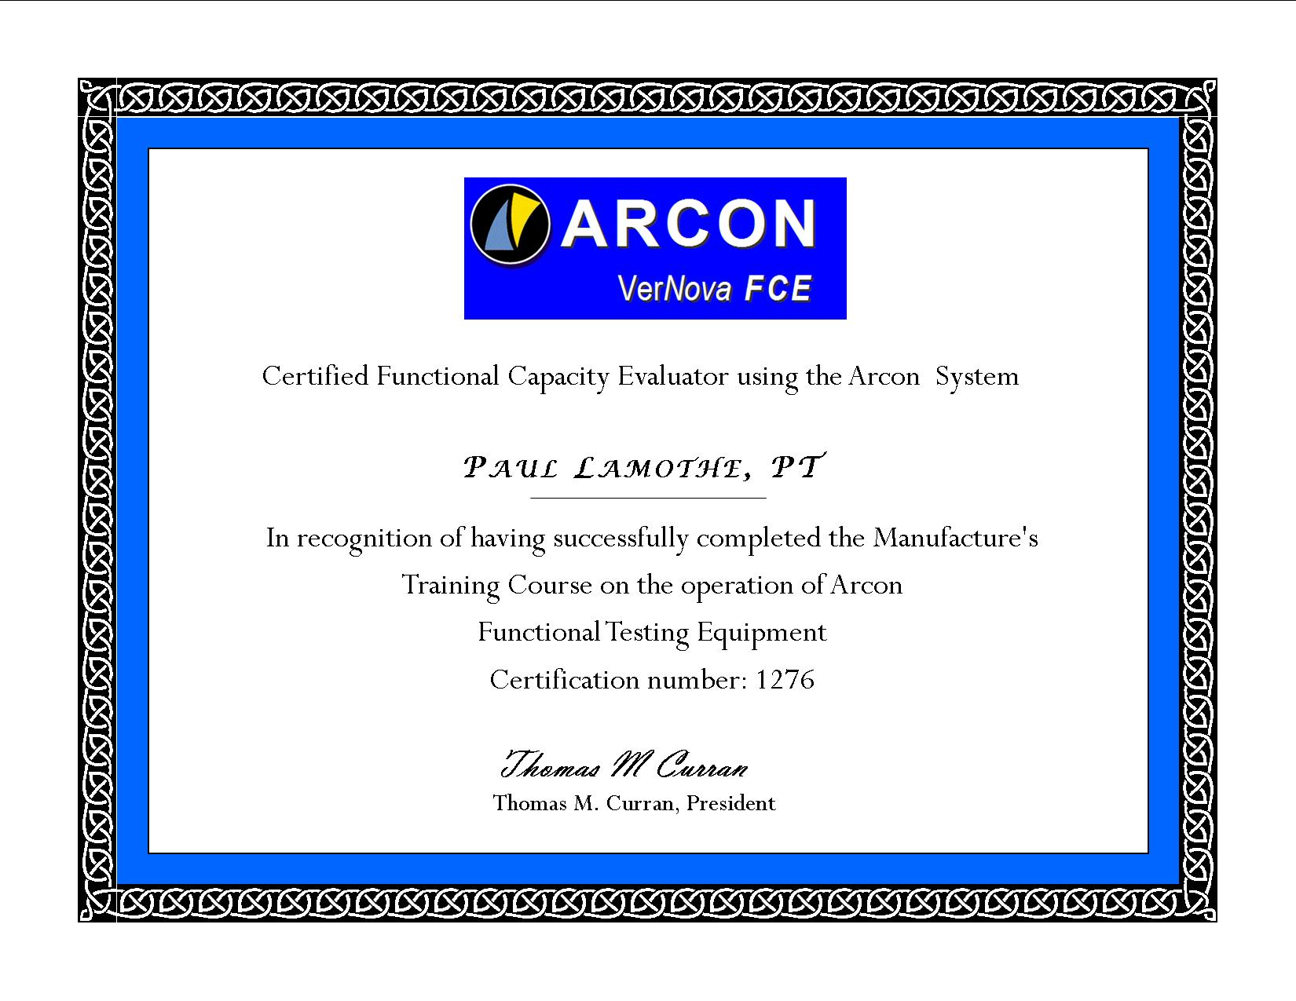

Computerized Tools and Protocols

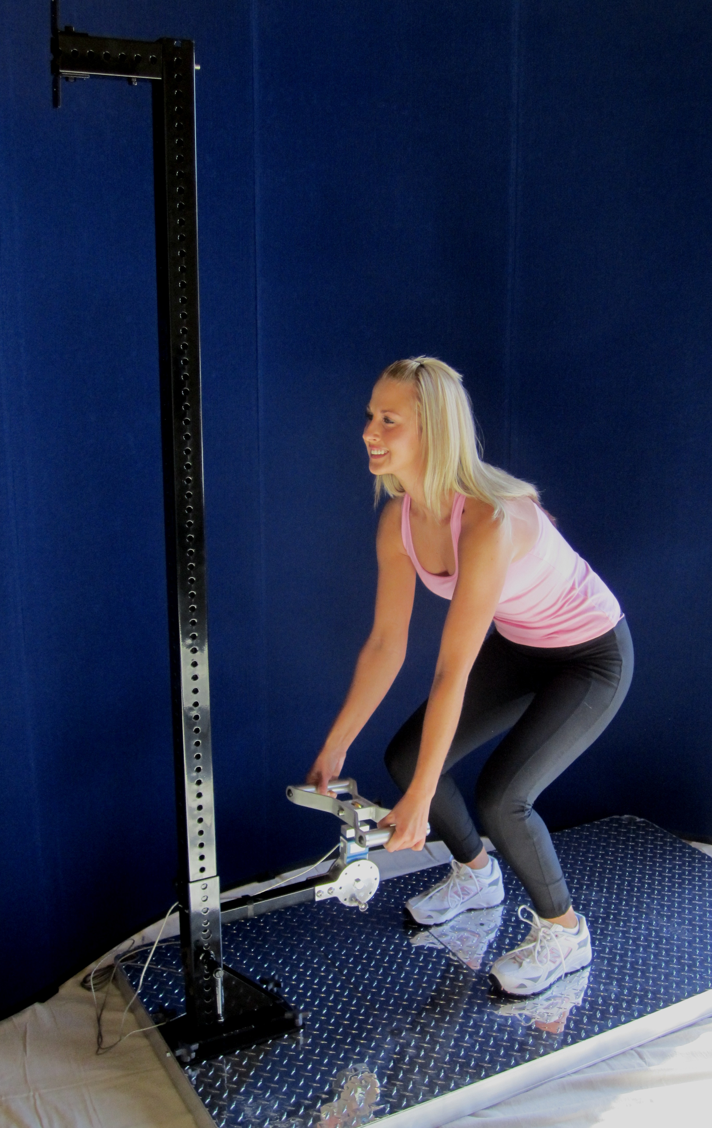 | 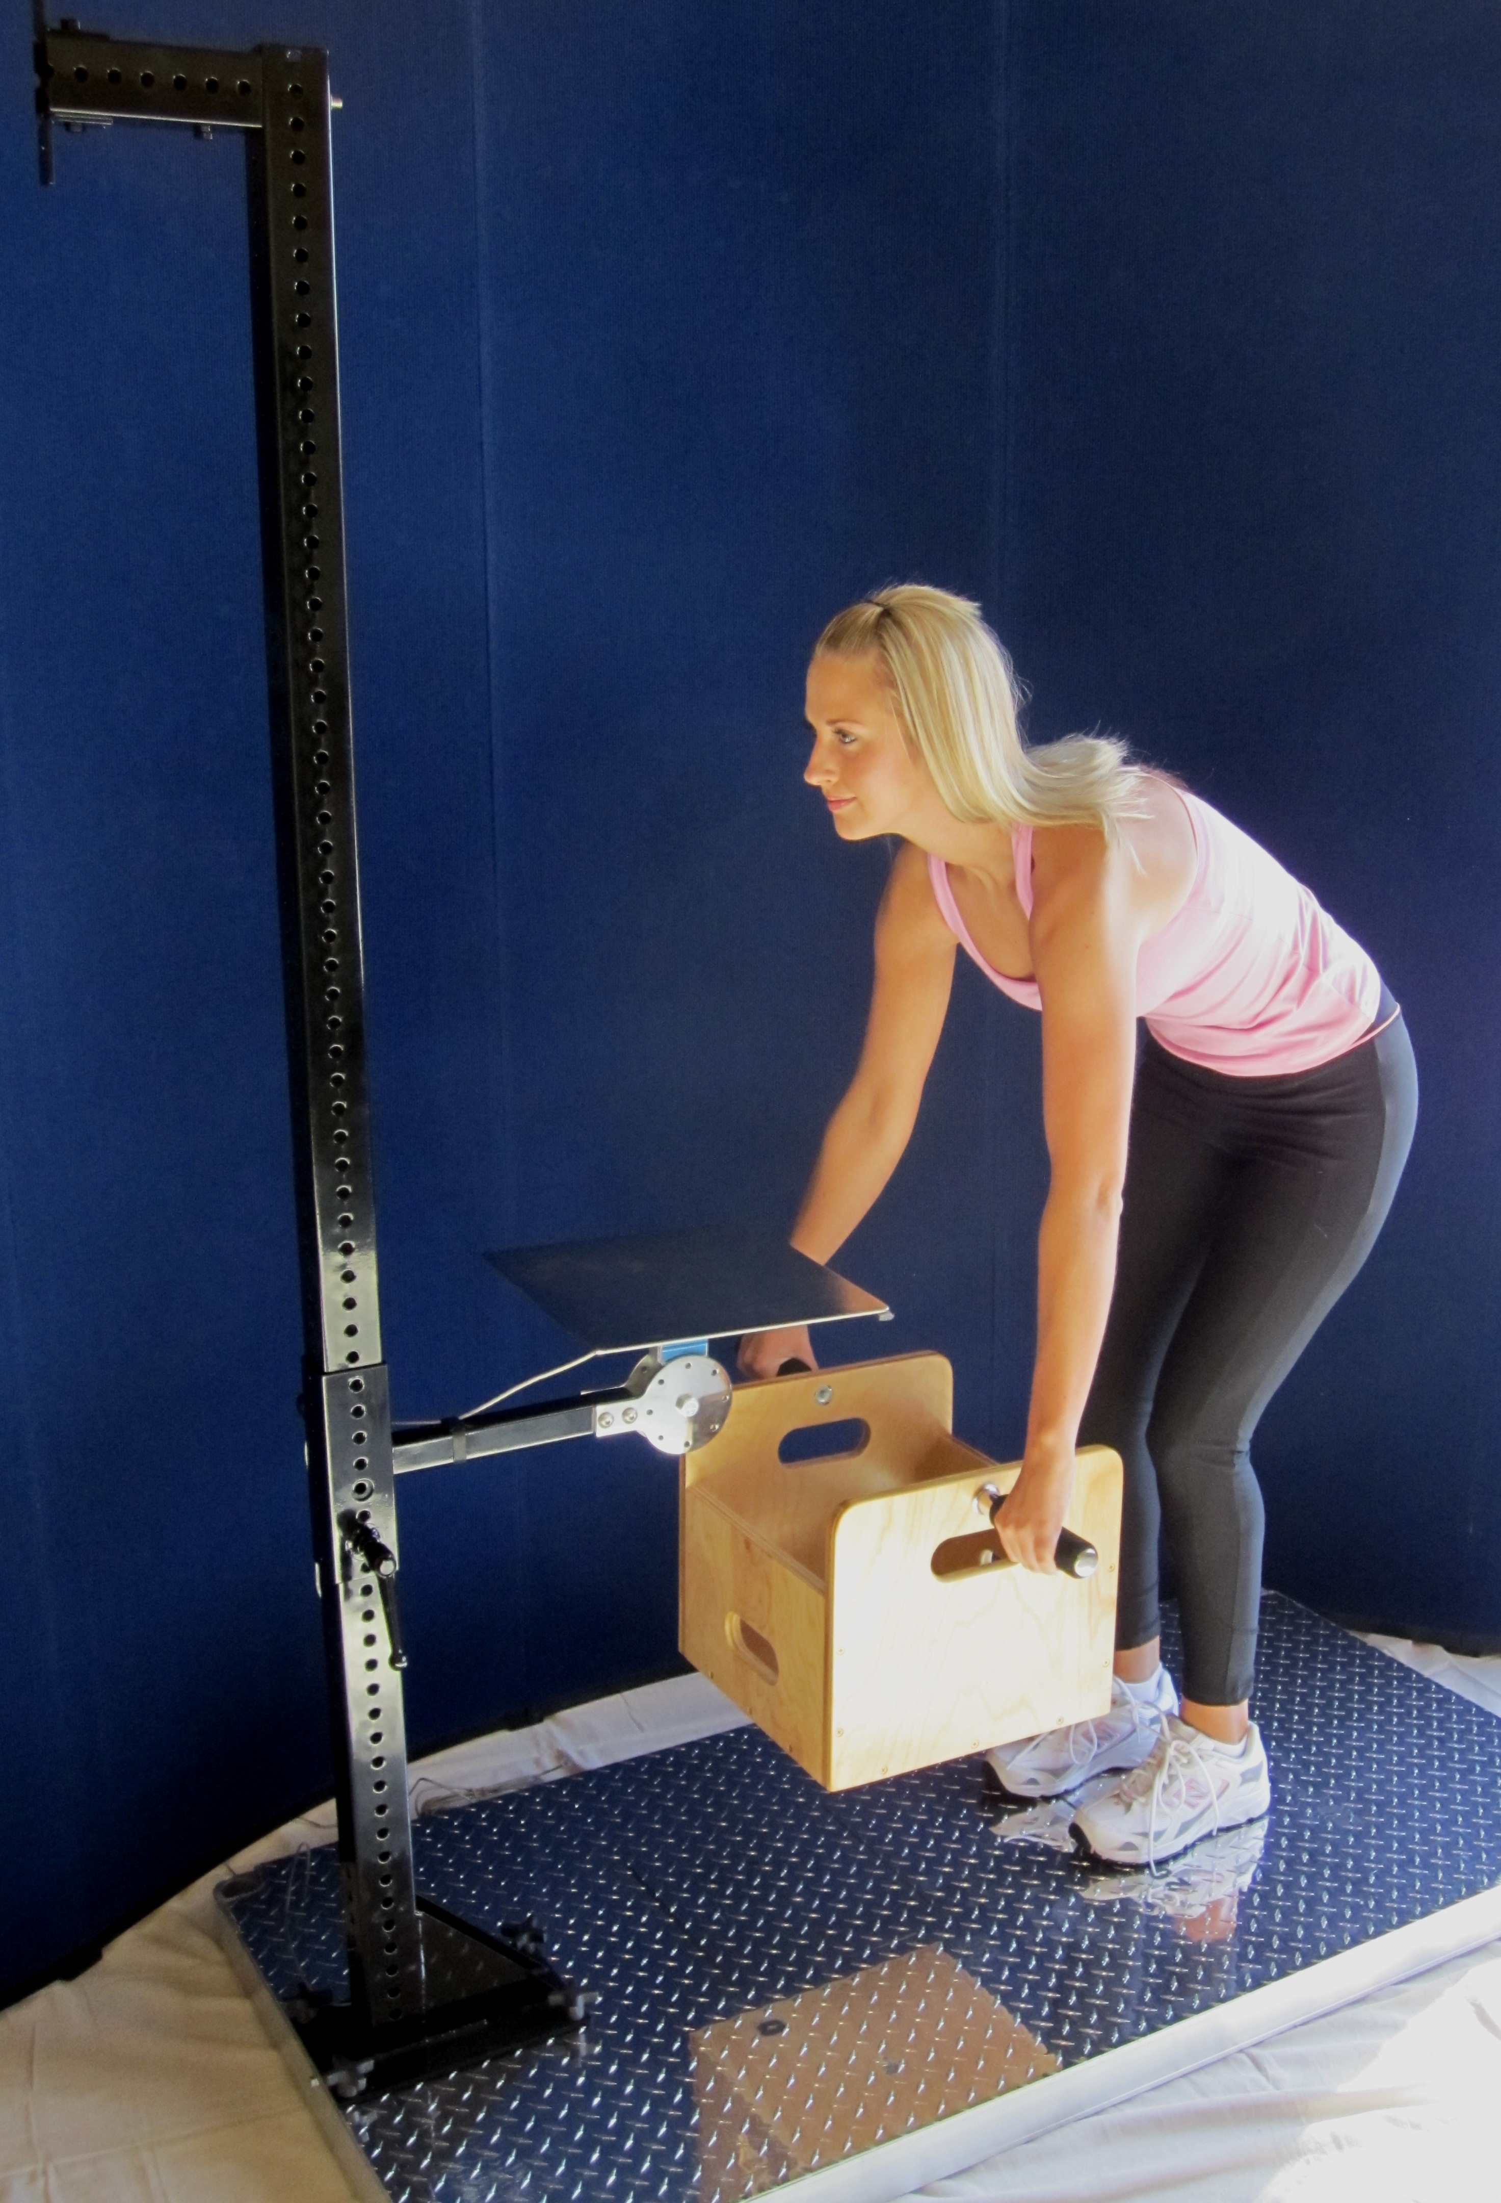 | 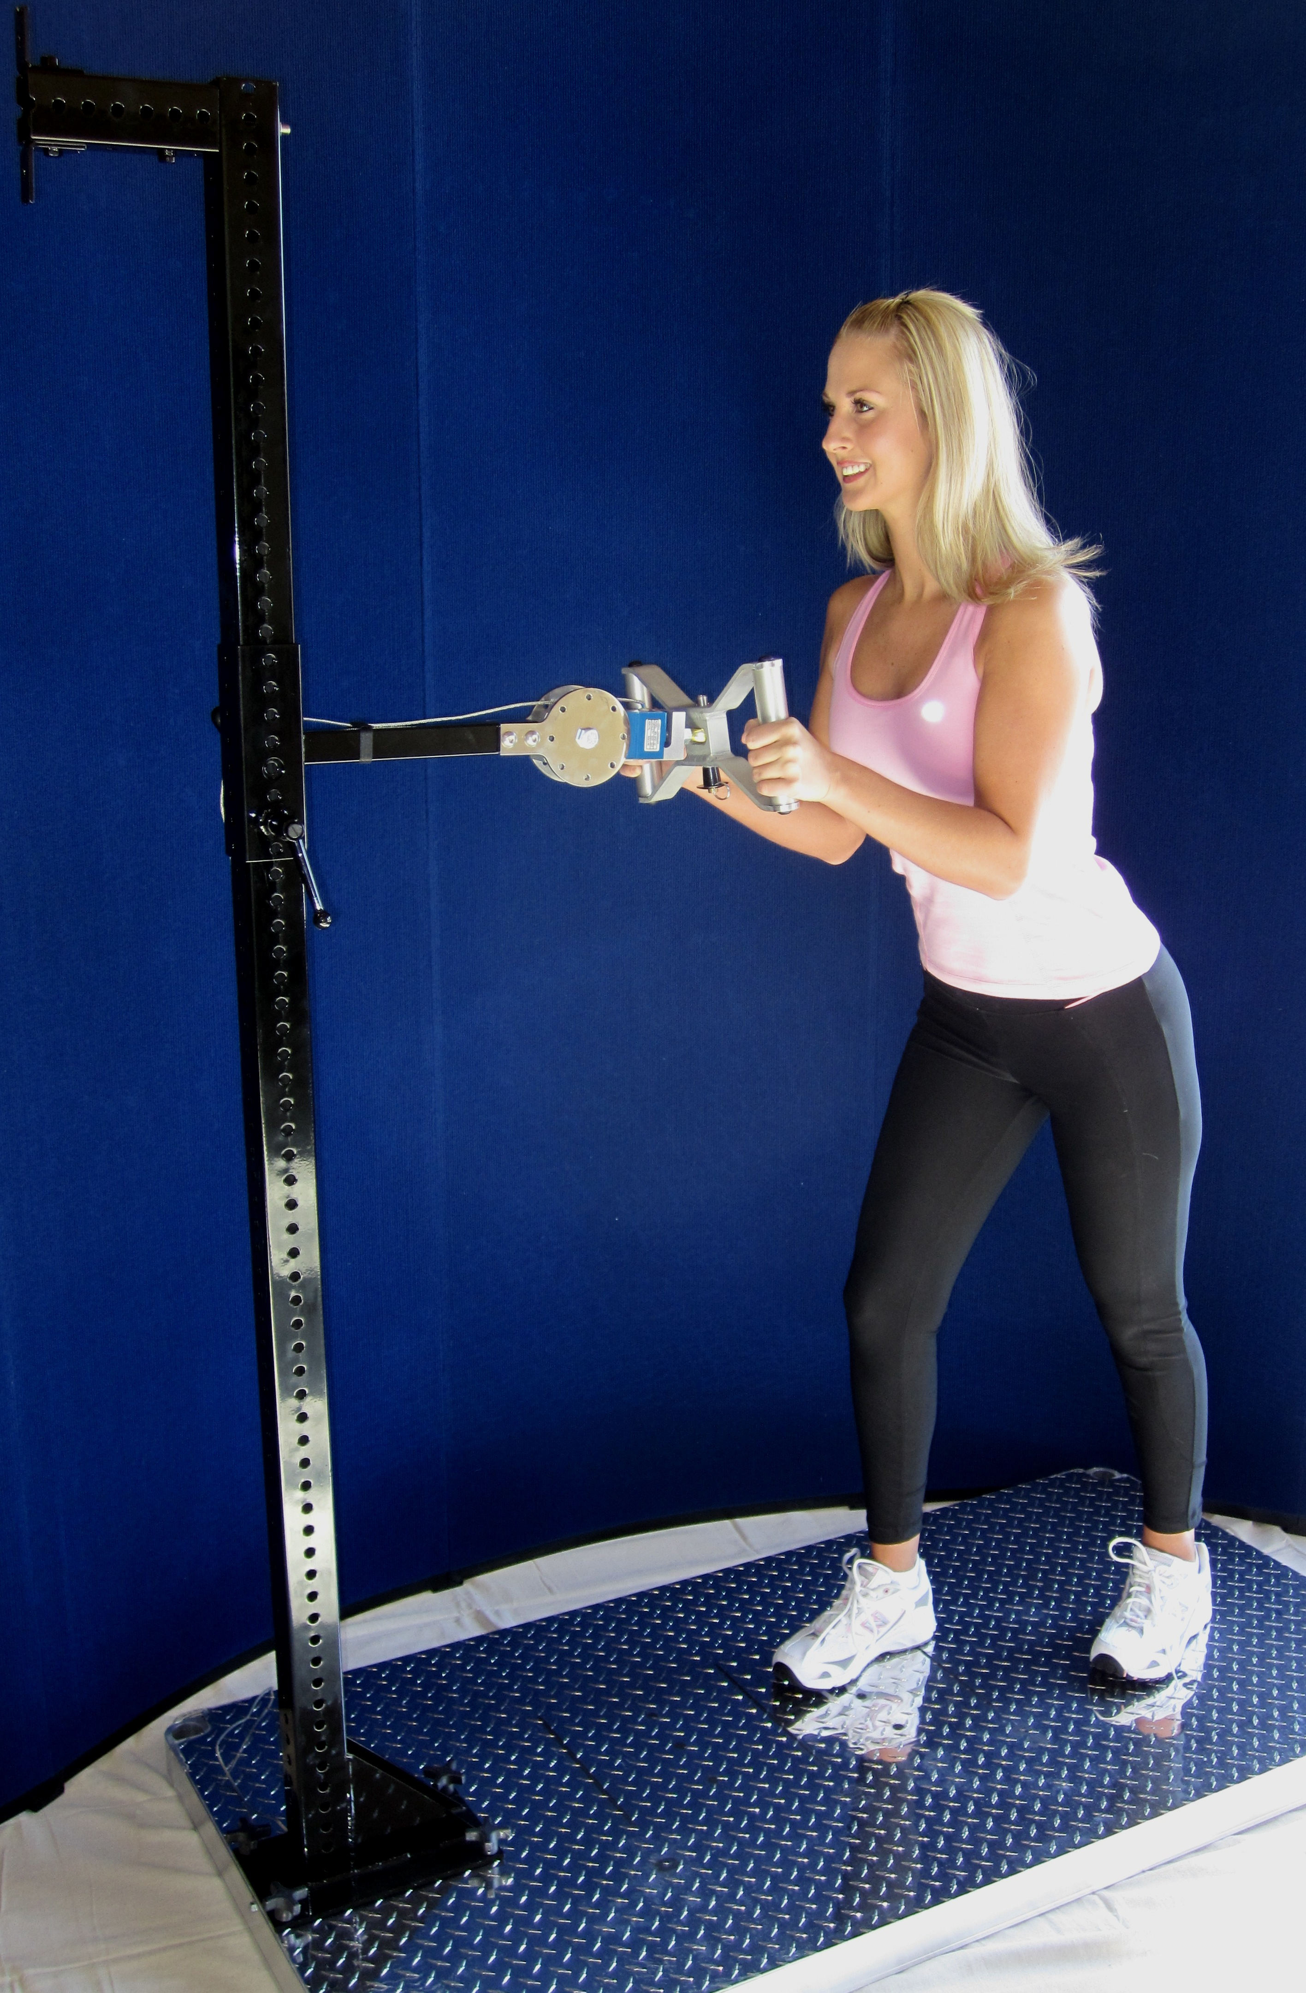
Isometric Lift | Dynamic Lift | Arcon FCE System
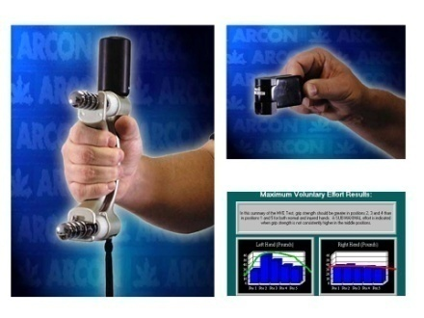 | 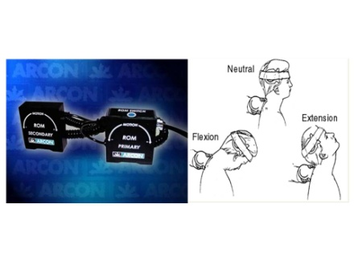 | 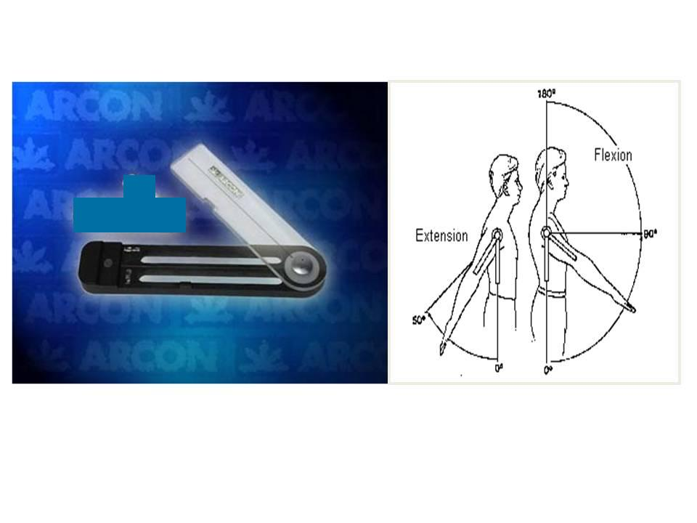
Isometric Grip & Pinch | Dual Range of Motion | Goniometry
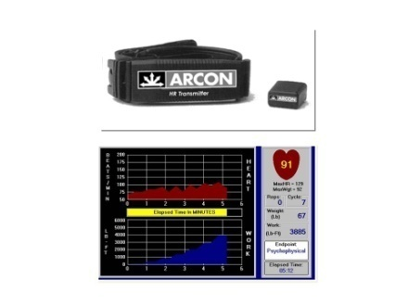 | 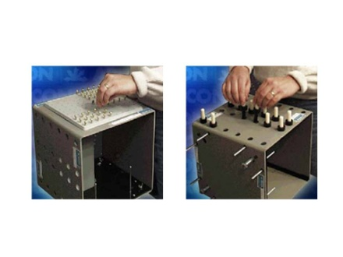 | 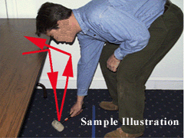
Wireless Heart Rate | Hand and Finger Dexterity | MTM Protocols
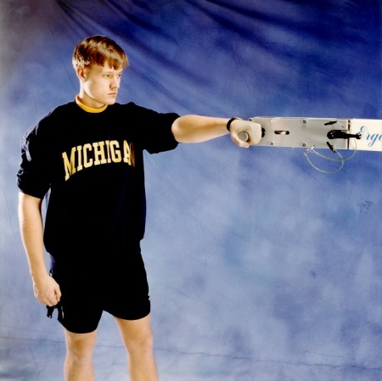
Isometric Torque Attachment
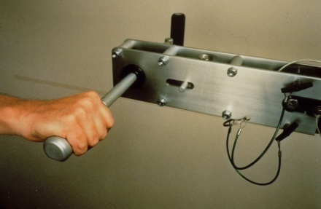 | 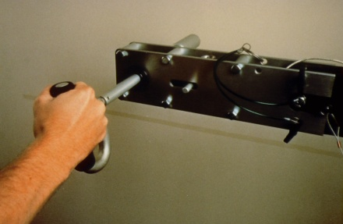 | 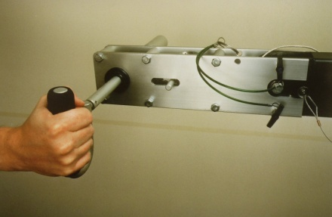
Isometric Flexion/Extension | Isometric Pronation/Supination | Isometric Radial/Ulnar
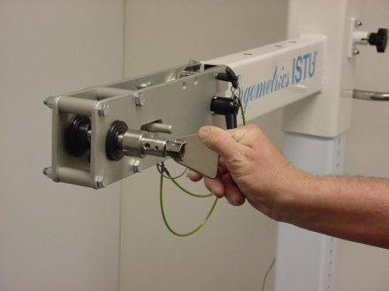 | 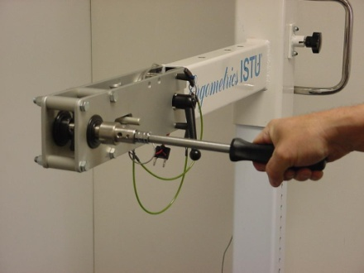 | 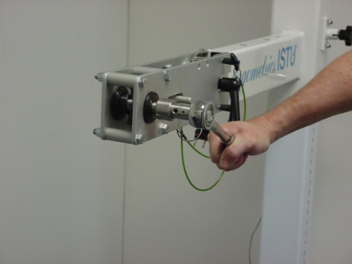
Isometric Key | Isometric Screw Driver | Isometric Ratchet Wrench
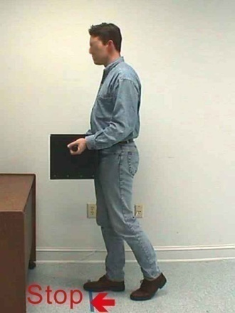 | 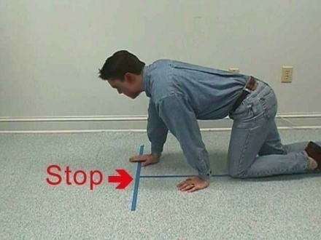 | 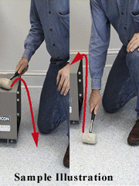
MTM Carry | MTM Crawl | MTM Kneel

 | Sample report summary (full report with graphs will typically run about 30 pages)
 |  | Your Evaluation Center  Your Street, Your City, ST  Phone: 123-456-7890 FAX: 123-456-9870 | FUNCTIONAL  CAPACITY  EVALUATION

Ms. Edna Benoiter
Hastings Insurance Co.
100 American Way
New York, NY 10000

RE: Product Brochure (12345678)

PURPOSE OF ASSESSMENT
Mr. Patient has completed a course of physical therapy for Lumbar Sprain/Strain sustained in an accident at work. Treating physician seeks to determine if he currently meets the essential physical demands of his own job, or to determine appropriate restrictions or modifications that would permit Mr. Patient to return to work on a full-time basis.

RELIABILITY AND CONSISTENCY OF EFFORT
The results of this evaluation suggest that Mr. Patient gave a reliable effort, with 68 of 70 consistency measures within expected limits.

FUNCTIONAL ABILITIES
Mr. Patient's demonstrated abilities meet specified job demands in the following categories: Walk, Carry - 11 Lb, Carry - 21 Lb, Carry - 51 Lb, Push Cart - 41 Lb, Pull Cart - 41 Lb, Balance, Stoop, Crouch, Kneel, Climb Stairs, Reach to Front, Reach Side/Across, Reach with Weight, Handling, Bi-Manual Handling, Fingering, Bi-Manual Fingering, Feeling, Eye-Hand-Foot, Tool Use, Stand/Sit, Sitting, Standing.

FUNCTIONAL LIMITATIONS
Mr. Patient is unable to meet job demands in the following categories: Mid Lift, Low Lift, Full Lift.

CONCLUSIONS
Mr. Patient can return to work with a temporary modification of duties. He is limited to the medium lifting category (less than 50 lb) until a re-evaluation can be performed in six weeks.

Sincerely,

Peter Starr, PT

Functional Abilities Summary
Mr. Patient’s demonstrated abilities in this evaluation (FCE) are summarized below. A value of n/a indicates the activity was not included in the evaluation. If job demands were provided with this evaluation, functional abilities are compared to the corresponding job demand level. FCE performance below job demand is shown as a Yes in the deficit column, while mixed performance (both above and below the job demand level) is shown as ? indicating a possible deficit.

Activities Rated by Strength Level
Activity | FCE Performance  (PDC Category) | Equivalent Strength Level |  |  |  |  |  | Job Demand  (PDC Category) | Deficit
Activity | FCE Performance  (PDC Category) | Occasional  0 to 2.6 hours/day |  |  | Frequent  2.7 to 5.3 hours/day |  | Constant  5.4 to 8 hours/day | Job Demand  (PDC Category) | Deficit
Low Lift (floor to knuckle) | Medium | 21 - 50 lb |  |  | 11 - 25 lb |  | 1 - 10 lb | Very Heavy | Yes
Mid Lift (knuckle to shoulder) | Medium | 21 - 50 lb |  |  | 11 - 25 lb |  | 1 - 10 lb | Very Heavy | Yes
High Lift (shoulder and above) | n/a
Full Lift (floor to shoulder) | Medium | 21 - 50 lb |  |  | 11 - 25 lb |  | 1 - 10 lb | Very Heavy | Yes
Carry | Very Heavy | over 100 lb |  |  | over 50 lb |  | over 20 lb | Heavy | No
Push (static) | Heavy | 51 - 100 lb |  |  | 26 - 50 lb |  | 11 - 20 lb | Medium | No
Pull (static) | Medium | 21 - 50 lb |  |  | 11 - 25 lb |  | 1 - 10 lb | Medium | No
Overall Strength Category | n/a
Activities Rated by Frequency and Duration
Activity | FCE Performance |  |  |  |  |  |  | Job Demand | Deficit
Walk | Constant |  |  |  |  |  |  | Constant | No
Climb Stairs | Constant |  |  |  |  |  |  | Occasional | No
Balance | Constant |  |  |  |  |  |  | Frequent | No
Stoop | Frequent |  |  |  |  |  |  | Occasional | No
Kneel | Constant |  |  |  |  |  |  | Occasional | No
Crouch | Frequent |  |  |  |  |  |  | Occasional | No
Crawl | Constant |  |  |  |  |  |  | Not Required | No
Reach (front) | Left: Constant |  |  | Right: Constant |  |  |  | Frequent | No
Reach (side) | Left: Constant |  |  | Right: Constant |  |  |  | Frequent | No
Handling | Left: Constant |  | Right: Constant |  |  | Both: Constant |  | Frequent | No
Fingering | Left: Constant |  | Right: Constant |  |  | Both: Constant |  | Frequent | No
Feeling | Constant |  |  |  |  |  |  | Frequent | No
Eye-hand-foot | Constant |  |  |  |  |  |  | Frequent | No
Sitting | Frequent |  |  |  |  |  |  | Frequent | No
Standing | Frequent |  |  |  |  |  |  | Frequent | No
Push Cart | Constant |  |  |  |  |  |  | Frequent | No
Pull Cart | Frequent |  |  |  |  |  |  | Occasional | No
Other Activities
Grip/Grasping Strength (Dynamometer Position 2) | Left: 83.8 lb |  |  | Right: 94.8 lb |  |  |  |  | low
Cardiovascular Fitness | Above average

