STRATEGIC PLANNING GUIDE

Strategic planning involves creating a vision, with supporting goals that can be regularly measured and adjusted as needed. Use this guide and the accompanying worksheet as a starting point for developing your strategic plan. The guide is designed for Rotary clubs but can be adapted for districts. Complete the worksheet on your own or with other club members. Facilitators should become familiar with these resources and prepare an agenda before conducting a strategic planning meeting. The agenda should allot the majority of time to the second and third steps of the process, which focus on the future, and less time to the current state of the club.

During the strategic planning process, keep the following tips in mind:
• Involve past, current, and incoming club leaders.
• Include a wide variety of perspectives by involving the full club or a diverse representation of your club’s membership.
• Consider all ideas.
• Ask an unbiased facilitator or a small group of facilitators to run strategic planning meetings.
• Reflect on how your club’s goals align with those of your district and the priorities and goals of Rotary's Strategic Plan.
• Be prepared to revisit your plan each year and adjust your strategic priorities and annual goals as needed.
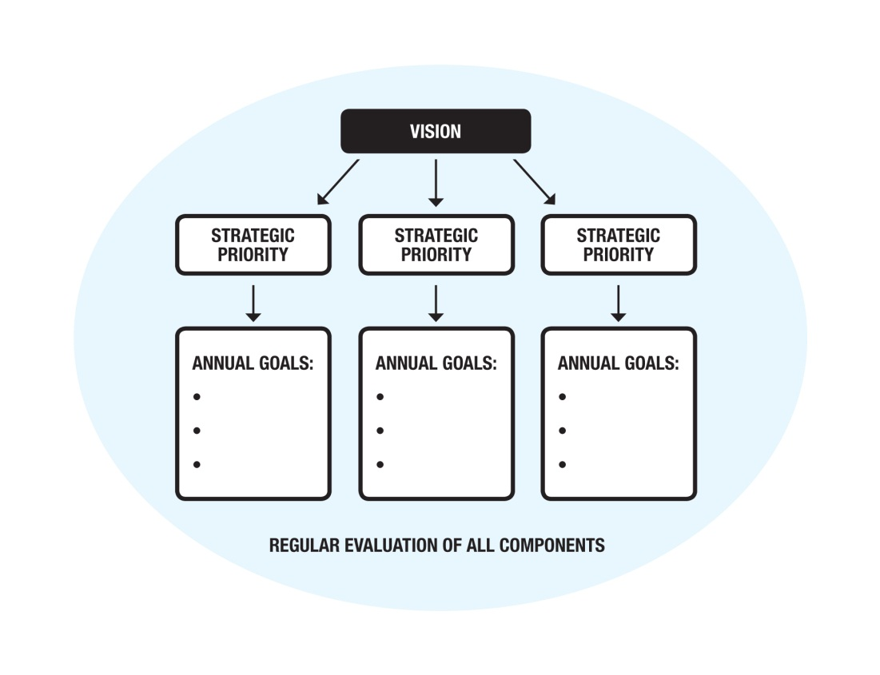
October 2014
The Strategic Planning Model
Create a vision for your club, with strategic priorities that will help you achieve it. Then develop annual goals that support each strategic priority.
Process

Develop a strategic plan by engaging members in the process below. Use the accompanying worksheet to record your ideas.
1. Where are we now?
• Create a list of your club’s strengths and weaknesses as of today.
• Create a list of opportunities and challenges facing your community.
When assessing your club’s current state, consult your region’s version of Be a Vibrant Club to determine what your club is already doing well and what you could do to rejuvenate it.
2. Where do we want to be?
• Create a list of 5 to 10 characteristics that you would like to see in your club three to five years from now.
• Draft a one-sentence vision statement describing your club and what you want it to be in three to five years. Allow for both individual and group work on this step.
• Finalize the vision statement with the full group, and make sure that all club members support it.
3. How do we get there?
• Develop strategic priorities that will help your club achieve the vision, considering:
– Strengths and weaknesses of the club
- Programs and missions of Rotary International and The Rotary Foundation
- External environment

– Involvement of all members
– Achievability in three to five years
• As a group, decide on the most important strategic priorities — those that will have the greatest impact as your club works toward the vision.
• Identify annual goals that support each of the top strategic priorities.
• Determine the timeline, resources, and people necessary to meet the annual goals under each of the strategic priorities.
Use Rotary Club Central to set annual goals and track achievements.
4. How are we doing?
• Create a strategic planning team to regularly monitor progress and recommend revisions to the plan, if needed.
• Allocate sufficient resources for the plan’s implementation.
• Continually evaluate all decisions to make sure they support the plan, providing feedback to the strategic planning team on their implementation.
• Review your strategic plan annually with all club members, including the vision statement, strategic priorities, and annual goals, and revise it as needed.
• Repeat the full strategic planning process every three to five years to create a new plan or uphold the current one.
Strategic Planning Worksheet
Complete this worksheet to create your strategic plan.
1. Where are we now? Today’s date: _____________
Club strengths | Club weaknesses
Opportunities for the community (e.g., new businesses, growing population) | Challenges facing the community (e.g., economic decline, competing services)
Club strengths Club weaknesses
2. Where do we want to be? Target date: ______________
Key characteristics of future state (e.g., number of members, retention percentage, balance between local and international projects, support of The Rotary Foundation)

Vision statement (Include something that will make your club stand out from other service clubs in your community — e.g., Our vision is to be the most internationally diverse service club in our community, Our vision is to be the service club most supportive of youth in our community.)

3. How do we get there?
To reach our vision, we must achieve the following goals. (On the lines below, write out each of your strategic priorities. Then, in the chart beneath each one, list annual goals that will help you achieve each of them. Though there is no limit to the number of strategic priorities or annual goals in your strategic plan, consider the resources available to you, and focus on goals that you can accomplish.)
Strategic priority 1:
Annual goals | Timeline | Resources needed | Member assigned
Strategic priority 2:
Annual goals | Timeline | Resources needed | Member assigned
Strategic priority 3:
Annual goals | Timeline | Resources needed | Member assigned
4. How are we doing?
To monitor our progress, we will take these steps. (List the actions the club will take to follow up on the plan’s implementation, including a timeline for checking in and evaluating your progress — e.g., reports at board meetings each month, strategic plan reviews at club assemblies, annual reviews.)

