 | A BROWN UNIVERSITY CASE STUDY Spring 20056

Citigroup

Our growth over the years has been extraordinary. Despite this empirical record, we are sometimes asked: Can you still grow? Are you too big to grow? Are you dependent on “big deals” for too much of your growth?

- Chuck Prince, CEO and Bob Willumstad, CFO
in 2003 Annual Report

Beth Markle put down the phone, and quickly jolted down several talking points on her legal pad for the next meeting. She had just spoken with the manager of a new Citibank retail branch in Brooklyn. As Citibank N.A.’s Director of Product and Marketing, Markle is responsible for deciding whether or not Citibank retail branches nationwide would begin offering free checking to all customers. Admiring the view of Lower Manhattan skyline from her office on the 37th floor of Citigroup Tower, she wondered what the banking landscape would look like 10 years from now.

As more and more financial institutions began to offer free checking, Citigroup – the most profitable company in the world in 2003 – felt more and more pressure to make a decision. Markle had mixed feelings about free checking. On one hand, it would attract more customers, but on the other hand, it could hurt Citibank’s brand. “We do not want to just ‘follow the herd’. We want to make our own decision based on what is right for us,” Markle said, “However, it is time to make a decision.”

Citigroup

In 2004, Citigroup was the largest U.S. bank holding company and a leading global financial services firm. Headquartered in New York, it had a presence in more than 100 countries across six continents, where its 275,000 employees managed 200 million customer accounts. Its services included credit cards, consumer finance, retail banking, corporate and investment banking, retail brokerage, life insurance and investment management. Major brand names under Citigroup’s trademark red umbrella included Citibank, CitiFinancial, Primerica, Smith Barney, Banamex, and Travelers Life and Annuity (see Exhibit 1).

Founded in 1812 with $2 million authorized capital and $800,000 paid-in capital, the City Bank of New York opened for business to serve a group of New York merchants. Over the next century, the bank continued to expand and diversify its product line and services, serving businesses as well as individuals. By 1929, it became the largest commercial bank in the world with over $1 billion in assets, with offices in Asia, Europe and India. In 1976, the bank changed its name to Citibank, N.A. (National Association), following its parent holding company’s change to Citicorp two years ago to “better suit its global business”.

Major Events

Citicorp-Travelers Merger

On October 8, 1996, Citicorp and the Travelers Group completed their $70 billion merger to form Citigroup, Inc. Citicorp was then the 2nd largest commercial bank and Travelers Group a leading global insurance and investment banking firm. Such alliance between a commercial bank and an insurance company or an investment bank was previously illegal to prevent a conflict of interests. The Citicorp-Travelers merger thus represented a new era of horizontal expansion. As an equal merger, the CEOs of the two companies - Sanford (Sandy) Weill of Citicorp and John Reed of Travelers - became co-CEOs. However, the configuration did not work out, and Reed resigned in February 2002.

Expansions and Acquisitions after the Merger

Under the leadership of Weill, Citigroup’s acquisition spree began. In the first couple years, its drive for “a relentless focus on growth, aiming to increase earnings by double digits on average” was fulfilled by acquiring or becoming the major stakeholder in over a dozen international banks and brokerages, including Nikko Beans, a Japanese online brokerage firm, Bank Handlowy w Warszawie SA, a leading corporate bank in Poland, Mexico's "Banacci" (Grupo Financiero Banamex-Accival) and the majority of Diner’s Club Europe.

It had three major acquisitions in the U.S. In July 2001, Citigroup acquired the full-service commercial bank European American Bank, adding 97 branches in the New York Area. Four months later, it acquired Golden State Bancorp, the parent company of First Nationwide Mortgage and Cal Fed, adding 352 branches and approximately 1.5 million new customers in key California and Nevada markets. Exhibit 2 shows the new market share and distribution in those areas. At the May 29th, 2003 Investor Presentation, Bob Willumstad, President of Global Consumer Group, announced the company’s intentions to expand distribution by market share, geography and the Hispanic market. In January, 2004, it announced the acquisition of Washington Mutual Finance.

California Free Checking Trial

As a result of the acquisition of Golden State Bancorp, all Citibank branches in California began offering free checking. The decision was made because there was “no choice”, according to Markle. California customers were used to free checking, and it would be impossible for Citibank to compete if they did not offer a comparable package. No affects were observed on Citibank branches that switched to free checking, and customers were reported to not notice a difference.

Enron Litigation

In 2002, former Salmon Smith Barney was under investigation for involvement in the Enron corporate fraud trial. On April 28, 2003, Citigroup announced that Citigroup Global Markets, Inc. (formerly Salomon Smith Barney) had reached an agreement with the New York Attorney General and regulators to resolve outstanding investigations into research, IPO allocation, and distribution practices. On July 28, 2003, it agreed to pay over $130 million in fines to the Securities and Exchange Commission and the New York State. As part of the agreement, Weill would not be charged and Citigroup was not liable for any wrongdoings, however, it had issued statements of regret to customers and investors.

New Leadership

On October 1, 2003, Charles O. (“Chuck”) Prince succeeded Weill as Chief Executive Officer of Citigroup, and Robert B. Willumstad, President, added Chief Operating Officer to his role. Mr. Weill would remain Chairman of the Board until the 2006 annual shareholders meeting.

Citibank Consumer Retail Banking

Retail banking was the 2nd biggest grossing product line in the Citigroup family, just after its world leading credit card business. It had a net income of $4.2 billion in 2003 (see Exhibit 3). Citigroup’s retail banking offered banking, lending, insurance and investment services to individual consumers around the world. It had 3,100 retail bank branches, 9,800 ATMS, online services as well as a network of Priamerica independent agents worldwide.

Citigroup’s retail banking boasted many successful innovations; in the early 1920s, it was the first national bank to offer services to consumers; in 1961, it created the Certificate of Deposit and in the late 1970s it widely deployed and popularized the use of 24-hour ATMS in the U.S.

However, it took them over a decade to launch a fully integrated Internet service. Citigroup’s size had created a hurdle for integration of its many financial services onto one single Web portal. As other national and regional banks began to offer the technology to consumers, Citigroup was still trying to create a “new standard”. It launched the award-winning CitiDirect in late 2000. However, it is estimated that fewer of its consumers actually conduct transactions online than Bank of America and Wells Fargo.

Markle joined the managerial associate program after graduating from business
school in 2000. At the end of the comprehensive training program, she chose to work in the Marketing Division of Citibank. As the Director of Product and Marketing, Markle’s marketing team is responsible for working out the overall marketing strategy nationwide, in key markets and by market segment. Some major concerns in her job included the acquisition and retention of customers.

“Citi, Live Richly” campaign

Citigroup gave the impression of an elite bank. Its average borrower in North America belonged to the “Middle America” - 47 years old with an income of $43,000 to $57,000 a year, married with a house and 14 years of schooling.

To leverage upon its brand and international presence, and to emphasize itself as a one-stop financial service provider, in mid-2003, Citigroup ran a series of advertisements with a tag line of “Citi, Live Richly”. Gracing bus stops and billboards, the posters all had a uniform simple design and carried messages emphasizing quality time with your family and yourself. The large posters had a white background, a distinct red arch over the royal blue “Citi, live richly” letters. The visible campaign drew attention to Citigroup’s new focus on promoting the idea of asset management to mass consumers as well as young, urban consumers (See Exhibit 4 for Citibank’s advertisements).

Retail Banking Fundamentals

Retail banks provided services to a diverse clientele with a vast range of needs in the business of retail banking. When retail bank personnel reviewed customers, they looked at the prospect of gaining revenue, the actual cost to serve a customer, and finally profitability. Numerous different variables were taken into account when determining how profitable a customer would be. A customer would be more profitable to a bank if the customer kept a higher balance in the account. Similarly, one who performed most of his transactions online, and thus eliminated the paper and bank employee aspect of a transaction, would be more profitable to a bank.

Revenue

In its most basic form, one of the two components that retail banks viewed when assessing their business was the revenue that could be gained from a customer. Customers generated revenue for the bank in three basic ways: loan interest, fee income, and investment income resulting from deposit balances. Loan interest generated the most revenue for retail banks. Therefore, banks were very conscious of how this area affected the overall picture. Fees were generally levied for checking accounts, late payments, and overdrafts.

Cost to provide services

On the contrary, customers also cost retail banks money. The second component was the total cost of services. Similarly, there were three general costs that a bank must incur while providing services to customers: interest on savings accounts and certificates of deposit, transactions, and fixed costs. Each time a transaction occurs, a bank must pay a fee. As mentioned earlier, online transactions are less costly than teller transactions. Exhibit 5 shows that the average cost per transaction for a “Full Service Branch” is valued at $1.07 while an internet transaction only costs $0.01. The art of successful retail banking, as with any business, became maximizing the profits gained and minimizing the cost of providing services to a customer.

Major Competitors

Citibank must be concerned with the actions of its competitors during its decision-making process. Exhibit 6 shows the distribution of Deposit Market Share in the retail banking industry. Citigroup Inc. was ranked fifth in terms of total deposits. The top three banks on the list (Bank of America Corporation, Wells Fargo & Company, and Wachovia Corporation) offered free checking. Exhibit 7 shows free checking account comparisons. It is crucial for Citibank to take into account the currents trends of other leading banks before making any major decisions.

Bank of America Corporation

Bank of America was the both the largest retail bank in terms of offices and had the highest percentage of market share in terms of total deposits. It was headquartered out of North Carolina. One of Bank of America’s major initiatives was community development, in which they strove to “serve low- and moderate-income individuals and families, improve underserved low- and moderate-income communities, and create sustainable practices for the long haul.” Bank of America merged with FleetBoston Financial Corporation in early 2004, which was the eighth-largest bank in terms of deposit market share. After the merger, Bank of America had “nearly 5,700 branches in nearly 29 states and the District of Columbia.”

Wells Fargo & Company

Wells Fargo was headquartered in California and possessed the second-highest market share of total deposits. Their vision, as stated by Chairman and CEO Richard M. Kovacevich was to “satisfy all our customers' financial needs, help them succeed financially, and become known as one of America's great companies and the number one financial services provider in each of our markets” Wells Fargo prided themselves on their humble beginnings 150 years ago when they opened banks in California that served the western frontier of the United States. They have erected Wells Fargo museums in many cities around the country to build brand awareness.

Wachovia Corporation

Wachovia, which was based out of North Carolina, was the third-largest bank in terms of market share. In 2001, Wachovia merged with First Union, gaining significant market share. Wachovia put trust in high esteem. Part of Wachovia’s company information included the statement, “Strong relationships are built on trust, and trusting a company means knowing it well.” Wachovia also sponsored the Wachovia Championship, a PGA tour event played annually in North Carolina in May. These efforts helped to build community relations and embrace company culture.

The Present State of Retail Banking

Retail banking was at a current state that many competitive industries eventually reach. Competitive market share was divided among approximately 14 retail banks. Partly due to the lack of availability of market share, major barriers of entry were present for start-up banks. Thus, the current trend was that smaller banks were purchased by larger ones, and in turn, larger banks merged to maximize market share. This was evident by the 2004 merger of Bank of America and FleetBoston Financial Corporation and the 2001 Merger of Wells Fargo & Company and First Union. Both of these mergers helped the two newly-formed companies to remain as major players in the retail banking industry. Because of this structure, banks competed for any amount of market share, even very minute percentages. The only way for banks to increase their market share exponentially was to consolidate.

Free Checking

There existed several options for Citibank to obtain a larger market share in the newly consolidated banking industry. These options included acquisitions, increasing and improving branches, and offering free checking. Once a distant memory, many financial institutions had reinstituted free checking accounts. Fifth Third Bank experienced 17 percent growth in account balances after becoming one of the first U.S. banks to reintroduce free checking. Since then, nearly all national banks had followed suit, offering a similar product. In 2003, Free Checking accounts were offered at 35 percent of all US financial institutions (See Exhibit 8).

Financial Institutions often marketed all checking accounts with no monthly fee as “Free Checking.” However some of these accounts did not adhere to the legal definition set forth in the Truth in Savings Act of 1993. This act stated that “free accounts” cannot require an average minimum balance, charge a monthly maintenance fee or incur per-item transaction fees. Additionally, under regulatory guidelines, banks cannot require direct deposit and still market accounts as free.16

Negatives

There were several factors associated with free checking that needed to be considered. The first and largest factor of Citigroup was brand erosion. Citibank had always been a price leader, offering a premium product and foregoing market share. By switching to free checking, a new type of customer with less money to deposit would be attracted. Markle was unsure if this type of customer would be more transient and jump from bank to bank in order to avoid fees. Since retention rates varied greatly in the industry the California trial was not a clear indicator of retention for Citigroup. While the current attrition rate for Citibank checking accounts ranged from 20%-50% on average, it was unknown how free checking would affect this rate on a national level.

The perceived value of a free product was also a concern. Markle believed strongly that customers would feel that they were getting a premium service when they pay monthly fees. With free checking, people may be less trustworthy of the quality of service that they will receive. The final concern Markle faced was the lost fees from a free checking account. In 2003 Citibank was making an average of approximately $100 in customer net revenue on checking accounts (See Exhibit 9 for existing Citibank checking accounts).

Positives

On the other hand, free checking had already become a commodity in the banking industry. Almost all major banks were already using it in some form, and it was almost expected from the customer. Because of the consolidations in the industry, it had become increasingly difficult to gain market share. The industry standard was to offer free checking, and customers had become aware of which banks were offering this product.

As far as retaining newly attracted customers, various requirements could be tied to the checking accounts in order to increase the rate. For example, many banks offered free checking only with a direct deposit requirement. Because direct deposit took time and effort to set up, people were less likely to switch banks. Citibank also offered other free services such as online banking and financial needs analysis which helped retain customers. However, Markle was concerned that these perks would not have a strong enough effect to increase retention to the necessary rate.

Cross selling products was a major selling point for free checking. While fees might be lost and low-income customers attracted, these two negatives might only be short term. As a person goes through one’s life cycle, financial situations would change. Citigroup wanted to capture all customers and recognized that a person with little money could eventually be earning and saving a substantial amount. One would then turn to one’s bank for other services such as investing, mortgages, and loans. In the end lost fees could be made up by customer spending, and thus it would be most important to first obtain the customer regardless of financial situation.

Other Alternatives

Few alternatives existed for banks to attract new customers. Aside from free checking, the other main focus was on customer experience in branches. According to the Council on Financial Competition, the majority of institutions consider the branch to be a banks primary distribution center.
Acquisitions

The obvious solution to growth would be acquiring or merging with other banks in order to increase market share. This strategy had been extremely important for Citibank’s growth in the past. Today, most regional banks have become acquired by national financial institutions resulting in a highly consolidated market containing about 14 major players. This consolidation makes acquisitions increasingly difficult.
Role of Branches

At many banks the role of the branch is shifting from a transaction center to a sales and advice center. This strategy targeted a more affluent customer who will benefit from this service. For example, in Europe banks were investing in portfolio management tools, analytics, and financial planning software for branches.
Innovative Branch Design

Another strategy was to redesign the branch in order to increase customer experience. Washington Mutual was implementing a new branch strategy in which branches were designed more like a retail store than a typical bank. A concierge greeted customers and directed them to a service representative or sales associate who roamed the store with remote headsets and handheld computers. Another financial institution, Commerce Bank, intentionally maintained the image of a community bank with inviting structures to attract customers. Passers by could see employees at work through ceiling-to-floor clear glass windows. Other innovations included online kiosks and handheld computer technology.
Where to Go From Here?

Beth Markle had a difficult decision to make. Citibank witnessed higher incidence of customer defections and decreasing growth of new deposits in 2003 (See Exhibit 10 for Citibank Income Statements). Unlike most of its competitors Citibank had yet to switch to free checking on a national basis, rather was offering Free Transactional Banking only in California markets. Given the competitive environment and decreasing growth rate in deposit accounts, a decision needed to be made whether or not to roll out with Free Transactional Checking or find an alternative to increase growth. Brand erosion weighed heavily on Markle’s mind as she sat pensively staring out her window. In addition, she did not want Citibank to lose any credibility as an innovator and leader in the retail banking industry. She walked over to her table and poured herself a cup of coffee for the long night ahead.

Exhibit 1 Citigroup Organizational Hierarchy


 |  |  |  | 
Source: http://www.citigroup.com/citigroup/business/index.htm

Exhibit 2 Market Share Distribution by Region

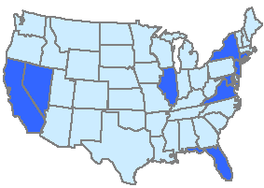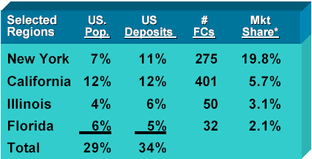
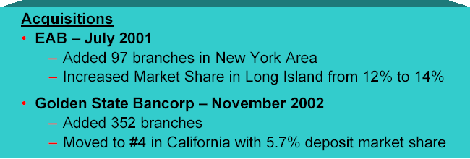

Source: Global Consumer Group Investor Presentation, May 29, 2003. http://www.citigroup.com/citigroup/fin/data/p030529a.pdf (pg 107)

Exhibit 3: Citibank Income Breakdown
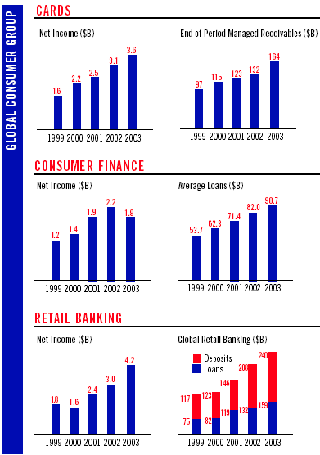
Source: Citigroup 2003 Annual Report
http://www.citigroup.com/citigroup/fin/data/ar031c_en.pdf

Exhibit 4: Sample Advertisement from “Citi, Live Richly” campaign

Source: Advertising Showcase, Live richly
http://www.citigroup.com/citigroup/showcase/liverichly.htm

Exhibit 5: Estimated banking transaction costs (in U.S. $)

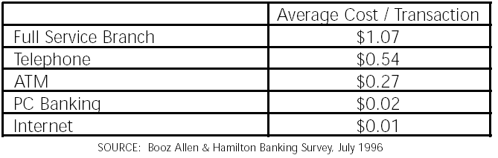

Exhibit 6: Deposit Market Share

Institution Name | Headquartered | No. of Offices | Total Deposits | Market Share | Rank
 |  |  | 30-Jun-03
Bank Of America Corporation | North Carolina | 4,296 | 388,967,728 | 7.5% | 1
Wells Fargo & Company | California | 3,017 | 227,791,026 | 4.4% | 2
Wachovia Corporation | North Carolina | 2,667 | 196,835,773 | 3.8% | 3
J.P. Morgan Chase & Co. | New York | 608 | 196,301,904 | 3.8% | 4
Citigroup Inc. | New York | 814 | 184,248,727 | 3.6% | 5
Bank One Corporation | Illinois | 1,821 | 156,879,273 | 3.0% | 6
U.S. Bancorp | Minnesota | 2,305 | 125,141,603 | 2.4% | 7
Fleet Boston Financial Corporation | Massachusetts | 1,534 | 124,529,519 | 2.4% | 8
Washington Mutual Bank, Fa | California | 1,626 | 134,608,420 | 2.6% | 9
Suntrust Banks, Inc. | Georgia | 1,223 | 74,473,905 | 1.4% | 10
National City Corporation | Ohio | 1,213 | 63,870,131 | 1.2% | 11
Merrill Lynch Bank USA | Utah | 2 | 54,368,342 | 1.1% | 12
BB&T Corporation | North Carolina | 1,117 | 54,273,541 | 1.0% | 13
Royal Bank of Scotland Group PLC, The | Foreign * | 841 | 53,574,048 | 1.0% | 14
Fifth Third Bank Corp | Ohio | 985 | 53,418,270 | 1.0% | 15

Source: Citibank internal document

Exhibit 7: Financial Institutions that offer Free Checking 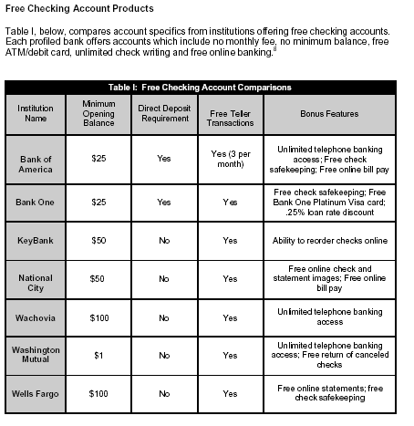
Source: Free Transactional Banking – November 2003, Corporate Executive Board

Exhibit 8: Industry Growth
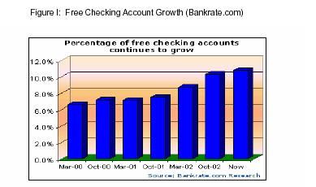
Source: Free Checking Account Growth, www.bankrate.com

Exhibit 9: Types of Accounts Citigroup Currently Offers (as of March, 2004)

 | Access Account (ATM/Debit card) | Citibank EZ Checking | Citibank Account | Everything Counts Account | Basic Checking Account
Minimum balance | No | $1500 across certain linked accounts (CD, checking, day-to-day, money market) | $6000 across linked accounts | $10000 or $20000 across linked accounts | No
Free checking | No | Yes if maintain minimum balance | Yes if maintain minimum balance | Yes if maintain minimum balance | No
Monthly fee | $3 | No if maintain minimum balance | No if maintain minimum balance | No if maintain minimum balance | Yes, vary by state
Free online banking, bill payment, statements, E-mail alerts | Yes | Yes | Yes | Yes | Yes
Other perks |  | Unlimited free checkwriting | Unlimited free checkwriting  Unlimited free use of non-Citibank ATMs | Unlimited free checkwriting  Unlimited free use of non-Citibank ATMs and more
Source: Checking-At-A-Glance, www.citigroup.com

Exhibit 10: Citibank Income Statements

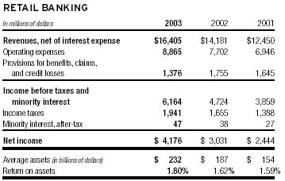

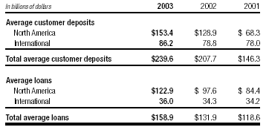

Source: Financial Statement 2003, www.citigroup.com/Citigroup/fin/data/ar032c.pdf

? Protagonist created
About Citigroup http://www.citigroup.com/citigroup/corporate/history/citibank.htm
illegal under the Glass-Steagall Act of 1933
Corporate Values http://www.citigroup.com/citigroup/corporate/values/index.htm
Global Consumer Group Investor Presentation, May 29, 2003. http://www.citigroup.com/citigroup/fin/data/p030529a.pdf (pg 28)
Ibid
Ibid (pg 107)
About Citigroup http://www.citigroup.com/citigroup/corporate/history/citibank.htm
Citigroup’s Product Lines http://www.citigroup.com/citigroup/about/productlines/retailbank.htm
Frei, Frances X. Economics of Retail Banking Note. President and Fellows of Harvard College, 2002.
Bank of America Community Relations, http://www.bankofamerica.com/community/index.cfm?template=cdb_comm_impact
Bank of America and Fleet merger, http://www.fleet.com/bankofamerica/index.asp
Wells Fargo Banking Vision, http://wellsfargo.com/invest_relations/vision_values/2
Wachovia Mission Statement, http://www.wachovia.com/inside/page/0,,132,00.html
“Free Transactional Banking”, the Council on Financial Competition Web site, http://www.councilonfinancialcompetition.com
1
Checking (Interest or Regular), Citicorp Investment Services Brokerage, Citibank credit cards, Loans & credit lines, Mortgages, Retirement accounts, Savings (CDs, Day-to-Day Savings, Money Market
$10000 minimum balance in checking (interest or regular) and savings (CDs, Day-to-Day Savings, Money Market) or $20000 minimum balance in a combination of deposit and non-deposit accounts including Credit Cards, Citicorp Investment Services Brokerage and Retirement accounts.

