Creating A Plan Itinerary
The travel allowance pane contains the Itinerary Information. An itinerary is used to provide travel details (travel departure and arrival locations, dates and times), which the system uses to calculate per diem allowances. The adding of an itinerary is step 2 in the process of creating an expense report. In the Add New Itinerary tab the New Itinerary Stop fields are displayed for the entry of the first stop. See screen shot below.

Travel Allowances:
Travel Allowances contains 3 tabs that are used in the calculation of per diem. See screen shot below
- Tab 1 is Create New Itinerary.
- Tab 2 is Available Itineraries which contains 2 tables. One listing assigned itineraries and one listing available itineraries.
- Tab 3 is Expenses & Adjustments which contains the fixed allowances.
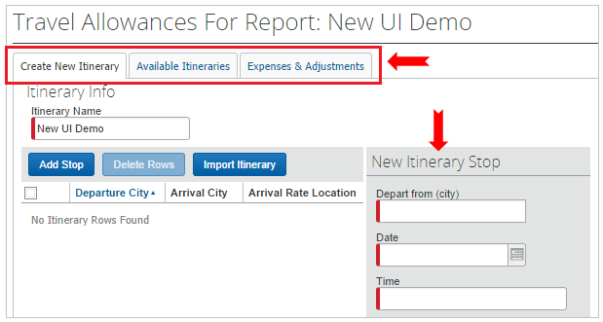
Per diem allowance amounts are determined by the location fields in the itineraries. For overnight travel it is the overnight stay location that determines the per diem for the day. On the last day of travel the previous night’s location determines the per diem. For one day travel the destination location determines the per diem rate.

Each itinerary must have at least two (2) stops. Travel that includes several destinations with overnight stays will have a stop for each overnight location. The itinerary is not a travel log and thus does not need to show every location visited. Just overnight stay locations require a stop.

Itineraries can be create prior to travel and then assigned to the expense report after travel is complete or itineraries can be created while creating a report or while working on an existing report:
- To create an itinerary during the process of creating a new report, follow the screens.
- To create an itinerary in an existing report in the Expense List in the Details menu select New Itinerary.
- To create an itinerary prior to travel: on the Report List in the Create & Edit menu select New Itinerary.

Two Data Entry Methods for Itineraries
There are two methods for entering travel details.
- Standard Itineraries page can be used for entering all travel including those that involve overnight stays.
- Single Day Itineraries page can be used for entering one-day travel. The simplified process is provided as an easy way to enter one-day travel.

By default the Standard Itineraries page open when a new report is created. The single day page can be selected as default in the Expense Preferences.

Creating an Itinerary from Flight Itinerary Icon
The Flight Itinerary created while booking airfare online can be used to create an itinerary in an Expense Report.
- In Travel Allowance window on the Create New Itinerary tab.
- Click the Import Itinerary button.
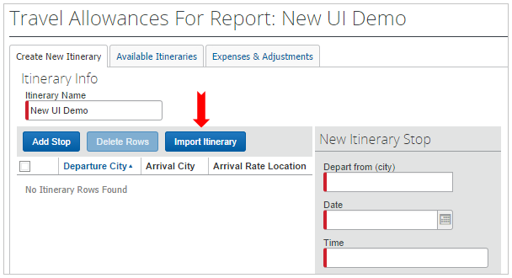
- Select the flight with the icon from list of trips and charges.

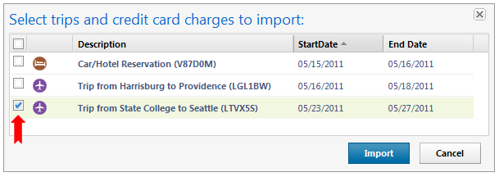

- Click Import.
- Itinerary will be created from the flight itinerary as seen on the flight icon. See screen shot below.
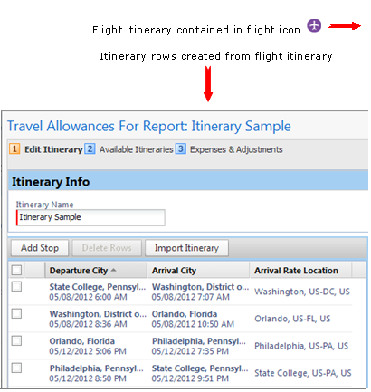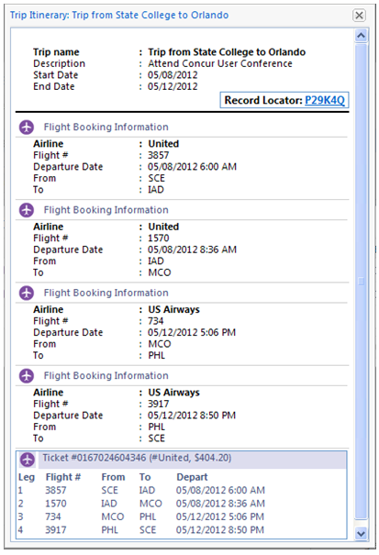

Create a Standard Itinerary
- The Itinerary Name will default to the report name. It may be edited.
- Begin stop 1 by completing the fields in the New Itinerary Stop section. Fields include departure location, date and time, and the arrival location, date and time, for the first day of travel. This information is used by ERS to determine per diem.
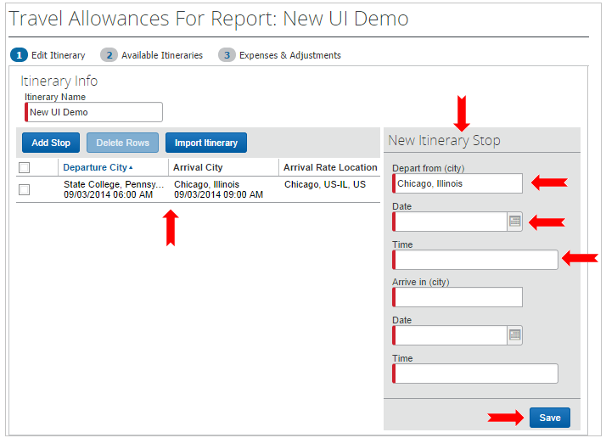
- Location field search is automatically started when the field is clicked. If the location is not in the most recently used list begin typing the location. The search will begin searching for the location.
- When all fields are complete for stop/row 1, click Save.
- Note that the stop/row 1 is listed on the left side of the screen. Complete the entries for the second stop/row in the New Itinerary Stop fields on the right. And click Save.
- Add as many stops/rows as needed for the travel; always clicking Save when the stop is complete. The New Itinerary Stop fields will continue to display on the right side of the screen. Each itinerary stop/row completed will display on the left side of the screen.
- When all needed stops/rows are complete, click Next. CAUTION: Do not click Next until all needed stops/rows have been saved and are listed in the itinerary on the left side of the pane.

Create a Single Day Itinerary
This data entry screen simplifies the process of entering one-day travel. In the Travel Allowance pane click the Go to Single Day Itineraries link to open the pane. The Single Day Itinerary pane allows the entry of one or more single day trips. This feature provides a shortcut for creating an itinerary for a one day trip to one destination. Any number of one day trips can be entered. After the one-day itinerary is created it is processed by the system and then displayed in the standard itinerary format on the Assigned Itineraries tab in Travel Allowances.

To add a Single Day Itinerary:
- In Travel Allowances pane, click the Go to Single Day Itineraries link.
- Select a Start Date for the first one day travel and click Go. See screen shot below.
- Enter all the details of the trip in the fields on the date of travel.
- Enter all the one day trips for the dates shown.
- Click Save Itineraries before selecting another set of dates.
- When all the single day itineraries have been entered click the Go to Standard Itinerary.
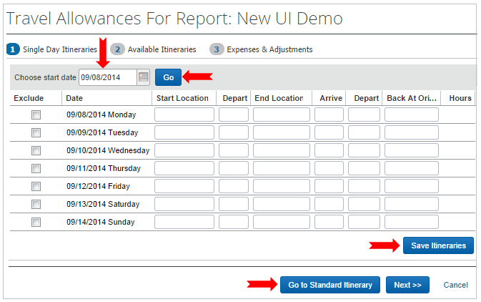
- Click Next.
- The Available Itinerary tab will display the Assigned Itineraries.

Available Itineraries Tab
The Available Itineraries window contains 2 tables. The Assigned Itineraries table displays the itinerary(ies) assigned to the report. The Available Itineraries table displays the Itinerary List of all itineraries that are not in paid reports. The list is filtered to the last 6 months. Other time frames can be selected.

Assigned Itineraries table
The newly created itinerary(ies) will display here. They can be edited if needed by clicking on a stop/row and then clicking the Edit button.

Available Itineraries table
This table contains all the itineraries that are not assigned to paid reports. Itineraries listed can be assigned to this report by selecting them and clicking the Assign button. Itineraries can be deleted from the list by selecting them and clicking the Delete button. If an itinerary is not displaying in the itinerary list use the Current Itineraries drop down to filter the list to display Itineraries for this Year. This will display all itineraries dated in the current year that are not assigned to paid reports. Current itineraries are those dated within the last 6 months.

Click Next to move to the Expenses & Adjustments tab for the per diem allowances, or click the Expenses and Adjustments tab at the top of the window.

Expenses & Adjustments (Per Diem)
The Expenses & Adjustments tab of the Travel Allowances pane will display the per diem allowance for each day of travel. The Allowance column displays the per diem allowance. See screen shot below. There is no display that shows which meals are included in the allowance. The per diem allowance contains the meal and incidental allowances. If the travel is OCONUS (outside the continental United States) it will also include the lodging allowance.
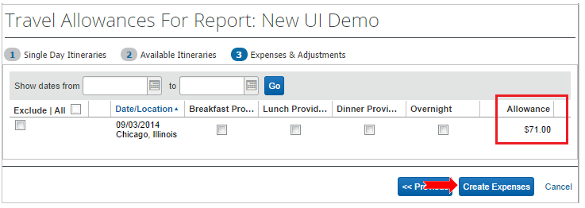
Save Per Diem Allowances into Report
To save the per diem allowances into the report click the Create Expenses link. See screen shot above.

Note: If you return and make changes to the allowances you click the Update Expenses button to save the changes into the report.

