Hamilton County Historical Society Newsletter
Fall 2010
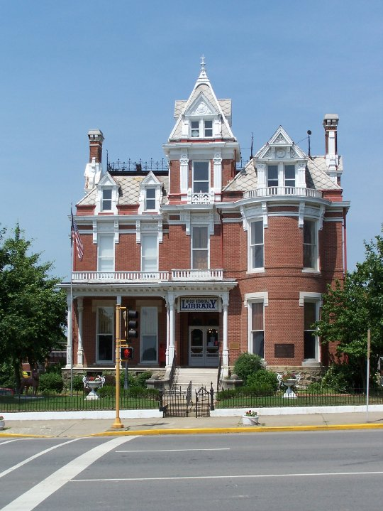

2010 PHOTO PROJECT
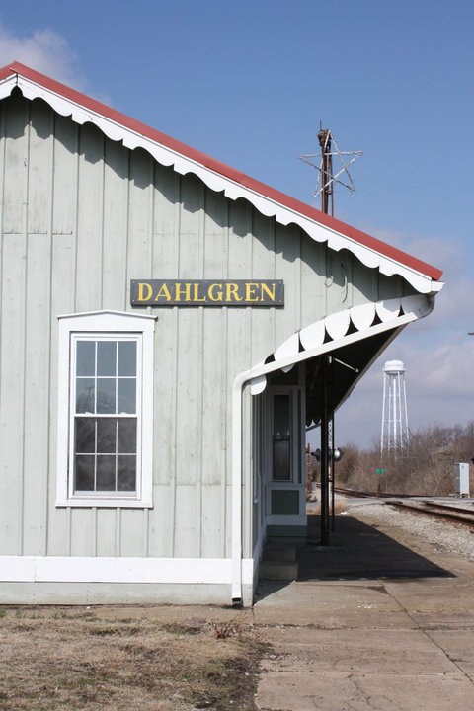

Hamilton County Historical Society members recently took almost 3000 photographs encompassing almost every corner of the county. We are trying to record what Hamilton County looks like at this point in time so that it will be a resource for future generations. We want to identify each picture currently, historically, and by location. If this project is repeated in the future, these photographs will be able to show the evolution of our county.

Special thanks are in order to photographers Doris Nelson, Micki Faruzzi, Karen Rapp, Debra Hamson, Kyle Shoultz, Charlie Frey, Ron Nelson, Ryan Nelson and others for taking photographs this year. We’d also like to thank Rick Moore, Brenda Tarlton, Alan Monroe, Bob Prince, Bill Hampton, Howard Ritchey, and others for giving of their time to point out places of interest to photograph. Finally, we would not have been able to identify many of the photographs without the generous input from the people of Hamilton County.

On Left: The McCoy Memorial Library, McLeansboro, Illinois. Photo by Micki Faruzzi
On Right: The Dahlgren Depot, Dahlgren, Illinois. Photo by Debra McCormick Hamson

New Book Shelves/Computers for Genealogy Library
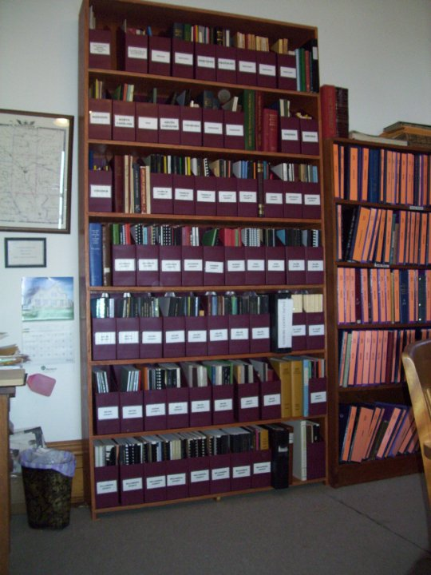
Over the past year, the Society has dedicated many hours and funds to the improvement of the genealogy library. Rick Moore recently constructed a new book shelf made specifically to accommodate our new shelf files and holds most of the more than 300 books the Society has acquired within the previous year. These books were made possible by purchases of the Society and by the donations of Christine Felty, Ryan Nelson, Joann Kennedy, Elizabeth Woodworth, Ron Nelson and others. In addition to shelving and books, the genealogy library now has two computer terminals and internet access. The Society would welcome donations of post-2005 Saga of Southern Illinois and previous plat books for Hamilton County. We are also in need of more shelving to hold the additional books acquired.

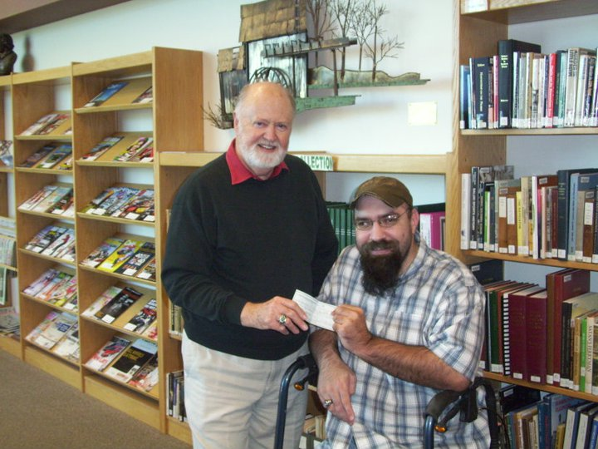
Society Donates $200 to High School Library
The Historical Society voted to donate $200 to the high school library to acquire books and materials for their “Southern Illinois Collection.” This Collection includes books about Southern Illinois and books by Southern Illinois authors. Since the section’s inception, the collection has grown to several hundred volumes. Pictured at left: Librarian Kenneth Kirkpatrick and Ryan Nelson, Hamilton County Historical Society President.

Did You Know?
Hamilton County’s most famous obituary clipper, Grandma Deem, has a Facebook group dedicated to her honor. Group members can learn more about this amazing woman as well as give testimonies as to how her years of dedicated scrapbooking obituaries and marriage notices have helped people with their research.

Genealogy Library Now Has Email Address
The new genealogy library email address is: hchsgenealogy@gmail.com.
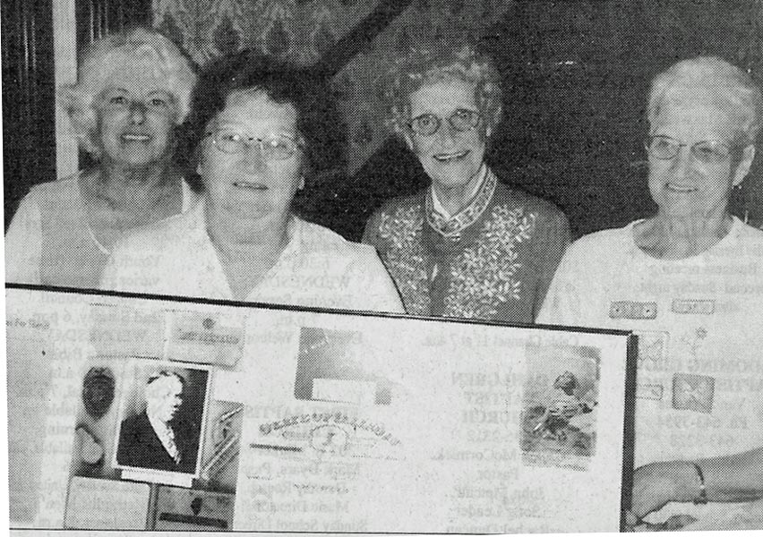

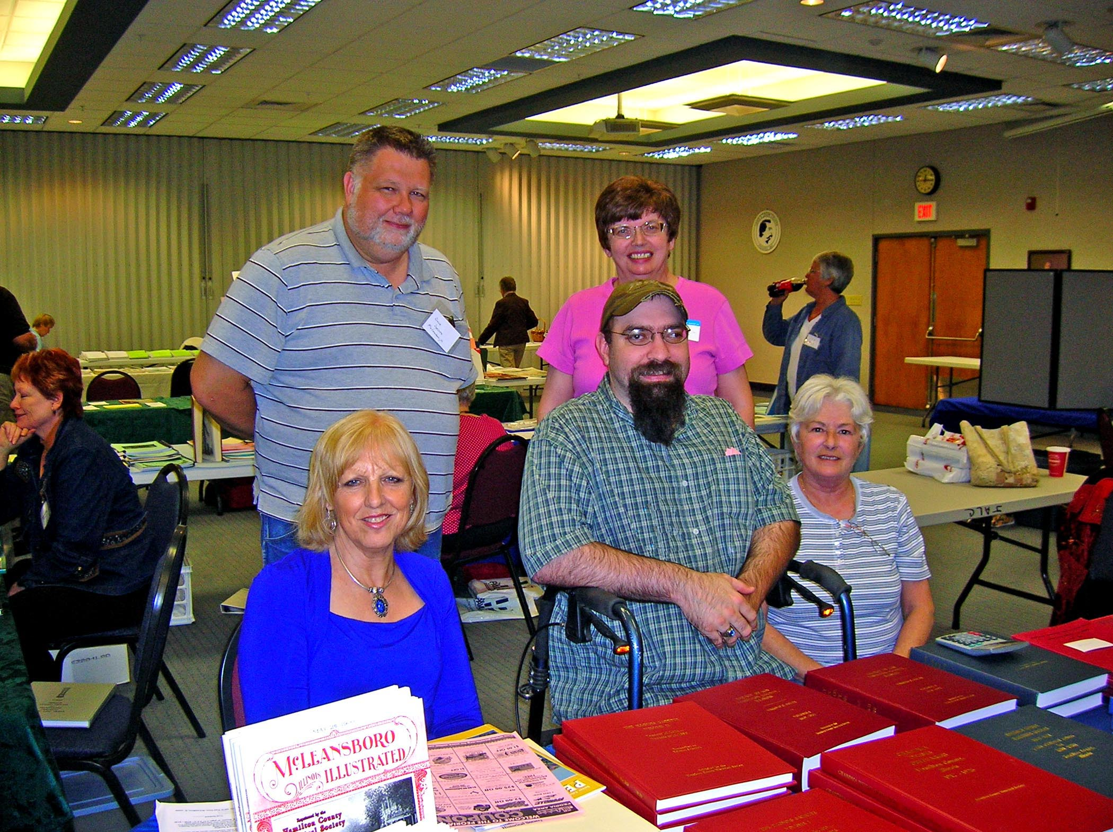
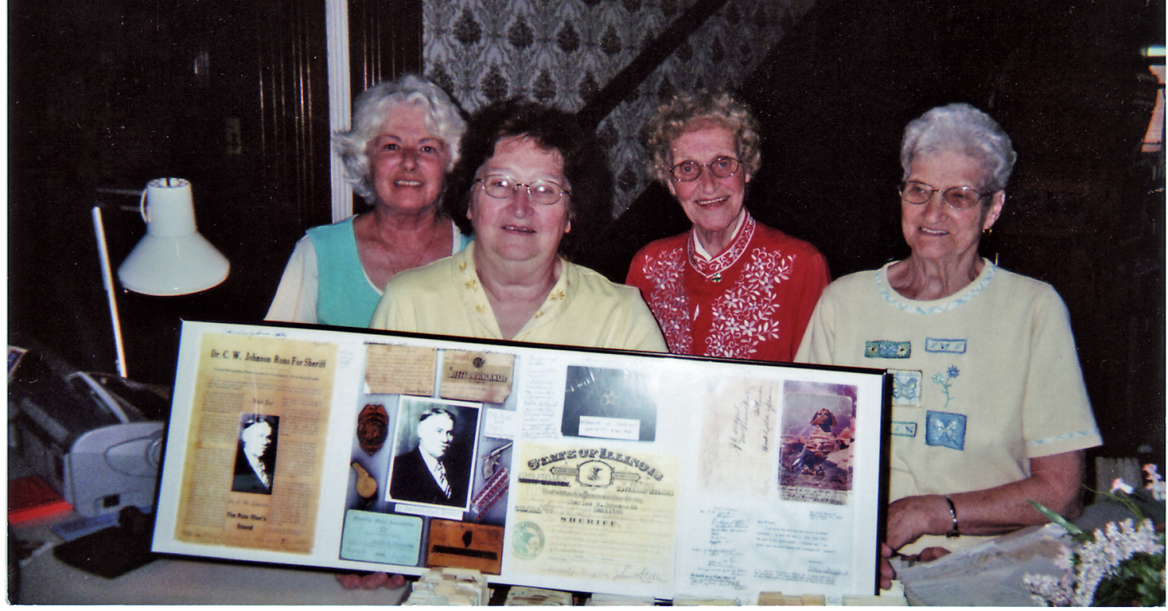
Genealogy Library Workers
Christine Felty recently donated a document collage of her father Dr. C.W. Johnson’s stint as Hamilton County sheriff. Pictured: Micki Faruzzi, Eileen Drake, Christine Felty, Elaine Ballard.
The Historical Society was well represented at the recent Genealogy Society of Southern Illinois (GSSI) Fall Conference and Book Fair, Oct. 16. Pictured: Clara Farris, Dave Dykstra, Ryan Nelson, Doris Nelson, Micki Faruzzi

Genealogy Library/Cemetery Walk Still Seeking Volunteers
The Genealogy Committee is seeking at least two individuals to volunteer at the genealogy library and Hamilton County museum, typically for three hours, one day a week. Volunteers can work on their own genealogy, assist patrons, and/or assist the Genealogy Committee in completing projects. If you are interested, please call the library at 643-2125 or email at hchsgenealogy@gmail.com.

The Cemetery Walk Committee is already planning the cemetery walk for next spring. If you would like to participate or assist in this event, please contact Donetta Reed at 643-3315.

2011 Memberships Now Being Accepted
If you would like to join the Hamilton County Historical Society or renew your membership for 2010, individual memberships are $10 per person. Business memberships are $30 or more per year. Make checks payable to the Hamilton County Historical Society and send to: Doris Nelson, Membership Chair, 409 N. Pearl St., McLeansboro, IL 62859.

2010 Business Members
The Hamilton County Historical Society would like to thank the following businesses for their continued support:

Auten’s Pizza Irvin’s Jewelry
Banerra Bank Little and Associates
Chapman Insurance Max Hunt Tank Trunk Service
Farris Family Restaurant McDonald’s Restaurant
Flannigan Tire Service McLeansboro Space Center
Fox Communications Peoples National Bank
Gholson Funeral Home Rapp Cabinets
Hamilton County Flooring White Oak Resources
Hamilton County Memorial Hospital District Wilson’s Computers
Harre Funeral Home and Ambulance York Pharmacy
Hunt’s Hardware and Grocery
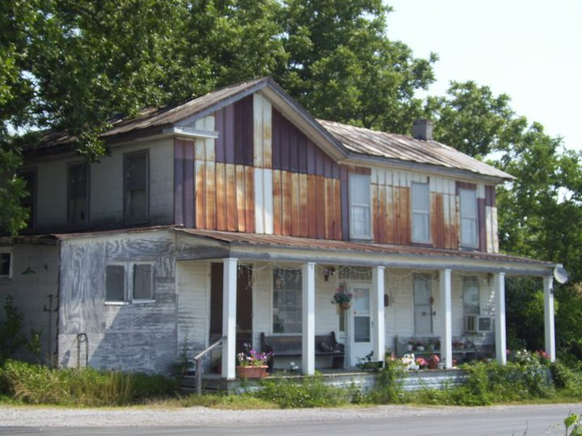
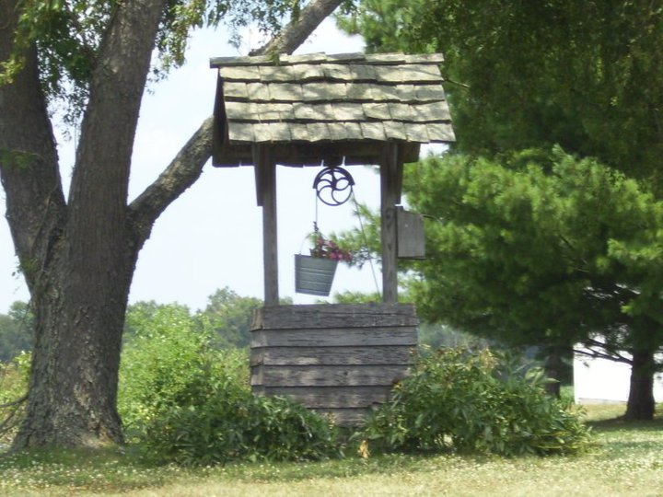
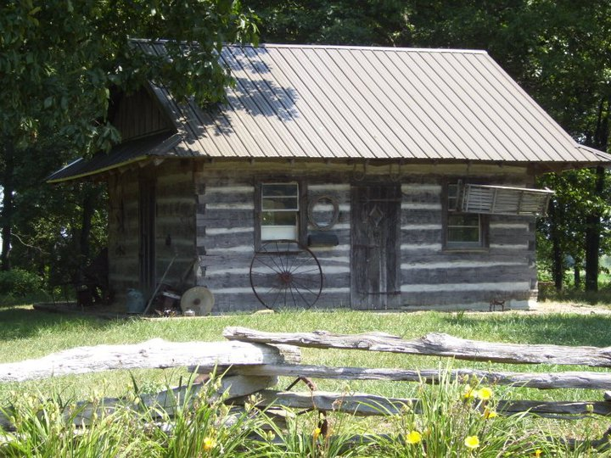
1
2
3
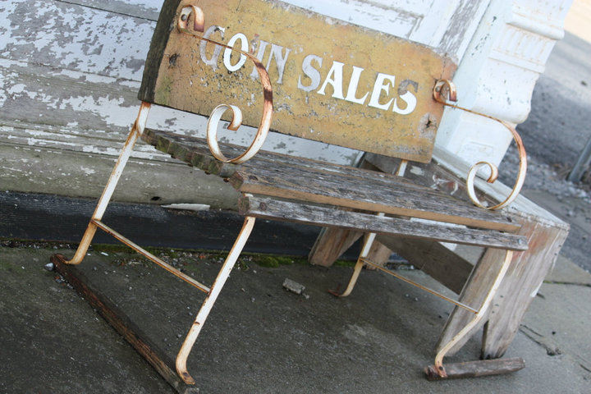
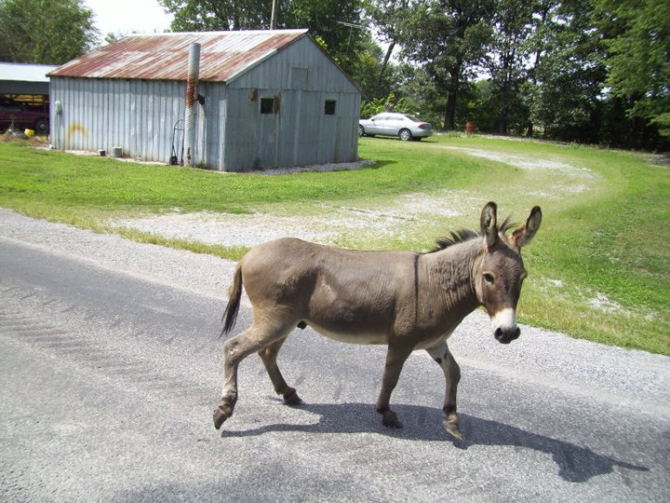
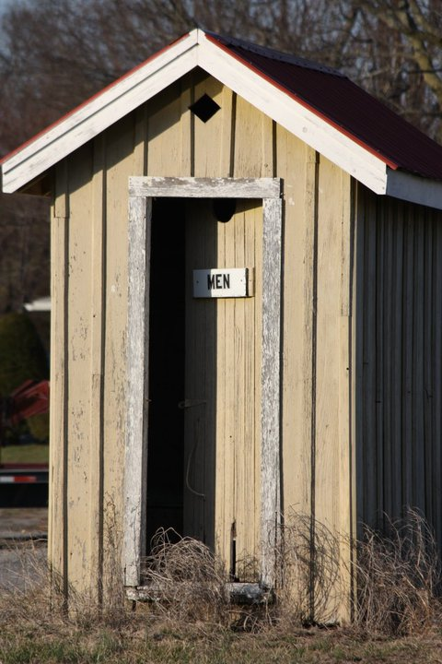
5
6
4

4

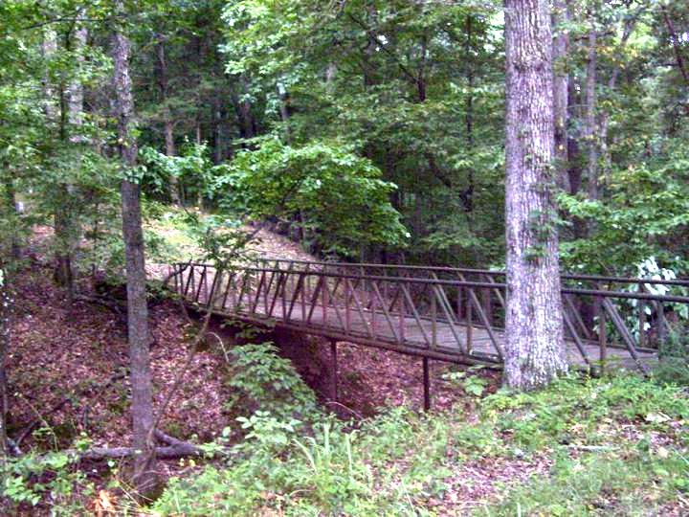
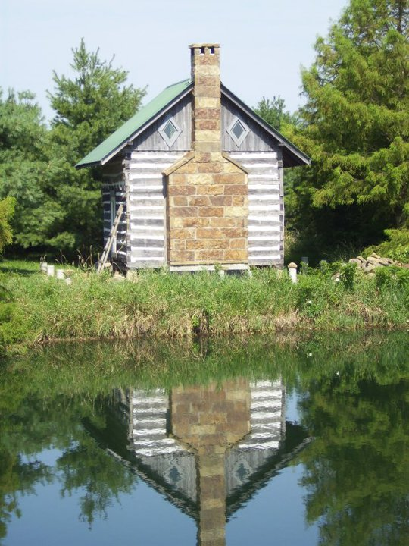
9
8

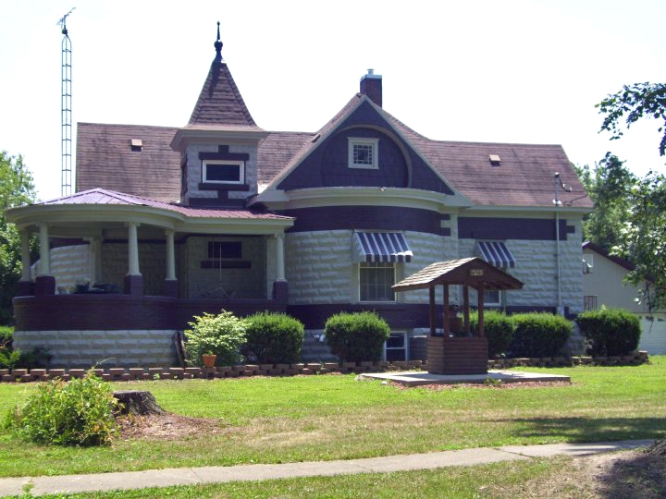

7

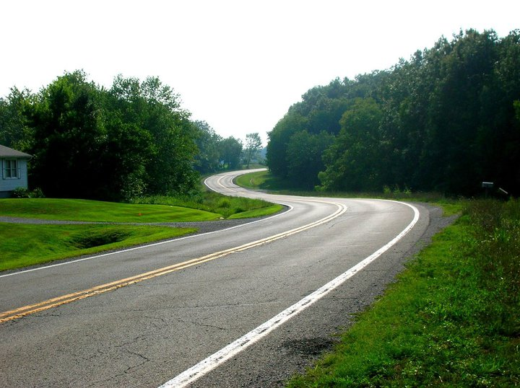
1. Charlie Frey’s Well, near Belle City
2. Clarence Karcher’s Log Cabin
3. Bond’s Store, Piopolis
4. Outhouse by Dahlgren Depot
5. Wayne, Teresa Biggerstaff’s donkey, Thackeray
6. Bench in Dahlgren
7. Home of Russell and Charlene Hart, Dahlgren
8. Ray Cemetery Bridge
9. Dennis Frey’s log cabin, Piopolis area
10. Sign on White Curve “Strawberries”
11. White Curve, east of McLeansboro
11
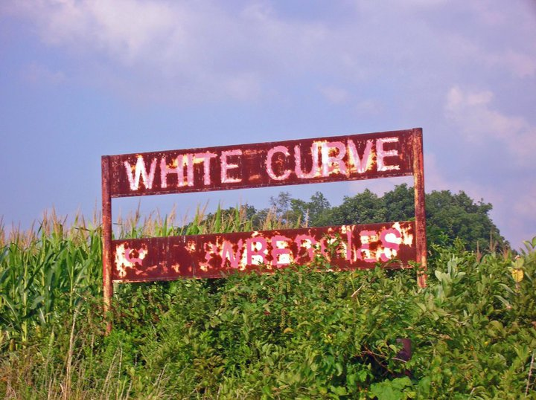
10

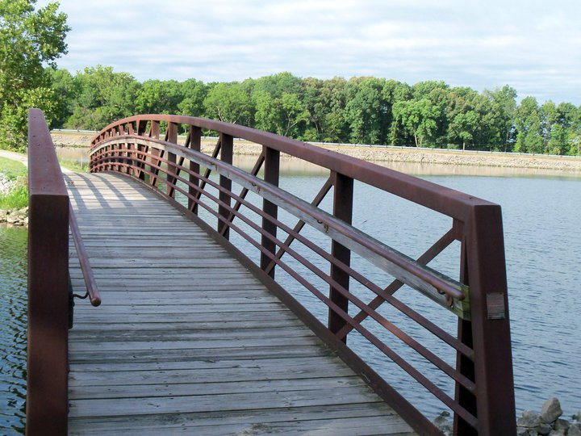
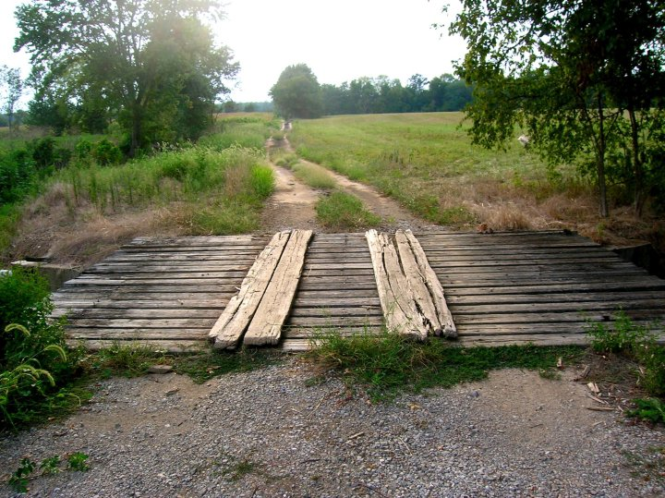
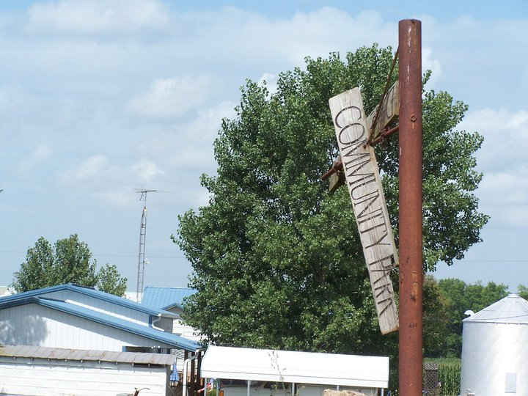
1
2
3

5
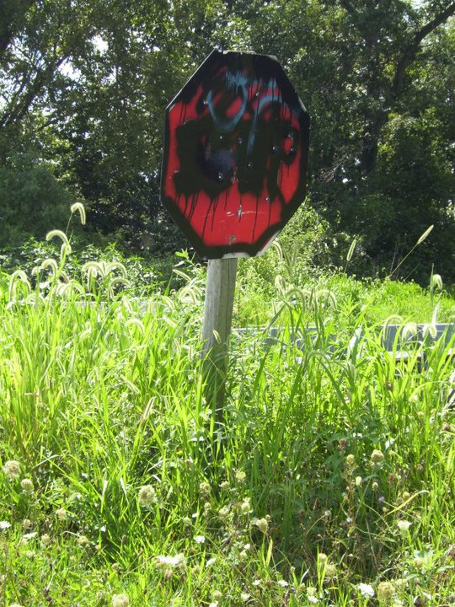
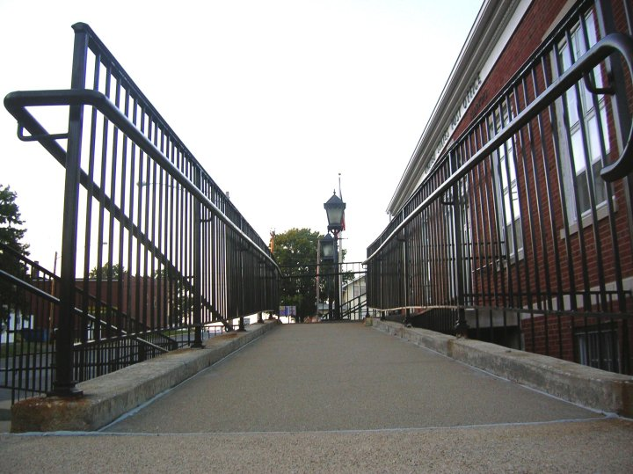
4

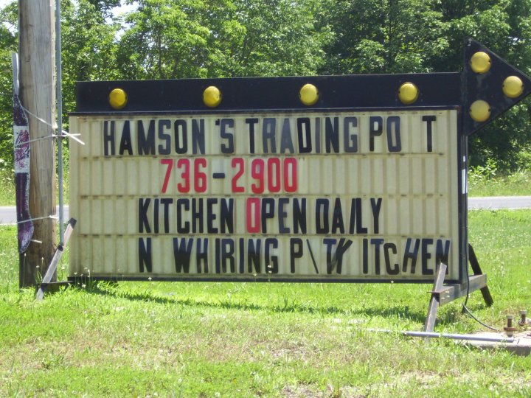
6

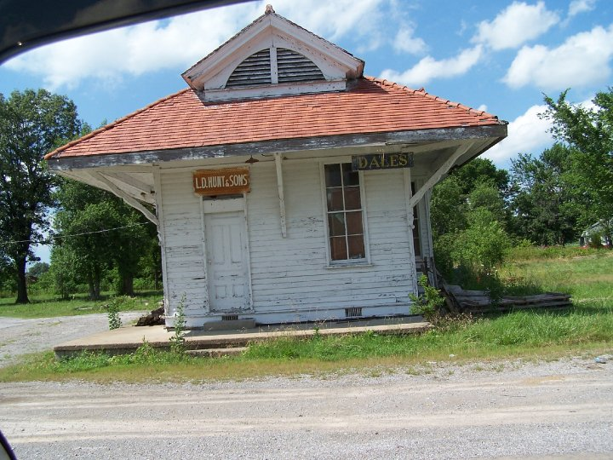
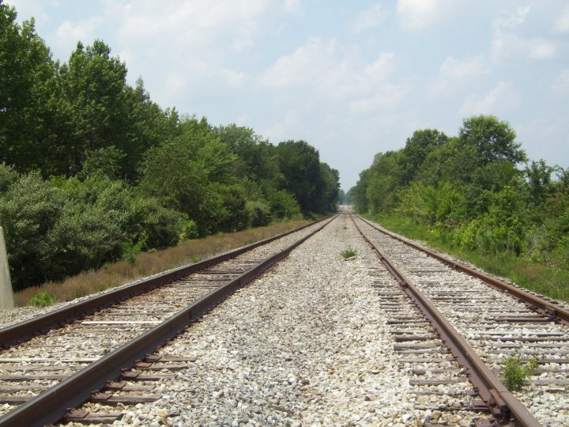
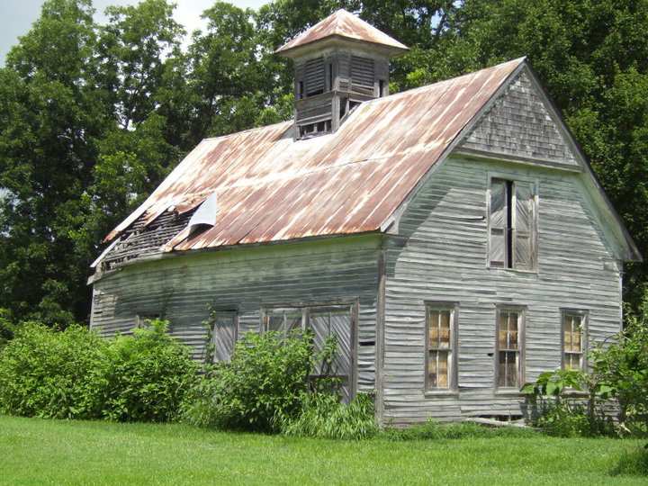
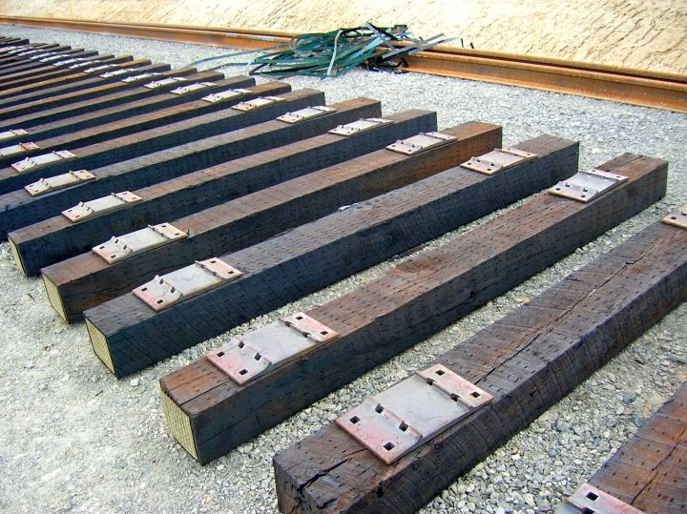
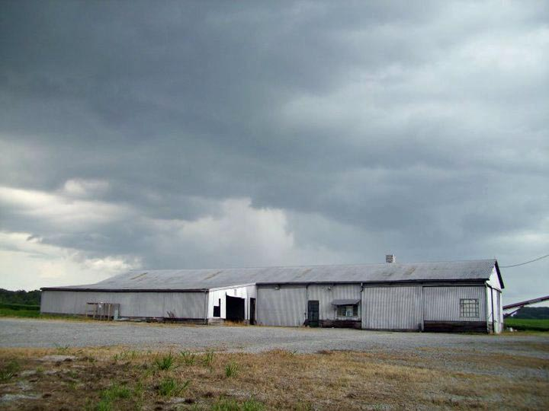
1. Bridge at Dolan Lake
2. Dale Park Sign
3. Farm bridge on east county line road
4. Stop sign located in east of county
5. McLeansboro Post Office ramp
6. Hamson’s Trading Post Sign, Dahlgren
7. Thompson’s Army/Navy Store
8. Nellie Dawe’s horse barn, Broughton
9. Railroad tracks at Delafield
10. New railroad on Rt. 142N
11. Old depot at Dale
7
8
9
10
11

Family Histories
Some new resources available

