**4

**Principals Corner**

**Coffee with the Principal**

I will once again be offering Coffee with the Principal beginning on Thursday January 21st. Please join me from 8-8:45 AM at the Upper Campus library for coffee and conversation about our school wide instructional focus: Facilitating Student Academic Conversation. We will meet at alternate campuses each month and cover a different topic. Childcare will be provided for Roosevelt Students only. I hope you will be able to join me!  Mrs. Sheridan

N**ew Year's Resolution**

**Please** help us improve our daily attendance by making sure your child gets to school on time. Tardiness creates disruptions in the classrooms as students settle in and are brought up to speed, but it also accounts for missed learning. Let's make this the Roosevelt Resolution that all students arrive to school on time! We'll post the progress in each newsletter! Thank you in advance for your efforts to increase success for all!

**8th Grade Families:**

During the month of January, there are a number of important dates for you to keep in mind regarding high school placement.

**Friday 1/8/16** – ***Boston Arts Academy*** online application for audition is due.

*apply online at bostonartsacademy.org

**Saturday 1/9/16** @ 10am-11am – ***New Mission*** Open House

*families and students are welcome and no registration is required.

**Thursday 1/14/16** @ 9am-11am – **Fenway Open House**

*families and students are welcome, but registration is required.

([617) 635-9911](javascript:void(0))

**Week of January 22nd** – ***School Choice (Lottery Forms)*** should be sent home to families. Families will have approximately 2 weeks to select their top choices for their student.

*Please note that this date is not firm and could be pushed back based on District discretion.

**Friday 1/29/16** – ***BCLA*** applications are due.

**Saturday 1/30/16** – **Fenway** applications are due.

As always, if you have any questions, please contact Rebecca Witte, Guidance Counselor at 617-635-8676 or at rwitte@bostonpublicschools.org.



**No School**

Monday

January 18th

In honor of Martin Luther King’s birthday.

[**Inclusion**](https://www.google.com/url?sa=t&rct=j&q=&esrc=s&source=web&cd=2&ved=0ahUKEwik1JGxopPKAhXF8x4KHW9pBpkQFggnMAE&url=http%3A%2F%2Fwww.kidstogether.org%2Finclusion.htm&usg=AFQjCNGuK0956Q9FgHdrc6mcwaaxRu6Qzw&bvm=bv.110151844,d.dmo)

Our school is proud to be an inclusive school. This month, our core value is Inclusion. Inclusion is being included in life and participating using one's abilities in day to day activities as a member of the community.

**Student Parent Council**

The SPC would like to remind everyone that there will be an SPC meeting on Tuesday January 12th at 8:30 at the Lower Campus.  The Meeting will be held in the Gym, please enter through the gym doors.

The SPC would also like to remind families that we are still actively collecting "Box Tops for Education". So please continue to send them into school.

We had a very successful A+ Rewards program sign up day at Stop and Shop on December 19th.  We will be planning another one soon.  In the meantime, if you have not already signed up for Stop & Shop A+ rewards program please do so by going to the following link:  <https://stopandshop.com/aplus/register-card/>

It is quick and easy to do.  Don't worry, registering will not affect your gas points but it will raise necessary money for the school.  Tell your friends, family and neighbors to sign up as well.

**Up next:** Candy Sales.  More information will be coming home soon!!

**Academic Conversations**

**This year, all schools in Boston Public Schools have been asked to identify one school-wide Instructional Focus (IF). The Roosevelt Instructional Leadership Team with Mrs. Sheridan and Mrs. Steele chose: Facilitating Student Academic Conversation. Every day in every class at the Roosevelt this year, we work to support students' ability to engage in conversations in their academic classes. We are currently focusing on how to help our students elaborate on their thoughts about a certain topic and clarify what someone else is saying.**

**Please ask your Roosevelt Scholar about the work we are doing on this in school :**

**Technology Corner**

Technology meeting Wednesday, December 22 @ 7:15am LC.

**WEBSITES APPS**

Ixl.com Students in grades Pre-K to Mathematics 8 can practice math and Language Arts language art skills which are aligned

with state standards.

**Perseverance**

**Scholars of the Month**

|  |  |  |  |
| --- | --- | --- | --- |
| Room | Core Value | Scholar | Music |
| Purple | Allison | Dominic | Josmaly |
| Green | Azaria | William |  |
| Red | Leyla | Reagan | Jarelys |
| Yellow | Tajai | Austin |  |
| Blue | Daniel | Janelle | Jayla |
| Orange | Angel | Madison |  |

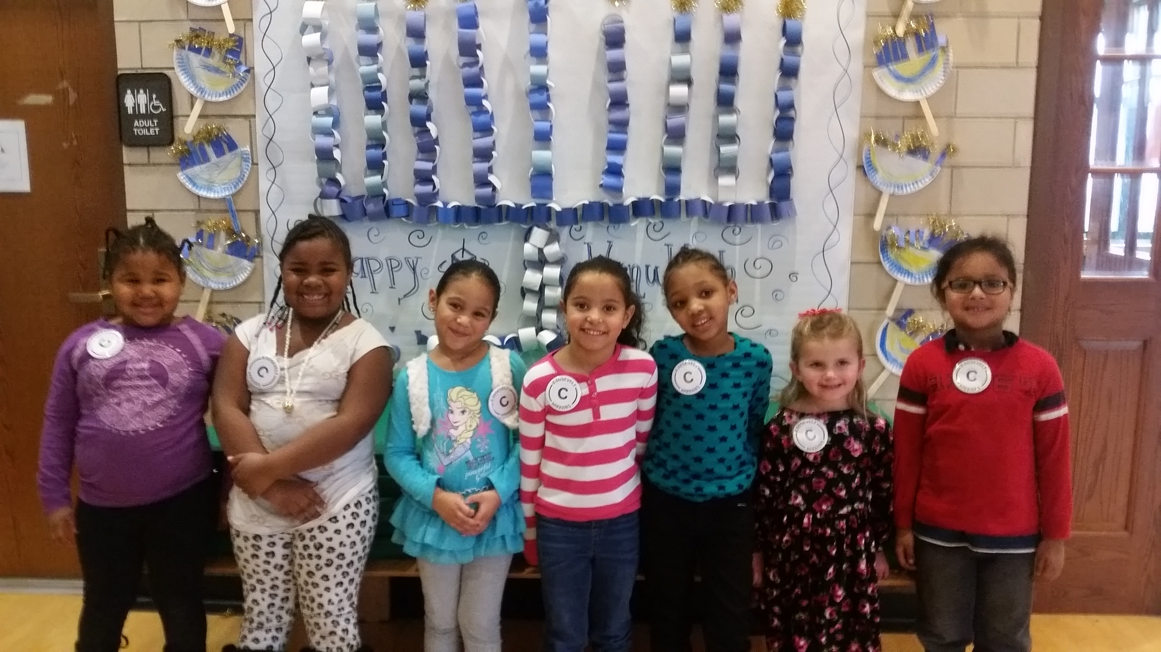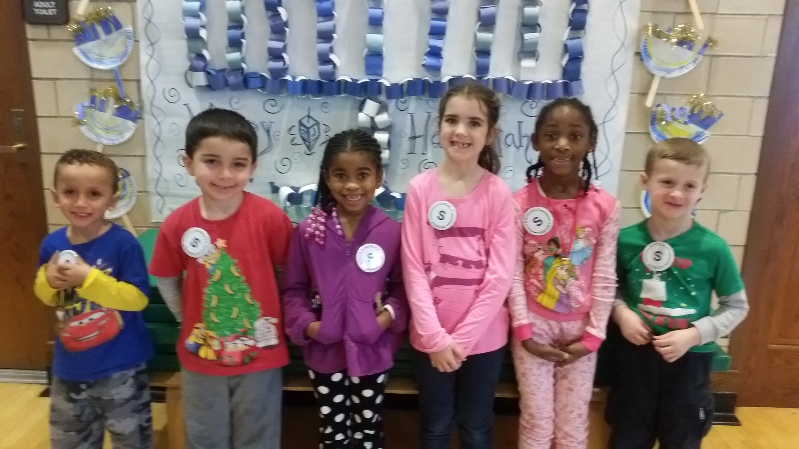

**Celtics Read to Achieve**

**Reading Program**

Students will continue reading at least 20 minutes per day for 5 days per week. This month we will also track names of students

who complete the optional weekly writing assignment. Keep reading and earning great prizes and possibly tickets to a Celtics game!

**Girl Scouts Cookie Sales!**

Girl Scout cookies are still on sale. Please email Mrs. Peterson at [awongpeterson@hotmail.com](mailto:awongpeterson@hotmail.com) if you want to place an order!

**Franklin D. Roosevelt School**

**Principal Lynda-Lee Sheridan**

**Assistant Principal Bannet Steele**

**Upper Campus**: 95 Needham Road, Hyde Park, MA 02136

P: 617-635-8676

F: 617-635-8679

**Lower Campus**: 30 Millstone Road, Hyde Park, MA 02136

P: 617-635-9280

F: 617-635-9284

Please visit our website at **bostonpublicschools.org/roosevelt**

to find all general information about the school and classroom web pages.

**Clothing Reminder**

Please include the students name on all his/her apparel (hats, gloves, headbands). We have a lot of clothing that no one has claimed at a certain point we donate it to good will. So one last chance to check and see if you find something that is missing!

**Perseverance**

**Scholars of the Month**

|  |  |  |  |
| --- | --- | --- | --- |
| Room | Core Value | Scholar | Music |
| Gr. 2 | Ayianah L, Bryan A | Daliah D. Kydrah Jean Louis |  |
| Gr. 3 | Ethan K, Michael M. | Jayden F., Luna/Zhira, Wand Niah S |  |
| Gr. 4 | Saray Valdez, Jayden Hill | James Cary, Wuliana Fevrier |  |
| Gr. 5 | Joi Honor | Azaria |  |
| Room | Math | ELA |  |
| Gr 5 | Teresa, Jaylee | Rakiiya, Nakhiyah |  |

**ACCESS Testing**

ACCESS (Assessing Comprehension and Communication in English State-to-State) is a standardized assessment that all ESL students in Massachusetts are required to take every year.  ACCESS will be administered at the Roosevelt from Thursday, January 7th through Friday, January 15th.  Please see Mrs. Sheridan if you have any questions.