Department or Program Name
[System/Application Name]

Implementation Plan

Project Implementation Plan
Template Guidelines

To aid in the completion of a Project Implementation Plan please adhere to the following guidelines. For specific information regarding project deliverables, please refer to the University Services Program Management Office. Remove these guidelines from the completed document.

Purpose | The Project Implementation Plan describes the strategy involved in preparing the end users and the target product, service, or system into daily use or production. This can include introducing a new product into the marketplace for customer consumption, installing and propagating a new technology, or carrying out a new process/business line. The objective of producing an Implementation Plan is to reduce risk of implementation failure by planning the impact to the business when the product, service, or system is implemented. Its intent is to have a centralized reference document that organizes all of the information needed for implementation (i.e., identifies all the tasks that must be completed and the responsible parties that must be involved to implement the project successfully).  The Project Implementation Plan is a master plan that summarizes all of the individual plans to be performed to implement the project. These plans may be documented as part of the implementation plan or as separate project plans, depending on the type, complexity, and size of the project.
Ownership | The Project Manager is responsible for completion of the Implementation Plan, with input from project leads and the Project Customer as necessary.
When  Phase: Execute  SDLC: Develop | The Implementation Plan is completed during the Design (planning of the document) and Develop (physically create the document) Phases of Solution Delivery Life Cycle.  It is a required deliverable on all Medium and Large projects, and a best practice for Small projects.
Template Completion  Note: Text within < > brackets needs to be replaced with project-specific information. | Do not include the Template Guidelines in your final document. Enter the project information in the page header and footer, title page, and document contributors and version control.  - Complete the document utilizing suggested text where applicable and entering text/fields where shown within <blue text> brackets. Note that the blue text is NOT to be included in your final document. Its purpose is to either provide guidance for completing the document, or to show where text/fields are to be input.  - Once changes are made to your document and you’re ready to finalize, ensure that you update your Table of Contents (TOC) section. To Update the TOC: If you are unsure how to do this, place your mouse arrow to the left of the first entry in the Table of Contents section and click the left button once. Once the entire section is highlighted, move the mouse arrow anywhere within the highlighted section and click the right button once. In the drop-down menu, choose Update Field and Page Numbers Only or Entire Field as needed. Note that you might need to repeat the aforementioned steps to change the font back to Tahoma 10 pt.  - If changes are to be made, update the Revision History information accordingly.  - The Implementation Plan is to be retained with other project-related documentation and maintained in accordance with the business line’s records retention policy.
Empowerment & Scalability | This template is provided as a guideline to follow in producing the minimum basic information needed to successfully complete a Project Implementation Plan in meeting EPM guidelines and illustrates the art and science of project management. Project Managers are empowered to use this template as needed to address any specific requirements of the proposed project at hand. The amount of detail included in the template will depend on the size and complexity of the project. Depending on project or business line needs, categories can be added, but cannot be deleted. If a category does not apply, do not delete it, but rather mark it as “Non-applicable” and provide a brief explanation as to why it does not apply to the project.
Important Notice | As this template may change, it is highly recommended that you access a blank template from the WFS Program Office Website each time you need one for a new project and not merely use one from a previous project by changing the old text.

Document Information and Approvals

Version History

Version # | Date | Revised By | Reason for change
1.0 | 9/17/09 | Aaron Demenge | PMO Review

Document Approvals

Approver Name | Project Role | Signature/Electronic Approval | Date

Table of Contents
Overview 1
Background 1
Overall Approach 1
Organizational Perspective 1
Involved User Groups 1
Implementation Communications 1
Management 1
User/Customer Support 1
Operations 1
Technical 1
Organizational Change Plan 1
Preparation 1
Execution 2
Follow-up 2
Staff Planning 2
Operations 2
Technical 2
Interdepartmental Roles and SLA’s (Service Level Agreements) Planning 2
Accounting and Billing 2
Policy Management 2
Implementation/Release Schedule 3
User Readiness Plan 3
Management 3
User/Customer Support 3
Operations 3
Technical 3
Data Migration/Conversion Plan 4
Preparation 4
Actual Conversion 4
Conversion Verification (Clean-up) 4
Installation Plan 4
Preparation 4
Execution 4
Clean-up Steps 4
Go/No Go Decision 4
Product Stabilization/Warranty Period 4
Transition to Production Support 5
Lessons Learned 6
Signoff/acknowledgement 6
Appendix 1 - Proposed Production support model 7
Appendix 2 – Implementation readiness assessment 8

Overview

Background
Provide a system overview, any requirements to use the system, required locations, and method to implementing the proposed project solution. This section is intended to be completed at a very high level. It may be as long as necessary, but most information should be contained in a half of a page. This section is intended to provide the background information necessary to place the individual plans that follow into perspective.

Overall Approach
Include the underlying rationale for using the approach described above and describe the overall schedule for implementing the plan.

Organizational Perspective
Describe all the modifications that will be necessary in the organizational structure, work flow, and personnel plans in order to support the new product, service, or system.

Involved User Groups
Describe all the stakeholders, users or other parties impacted by the delivery of this solution.

Implementation Communications

Management
Identify the audience who will receive the management communications and describe the type of communications medium to be used and the purpose for the communications message.

User/Customer Support
Identify the audience who will receive the user/customer support communications and describe the type of communications medium to be used and the purpose for the communications message.

Operations
Identify the audience who will receive the operations communications and describe the type of communications medium to be used and the purpose for the communications message.

Technical
Identify the audience who will receive the technical communications and describe the type of communications medium to be used and the purpose for the communications message.

Organizational Change Plan

Preparation
List all the steps that are needed to prepare for the organizational change. (The necessary organizational change was to be described earlier in the overview section.) For each step, describe the actions to be taken, all individuals or groups affected by the step, the individual(s) or group(s) responsible for executing the step, and the start and end date for the step. List steps in a logical sequence of events.

Execution
List all the steps that are needed to actually move the organization from its current state to the new state. For each step, describe the actions to be taken, all individuals or groups affected by the step, the individual(s) or group(s) responsible for executing the step, and the start and end date for the step. List steps in a logical sequence of events.

Follow-up
List all the steps that are needed to follow-up the organizational change to determine the success of the change, address any problems, concerns or issues arising from the change, and to ensure the organization has not reverted to its prior state. For each step, describe the actions to be taken, all individuals or groups affected by the step, the individual(s) or group(s) responsible for executing the step, and the start and end date for the step. List steps in a logical sequence of events.

Staff Planning

Operations
List the number, job description, and roles and responsibilities of business personnel needed - by location - during actual implementation and the ongoing operations of the new system in order to recover the business benefit described by the project.

Technical
List the number, job description, and roles and responsibilities of business personnel needed - by location - during actual implementation of the new system and the subsequent post-implementation production support.

Interdepartmental Roles and SLA’s (Service Level Agreements) Planning

List the key contacts by department and expected escalation and response SLAs required. If separate SLA document(s) are not to be prepared (i.e. falls within existing master SLA documents, include key information in this section and Appendix 1; otherwise refer to the new SLA document.

Accounting and Billing

Describe any changes to Accounting and Billing required to implement the proposed solution, if applicable.

Policy Management

List the changes to existing policy or procedures required to implement the proposed solution, if applicable.

Implementation/Release Schedule

Prepare a detailed implementation schedule. Include all of the sub-plans contained within the Implementation Plan (training, documentation, organizational change, and installation). For each activity listed on the schedule, include assigned personnel resources, start date, end date, and the estimated duration of the activity.

User Readiness Plan

Management
Identify the audience who will receive the management training and describe the purpose for the training. Identify all of the individual courses that will be prepared and presented for this training. For each identified course, include: (a) the course name, (b) the type of training (classroom, CBT, etc.), (c) the course content, and (d) the estimated duration. Identify all of the supporting materials that will be required for the training, such as: training manuals; teachers guides; overheads; etc. Prepare a tentative schedule and indicate what courses will be offered when and who from the management audience will attend each course offering.

User/Customer Support
Identify the audience who will receive the user/customer support training and describe the purpose for the training. Identify all of the individual courses that will be prepared and presented for this training. For each identified course, include: (a) the course name, (b) the type of training (classroom, CBT, etc.), (c) the course content, and (d) the estimated duration. Identify all of the supporting materials that will be required for the training, such as: training manuals; teacher’s guides; overheads; etc. Prepare a tentative schedule and indicate what courses will be offered when and who from the user/customer support audience will attend each course offering.

Operations
Identify the audience who will receive the operations training and describe the purpose for the training. Identify all of the individual courses that will be prepared and presented for this training. For each identified course, include: (a) the course name, (b) the type of training (classroom, CBT, etc.), (c) the course content, and (d) the estimated duration. Identify all of the supporting materials that will be required for the training, such as: training manuals; teacher’s guides; overheads; etc. Prepare a tentative schedule and indicate what courses will be offered when and who from the operations audience will attend each course offering.

Technical
Identify the audience who will receive the technical training and describe the purpose for the training. Identify all of the individual courses that will be prepared and presented for this training. For each identified course, include: (a) the course name, (b) the type of training (classroom, CBT, etc.), (c) the course content, and (d) the estimated duration. Identify all of the supporting materials that will be required for the training, such as: training manuals; teacher’s guides; overheads; etc. Prepare a tentative schedule and indicate what courses will be offered when and who from the technical audience will attend each course offering.

Data Migration/Conversion Plan

Preparation
Refer to any business requirement definition document(s) and any architectural or design document(s), or meet with the conversion team for the project to provide input for this section.

Actual Conversion
Conversion info goes here…

Conversion Verification (Clean-up)
Conversion info goes here…

Installation Plan

Preparation
List all hardware, software, equipment, environmental, supply, and other application systems requirements needed for installation of the new system as applicable. Include both existing and new hardware, software or equipment, and identify which is which. For environmental, include such items as construction of special rooms, installation of cooling systems, electrical rewiring, etc.

Execution
Describe the kind of testing that will take place in interim operations. List the activities to be performed for the actual system installation. List the activities to be performed to verify the system installation is correct. List the contingency activities to be performed if the installation should fail. Describe the procedure to be used to resolve problems encountered during installation.

Security

Application

Fall back plan to (to re-enable the legacy system in the event of catastrophic failure)

Clean-up Steps
Describe the steps to be followed to turn off the old system, obtain feedback on the implementation process, and measure initial use of the new system.

Go/No Go Decision
Describe the process to engage stakeholders in a process to commit to product/service release. This should be added with the Launch Readiness Assessments (appendix 2).

Product Stabilization/Warranty Period
The stabilization period is a scheduled one-week period in which resources will be dedicated to monitor, identify, troubleshoot, and respond to known issues affecting the ability to request, process, print, and manage Security ID badges.

Product stabilization will be managed by the departmental IT Manager who will own the product/system after transition to production support, but will rely on the following contacts to assist:

Process Owner | Role/Representation | Contact
 | Project Manager
 | Project Technical Lead

Transition to Production Support
Describe the steps to be followed for final knowledge transfer and transition to production support.

Transition Planning Schedule:
Activity | Key Deliverable | Role/Representation | Date
Review Implementation Readiness Assessment | Implementation Readiness Assessment (Appendix 2) | PM with Business and Technical Team
Review Business Continuity Planning | Implementation Plan | PM and Business Sponsor
Review and transition Technical Support | Technical Design Specification and Implementation Plan | PM and Technical Lead/Production Support Team
Review Testing Transition | Test Plan and Test Scripts | PM and PMO QA Lead
Review Training Transition | User guides, quick reference material and training outlines | PM and PMO Technical Trainer
Review Document Archiving | Project SharePoint website | PM and PMO PM

After the product stabilization period, the department will formally acknowledge client acceptance of the application and the system transitions to production support mode. The Project moves to Project Close-out and is no longer involved in the ongoing administration of the project or system.

Ownership of the technical support of agreed up modifications, changes, enhancements, or fixes falls to the departmental technical manager and as defined in the Service Level Agreement (SLA). The technical manager also works with others as defined in the Product Management Hierarchy Diagram (below) and the Production Support Model (appendix 1).

Product Management Hierarchy Diagram:
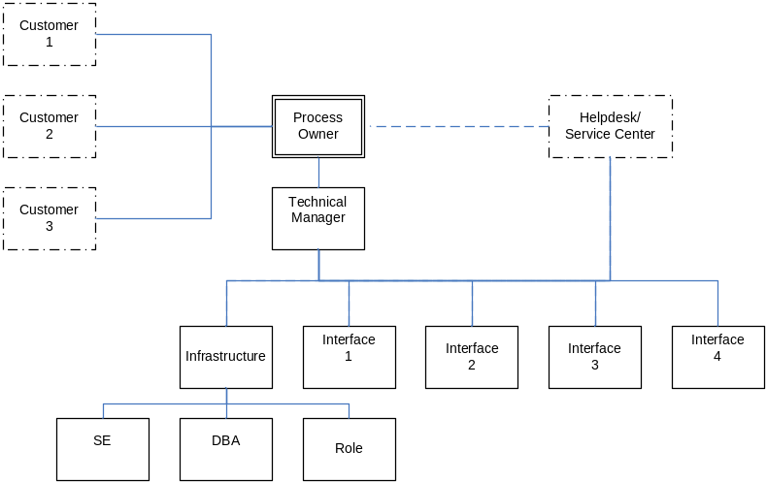

Lessons Learned
Describe how lessons learned from the project will be gathered, documented, and made available as a learning experience for each new departmental implementation.

Refer to the standard templates for lessons learned surveys and summary documents.

The PMO can facilitate any lessons learned surveying, meeting facilitation and summary documentation.

Signoff/acknowledgement

I agree that the [Project Name] Implementation Plan is complete as is known today, accurately reflect the strategic and operational direction of [Department Sponsor] regarding the project, and when delivered fulfill the business needs of my department within the broader project goals as defined by the project Business Case and Charter.

I understand that by agreeing to the Project Implementation Plan, I approve of the activities defined and authorize my department to participate as documented for the successful implementation of the [project solution] in our department.

________________________ Date: ___/___/___
Name
Title

________________________ Date: ___/___/___
Name
Title

________________________ Date: ___/___/___
Name
Title

Appendix 1 - Proposed Production support model
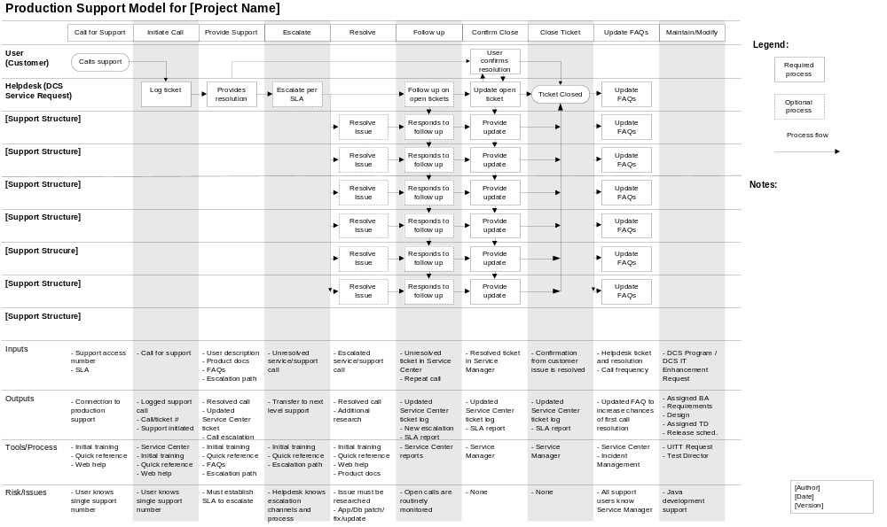

Appendix 2 – Implementation readiness assessment

30 Days Prior to Launch

Project Manager’s summary of the readiness to launch today.

Score (1 to 5 with 5 being completely ready) ____
Thoughtful commentary:

Summary (score and commentary) of the readiness of:
- The application as determined by the Tech lead or software architect
Score (1 to 5 with 5 being completely ready) ____
Thoughtful commentary:

- The application as determined by the BA lead
Score (1 to 5 with 5 being completely ready) ____
Thoughtful commentary:

- The application as determined by the QA lead
Score (1 to 5 with 5 being completely ready) ____
Thoughtful commentary:

- Business Partner assessment.
Score (1 to 5 with 5 being completely ready) ____
Thoughtful commentary:

- The launch materials as determined by the Business lead
Score (1 to 5 with 5 being completely ready) ____
Thoughtful commentary:

- The operational/user readiness as determined by the Business lead
Score (1 to 5 with 5 being completely ready) ____
Thoughtful commentary:

List and describe the most significant obstacles to launch. Assess each obstacle for impact and likelihood. Where the impacts are high, what mitigation (e.g. agreed on “plan b”) might be in the works?

Obstacle to Launch | Reason / Background | Impact / Risk | Mitigation
List any features that are candidates for not being included with the initial launch. Describe the effect of the absence.

Feature at Risk | Why, how hard to supply | Impact of launching without

10 Days Prior to Launch

Update the 30 day assessment above with status of things identified and any new information / concerns / risks on top.

Project Manager’s summary of the readiness to launch on schedule:

Score (1 to 5 with 5 being completely ready) ____

Thoughtful commentary:

Project Manager’s summary of the readiness to launch today:

Score (1 to 5 with 5 being completely ready) ____

Thoughtful commentary:

Project Manager’s recommendations for launch.
__ Complete, unaltered launch on schedule
__ On schedule launch but with conditions (e.g. certain features absent)
__ Delay (If the determination is to delay the launch be sure that is decided now so communication can begin ASAP. A no-go decision needs to be communicated in person to the stakeholders. )

Business Partner’s summary of the readiness to launch on schedule:

Score (1 to 5 with 5 being completely ready) ____

Thoughtful commentary:

Business Partner’s summary of the readiness to launch today:

Score (1 to 5 with 5 being completely ready) ____

Thoughtful commentary:

Business Partner’s recommendations for launch.
__ Complete, unaltered launch on schedule
__ On schedule launch but with conditions (e.g. certain features absent)
__ Delay (If the determination is to delay the launch be sure that is decided now so communication can begin ASAP. A no go decision needs to be communicated in person to the stakeholders. )

Just Prior to Launch Assessment

Update the 10 day assessment above with status of things identified and any new information / concerns / risks on top.

Has the PM signed off? __
Has QA Lead signed off? __
Has BA Lead signed off? __
Has the Tech Lead signed off? __
Has the Business Partner(s) accepted the product/application and the terms of the launch? The risks and absent features are documented and s/he has approved? ___
If there is significant concern, involve the Program Management Office!

