
National Association of Government Communicators (NAGC)
Mentor Value Program (MVP)
Career Development Plan 1-year/5-year

Mentee: First name, Last name | Mentor: First name, Last Name
Assistance Job Search Skills Resume and Cover Letter Interview Skills
Needed? Employer Search Education/Training Career Counseling/Coaching
Career Advancement Developing a Work Portfolio Other (specify): ____________________

Career Planning Long-Term Goals
(Place your career, educational and personal goals in the target on the staircase worksheet)

Career Goal: Where do you hope to be in your career development in one-year?

Educational Goal: What educational goals do you hope to accomplish with the next year?

Personal Goal: In the next year what would you like to accomplish to make you a better, better-rounded person?

Barriers: If barriers are listed, what actions are suggested to address them? During what timeframe?

Recommendations for Achieving Goals
(Place your objectives on each step of the staircase worksheet)

Career Planning | Career Objectives | Educational Objectives | Personal Objectives
Skill set:
Career Services:
Courses:
Research:
Work abroad/details/exchanges:
Service Learning:
Organizations
Activities
Leadership opportunities:
Internships/Other experience:

Notes

Signatures

Mentee _______________________________________________ Date _________________
Mentor _______________________________________________ Date _________________
NAGC Last Rev. 3/7/11
Career Planning
Objectives are those specific activities and strategies, which move us toward our goals. Use the staircase worksheet to develop short and or long term objectives and goals to reach "the top.” The following are questions that can help you formulate your objectives and goals.
Skills: What skills would you need to develop in order to realize your goals?
Career Services: How can you enhance your hiring prospect? What services and programs are offered by an agency or not-for-profit career services center to help you develop and implement your goals?
Courses: What specific general education, courses, seminars or conferences, such as the NAGC Communication School, might help you with your career or personal goals?
Research: Are there opportunities in your profession to work on a research project? If so, what would you like to explore?
Work Abroad, Details, Exchanges: Would you like to work abroad or attend another college or university, do a company exchange or detail? If so, where would you like to go?
Service Learning: What service learning project would you like to get involved in? Will it help you with your goals? How?
Organizations: Besides NAGC, what organizations would you like to join? How might joining these organizations help you attain your career or personal goals?
Activities: Are there any activities, which you would like to be involved? If so, which ones? What would you like to accomplish?
Leadership Opportunities: What opportunities are there for leadership at work or in activities and organizations? How might this help with your goals?
Internships: Is an internship or practical experience built into your career program? If not, what kind of internship or practical experience would you like to pursue?

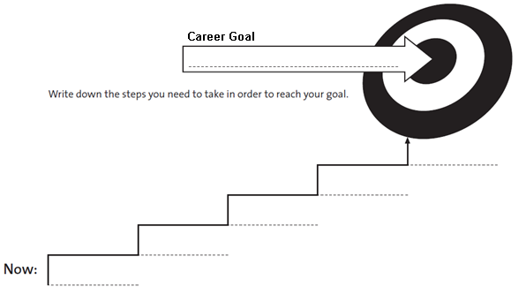
Staircase Worksheet
Short-term (1-year) or Long term (5-years)

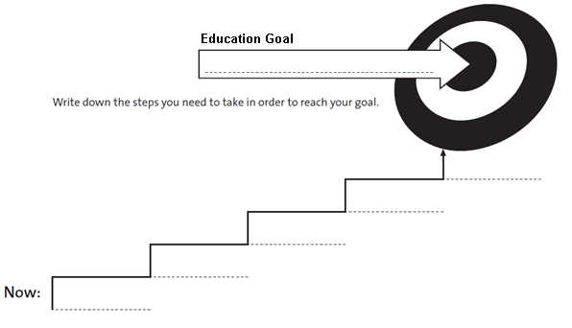
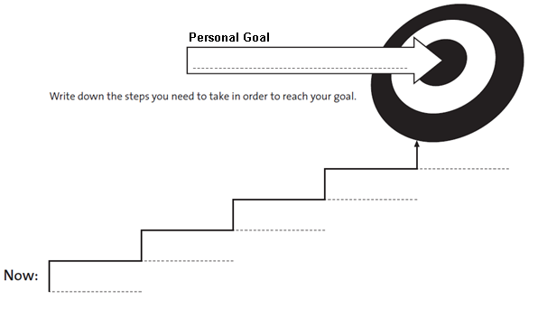
Objective
Comments:__________________________________________________________________________________________________________________
Comments:__________________________________________________________________________________________________________________
Comments:__________________________________________________________________________________________________________________
Comments:__________________________________________________________________________________________________________________
Objective
Objective
Objective
Objective
Objective
Objective
Objective
Objective
Objective
Objective
Objective
Objective
Objective
Time
Time
Time
Time
Time
Time
Time
Time
Time
Time
Time
Time
NAGC Last Rev. 3/7/11
Objective
Objective

