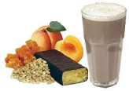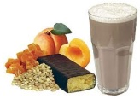

## Meal discount coupon

Receive one free pound of coffee

When you buy one of equal or lesser value

Redeemable at any participating Fourth Coffee

Expires December 31, 2004

www.vouchertemplate.com