–––
Estate Services

PROJECT EXECUTION PLAN (PEP)

Contents

- Introduction
- University of Leeds Project Manager Handbook
- Project Objectives and Priorities
- Organisation, Roles and Responsibilities
4.1 Project Reporting Structure (General Example)
4.2 The Project Team
4.3 Key Contacts
4.4 Complete Form of Appointment in agreed University of Leeds form:
4.5 Agree Fee Schedule:
4.6 Execute Appointment Documentation
4.7 Execute and issue Professional Warranties:
5. Project Strategy
5.1 Design
5.1.1 Specialists Surveys and Reports
5.1.2 FES3 – Prepare Design Brief
5.1.3 OP2 – Develop Concept
5.1.4 DP2 – Detailed Proposals
5.1.5 TP1 – Produce Tender Documentation
5.2 Consultation
5.3 Procurement
5.4 Construction
5.5 Commissioning, Operation and Maintenance
6. Project Controls
6.1 Change Control
6.2 Programme
6.3 Cost
6.3.1 Cost Planning
6.3.2 Cost Reporting
6.3.3 Invoicing Procedure
6.3.4 Risk
  - Quality
6.4.1 Definition of standards
    - Site Controls and Inspection
    - Defects Rectification
6.5 Organisation and Administration
6.5.1 Project Filing System
    - Meetings
    - Project Progress Reporting
6.6 Health and Safety

- Introduction

The purpose of this document is to define all procedural matters relating to the design, procurement and construction of the project. This document should be read in conjunction with the University of Leeds Project Manager Handbook.

The Project Execution Plan (PEP) is prepared by the Project Manager in consultation with the client and the Project team. It describes the general procedures to be adopted by the client and the team for the project.

The PEP is not a static document. It should be regularly updated by each team member, although all revisions will be issued through the Project Manager to retain an element of control.

The objectives of the PEP are to achieve the client’s requirements in terms of time, cost and quality via:

- Guiding the Project team members in the performance of their duties
- Monitoring and controlling project programme and delivery
- Maintaining an adequate and timely flow of critical information

The document is split into the following sections;

- The University of Leeds Project Manager Handbook
- Project objectives and priorities
- Organisation, roles and responsibilities
- Project strategy
- Project controls

- University of Leeds Project Manager Handbook

The University undertakes a wide range of maintenance and new build projects and has developed a University of Leeds Project Manager Handbook for use on University construction projects. At each stage of the project the handbook should be referred to for guidance and support. Within the handbook is a series of processes which are supported by a range of procedures and templates. Each project also has a set of eight gateway reviews that must be signed off by the relevant parties before a project can proceed to the next stage.

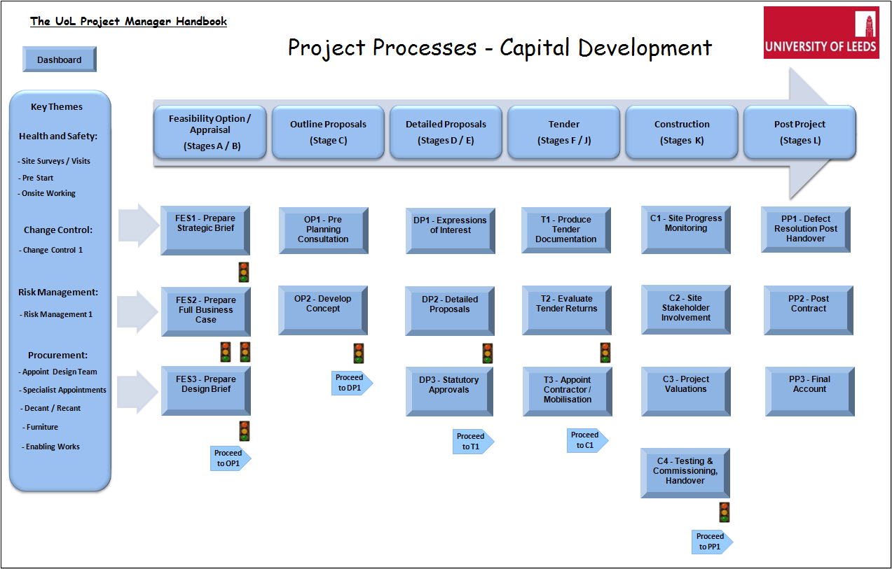
Project Processes
The processes have been developed to cover the tasks that are undertaken during each of the six project lifecycle stages:
Feasibility Option Appraisal (RIBA Stage A/B)
Outline Proposals (RIBA Stages C)
Detail Proposals (RIBA Stages D,E)
Tender (RIBA Stages F,H)
Construction (RIBA Stages J,K)
Post Project (RIBA Stage L)

3. Project Objectives and Priorities

Client’s brief and design criteria

Summary of project aims

Summary of location, general arrangements and any site constraints

Approval Stage | Approval Sign off Date
Gateway 1 Approval – Prima Facie Business case Sign off
Gateway 2 Approval – Full Business Case Sign off
Gateway 3 Approval – Funding Granted
Gateway 4 Approval – Stage A/B Sign Off
Gateway 5 Approval – Stage C Sign Off
Gateway 6 Approval – Stage D/E sign Off
Gateway 7 Approval – Tender Report Approval
Gateway 8 Approval - Completion

Current Approved Programme |  | Location:
Current Approved Budget

4 Organisation, Roles and Responsibilities

4.1 Project Reporting Structure (General Example)

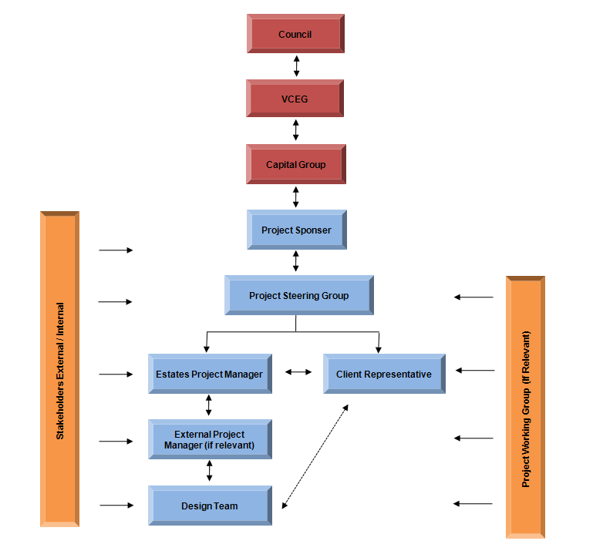

The names, address, telephone details of all the organisations involved in the project are included within the project directory. (Reference Template – Project Directory)

  - Key Contacts

The Project Team

The principle parties involved with the project are:

Client Liaison Officer:
Mobile
Email

Estates Project Manager:
Mobile
Email

External Project Manager:
Mobile
Email

Quantity Surveyor:
Mobile
Tel

Architect:
Mobile
Tel

M&E Services Engineer:
Mobile
Tel

Structural Engineer:
Mobile
Tel

CDM Consultant:
Mobile
Tel

Main Contractor:
Mobile
Tel

4.3 Design Team Tenders Received and Accepted:

 | Required | Received | Action
Project Manager
Architect
M&E Engineer
S&C Engineer
Quantity Surveyor
CDM Co-ordinator

4.4 Agree Design Team Fee Schedule and Drawdown:

 | Required | Received | Action
Project Manager
Architect
M&E Engineer
S&C Engineer
Quantity Surveyor
CDM Co-ordinator

4.5 Execute Design Team Appointment Documentation:

 | Required | Received | Action
Project Manager
Architect
M&E Engineer
S&C Engineer
Quantity Surveyor
CDM Co-ordinator

4.6 Execute and Issue Design Team Professional Warranties:

 | Required | Received | Action
Architect
M&E Engineer
S&C Engineer

4.7 Execute and Issue Design Team Novation Agreement:

 | Required | Received | Action
Architect
M&E Engineer
S&C Engineer

  - Construction Contract Particulars
 | Required | Received | Action
Contract Notice Issue
PQQ
PQQ Evaluation
ITT
ITT Evaluation
Tender Report
Execute and issue main contract

5.0 Project Strategy
The University has determined a strategy that will be adopted on each project for the management of design, procurement, construction and commissioning, Operation and Maintenance.
5.1 Design
The design team will be managed by the Architect as lead consultant. Roles and Responsibilities are detailed within the following templates;
- Scope of Service – External Project Manager
- Scope of Service – Architect
- Scope of Service – Mechanical and Electrical
- Scope of Service – Structural and Civil
- Scope of Service – Quantity Surveyor
- Scope of Service – CDMC & SWMP
- Scope of Service – BREEAM Assessor
- Scope of Service – Acoustics
- Scope of Service – Fire Engineer
- Scope of Service – Monitoring Architect
Consultant Design Responsibility Matrix  Reference:  Date:  1 = PRIMARY RESPONSIBILITY  2 = SUPPORTING ROLE  If there is no External Project Manager, the Estates Project Manager will undertake all the detailed responsibilities. | Project Manager | External Project Manager | Quantity Surveyor | Architect | Civil/Structural Eng | Mechanical & Electrical Eng | CDM Coordinator | Main Contractor
Appointment of Consultants | 1 | 2
Brief Information | 1 | 2 | 2 | 2 | 2 | 2
Instruct changes to brief | 1 | 2 | 2 | 2 | 2 | 2
Design team co-ordination |  |  | 2 | 1 | 2 | 2 | 2
Co-ordination of services |  |  | 2 | 2 | 2 | 1
Site ownership and boundaries | 1 | 2 | 2 | 2
Land and/or building survey | 2 | 1 | 2 | 2
Services survey | 2 | 1 | 2 | 2 | 2 | 2
Adjoining premises/department | 1 | 2 | 2 | 2 | 2 | 2 |  | 2
Air and/or water condition |  |  |  |  |  | 1
Planning Application | 2 | 2 | 2 | 1 | 2 | 2
Building Regs Compliance Certificate |  |  | 2 | 1 | 2 | 2
Fire Certificate Application |  |  | 2 | 1 | 2 | 2
Water retaining tanking DPC’s and DPM’s (roof) |  |  | 2 | 1 | 2 | 2 |  | 2
Building envelope design |  |  | 2 | 1 | 2 | 2 |  | 2
Internal walls, partitions, ceilings |  |  | 2 | 1 | 2 | 2 |  | 2
Internal finishes |  |  | 2 | 1 | 2 |  |  | 2
Building structure elements |  |  | 2 | 2 | 1 | 2 |  | 2
Paint performance spec to primary steel |  |  |  | 2 | 1 |  |  | 2
Galv perf spec to external steel |  |  |  | 2 | 1 |  |  | 2
Subcontractor design criteria for concealed steelwork connections |  |  |  |  | 1 |  |  | 2
Architectural metalwork |  |  | 2 | 1 | 2 | 2 |  | 2
Underground drainage |  |  |  | 2 | 1 | 2 |  | 2
Roof drainage |  |  | 2 | 1 | 2 | 2 |  | 2
Int drainage |  |  | 2 | 2 | 2 | 1 |  | 2
Int sanitary installation |  |  | 2 | 2 |  | 1 |  | 2
Sanitary fittings |  |  | 2 | 1 |  |  |  | 2
Rainwater system |  |  | 2 | 2 | 1 |  |  | 2
Main water supply |  |  | 2 | 2 |  | 1 |  | 2
Cold water distribution |  |  | 2 | 2 |  | 1 |  | 2
Hot water supply/distribution |  |  | 2 | 2 |  | 1 |  | 2
Structure fire protection performance spec for intumescent paint |  |  | 2 | 2 | 1 |  |  | 2
Fire stopping |  |  | 2 | 1 | 2 | 2 |  | 2
Fire fighting installations and strategy |  |  | 2 | 1 | 2 | 2 |  | 2
Fire alarm/detection |  |  | 2 | 2 |  | 1 |  | 2
Electrical power and lighting (Internal and External) |  |  | 2 | 2 |  | 1 |  | 2
Communications systems |  |  | 2 | 2 |  | 1 |  | 2
Security services | 2 | 1 | 2 | 2 |  | 2 |  | 2
BMS Systems |  |  | 2 | 2 | 2 | 1 |  | 2
Lightning protection (earthing and bonding) |  |  | 2 | 2 | 2 | 1 |  | 2
Heating installation/fuel supply |  |  | 2 | 2 | 2 | 1 |  | 2
Builders work holes >150 mm x 150 sq |  |  | 2 | 2 | 1 | 2 |  | 2
Builders work holes <150 x 150 |  |  | 2 | 2 | 1 | 2 |  | 2
Mechanical engineering |  |  | 2 | 2 | 2 | 1 |  | 2
Plant room layouts |  |  |  | 2 | 2 | 1 |  | 2
Air conditioning systems |  |  | 2 | 2 | 2 | 1 |  | 2
Main gas supply/distribution |  |  | 2 | 2 | 2 | 1 |  | 2
Lifts, conveyors and hoists |  |  | 2 | 2 | 2 | 1 |  | 2
Refrigeration plant/installations |  |  | 2 | 2 | 2 | 1 |  | 2
External Envelope Cleaning and Maintenance | 2 | 2 | 2 | 1 | 2 | 2 |  | 2
Laboratory Equipment | 2 | 1 | 2 | 2 | 2 | 2 |  | 2
Specialist Equipment schedule | 2 | 1 | 2 | 2 | 2 | 2 |  | 2
Lab furniture | 2 |  | 2 | 1 | 2 | 2 |  | 2
Services sound control and acoustics |  |  | 2 | 2 | 2 | 1 |  | 2
AV Systems |  |  | 2 | 2 |  | 1 |  | 2
Video conferencing services |  |  | 2 | 2 |  | 1 |  | 2
Fixed furniture and fittings (not loose) |  |  | 2 | 1 |  |  |  | 2
Signage |  |  | 2 | 1 |  | 2 |  | 2
Hard and soft landscaping | 2 | 2 | 2 | 1 | 2 | 2 |  | 2
Cost planning and control |  |  | 1 | 2 | 2 | 2
Building contract preliminaries | 2 | 2 | 1 | 2 | 2 | 2
Maintenance manuals |  |  |  |  |  |  | 2 | 1
On site quality inspection | 2 | 2 |  | 2 | 2 | 2 |  | 1
Pre Tender Health and Safety plan | 2 | 2 |  | 2 | 2 | 2 | 1
Construction Health and Safety Plan |  |  |  |  |  |  |  | 1
Health and Safety file (inc O&M Manuals) |  |  |  | 2 | 2 | 2 | 2 | 1

5.1.1 Specialists Surveys, Reports and Consultant Appointments

Survey | Required | Received | Action
Condition Survey of Services
Asbestos Type 3
Topographical
Site Investigation
CCTV / Drainage Survey
Ecological Survey
DDA Report
Acoustic Report
Fire Engineering Report
BREEAM
Transport Survey
Monitoring Architect
Landscaping Architect
Interior Designer

Information to be provided / obtained during the project:
    - FES3 – Prepare Design Brief
 | Required | Received | Action
Concept sketches
Concept floor lay outs
Proposed schematics
Initial Cost Plan
Gateway Approval

    - OP2 – Develop Concept
 | Required | Received | Action
Block Plan
Elevations
Area Schedules
Indicative Details of Structure
Services Schematics and typical details
Specifications
Technical Instructions
Cost Plan
Gateway Approval

    - DP2 - Detailed Proposals
 | Required | Received | Action
Room Data Sheets
Elevations
Detailed Building Services Specification
Detailed Architectural Specification
Schematics and typical details
Cost Plan
Gateway Approval

    - TP1 – Produce Tender Documentation
 | Required | Received | Action
Standard University Invitation to Tender Documentation
Specifications’ for development
Site plan, General Arrangements, Elevations and Typical Details Issued
Architect Contract (if to be novated)
Engineer Contract (if to be novated)
Planning Permission and Conditions
Detailed Building Services Specifications’
Detailed Architectural Specifications’
Construction Method Statement
University Standard Documentation
NEC Contract Documentation
Employers Requirement Documentation
Site Accommodation Layout
Pre Tender Health and Safety Plan
Site Waste Management Plan

5.2 Consultation
Consultation will be undertaken throughout the project at the following intervals:
FES2 – Prepare Full Business Case
 | Required | Received | Action
End User
Maintenance and Operations

FES3 – Prepare Design Brief
 | Required | Received | Action
End User
ISS
Catering
Engineering Services
Cleaning
Security
Maintenance & Operations – Area Maintenance Team
Maintenance & Operations – Fire & Emergency Lighting
Maintenance & Operations – Grounds Maintenance
Central H&S (Fire)
Central Teaching / AV
Equality and Diversity

OP2 – Develop Concept
 | Required | Received | Action
End User
ISS
Catering
Engineering Services
Cleaning
Security
Maintenance & Operations – Area Maintenance Team
Maintenance & Operations – Fire & Emergency Lighting
Maintenance & Operations – Grounds Maintenance
Estates Sustainability
Estates H&S (Asbestos)
Faculty H&S
Central H&S (Fire)
Central Teaching / AV
Equality and Diversity

DP2 – Detailed Proposals
 | Required | Received | Action
End User
ISS
Catering
Engineering Services
Cleaning
Security
Maintenance & Operations – Area Maintenance Team
Maintenance & Operations – Fire & Emergency Lighting
Maintenance & Operations – Grounds Maintenance
Estates Sustainability
Estates H&S (Asbestos)
Estates Interior Designer
Faculty H&S
Central H&S (Fire)
Central Teaching / AV
Equality and Diversity

C2 – Site Stakeholder Involvement
 | Required | Received | Action
End User
ISS
Catering
Engineering Services
Cleaning
Security
Maintenance & Operations – Area Maintenance Team
Maintenance & Operations – Fire & Emergency Lighting
Maintenance & Operations – Grounds Maintenance
Estates H&S (Asbestos)
Estates Interior Designer
Central H&S (Fire)
Central Teaching / AV

5.3 Procurement
Appointment of the design team refer to the following process:
P1 – Procurement Process 1 – Appoint Design Team
Appointment of specialist consultants / surveys refer to the following process:
P2 – Procurement Process 2 – Specialist Consultants / Surveys
Appointment of the main contractor refer to the following processes:
DP1 – Expressions of Interest
T1 – Produce Tender Documents
T2 – Evaluate Tender Returns
T3 – Appoint Contractor
5.4 Construction
Onsite management refer to the following process
C1 Site Progress Monitoring
C2 – Site Stakeholder Involvement
The contract is to be administered by the NEC Project Manager using the following templates;
Early Warning Notification
Record of Risk Reduction Meeting
Notification of a Compensation Event from the Project Manager
Notification of a Compensation Event from the Contractor
Quotation for a Compensation Event
Project Manager Instruction / Notification
Supervisor Instruction / Notification
Technical Enquiry
Contractors Submission
The Contractor will be paid in accordance with the following processes;
C2 – Project Valuation
PP3 – Project Final Account
5.5 Commissioning, Operation and Maintenance
For handover meetings / procedures refer to the following process;
C3 – Testing, Commissioning, Handover
For User commissioning, training and acceptance refer to the following procedures;
C3 – Testing, Commissioning, Handover
For updating the asset register refer to the following process;
PP2 – Post Completion
For H&S file and as-built drawings refer to the following process;
PP2 – Post Completion

6.0 Project Controls
The University has determined set processes that will allow the Project Manager to exercise control in the following areas;
6.1 Change Control
- Initiation of change requests
- Preparation of change proposals
- Approval of changes
- Registering of project changes
Refer to CC1 – Change Control Process
6.2 Programme
Through Stage’s A to J the Project Manager will manage the programme and update on a monthly basis. Once a Contractor is appointed a programme will be provided at four weekly intervals to the NEC Project Manager, this programme will subsequently be incorporated into the monthly report.
The key dates are as follows:

 | Planned  Programme | Duration  (weeks) | Actual  Programme | Variation
Stage A/B Signoff
Stage C signoff
Stage D signoff
Planning submission
Planning approval
Tender
Contract award
Construction start
Construction completion
Client fitting out
Occupation

6.3 Cost
6.3.1 Cost Planning
Refer to the following processes
FES3 – Prepare Design Brief
OP2 – Develop Concept
DP2 – Detailed Proposals
and utilise template Cost Plan - Cashflow
6.3.2 Cost Reporting
This is to be undertaken monthly when the project is on site by the Quantity Surveyor utilising template Monthly Project Cost Summary
6.3.3 Invoicing Procedure

Refer to University Purchase to Pay Procedure http://www.leeds.ac.uk/purchasing/UoL/guidelines/guidelines.htm

Consultant Invoices

All fee invoices should be in accordance with the agreed fee drawn down schedule and pre agreed with the Project Manager prior to submission.

All fee invoices from consultants are to be addressed to:

University of Leeds,
Accounts Payable,
EC Stoner Building,
Leeds,
LS2 9JT

The Payee is to be marked as ‘University of Leeds’ and all invoices have to clearly identify the purchase order number prescribed for the works.

Contractor Invoices
At commencement a schedule of application dates should be agreed and provided to Estates Finance.
On a monthly basis the Contractor’s work is valued and the Project Manager will issue a payment certificate. The Contractor will then raise an invoice for this amount.

6.4 Risk
The risk management process can be separated into three distinct phases:-

Risk Identification

Risks are either identified at a specific risk workshop, or on an ad hoc basis as the project progresses. The entire project team are responsible for identifying risks, and reporting new risks to the Project Manager.

The Project Manager has overall responsibility for the creation and management of the Risk Register, and all risks will be added to the risk register for the assessment stage.

Risk Assessment

Once a risk has been identified and added to the risk register it should be assessed. The risk will be assigned an owner, who will assist the Project Manager in assigning a risk score, and agreeing any actions require to mitigate or remove the risk.

The Project Manager will add these details to the risk register.

Risk Monitoring

The ultimate responsibility for monitoring and updating the risk register lies with the Project Manager, however regular input is required from the risk owners. Risks will be updated by the risk owner in the following instances:-

- Within each monthly report
- When the risk has a significant change in status

Updates on risks should be provided to the Project Manager.

Refer to R1 – Risk Management

  - Quality
6.5.1 Definition of standards
The University standards are contained within standard policies and procedures, this information will be passed to the Design Team at appointment and the Contractor at tender.
Refer to the following processes:
FES3 – Prepare Design Brief
T1 – Produce Tender Documentation
    - Site Controls and Inspection
Refer to the following process:
C1 – Site Progress Monitoring
    - Defects Rectification
Refer to the following process:
PP1 – Defects Resolution Post Handover
6.5 Organisation and Administration
6.5.1 Project Filing System
Refer to the following process:
FES3 – Prepare design Brief
    - Meetings
Refer to the following process:
C1 – Site Progress Monitoring
Meeting Strategy

The following meetings are proposed as being necessary to run at the intervals stated and where necessary by exception.

Meeting | Chaired by | Frequency
Project Team Meetings | Project Manager
Design Team Meetings | Architect
Stakeholder Meetings | Project Manager
Contract Liaison Meetings | Project Manager
Commissioning Meetings | Project Manager | At identified stages during the project.

    - Project Progress Reporting
Project Reports will be issued by the Project Manager on a monthly basis throughout the project in accordance with the client’s standards.

Generally this report will include:

- Executive Summary
- Health & Safety
- Programme
- Financial
- Statutory/Client approvals
- Procurement
- Risks/Opportunities
- Construction activity
- Quality
- Change Control
- Key issues/causes for concern
- Actions to be progressed next month
- Progress photographs
- Appendices

Consultant Reports

Issued monthly and containing input from consultants comprising:

- Design Development Status
- Information Requirements/Request Status
- Proposed Actions
- Update on Owned Risks
- Summary

These will be issued to coincide with the planned Project Team meetings.

Refer to the following templates:
Monthly Project Cost Summary
Monthly PM Report

6.6 Health and Safety
Refer to the following processes;
HS1 – Site Survey / Visits
HS2 – Pre Start
HS3 – Onsite Working
C1 – Site Progress Monitoring

