Fixed Assets Depreciation Schedule

Munis®
Last Updated: February 2013

OVERVIEW
The Fixed Assets Depreciation Schedule provides a listing of asset details that were depreciated for the report year as posted from the Fixed Asset module for the report year. Asset descriptions and depreciation details are included such as estimated life, number of periods taken for the year, first and last year periods of depreciation and acquisition cost; all to assist auditors in verifying the depreciation calculation and amounts. The report also includes assets that have been fully depreciated but have a balance remaining of Life-To-Date accumulated depreciation for the reported year.
The asset amounts are reported as posted from the Fixed Asset history detail records generated from the Fixed Asset module and does NOT include amounts generated from General Journal Entries. The Depreciation Schedule pulls from two different Fixed Asset sources -
- Fixed Asset Master File Maintenance
- Fixed Asset history records.
The Fixed Asset Master File Maintenance or Asset Inquiry is where the actual asset master records reside; where assets are added and maintained. Key fields and amounts such as the asset Acquisition cost field, Asset Type (Governmental or Proprietary), Class and Sub-class codes are pulled from the asset master file for the Depreciation Schedule. It is vital that these key fields are accurate and tie to the fixed asset history records.
Any discrepancies between the asset acquisition cost on the asset master and the asset history records will be evident.
The Fixed Asset history records are automatically created from fixed asset transactions PROPERLY processed from the key fields on the asset master. History records are generated from transactions created for assets added, adjusted, transferred and retired. History records are also generated from depreciation and the Fixed Asset General Journal Entry processes within the Fixed Asset module. Transaction history detail records provide the journal entry detail (DR/CR) as posted to the general ledger for each asset based on the asset account codes (org/objects) for types 1, 2, 5 and 6 existing on the asset when the asset transactions are created. If changes are made to the key fields for Acquisition cost and Status and a history transaction record is NOT created, such differences will become evident when verifying this report.

CHECKLIST TO PRODUCE THE DEPRECIATION SCHEDULE REPORT
- Reconcile the Fixed Asset module to the General Ledger.
- Generate the Depreciation Schedule Report.
- Verify the Current Year Depreciation total.
- Verify the LTD Accumulated Depreciation total.
- Verify the Acquisition Cost total.

RECONCILE THE FIXED ASSET MODULE TO THE GENERAL LEDGER
It is required to reconcile the Fixed Asset module to the General Ledger module to the Fixed Asset balance sheet accounts to verify the amounts reported on the Fixed Assets Depreciation Schedule.

NOTE: This is part of the recommended process for Fixed Assets at the end of year. It is not necessary to recreate the report unless additional Fixed Asset transactions have been processed for the report year.

To Generate a Fixed Assets History by GL Account report, Select:
Select:
Financials > Fixed Assets > Inquiries and Reports > Asset History by GL Account
- Select Seg Find
  - Enter 62* in the Object field
    - Select
  - Select Define
    - Enter 2002/01-20XX/13 in Year/period field (where XX=fiscal year reporting through)
    - Enter 07/01/2001 to CURRENT DATE in the Effective date fields
    - Check the following boxes:
      - All boxes within “Status” and “Type” sections of screen
      - Totals by account
      - Totals only
    - Select (the screen should look as follows)
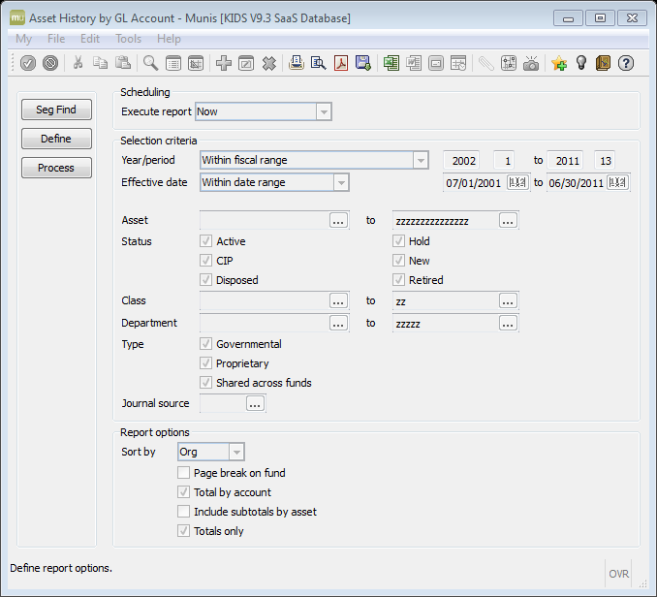

  - Select Process
  - Select Excel Output icon
- Calculate (in column H) the Net of Debit Amt/Credit Amt (per org/object) in the spreadsheet.
- Find the Balance Sheet accounts in the General Ledger for the asset balance sheet org/objects. If the year has been closed then process the Balance Sheet for funds 8-84 otherwise Go to the GL Account Inquiry to find the GL balances as follows

Select:
Financials > General Ledger Menu > Inquiries and Reports > Account Inquiry
    - Find on org=8* and object=62*
    - Select
- Enter (in column I) the General Ledger amounts from the Balance Sheet or the GL Account Inquiry (memo field) balances per org/object.
- Calculate any differences between the Fixed Asset and General Ledger amounts in column J.

GENERATING THE FIXED ASSETS DEPRECIATION SCHEDULE
Process the Fixed Assets Depreciation Schedule as follows:
Financials > Fixed Assets > Inquiries and Reports > Asset Depreciation Schedule
The following screen is displayed:
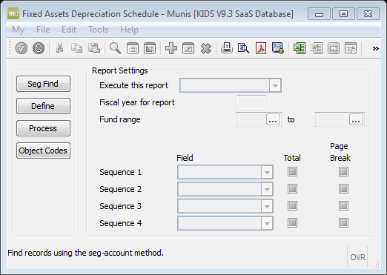

- Select Seg Find
  - Enter 0740 in the Object code field
  - Select
- Select Define
- Enter the fiscal year in the Fiscal Year for report field.
NOTE: The report can be run for the current or two prior years.
  - Enter Sequence report by fields as follows:
    - 1 in Asset Type
    - 2 in Class
- Select
- Select Process
Note: The Object Codes tab does NOT need to be selected. This information was already preset with the KDE asset balance sheet accounts and does NOT require entry. The Balance sheet object codes are used to calculate each asset’s LTD Accumulated depreciation balance based on the asset’s history transactions through the fiscal year specified on the report.
- Select File and Output or click on to print, to display, for PDF version, for Excel version or to save the report..
NOTE: It is recommended to produce an EXCEL version of the report to assist in verifying the data. For example, sorting by status and confirming the conditions of assets appearing on the report as identified below under “Things to verify.”
Sample:
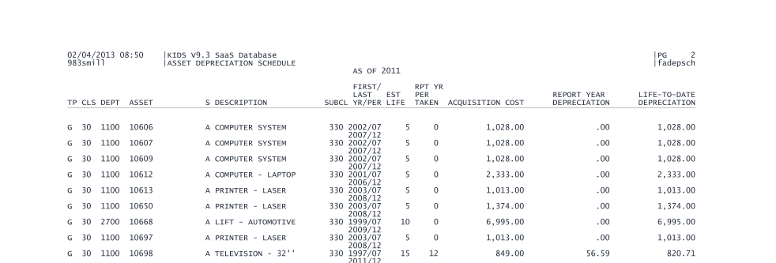

VERIFYING THE REPORT
This report does NOT reflect any GEN or GRV journal entries posted to the fixed asset accounts. Assets will NOT appear if they have zero balances for the both the current year deprecation and LTD Accumulated depreciation for the year reported. Differences between the fixed asset master records and the fixed asset history records will become evident in the following verification process.

REPORT YEAR - CURRENT YEAR DEPRECIATION
Current year deprecation amounts reported are Fixed Asset history transactions posted to the object code 0740 as specified during the “Seg Find” process for the reported year. The Current Year activity for object code=0740 should be equal to the total amount of Depreciation expense posted to the General Ledger from the Fixed Asset module. The report does NOT reflect GEN or GRV journal entries posted to the 0740 object code.

Things to verify:
- Assets listed with $0 current year depreciation should ONLY be Active assets (Status A under column E (labeled S) of the printed report) AND have a balance in the Life-To-Date Depreciation column for the report year.
- Retired assets (Reported as R under Column E) appearing on the report should have current year depreciation and $0 in the Life-To-Date Depreciation column.
- Total of Current Year Deprecation should = GL Inquiry for object code 0740 totals for Asset Funds for the report year.

LIFE-TO-DATE DEPRECIATION
Life-To-Date (LTD) Depreciation or LTD Accumulated Depreciation amounts reported are the asset history transactions posted to the Fixed Asset balance sheet object codes (62?2) through the report year.
Things to verify:
- Assets with $0 in the LTD Depreciation should ONLY be Retired assets with final depreciation expense for the report year.
- A negative LTD Depreciation is incorrect and should be corrected.
- Total of Life-To-Date Depreciation should =GL Inquiry object code 62?2 for Asset Funds for the report year.

ACQUISITION COST TOTAL
Acquisition cost amounts reported are pulled directly from the Fixed Asset Master File Maintenance or Asset Inquiry. Therefore, any differences between the master file and the asset history transactions posted for the acquisition cost will appear when verifying this total. Once the Fixed Asset master file matches the Fixed Asset History transaction records, then reconciliation is possible to verify the total depreciable assets reported on the Depreciation Schedule for the report year.

Things to verify:
- Assets appearing on the report with a sub-class of 110 or 610 need to be corrected as they should NOT have depreciation. This may happen if the asset is coded incorrectly to either the wrong sub-class code or to the wrong org/object codes or the Flag to depreciate is Y on the asset. A correction is required and should be posted to the report year (period 13) to reverse the expense or to the correct the org/object and sub-class codes. Then reprocess the report.
- Total of Acquisition cost on the report should = calculated Depreciable asset total which is the totals of object codes = 62?1 excluding land and CWIP (object codes 6201 and 6261). SEE STEPS BELOW TO VERIFY ACQUISITION COST ON THE REPORT.
Calculation as follows to verify Acquisition Cost total:
Depreciable Asset total: General Ledger or FA History net-62?1
Less net land (6201)
Less Construction Work In Progress (6261)
Depreciable Asset total = A

- Calculate the Total Asset History Acquisition cost by subtracting the Report Total of the Credit amount from the Debit amount for the sum of object codes 62?1. (See Appendix A.)
- Subtract from the Total Asset History Acquisition cost (calculated in the previous step) the Net of Debit and Credit for non-depreciable assets which would include the following:
  - Land (object code 6201)
  - Construction Work in Progress (object code 6261)
  - This provides a total for non-depreciable assets.

- Compare this calculated Depreciable Asset total (A) to the Active Total of the Acquisition Cost column on the Depreciation Schedule as shown below.
Depreciation Schedule report total page
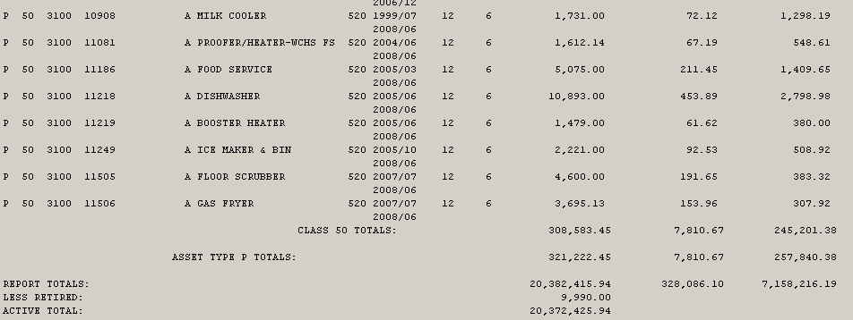
- Any differences will need to be investigated.
  - Determine if any land assets (sub-class 110) or Construction Work in Progress or CWIP (sub-class 610) are included on the report, this is due to an error and needs to be corrected via adjustments.
  - Subtract any sub-class 110 or 610 asset acquisition costs from the Active Total.
Adjusted Active Total: Active Total on the report (Report total less Retired)
Less any land or CWIP included in the report (subclass 110 or 610)
Adjusted Active totals on the report = B
- Compare A to B as calculated above: Depreciable Asset total to Adjusted Active Total. Differences can occur due to the Acquisition cost History total not equal to the actual Acquisition cost on the report that is pulled from the asset master. If this is the case, then begin by comparing totals by Governmental and Proprietary and then by sub-class totals to determine where the difference exists.
- Make the necessary corrections and post to period 13 and reprocess the report.

APPENDIX A

Generating a Fixed Asset History Report for Total Acquisition Cost

Select:
Financials > Fixed Assets > Inquiries and Reports > Asset History by GL Account
- Select Seg Find
  - Enter 62?1 in the Object field
    - Select
  - Select Define
    - Enter 2002/01-20XX/13 in Year/period field (where XX=fiscal year reporting through)
    - Enter 07/01/2001 to CURRENT DATE in the Effective date fields
    - Check the boxes
Totals by account
Totals only
The screen should appear as follows:
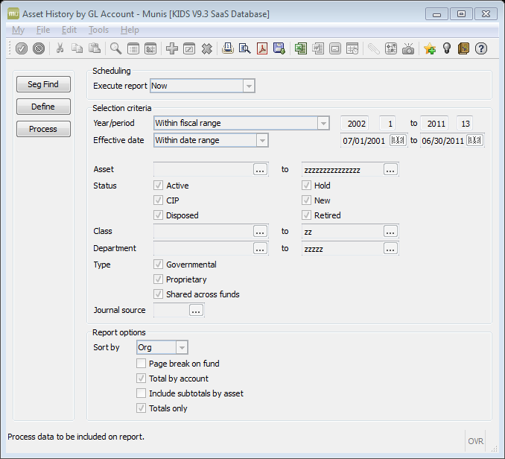
- Select
- Select Process
- Select desired option to view report: print , display , PDF or Excel .
Sample report:
