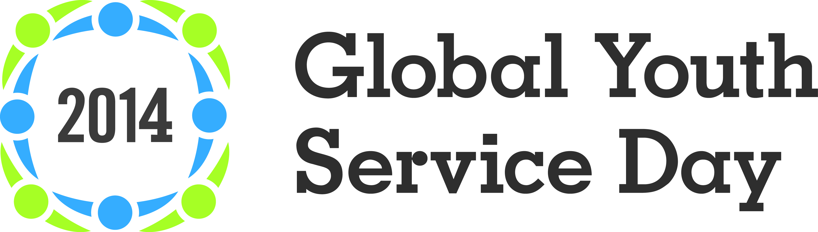

Sample Email “Pitch” and Press Release

The sample pitch and press release are intended as helpful guides. Project organizers are encouraged to customize them to best fit their project, style, organization, and audience. Think about including your young people in crafting the messages below—it’s a great learning experience!

STEP 1 Research contact information for reporters, bloggers, news outlets that may be interested in your GYSD project. A small, well-researched list will give you better results than a large, general list. Use Google, flip through newspapers to see who’s writing about your community or youth issues, or give a quick call to the newspapers main number to ask for a specific reporter’s email.

STEP 2 Customize your press release and pitches. Personalize your pitch for each individual report/blogger (no mass emails). Proofread carefully.

STEP 3 Send your pitch and press release approximately 2-4 weeks before your preferred date of publication/broadcast. If you want to work with long-form radio programs or weekly newspapers, you may need to contact them 5-8 weeks in advance.

Step 4 Follow up by phone or email 2-3 days after sending, to make sure the reporter has received your press release. Offer any additional details of interest, and ask whether s/he would like more information.

Hi [NAME],

I wanted to send you a quick note about [ORGANIZATION’s] Global Youth Service Day celebrations on April XXXX. Led by the young people of [TOWN], we’ll be [briefly describe activity and the “who, what, when, where, why” Who’s participating? What do you hope to accomplish? Any VIP’s attending? INCLUDE ONLY THE MOST COMPELLING INFO HERE]. I’ve pasted a press release with additional details below, and I can provide more info and photos, and arrange interviews, if you’d like.

Do you think [NEWS OUTLET] may be interested in attending and covering our Global Youth Service Day activities? There are some great stories about inspiring young people, as well as photo opportunities, that I know would be meaningful to our community. I’ll follow up in a few days to see if you might want to attend. Thanks very much!

[YOUR NAME & CONTACT INFORMATION]

[PASTE YOUR PRESS RELEASE HERE]

[YOUR GROUP’S LOGO HERE, IF AVAILABLE]

FOR IMMEDIATE RELEASE

[CITY/REGION/GROUP/ORG] Youth Lead Community Change on
Global Youth Service Day, April [XX], 2014
[Optional subtitle may describe specific project. Example: “Operation Clean Sweep” is a youth-led initiative
designed to clean up Main Street, promote downtown revitalization]

[CITY, STATE], [(DATE)] – On [DATE OF PROJECT], [SENTENCE INTRODUCING LOCAL PROJECT AND THE WHO, WHAT, WHEN, WHERE. Example: On April 11, hundreds of teens will take to the streets of Smithtown for “Operation Clean Sweep,” a youth-led initiative designed to beautify Main Street]. The young people join millions of others around the globe who are celebrating Global Youth Service Day. Editor’s note: Media are invited to attend [YOUR ORG/GROUP’S] Global Youth Service Day activities. Interviews and photos are available upon request.

[INSERT A BRIEF PARAGRAPH OF 3-4 SENTENCES ABOUT YOUR SPECIFIC, LOCAL GYSD PROJECT. WHAT ARE THE PRIMARY GOALS/ISSUES THE PROJECT ADDRESSES? HOW MANY YOUTH VOLUNTEERS ARE INVOLVED AND HOW MANY PEOPLE MAY BE SERVED? EMPHASIZE PROJECTS ARE YOUTH-LED.]

Global Youth Service Day recognizes the positive impact that young people have on their communities 365 days a year. GYSD is celebrated in more than 135 countries with youth-led service projects.

“Congratulations and thanks to the young people of [INSERT LOCATION/REGION] for their work to improve their community,” said Steven A. Culbertson, president of YSA (Youth Service America), the founder and chief convener of GYSD. “On Global Youth Service Day, the world stands in awe as we see what’s possible when kids take the lead as change-makers.”

[Optional: INSERT QUOTE FROM SCHOOL/PROJECT COORDINATOR/YOUTH. GREAT QUOTES ARE SHORT, PUNCHY, AND ADD AN OPINION OR IDEA.]

###

[YOUR SCHOOL/ORG’S SHORT BOILERPLATE DESCRIPTION, IF APPLICABLE]

Celebrating 26 years, Global Youth Service Day (April 11-13, 2014) recognizes the positive impact that young people have to their communities year-round. Held each year in April, Global Youth Service Day is a time when millions of young people come together for celebrations and community service projects, often designed to address and raise awareness around tough community issues. With GYSD projects in all 50 states and more than 100 countries, GYSD is the largest service event in the world.

Learn more and browse GYSD activities around the world on the GYSD Map at www.GYSD.org.
Connect on Facebook at www.facebook.com/globalyouthserviceday and on Twitter @YouthService and #GYSD.
Local Media Contact:

[Your Name]
[Your School/Organization, if applicable]
[Your Number]
[Your Email]

