CONFIDENTIAL

Business Plan

,

Table of Contents
Executive Summary 1
Summary 1
Management Team 1
Products and Services 1
Customers 1
Marketing and Sales 1
Financial Forecast 1
Required Funds 1
Company and Financing 1
Company Overview 1
Management Team 1
Required Funds 1
Exit Strategy 1
Mission Statement 1
Company History 1
Locations and Facilities 1
Products and Services 2
Products and Services 2
Competitors 2
Sourcing and Fulfillment 2
Technology 2
Intellectual Property 2
Future Products and Services 2
Customers 3
Market Overview 3
Market Needs 3
Market Trends 3
Market Growth 3
Industry Analysis 3
Key Customers 3
Marketing and Sales 3
Overview 3
Positioning 3
Pricing 3
Promotion 3
Distribution 3
Strategy and Implementation 3
Milestones 3
SWOT Analysis 3
Competitive Edge 3
Strategic Alliances 3
Financial Plan 3
Sales Forecast 3
Personnel Plan 4
Budget 4
Cash Flow Assumptions 6
Loans and Investments 6
Starting Balances 6
Historical Financials 7
Key Metrics for Success 7
Financial Statements 8
Profit and Loss Statement Table 8
Balance Sheet Table 10
Cash Flow Statement Table 11
Financial Ratio Table 13
Appendix 16
Sales Forecast 16
Personnel Plan 18
Budget 19
Loans and Investments 21
Profit and Loss Statement 22
Balance Sheet 25
Cash Flow Statement 31
Glossary 37

Executive Summary

Summary

Management Team

Products and Services

Customers

Marketing and Sales

Financial Forecast

Required Funds

Company and Financing

Company Overview

Management Team

Required Funds

Exit Strategy

Mission Statement

Company History

Locations and Facilities

Products and Services

Products and Services

Competitors

Sourcing and Fulfillment

Technology

Intellectual Property

Future Products and Services

Customers

Market Overview

Market Needs

Market Trends

Market Growth

Industry Analysis

Key Customers

Marketing and Sales

Overview

Positioning

Pricing

Promotion

Distribution

Strategy and Implementation

Milestones

SWOT Analysis

Competitive Edge

Strategic Alliances

Financial Plan

Sales Forecast

Sales Forecast Table
 | Year 1 | Year 2 | Year 3
Unit Sales
Price Per Unit
Sales
Total Sales | $0 | $0 | $0
Direct Cost Per Unit
Direct Cost
Total Direct Cost | $0 | $0 | $0
Gross Profit | $0 | $0 | $0
Gross Profit % | (0%) | (0%) | (0%)

Sales by Month
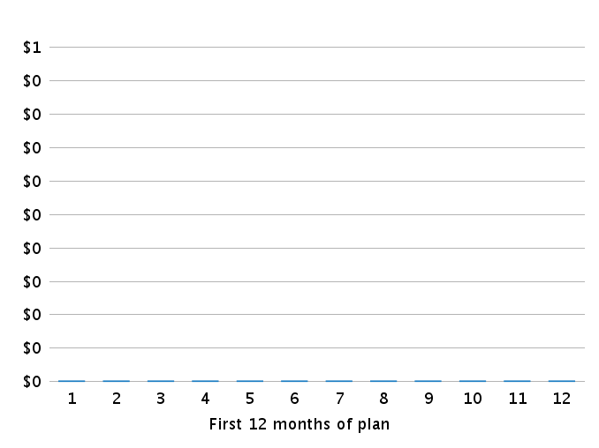

Personnel Plan

Personnel Table
 | Year 1 | Year 2 | Year 3
Total | $0 | $0 | $0

Budget

Budget Table
 | Year 1 | Year 2 | Year 3
Expenses
Salary | $0 | $0 | $0
Employee Related Expenses | $0 | $0 | $0
Total Expenses | $0 | $0 | $0
Long-term Assets
Total Long-term Assets | $0 | $0 | $0
Other Current Assets
Total Other Current Assets | $0 | $0 | $0
Dividends and Distributions
Total Dividends and Distributions | $0 | $0 | $0

Expenses by Month

Cash Flow Assumptions

Cash Flow Assumptions Table
Cash Inflow
% of Sales on Credit | 0%
 | 0 days
Cash Outflow
% of Purchases on Credit | 0 %
Avg Payment Period (Days) | 0 days
Inventory
Months to Keep on Hand
Minimum Inventory Purchase

Loans and Investments

Loans and Investments Table
 | Year 1 | Year 2 | Year 3
Total Amount Received | $0 | $0 | $0

Starting Balances
Sales
Sales Last Month | $0
Sales 2 Months Ago | $0
Sales 3 Months Ago | $0
Sales 4 Months Ago | $0
Sales 5 Months Ago | $0
Sales 6 Months Ago | $0
Assets
Cash | $0
Accounts Receivable | $0
Inventory | $0
Other Current Assets | $0
Long-Term Assets | $0
Accumulated Depreciation | $0
Liabilities
Accounts Payable | $0
Sales Taxes Payable | $0
Capital
Paid-in Capital | $0
Retained Earnings | $0

Historical Financials

Key Metrics for Success

Financial Statements

Profit and Loss Statement Table
 | Year 1 | Year 2 | Year 3
Revenue | $0 | $0 | $0
Direct Cost | $0 | $0 | $0
Gross Profit | $0 | $0 | $0
Gross Profit % | (0%) | (0%) | (0%)
Operating Expenses
Salary | $0 | $0 | $0
Employee Related Expenses | $0 | $0 | $0
Expensed Portion of Other Current Assets | $0 | $0 | $0
Depreciation and Amortization | $0 | $0 | $0
Total Operating Expenses | $0 | $0 | $0
Operating Income | $0 | $0 | $0
Other Expenses (& Other Income)
Loss (or Gain) on Sale of Asset | $0 | $0 | $0
Interest Expense | $0 | $0 | $0
Total Other Expenses (& Other Income) | $0 | $0 | $0
Income Before Income Tax | $0 | $0 | $0
Income Taxes | $0 | $0 | $0
Net Income | $0 | $0 | $0
Net Income / Sales | (0%) | (0%) | (0%)

Gross Margin by Year
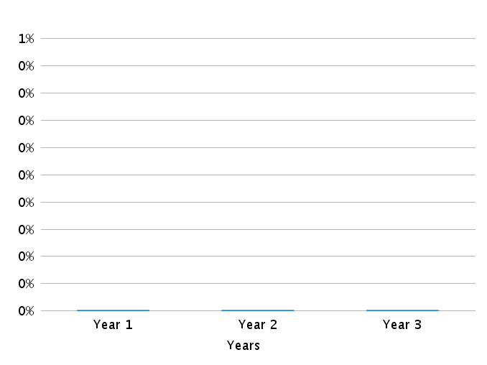

Net Profit (or Loss) by Year
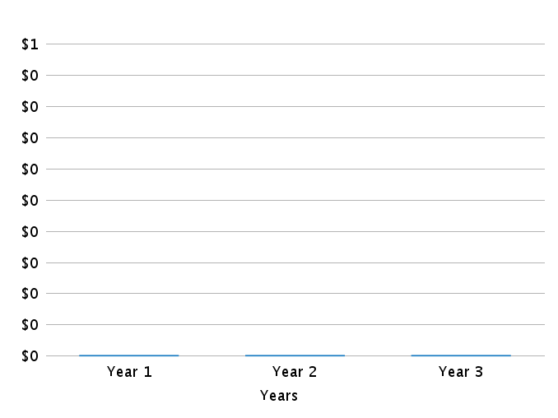

Balance Sheet Table
As of Period's End | Starting Balances | Year 1 | Year 2 | Year 3
Cash | $0 | $0 | $0 | $0
Accounts Receivable | $0 | $0 | $0 | $0
Inventory | $0 | $0 | $0 | $0
Other Current Assets | $0 | $0 | $0 | $0
Total Current Assets | $0 | $0 | $0 | $0
Long-Term Assets | $0 | $0 | $0 | $0
Accumulated Depreciation | $0 | $0 | $0 | $0
Total Long Term Assets | $0 | $0 | $0 | $0
TOTAL ASSETS | $0 | $0 | $0 | $0
Accounts Payable | $0 | $0 | $0 | $0
Sales Taxes Payable | $0 | $0 | $0 | $0
Short-Term Debt | $0 | $0 | $0 | $0
Total Current Liabilities | $0 | $0 | $0 | $0
Long-Term Debt | $0 | $0 | $0 | $0
TOTAL LIABILITIES | $0 | $0 | $0 | $0
Paid-in Capital | $0 | $0 | $0 | $0
Retained Earnings | $0 | $0 | $0 | $0
Profit and Loss - Current Period | $0 | $0 | $0 | $0
TOTAL OWNER'S EQUITY | $0 | $0 | $0 | $0
TOTAL LIABILITIES & EQUITY | $0 | $0 | $0 | $0

Cash Flow Statement Table
 | Year 1 | Year 2 | Year 3
OPERATING ACTIVITIES
Net Income | $0 | $0 | $0
Depreciation and Amortization | $0 | $0 | $0
Gain or Loss on Disposal of Asset | $0 | $0 | $0
Change in Accounts Receivable | $0 | $0 | $0
Change in Inventory | $0 | $0 | $0
Change in Accounts Payable | $0 | $0 | $0
Change in Sales Taxes Payable | $0 | $0 | $0
Change in Other Current Assets | $0 | $0 | $0
Net Cash from Operating Activities | $0 | $0 | $0
INVESTING & FINANCING ACTIVITIES
Long-Term Assets Purchased or Sold | $0 | $0 | $0
Investments and Contributions Received | $0 | $0 | $0
Change in Short-Term Debt | $0 | $0 | $0
Change in Long-Term Debt | $0 | $0 | $0
Dividends and Distributions | $0 | $0 | $0
Net Cash from Investing & Financing | $0 | $0 | $0
Cash at Beginning of Period | $0 | $0 | $0
Net Change in Cash | $0 | $0 | $0
Cash at End of Period | $0 | $0 | $0

Cash Flow by Month
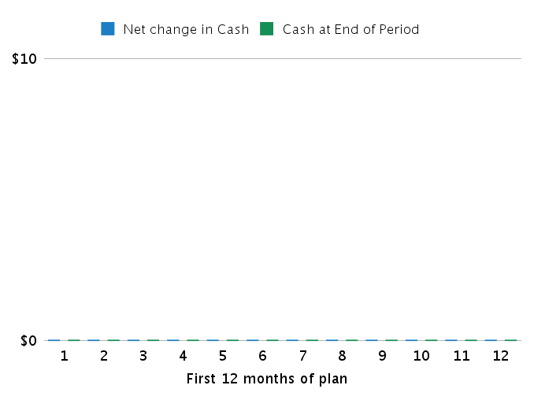

Cash Flow by Year
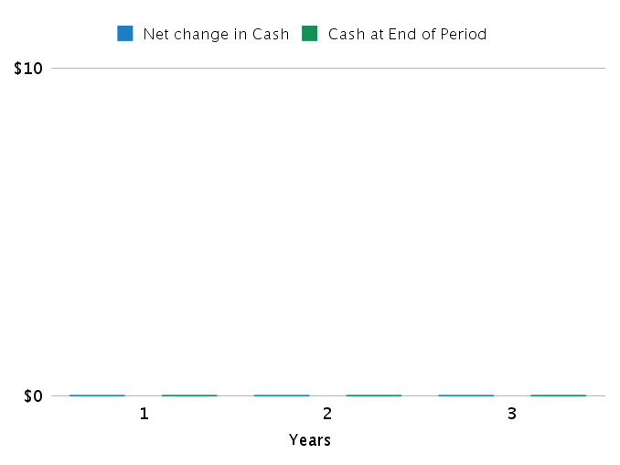

Financial Ratio Table
 | Projected
As of Period's End | Year 1 | Year 2 | Year 3
Liquidity Analysis
Net working capital | $0 | $0 | $0
Current ratio | 0% | 0% | 0%
Quick ratio | 0% | 0% | 0%
Profitability Analysis
Gross profit margin | 0% | 0% | 0%
Operating profit margin | 0% | 0% | 0%
Net profit margin | 0% | 0% | 0%
Debt Ratios
Debt to assets | 0% | 0% | 0%
Debt to equity | 0% | 0% | 0%
Investment Measures
ROI | 0% | 0% | 0%

Appendix

Sales Forecast

Table (With Monthly Detail)
Year1 | Y1 M1 | Y1 M2 | Y1 M3 | Y1 M4 | Y1 M5 | Y1 M6 | Y1 M7 | Y1 M8 | Y1 M9 | Y1 M10 | Y1 M11 | Y1 M12
Units Sales
Price Per Unit
Sales
Total Sales | $0 | $0 | $0 | $0 | $0 | $0 | $0 | $0 | $0 | $0 | $0 | $0
Direct Cost Per Unit
Direct Cost
Total Direct Cost | $0 | $0 | $0 | $0 | $0 | $0 | $0 | $0 | $0 | $0 | $0 | $0
Gross Margin | $0 | $0 | $0 | $0 | $0 | $0 | $0 | $0 | $0 | $0 | $0 | $0
Gross Margin % | (0%) | (0%) | (0%) | (0%) | (0%) | (0%) | (0%) | (0%) | (0%) | (0%) | (0%) | (0%)

Year2 | Y2 M1 | Y2 M2 | Y2 M3 | Y2 M4 | Y2 M5 | Y2 M6 | Y2 M7 | Y2 M8 | Y2 M9 | Y2 M10 | Y2 M11 | Y2 M12
Units Sales
Price Per Unit
Sales
Total Sales | $0 | $0 | $0 | $0 | $0 | $0 | $0 | $0 | $0 | $0 | $0 | $0
Direct Cost Per Unit
Direct Cost
Total Direct Cost | $0 | $0 | $0 | $0 | $0 | $0 | $0 | $0 | $0 | $0 | $0 | $0
Gross Margin | $0 | $0 | $0 | $0 | $0 | $0 | $0 | $0 | $0 | $0 | $0 | $0
Gross Margin % | (0%) | (0%) | (0%) | (0%) | (0%) | (0%) | (0%) | (0%) | (0%) | (0%) | (0%) | (0%)

Year3 | Y3 M1 | Y3 M2 | Y3 M3 | Y3 M4 | Y3 M5 | Y3 M6 | Y3 M7 | Y3 M8 | Y3 M9 | Y3 M10 | Y3 M11 | Y3 M12
Units Sales
Price Per Unit
Sales
Total Sales | $0 | $0 | $0 | $0 | $0 | $0 | $0 | $0 | $0 | $0 | $0 | $0
Direct Cost Per Unit
Direct Cost
Total Direct Cost | $0 | $0 | $0 | $0 | $0 | $0 | $0 | $0 | $0 | $0 | $0 | $0
Gross Margin | $0 | $0 | $0 | $0 | $0 | $0 | $0 | $0 | $0 | $0 | $0 | $0
Gross Margin % | (0%) | (0%) | (0%) | (0%) | (0%) | (0%) | (0%) | (0%) | (0%) | (0%) | (0%) | (0%)

 | Year 1 | Year 2 | Year 3
Unit Sales
Price Per Unit
Sales
Total Sales | $0 | $0 | $0
Direct Cost Per Unit
Direct Cost
Total Direct Cost | $0 | $0 | $0
Gross Profit | $0 | $0 | $0
Gross Profit % | (0%) | (0%) | (0%)

Personnel Plan

Personnel Table (With Monthly Detail)
Year1 | Y1 M1 | Y1 M2 | Y1 M3 | Y1 M4 | Y1 M5 | Y1 M6 | Y1 M7 | Y1 M8 | Y1 M9 | Y1 M10 | Y1 M11 | Y1 M12
Total | $0 | $0 | $0 | $0 | $0 | $0 | $0 | $0 | $0 | $0 | $0 | $0

Year2 | Y2 M1 | Y2 M2 | Y2 M3 | Y2 M4 | Y2 M5 | Y2 M6 | Y2 M7 | Y2 M8 | Y2 M9 | Y2 M10 | Y2 M11 | Y2 M12
Total | $0 | $0 | $0 | $0 | $0 | $0 | $0 | $0 | $0 | $0 | $0 | $0

Year3 | Y3 M1 | Y3 M2 | Y3 M3 | Y3 M4 | Y3 M5 | Y3 M6 | Y3 M7 | Y3 M8 | Y3 M9 | Y3 M10 | Y3 M11 | Y3 M12
Total | $0 | $0 | $0 | $0 | $0 | $0 | $0 | $0 | $0 | $0 | $0 | $0

 | Year 1 | Year 2 | Year 3
Total | $0 | $0 | $0

Budget

Budget Table (With Monthly Detail)
Year1 | Y1 M1 | Y1 M2 | Y1 M3 | Y1 M4 | Y1 M5 | Y1 M6 | Y1 M7 | Y1 M8 | Y1 M9 | Y1 M10 | Y1 M11 | Y1 M12
Expenses
Salary | $0 | $0 | $0 | $0 | $0 | $0 | $0 | $0 | $0 | $0 | $0 | $0
Employee Related Expenses | $0 | $0 | $0 | $0 | $0 | $0 | $0 | $0 | $0 | $0 | $0 | $0
Total Expenses | $0 | $0 | $0 | $0 | $0 | $0 | $0 | $0 | $0 | $0 | $0 | $0
Long-term Assets
Total Long-term Assets | $0 | $0 | $0 | $0 | $0 | $0 | $0 | $0 | $0 | $0 | $0 | $0
Other Current Assets
Total Other Current Assets | $0 | $0 | $0 | $0 | $0 | $0 | $0 | $0 | $0 | $0 | $0 | $0
Dividends and Distributions
Total Dividends and Distributions | $0 | $0 | $0 | $0 | $0 | $0 | $0 | $0 | $0 | $0 | $0 | $0
Year2 | Y2 M1 | Y2 M2 | Y2 M3 | Y2 M4 | Y2 M5 | Y2 M6 | Y2 M7 | Y2 M8 | Y2 M9 | Y2 M10 | Y2 M11 | Y2 M12
Expenses
Salary | $0 | $0 | $0 | $0 | $0 | $0 | $0 | $0 | $0 | $0 | $0 | $0
Employee Related Expenses | $0 | $0 | $0 | $0 | $0 | $0 | $0 | $0 | $0 | $0 | $0 | $0
Total Expenses | $0 | $0 | $0 | $0 | $0 | $0 | $0 | $0 | $0 | $0 | $0 | $0
Long-term Assets
Total Long-term Assets | $0 | $0 | $0 | $0 | $0 | $0 | $0 | $0 | $0 | $0 | $0 | $0
Other Current Assets
Total Other Current Assets | $0 | $0 | $0 | $0 | $0 | $0 | $0 | $0 | $0 | $0 | $0 | $0
Dividends and Distributions
Total Dividends and Distributions | $0 | $0 | $0 | $0 | $0 | $0 | $0 | $0 | $0 | $0 | $0 | $0
Year3 | Y3 M1 | Y3 M2 | Y3 M3 | Y3 M4 | Y3 M5 | Y3 M6 | Y3 M7 | Y3 M8 | Y3 M9 | Y3 M10 | Y3 M11 | Y3 M12
Expenses
Salary | $0 | $0 | $0 | $0 | $0 | $0 | $0 | $0 | $0 | $0 | $0 | $0
Employee Related Expenses | $0 | $0 | $0 | $0 | $0 | $0 | $0 | $0 | $0 | $0 | $0 | $0
Total Expenses | $0 | $0 | $0 | $0 | $0 | $0 | $0 | $0 | $0 | $0 | $0 | $0
Long-term Assets
Total Long-term Assets | $0 | $0 | $0 | $0 | $0 | $0 | $0 | $0 | $0 | $0 | $0 | $0
Other Current Assets
Total Other Current Assets | $0 | $0 | $0 | $0 | $0 | $0 | $0 | $0 | $0 | $0 | $0 | $0
Dividends and Distributions
Total Dividends and Distributions | $0 | $0 | $0 | $0 | $0 | $0 | $0 | $0 | $0 | $0 | $0 | $0

 | Year 1 | Year 2 | Year 3
Expenses
Salary | $0 | $0 | $0
Employee Related Expenses | $0 | $0 | $0
Total Expenses | $0 | $0 | $0
Long-term Assets
Total Long-term Assets | $0 | $0 | $0
Other Current Assets
Total Other Current Assets | $0 | $0 | $0
Dividends and Distributions
Total Dividends and Distributions | $0 | $0 | $0

Loans and Investments

Loans and Investments Table (With Monthly Detail)
Year1 | Y1 M1 | Y1 M2 | Y1 M3 | Y1 M4 | Y1 M5 | Y1 M6 | Y1 M7 | Y1 M8 | Y1 M9 | Y1 M10 | Y1 M11 | Y1 M12
Total Amount Received | $0 | $0 | $0 | $0 | $0 | $0 | $0 | $0 | $0 | $0 | $0 | $0

Year2 | Y2 M1 | Y2 M2 | Y2 M3 | Y2 M4 | Y2 M5 | Y2 M6 | Y2 M7 | Y2 M8 | Y2 M9 | Y2 M10 | Y2 M11 | Y2 M12
Total Amount Received | $0 | $0 | $0 | $0 | $0 | $0 | $0 | $0 | $0 | $0 | $0 | $0

Year3 | Y3 M1 | Y3 M2 | Y3 M3 | Y3 M4 | Y3 M5 | Y3 M6 | Y3 M7 | Y3 M8 | Y3 M9 | Y3 M10 | Y3 M11 | Y3 M12
Total Amount Received | $0 | $0 | $0 | $0 | $0 | $0 | $0 | $0 | $0 | $0 | $0 | $0

 | Year 1 | Year 2 | Year 3
Total Amount Received | $0 | $0 | $0

Profit and Loss Statement

Profit and Loss Statement (With Monthly Detail)
Year1 | Y1 M1 | Y1 M2 | Y1 M3 | Y1 M4 | Y1 M5 | Y1 M6 | Y1 M7 | Y1 M8 | Y1 M9 | Y1 M10 | Y1 M11 | Y1 M12
Revenue | $0 | $0 | $0 | $0 | $0 | $0 | $0 | $0 | $0 | $0 | $0 | $0
Direct Cost | $0 | $0 | $0 | $0 | $0 | $0 | $0 | $0 | $0 | $0 | $0 | $0
Gross Profit | $0 | $0 | $0 | $0 | $0 | $0 | $0 | $0 | $0 | $0 | $0 | $0
Gross Profit % | (0%) | (0%) | (0%) | (0%) | (0%) | (0%) | (0%) | (0%) | (0%) | (0%) | (0%) | (0%)
Operating Expenses
Salary | $0 | $0 | $0 | $0 | $0 | $0 | $0 | $0 | $0 | $0 | $0 | $0
Employee Related Expenses | $0 | $0 | $0 | $0 | $0 | $0 | $0 | $0 | $0 | $0 | $0 | $0
Expensed Portion of Other Current Assets | $0 | $0 | $0 | $0 | $0 | $0 | $0 | $0 | $0 | $0 | $0 | $0
Depreciation and Amortization | $0 | $0 | $0 | $0 | $0 | $0 | $0 | $0 | $0 | $0 | $0 | $0
Total Operating Expenses | $0 | $0 | $0 | $0 | $0 | $0 | $0 | $0 | $0 | $0 | $0 | $0
Operating Income | $0 | $0 | $0 | $0 | $0 | $0 | $0 | $0 | $0 | $0 | $0 | $0
Other Expenses (& Other Income)
Loss (or Gain) on Sale of Asset | $0 | $0 | $0 | $0 | $0 | $0 | $0 | $0 | $0 | $0 | $0 | $0
Interest Expense | $0 | $0 | $0 | $0 | $0 | $0 | $0 | $0 | $0 | $0 | $0 | $0
Total Other Expenses (& Other Income) | $0 | $0 | $0 | $0 | $0 | $0 | $0 | $0 | $0 | $0 | $0 | $0
Income Before Income Tax | $0 | $0 | $0 | $0 | $0 | $0 | $0 | $0 | $0 | $0 | $0 | $0
Income Taxes | $0 | $0 | $0 | $0 | $0 | $0 | $0 | $0 | $0 | $0 | $0 | $0
Net Income | $0 | $0 | $0 | $0 | $0 | $0 | $0 | $0 | $0 | $0 | $0 | $0
Net Income / Sales | 0% | 0% | 0% | 0% | 0% | 0% | 0% | 0% | 0% | 0% | 0% | 0%

Year2 | Y2 M1 | Y2 M2 | Y2 M3 | Y2 M4 | Y2 M5 | Y2 M6 | Y2 M7 | Y2 M8 | Y2 M9 | Y2 M10 | Y2 M11 | Y2 M12
Revenue | $0 | $0 | $0 | $0 | $0 | $0 | $0 | $0 | $0 | $0 | $0 | $0
Direct Cost | $0 | $0 | $0 | $0 | $0 | $0 | $0 | $0 | $0 | $0 | $0 | $0
Gross Profit | $0 | $0 | $0 | $0 | $0 | $0 | $0 | $0 | $0 | $0 | $0 | $0
Gross Profit % | (0%) | (0%) | (0%) | (0%) | (0%) | (0%) | (0%) | (0%) | (0%) | (0%) | (0%) | (0%)
Operating Expenses
Salary | $0 | $0 | $0 | $0 | $0 | $0 | $0 | $0 | $0 | $0 | $0 | $0
Employee Related Expenses | $0 | $0 | $0 | $0 | $0 | $0 | $0 | $0 | $0 | $0 | $0 | $0
Expensed Portion of Other Current Assets | $0 | $0 | $0 | $0 | $0 | $0 | $0 | $0 | $0 | $0 | $0 | $0
Depreciation and Amortization | $0 | $0 | $0 | $0 | $0 | $0 | $0 | $0 | $0 | $0 | $0 | $0
Total Operating Expenses | $0 | $0 | $0 | $0 | $0 | $0 | $0 | $0 | $0 | $0 | $0 | $0
Operating Income | $0 | $0 | $0 | $0 | $0 | $0 | $0 | $0 | $0 | $0 | $0 | $0
Other Expenses (& Other Income)
Loss (or Gain) on Sale of Asset | $0 | $0 | $0 | $0 | $0 | $0 | $0 | $0 | $0 | $0 | $0 | $0
Interest Expense | $0 | $0 | $0 | $0 | $0 | $0 | $0 | $0 | $0 | $0 | $0 | $0
Total Other Expenses (& Other Income) | $0 | $0 | $0 | $0 | $0 | $0 | $0 | $0 | $0 | $0 | $0 | $0
Income Before Income Tax | $0 | $0 | $0 | $0 | $0 | $0 | $0 | $0 | $0 | $0 | $0 | $0
Income Taxes | $0 | $0 | $0 | $0 | $0 | $0 | $0 | $0 | $0 | $0 | $0 | $0
Net Income | $0 | $0 | $0 | $0 | $0 | $0 | $0 | $0 | $0 | $0 | $0 | $0
Net Income / Sales | 0% | 0% | 0% | 0% | 0% | 0% | 0% | 0% | 0% | 0% | 0% | 0%

Year3 | Y3 M1 | Y3 M2 | Y3 M3 | Y3 M4 | Y3 M5 | Y3 M6 | Y3 M7 | Y3 M8 | Y3 M9 | Y3 M10 | Y3 M11 | Y3 M12
Revenue | $0 | $0 | $0 | $0 | $0 | $0 | $0 | $0 | $0 | $0 | $0 | $0
Direct Cost | $0 | $0 | $0 | $0 | $0 | $0 | $0 | $0 | $0 | $0 | $0 | $0
Gross Profit | $0 | $0 | $0 | $0 | $0 | $0 | $0 | $0 | $0 | $0 | $0 | $0
Gross Profit % | (0%) | (0%) | (0%) | (0%) | (0%) | (0%) | (0%) | (0%) | (0%) | (0%) | (0%) | (0%)
Operating Expenses
Salary | $0 | $0 | $0 | $0 | $0 | $0 | $0 | $0 | $0 | $0 | $0 | $0
Employee Related Expenses | $0 | $0 | $0 | $0 | $0 | $0 | $0 | $0 | $0 | $0 | $0 | $0
Expensed Portion of Other Current Assets | $0 | $0 | $0 | $0 | $0 | $0 | $0 | $0 | $0 | $0 | $0 | $0
Depreciation and Amortization | $0 | $0 | $0 | $0 | $0 | $0 | $0 | $0 | $0 | $0 | $0 | $0
Total Operating Expenses | $0 | $0 | $0 | $0 | $0 | $0 | $0 | $0 | $0 | $0 | $0 | $0
Operating Income | $0 | $0 | $0 | $0 | $0 | $0 | $0 | $0 | $0 | $0 | $0 | $0
Other Expenses (& Other Income)
Loss (or Gain) on Sale of Asset | $0 | $0 | $0 | $0 | $0 | $0 | $0 | $0 | $0 | $0 | $0 | $0
Interest Expense | $0 | $0 | $0 | $0 | $0 | $0 | $0 | $0 | $0 | $0 | $0 | $0
Total Other Expenses (& Other Income) | $0 | $0 | $0 | $0 | $0 | $0 | $0 | $0 | $0 | $0 | $0 | $0
Income Before Income Tax | $0 | $0 | $0 | $0 | $0 | $0 | $0 | $0 | $0 | $0 | $0 | $0
Income Taxes | $0 | $0 | $0 | $0 | $0 | $0 | $0 | $0 | $0 | $0 | $0 | $0
Net Income | $0 | $0 | $0 | $0 | $0 | $0 | $0 | $0 | $0 | $0 | $0 | $0
Net Income / Sales | 0% | 0% | 0% | 0% | 0% | 0% | 0% | 0% | 0% | 0% | 0% | 0%

Balance Sheet

Balance Sheet (With Monthly Detail)
As of Period's End | Starting Balances | Y1 M1 | Y1 M2 | Y1 M3 | Y1 M4 | Y1 M5 | Y1 M6 | Y1 M7 | Y1 M8 | Y1 M9 | Y1 M10 | Y1 M11 | Y1 M12
Cash | $0 | $0 | $0 | $0 | $0 | $0 | $0 | $0 | $0 | $0 | $0 | $0 | $0
Accounts Receivable | $0 | $0 | $0 | $0 | $0 | $0 | $0 | $0 | $0 | $0 | $0 | $0 | $0
Inventory | $0 | $0 | $0 | $0 | $0 | $0 | $0 | $0 | $0 | $0 | $0 | $0 | $0
Other Current Assets | $0 | $0 | $0 | $0 | $0 | $0 | $0 | $0 | $0 | $0 | $0 | $0 | $0
Total Current Assets | $0 | $0 | $0 | $0 | $0 | $0 | $0 | $0 | $0 | $0 | $0 | $0 | $0
Long-Term Assets | $0 | $0 | $0 | $0 | $0 | $0 | $0 | $0 | $0 | $0 | $0 | $0 | $0
Accumulated Depreciation | $0 | $0 | $0 | $0 | $0 | $0 | $0 | $0 | $0 | $0 | $0 | $0 | $0
Total Long-Term Assets | $0 | $0 | $0 | $0 | $0 | $0 | $0 | $0 | $0 | $0 | $0 | $0 | $0
Total Assets | $0 | $0 | $0 | $0 | $0 | $0 | $0 | $0 | $0 | $0 | $0 | $0 | $0
Accounts Payable | $0 | $0 | $0 | $0 | $0 | $0 | $0 | $0 | $0 | $0 | $0 | $0 | $0
Sales Taxes Payable | $0 | $0 | $0 | $0 | $0 | $0 | $0 | $0 | $0 | $0 | $0 | $0 | $0
Short-Term Debt | $0 | $0 | $0 | $0 | $0 | $0 | $0 | $0 | $0 | $0 | $0 | $0 | $0
Total Current Liabilities | $0 | $0 | $0 | $0 | $0 | $0 | $0 | $0 | $0 | $0 | $0 | $0 | $0
Long-Term Debt | $0 | $0 | $0 | $0 | $0 | $0 | $0 | $0 | $0 | $0 | $0 | $0 | $0
Total Liabilities | $0 | $0 | $0 | $0 | $0 | $0 | $0 | $0 | $0 | $0 | $0 | $0 | $0
Paid-in Capital | $0 | $0 | $0 | $0 | $0 | $0 | $0 | $0 | $0 | $0 | $0 | $0 | $0
Retained Earnings | $0 | $0 | $0 | $0 | $0 | $0 | $0 | $0 | $0 | $0 | $0 | $0 | $0
Profit and Loss - Current Period | $0 | $0 | $0 | $0 | $0 | $0 | $0 | $0 | $0 | $0 | $0 | $0 | $0
Total Owner's Equity | $0 | $0 | $0 | $0 | $0 | $0 | $0 | $0 | $0 | $0 | $0 | $0 | $0
Total Liabilities & Equity | $0 | $0 | $0 | $0 | $0 | $0 | $0 | $0 | $0 | $0 | $0 | $0 | $0

As of Period's End | Starting Balances | Y2 M1 | Y2 M2 | Y2 M3 | Y2 M4 | Y2 M5 | Y2 M6 | Y2 M7 | Y2 M8 | Y2 M9 | Y2 M10 | Y2 M11 | Y2 M12
Cash | $0 | $0 | $0 | $0 | $0 | $0 | $0 | $0 | $0 | $0 | $0 | $0 | $0
Accounts Receivable | $0 | $0 | $0 | $0 | $0 | $0 | $0 | $0 | $0 | $0 | $0 | $0 | $0
Inventory | $0 | $0 | $0 | $0 | $0 | $0 | $0 | $0 | $0 | $0 | $0 | $0 | $0
Other Current Assets | $0 | $0 | $0 | $0 | $0 | $0 | $0 | $0 | $0 | $0 | $0 | $0 | $0
Total Current Assets | $0 | $0 | $0 | $0 | $0 | $0 | $0 | $0 | $0 | $0 | $0 | $0 | $0
Long-Term Assets | $0 | $0 | $0 | $0 | $0 | $0 | $0 | $0 | $0 | $0 | $0 | $0 | $0
Accumulated Depreciation | $0 | $0 | $0 | $0 | $0 | $0 | $0 | $0 | $0 | $0 | $0 | $0 | $0
Total Long-Term Assets | $0 | $0 | $0 | $0 | $0 | $0 | $0 | $0 | $0 | $0 | $0 | $0 | $0
Total Assets | $0 | $0 | $0 | $0 | $0 | $0 | $0 | $0 | $0 | $0 | $0 | $0 | $0
Accounts Payable | $0 | $0 | $0 | $0 | $0 | $0 | $0 | $0 | $0 | $0 | $0 | $0 | $0
Sales Taxes Payable | $0 | $0 | $0 | $0 | $0 | $0 | $0 | $0 | $0 | $0 | $0 | $0 | $0
Short-Term Debt | $0 | $0 | $0 | $0 | $0 | $0 | $0 | $0 | $0 | $0 | $0 | $0 | $0
Total Current Liabilities | $0 | $0 | $0 | $0 | $0 | $0 | $0 | $0 | $0 | $0 | $0 | $0 | $0
Long-Term Debt | $0 | $0 | $0 | $0 | $0 | $0 | $0 | $0 | $0 | $0 | $0 | $0 | $0
Total Liabilities | $0 | $0 | $0 | $0 | $0 | $0 | $0 | $0 | $0 | $0 | $0 | $0 | $0
Paid-in Capital | $0 | $0 | $0 | $0 | $0 | $0 | $0 | $0 | $0 | $0 | $0 | $0 | $0
Retained Earnings | $0 | $0 | $0 | $0 | $0 | $0 | $0 | $0 | $0 | $0 | $0 | $0 | $0
Profit and Loss - Current Period | $0 | $0 | $0 | $0 | $0 | $0 | $0 | $0 | $0 | $0 | $0 | $0 | $0
Total Owner's Equity | $0 | $0 | $0 | $0 | $0 | $0 | $0 | $0 | $0 | $0 | $0 | $0 | $0
Total Liabilities & Equity | $0 | $0 | $0 | $0 | $0 | $0 | $0 | $0 | $0 | $0 | $0 | $0 | $0

As of Period's End | Starting Balances | Y3 M1 | Y3 M2 | Y3 M3 | Y3 M4 | Y3 M5 | Y3 M6 | Y3 M7 | Y3 M8 | Y3 M9 | Y3 M10 | Y3 M11 | Y3 M12
Cash | $0 | $0 | $0 | $0 | $0 | $0 | $0 | $0 | $0 | $0 | $0 | $0 | $0
Accounts Receivable | $0 | $0 | $0 | $0 | $0 | $0 | $0 | $0 | $0 | $0 | $0 | $0 | $0
Inventory | $0 | $0 | $0 | $0 | $0 | $0 | $0 | $0 | $0 | $0 | $0 | $0 | $0
Other Current Assets | $0 | $0 | $0 | $0 | $0 | $0 | $0 | $0 | $0 | $0 | $0 | $0 | $0
Total Current Assets | $0 | $0 | $0 | $0 | $0 | $0 | $0 | $0 | $0 | $0 | $0 | $0 | $0
Long-Term Assets | $0 | $0 | $0 | $0 | $0 | $0 | $0 | $0 | $0 | $0 | $0 | $0 | $0
Accumulated Depreciation | $0 | $0 | $0 | $0 | $0 | $0 | $0 | $0 | $0 | $0 | $0 | $0 | $0
Total Long-Term Assets | $0 | $0 | $0 | $0 | $0 | $0 | $0 | $0 | $0 | $0 | $0 | $0 | $0
Total Assets | $0 | $0 | $0 | $0 | $0 | $0 | $0 | $0 | $0 | $0 | $0 | $0 | $0
Accounts Payable | $0 | $0 | $0 | $0 | $0 | $0 | $0 | $0 | $0 | $0 | $0 | $0 | $0
Sales Taxes Payable | $0 | $0 | $0 | $0 | $0 | $0 | $0 | $0 | $0 | $0 | $0 | $0 | $0
Short-Term Debt | $0 | $0 | $0 | $0 | $0 | $0 | $0 | $0 | $0 | $0 | $0 | $0 | $0
Total Current Liabilities | $0 | $0 | $0 | $0 | $0 | $0 | $0 | $0 | $0 | $0 | $0 | $0 | $0
Long-Term Debt | $0 | $0 | $0 | $0 | $0 | $0 | $0 | $0 | $0 | $0 | $0 | $0 | $0
Total Liabilities | $0 | $0 | $0 | $0 | $0 | $0 | $0 | $0 | $0 | $0 | $0 | $0 | $0
Paid-in Capital | $0 | $0 | $0 | $0 | $0 | $0 | $0 | $0 | $0 | $0 | $0 | $0 | $0
Retained Earnings | $0 | $0 | $0 | $0 | $0 | $0 | $0 | $0 | $0 | $0 | $0 | $0 | $0
Profit and Loss - Current Period | $0 | $0 | $0 | $0 | $0 | $0 | $0 | $0 | $0 | $0 | $0 | $0 | $0
Total Owner's Equity | $0 | $0 | $0 | $0 | $0 | $0 | $0 | $0 | $0 | $0 | $0 | $0 | $0
Total Liabilities & Equity | $0 | $0 | $0 | $0 | $0 | $0 | $0 | $0 | $0 | $0 | $0 | $0 | $0

Balance Sheet Table
As of Period's End | Starting Balances | Year 1 | Year 2 | Year 3
Cash | $0 | $0 | $0 | $0
Accounts Receivable | $0 | $0 | $0 | $0
Inventory | $0 | $0 | $0 | $0
Other Current Assets | $0 | $0 | $0 | $0
Total Current Assets | $0 | $0 | $0 | $0
Long-Term Assets | $0 | $0 | $0 | $0
Accumulated Depreciation | $0 | $0 | $0 | $0
Total Long Term Assets | $0 | $0 | $0 | $0
TOTAL ASSETS | $0 | $0 | $0 | $0
Accounts Payable | $0 | $0 | $0 | $0
Sales Taxes Payable | $0 | $0 | $0 | $0
Short-Term Debt | $0 | $0 | $0 | $0
Total Current Liabilities | $0 | $0 | $0 | $0
Long-Term Debt | $0 | $0 | $0 | $0
TOTAL LIABILITIES | $0 | $0 | $0 | $0
Paid-in Capital | $0 | $0 | $0 | $0
Retained Earnings | $0 | $0 | $0 | $0
Profit and Loss - Current Period | $0 | $0 | $0 | $0
TOTAL OWNER'S EQUITY | $0 | $0 | $0 | $0
TOTAL LIABILITIES & EQUITY | $0 | $0 | $0 | $0

Cash Flow Statement

Cash Flow Statement (With Monthly Detail)
Year1 | Y1 M1 | Y1 M2 | Y1 M3 | Y1 M4 | Y1 M5 | Y1 M6 | Y1 M7 | Y1 M8 | Y1 M9 | Y1 M10 | Y1 M11 | Y1 M12
OPERATING ACTIVITIES
Net Income | $0 | $0 | $0 | $0 | $0 | $0 | $0 | $0 | $0 | $0 | $0 | $0
Depreciation and Amortization | $0 | $0 | $0 | $0 | $0 | $0 | $0 | $0 | $0 | $0 | $0 | $0
Gain or Loss on Disposal of Assets | $0 | $0 | $0 | $0 | $0 | $0 | $0 | $0 | $0 | $0 | $0 | $0
Change in Accounts Receivable | $0 | $0 | $0 | $0 | $0 | $0 | $0 | $0 | $0 | $0 | $0 | $0
Change in Inventory | $0 | $0 | $0 | $0 | $0 | $0 | $0 | $0 | $0 | $0 | $0 | $0
Change in Accounts Payable | $0 | $0 | $0 | $0 | $0 | $0 | $0 | $0 | $0 | $0 | $0 | $0
Change in Sales Taxes Payable | $0 | $0 | $0 | $0 | $0 | $0 | $0 | $0 | $0 | $0 | $0 | $0
Change in Other Current Assets | $0 | $0 | $0 | $0 | $0 | $0 | $0 | $0 | $0 | $0 | $0 | $0
Net Cash Flow from Operations | $0 | $0 | $0 | $0 | $0 | $0 | $0 | $0 | $0 | $0 | $0 | $0
INVESTING & FINANCING ACTIVITIES
Long-Term Assets Purchased or Sold | $0 | $0 | $0 | $0 | $0 | $0 | $0 | $0 | $0 | $0 | $0 | $0
Investments and Contributions Received | $0 | $0 | $0 | $0 | $0 | $0 | $0 | $0 | $0 | $0 | $0 | $0
Change in Short-Term Debt | $0 | $0 | $0 | $0 | $0 | $0 | $0 | $0 | $0 | $0 | $0 | $0
Change in Long-Term Debt | $0 | $0 | $0 | $0 | $0 | $0 | $0 | $0 | $0 | $0 | $0 | $0
Dividends and Distributions | $0 | $0 | $0 | $0 | $0 | $0 | $0 | $0 | $0 | $0 | $0 | $0
Net Cash Flow from Investing & Financing | $0 | $0 | $0 | $0 | $0 | $0 | $0 | $0 | $0 | $0 | $0 | $0
Cash at Beginning of Period | $0 | $0 | $0 | $0 | $0 | $0 | $0 | $0 | $0 | $0 | $0 | $0
Net Change in Cash | $0 | $0 | $0 | $0 | $0 | $0 | $0 | $0 | $0 | $0 | $0 | $0
Cash at End of Period | $0 | $0 | $0 | $0 | $0 | $0 | $0 | $0 | $0 | $0 | $0 | $0

Year2 | Y2 M1 | Y2 M2 | Y2 M3 | Y2 M4 | Y2 M5 | Y2 M6 | Y2 M7 | Y2 M8 | Y2 M9 | Y2 M10 | Y2 M11 | Y2 M12
OPERATING ACTIVITIES
Net Income | $0 | $0 | $0 | $0 | $0 | $0 | $0 | $0 | $0 | $0 | $0 | $0
Depreciation and Amortization | $0 | $0 | $0 | $0 | $0 | $0 | $0 | $0 | $0 | $0 | $0 | $0
Gain or Loss on Disposal of Assets | $0 | $0 | $0 | $0 | $0 | $0 | $0 | $0 | $0 | $0 | $0 | $0
Change in Accounts Receivable | $0 | $0 | $0 | $0 | $0 | $0 | $0 | $0 | $0 | $0 | $0 | $0
Change in Inventory | $0 | $0 | $0 | $0 | $0 | $0 | $0 | $0 | $0 | $0 | $0 | $0
Change in Accounts Payable | $0 | $0 | $0 | $0 | $0 | $0 | $0 | $0 | $0 | $0 | $0 | $0
Change in Sales Taxes Payable | $0 | $0 | $0 | $0 | $0 | $0 | $0 | $0 | $0 | $0 | $0 | $0
Change in Other Current Assets | $0 | $0 | $0 | $0 | $0 | $0 | $0 | $0 | $0 | $0 | $0 | $0
Net Cash Flow from Operations | $0 | $0 | $0 | $0 | $0 | $0 | $0 | $0 | $0 | $0 | $0 | $0
INVESTING & FINANCING ACTIVITIES
Long-Term Assets Purchased or Sold | $0 | $0 | $0 | $0 | $0 | $0 | $0 | $0 | $0 | $0 | $0 | $0
Investments and Contributions Received | $0 | $0 | $0 | $0 | $0 | $0 | $0 | $0 | $0 | $0 | $0 | $0
Change in Short-Term Debt | $0 | $0 | $0 | $0 | $0 | $0 | $0 | $0 | $0 | $0 | $0 | $0
Change in Long-Term Debt | $0 | $0 | $0 | $0 | $0 | $0 | $0 | $0 | $0 | $0 | $0 | $0
Dividends and Distributions | $0 | $0 | $0 | $0 | $0 | $0 | $0 | $0 | $0 | $0 | $0 | $0
Net Cash Flow from Investing & Financing | $0 | $0 | $0 | $0 | $0 | $0 | $0 | $0 | $0 | $0 | $0 | $0
Cash at Beginning of Period | $0 | $0 | $0 | $0 | $0 | $0 | $0 | $0 | $0 | $0 | $0 | $0
Net Change in Cash | $0 | $0 | $0 | $0 | $0 | $0 | $0 | $0 | $0 | $0 | $0 | $0
Cash at End of Period | $0 | $0 | $0 | $0 | $0 | $0 | $0 | $0 | $0 | $0 | $0 | $0

Year3 | Y3 M1 | Y3 M2 | Y3 M3 | Y3 M4 | Y3 M5 | Y3 M6 | Y3 M7 | Y3 M8 | Y3 M9 | Y3 M10 | Y3 M11 | Y3 M12
OPERATING ACTIVITIES
Net Income | $0 | $0 | $0 | $0 | $0 | $0 | $0 | $0 | $0 | $0 | $0 | $0
Depreciation and Amortization | $0 | $0 | $0 | $0 | $0 | $0 | $0 | $0 | $0 | $0 | $0 | $0
Gain or Loss on Disposal of Assets | $0 | $0 | $0 | $0 | $0 | $0 | $0 | $0 | $0 | $0 | $0 | $0
Change in Accounts Receivable | $0 | $0 | $0 | $0 | $0 | $0 | $0 | $0 | $0 | $0 | $0 | $0
Change in Inventory | $0 | $0 | $0 | $0 | $0 | $0 | $0 | $0 | $0 | $0 | $0 | $0
Change in Accounts Payable | $0 | $0 | $0 | $0 | $0 | $0 | $0 | $0 | $0 | $0 | $0 | $0
Change in Sales Taxes Payable | $0 | $0 | $0 | $0 | $0 | $0 | $0 | $0 | $0 | $0 | $0 | $0
Change in Other Current Assets | $0 | $0 | $0 | $0 | $0 | $0 | $0 | $0 | $0 | $0 | $0 | $0
Net Cash Flow from Operations | $0 | $0 | $0 | $0 | $0 | $0 | $0 | $0 | $0 | $0 | $0 | $0
INVESTING & FINANCING ACTIVITIES
Long-Term Assets Purchased or Sold | $0 | $0 | $0 | $0 | $0 | $0 | $0 | $0 | $0 | $0 | $0 | $0
Investments and Contributions Received | $0 | $0 | $0 | $0 | $0 | $0 | $0 | $0 | $0 | $0 | $0 | $0
Change in Short-Term Debt | $0 | $0 | $0 | $0 | $0 | $0 | $0 | $0 | $0 | $0 | $0 | $0
Change in Long-Term Debt | $0 | $0 | $0 | $0 | $0 | $0 | $0 | $0 | $0 | $0 | $0 | $0
Dividends and Distributions | $0 | $0 | $0 | $0 | $0 | $0 | $0 | $0 | $0 | $0 | $0 | $0
Net Cash Flow from Investing & Financing | $0 | $0 | $0 | $0 | $0 | $0 | $0 | $0 | $0 | $0 | $0 | $0
Cash at Beginning of Period | $0 | $0 | $0 | $0 | $0 | $0 | $0 | $0 | $0 | $0 | $0 | $0
Net Change in Cash | $0 | $0 | $0 | $0 | $0 | $0 | $0 | $0 | $0 | $0 | $0 | $0
Cash at End of Period | $0 | $0 | $0 | $0 | $0 | $0 | $0 | $0 | $0 | $0 | $0 | $0

Cash Flow Statement Table
 | Year 1 | Year 2 | Year 3
OPERATING ACTIVITIES
Net Income | $0 | $0 | $0
Depreciation and Amortization | $0 | $0 | $0
Gain or Loss on Disposal of Asset | $0 | $0 | $0
Change in Accounts Receivable | $0 | $0 | $0
Change in Inventory | $0 | $0 | $0
Change in Accounts Payable | $0 | $0 | $0
Change in Sales Taxes Payable | $0 | $0 | $0
Change in Other Current Assets | $0 | $0 | $0
Net Cash from Operating Activities | $0 | $0 | $0
INVESTING & FINANCING ACTIVITIES
Long-Term Assets Purchased or Sold | $0 | $0 | $0
Investments and Contributions Received | $0 | $0 | $0
Change in Short-Term Debt | $0 | $0 | $0
Change in Long-Term Debt | $0 | $0 | $0
Dividends and Distributions | $0 | $0 | $0
Net Cash from Investing & Financing | $0 | $0 | $0
Cash at Beginning of Period | $0 | $0 | $0
Net Change in Cash | $0 | $0 | $0
Cash at End of Period | $0 | $0 | $0

Glossary

