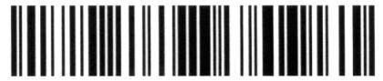

Restaurant Name
Address 1
Address 2

3/15/12 6:06:44 PM | Server: John
Table: 201 Sec: S1 Guest: 1 | Chk: #1111

5 BLOODY MARY | $ 40.75
1 FRESH OYSTER | $ 12.50
SUBTOTAL | $ 53.25
TAX | $ 5.33
GRATUITY | $ 6.00
TOTAL | $ 64.60

Thank You for Dining With Us!
Please Come Again

