Investment proposal (real estate)

1. General Information
Name |  | High-status property complex. The territory of the complex includes:  1. 3-storey reception house – total floor area of 2156,7 m², includes 13 guest rooms, a meeting room, a billiard room, a fireplace room, a sauna, a swimming pool, a fully equipped kitchen, a dining room, a laundry room;  2. One-storey guest house with an attic floor, total area – 210.7 m², includes 2 guest rooms, a fireplace room, a kitchen, a wine vault. The reception house and the guest house are fully furnished and equipped.  3. Service and security staff building, total area – 62.1 m².  4. Boiler-house (gas substation).  5. Shelter and an open parking lot, a pavilion with a wood-fired grill (barbecue), a pond, recreation area.  The complex is fenced on all the sides with a capital concrete fence; the whole periphery is equipped with CCTV cameras.  For reference: The real property is registered in the Unified State Register of Rights to Real Estate and Transactions Therewith at Moscow Regional Office of Federal Registration Service and is owned by Nathan, OJSC.
Location | Country | Russian Federation
Location | Region | Moscow Region
Location | District
Location | Town | Balashiha,  N 55º46′13″, E 37º55′16″  Latitude 55.7703, longitude 37.9212
Location | Address | 12, Profsoyuznaya St., Residential Area Saltykovka, Balashiha, Moscow Region, Russian Federation
Owner’s name  Ownership |  | Open Joint Stock Company “Naftan”
 |  | ☑ private |  |  | ☐ state
Purpose of use |  | ☐ industry  ☐service |  | ☐ commerce ☐ logistics |  |  | ☑ other (specify)  (private use, corporate recreation, reception house for delegations, holiday hotel, recreation centre)
Land plot area (ha) |  | - Land plot for allocation of a holiday hotel – 0.9048 ha (cadastral number in the Unified State Register of Rights to Real Estate and Transactions Therewith 50:15:030107:0002)  - Land plot for a reception house allocation – 0.0718 ha (cadastral number in the Unified State Register of Rights to Real Estate and Transactions Therewith 50:15:030107:0003)
Means of use |  | ☑ lease | ☑ sale |  |  | ☐other (specify) ______________
Property cost |  | Demand analysis

2. Property description
Year of construction | 1999, 2001
Walls material | Brick, monolithic concrete
Interior finish | ☑Yes ☐No
Water piping | ☑Yes ☐No
Sewerage | ☑Yes ☐No
Ventilation system | ☑Yes ☐No
Lighting | ☑Yes ☐No
Electricity supply | ☑Yes ☐No
Heating system | ☑Yes ☐No
Water supply | ☑Yes ☐No
Hot water supply | ☑Yes ☐No
Wells | ☑Yes Artesian well, depth - 135 m
Gas supply | ☑Yes ☐No
Other | Phone network, elevator
3. Transport connection
 | Destination from the property (km) | Name
Highway | 5 km from Moscow ring road (MKAD) along Gorky highway
Airport | Moscow airports
Railway | Moscow railway stations
Access roads | ☑Yes
Regional center | Moscow
Other (incl. adjoining infrastructure: industrial enterprises, raw material sources) | Holiday village

4. Contact information
Contact person (position) | Alexander V. Behunov
Phone | + 375 214 59 81 58, +375 33 398 07 19
E-mail | ABehunov@naftan.vitebsk.by

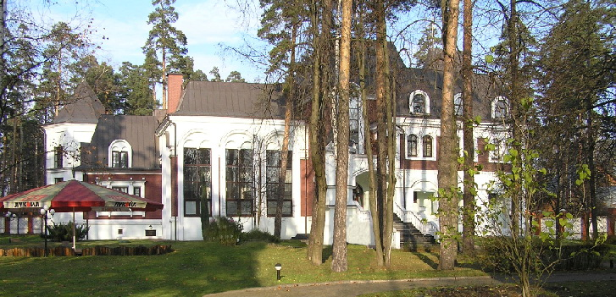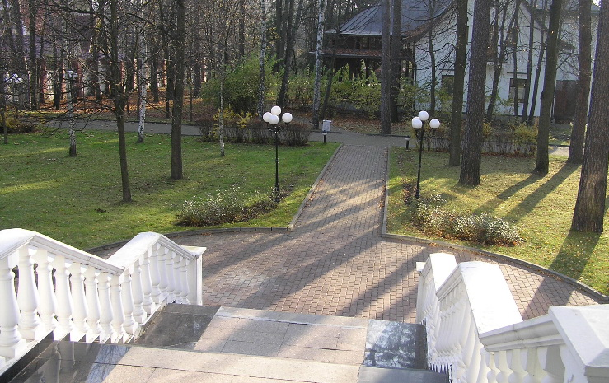

1. Reception house 2. Reception house (view from the porch)
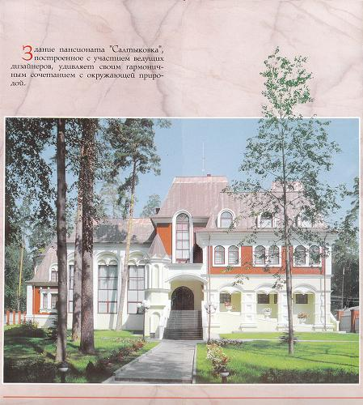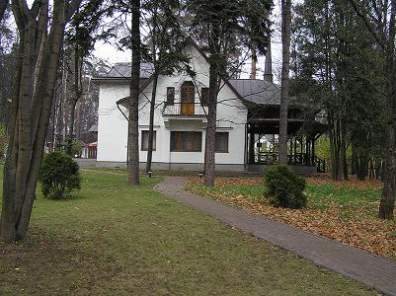
3. Reception house 4. Guest house
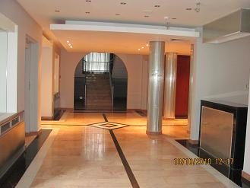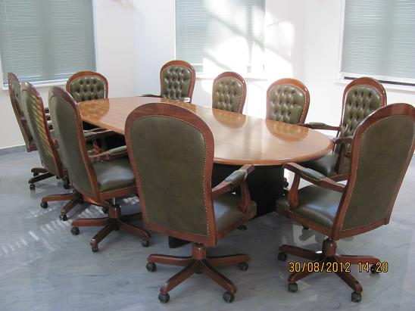
5. Reception house (entrance) 6. Meeting room
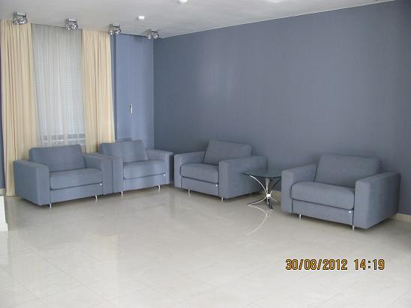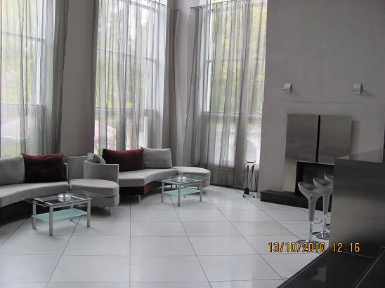
7. Conference room 8.Hall
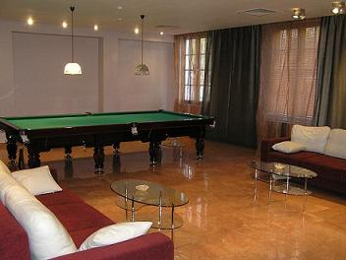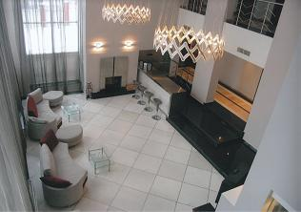
9. Billiard room 10. Hall (view from the 3rd storey)
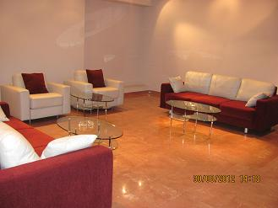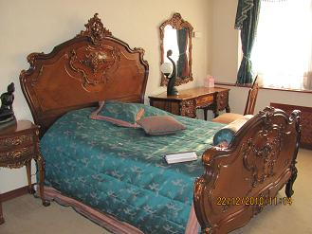
11. Billiard room 12. Guest room
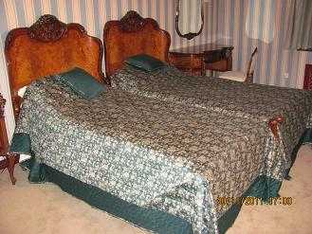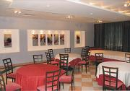
13. Guest room 14. Dining room
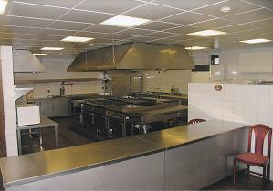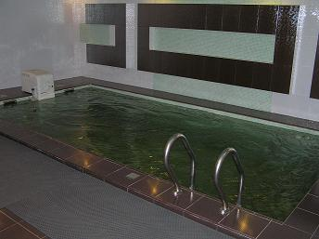
15. Fully equipped kitchen 16. Swimming pool
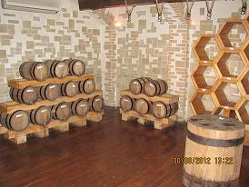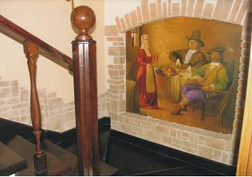
17-18. Wine vault
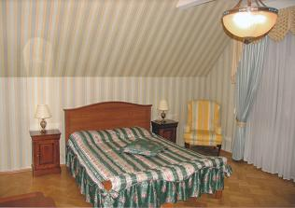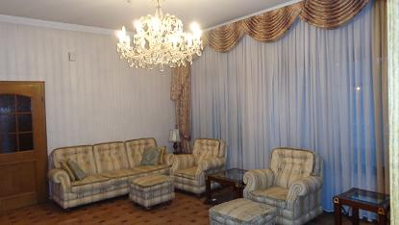
19. Room in the guest house 20. Fireplace room in the guest house
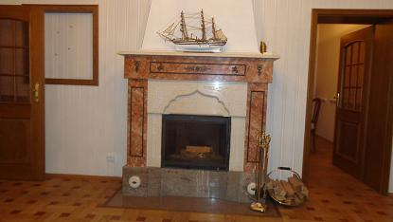
21. Fireplace
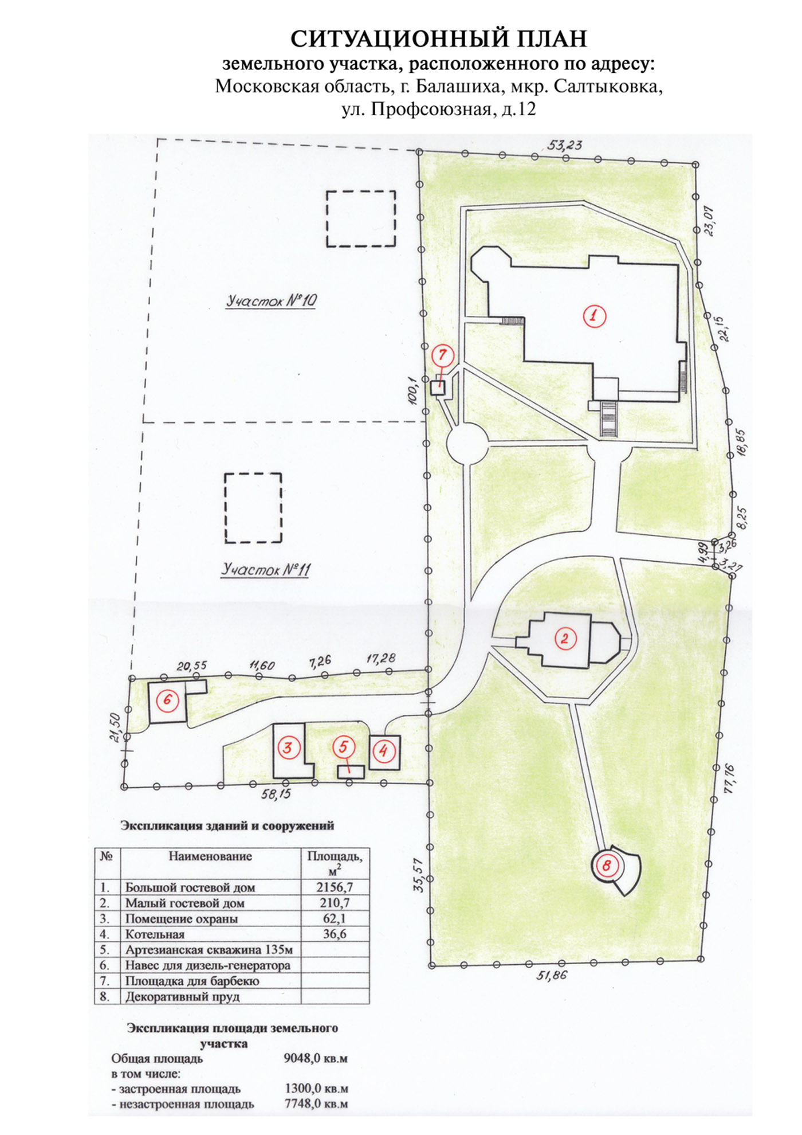

SITE LAYOUT PLAN

LOCATION PLAN



