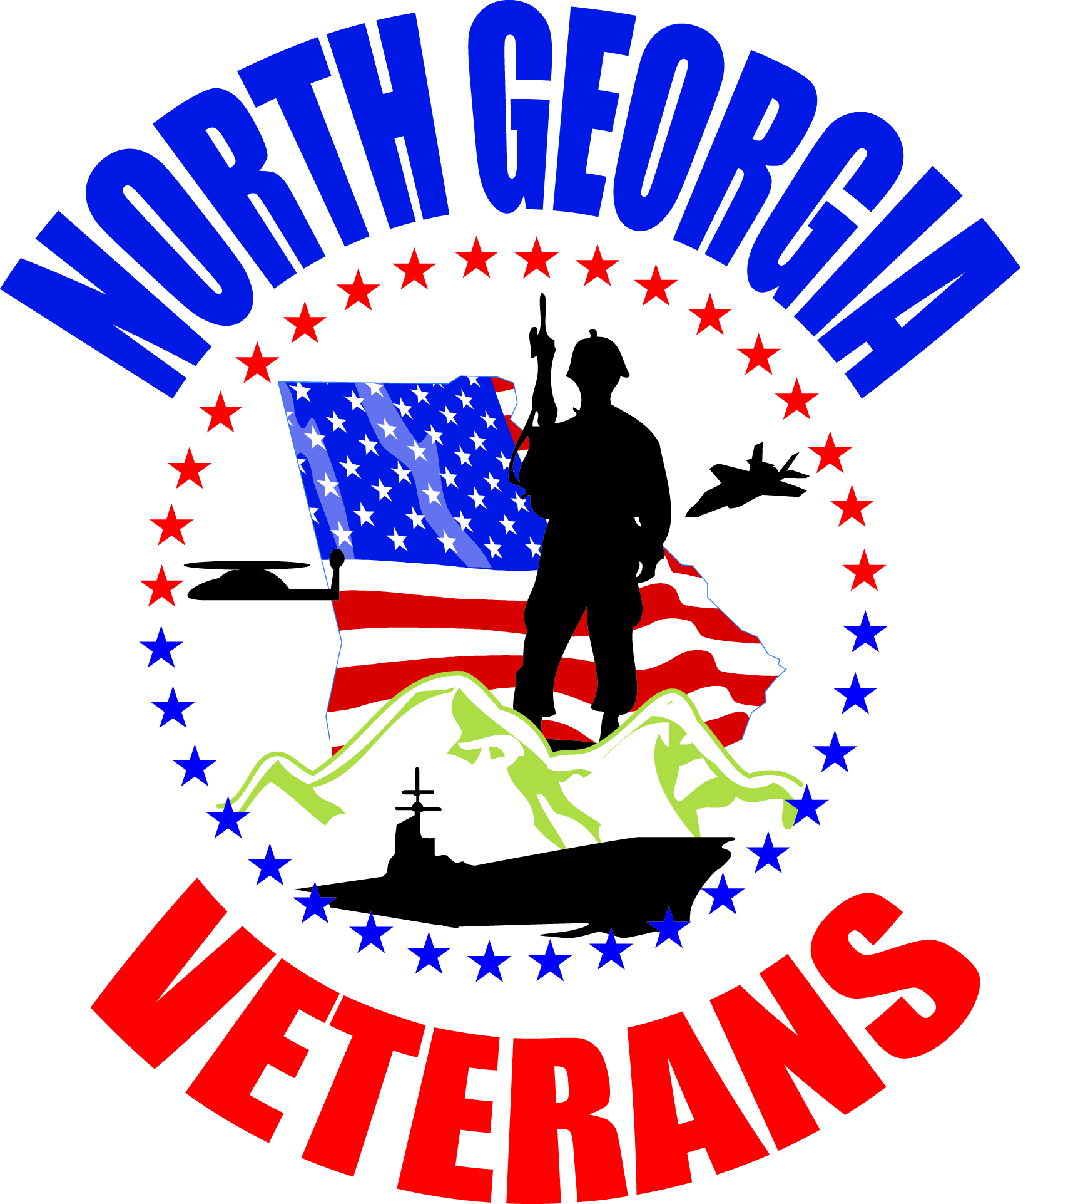
North Georgia Veterans Memorial Service

Outline for a family to recognize the military service
at a Memorial or Funeral Service

Prepared by the
North Georgia Veterans
North Georgia Veterans Memorial Service

Purpose: To provide the family with a means of recognizing a deceased family member’s military service at the conclusion of a memorial or funeral service.
Who: To properly execute this program you should have six NGV veterans, in uniform, wearing authorized medals.
When: This program is designed to be implemented after the conclusion of a memorial or funeral service. At that time the official would say to the congregation “at this time we want to recognize (name of deceased) military service.”
How: The six NGV members will serve as ushers during the period prior to the memorial or funeral service helping seat those attending. Two should hand out programs at the front entrance; two should be stationed in the main aisle to help direct seating from the front to the rear; two should help seat people in other areas (side or balcony).
Just prior to the entry of the family, all NGV members should take their position on one side of the main entry aisle, facing the aisle standing at attention. As the family passes, each NGV member will execute a left face (facing the front) and remain standing until the family is seated. At that time the NGV members will walk forward and take their place seated behind the family.
At the appropriate time, at the conclusion of the service and the official says “at this time we want to recognize (name of deceased) military service.” The designated NGV member will move to the front of the audience and read the NGV recognition program after the other NGV members are in place along the main aisle. When the designated NGV member moves to the front of the audience the remaining five NGV members move to their positions along the main aisle, facing the front. When the program is complete and the family members have departed the NGV members on the main aisle will do an about face and depart through the front entrance.
North Georgia Veterans Memorial Service

We are gathered today to recognize the service of Captain Joseph Smith. United States Army, who entered active military service in February, 1965, when he swore an oath to defend and uphold the constitution of the United States of America.
Captain Smith is part of the brotherhood of arms that have and continue to serve in this Country’s Armed Forces.
- You stood watch in the jungles of Vietnam
- You stood watch as a husband
- You stood watch as a father and grandfather
- You stood watch as a community leader
- You stood watch as a volunteer helping others
The citizens of our great Country continue to be free to pursue their dreams and sleep soundly every night because you and your comrades had the watch.
Today, we are here to say, your watch stands relieved. Relieved by those you have trained and guided over the years.
Sir, you stand relieved, we have the watch.
All veterans please stand to render honors… our fallen comrade is coming home.
All veterans present render hand salute during the playing of taps.
Thank you, that concludes our program.
Items to be customized for each individual being recognized.

