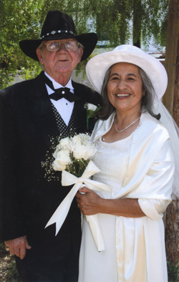

***To a Very Special Couple***

***On a Really Happy Day***

***This Simple Anniversary Wish***

***Quite Simply Wants to Say***

***Congratulations to You Both***

***Be Happy all Day Through***

***Remembering Times Gone By***

***And***

***Looking Forward to the New***

***Love has stayed within Your Hearts***

***Ever Since You’re Wedding Day***

***When You Promised One Another***

***You’d Stay Together Come What May***

***To _____________________________ Couple Names***

***Happy Anniversary Card***

***From***

***Sender Name***