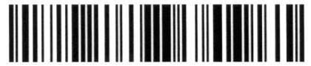

Restaurant Name
Address 1
Address 2

3/15/09 6:06:44 PM
-------------------------------
Table: 201 | Chk: #1111 | Guest: 2
-------------------------------

5 BLOODY MARY | $ 40.75
1 FRESH OYSTER | $ 12.50
SUBTOTAL | $ 53.25
TAX | $ 5.33
GRATUITY | $ 6.00
TOTAL DUE | $ 64.60

THANK YOU FOR DINING WITH US!
PLEASE COME AGAIN

