iPad Personal Timeline with Popplet
Instructions:
Use the Popplet app on the iPad to create a personal time line about your past, present, and future.
- Open the Popplet app and double tap to create the first “Popple” box.
- Tap once inside your first Popple box and then take a photo of yourself or add your picture from the library.
- Add more Popple boxes to create your timeline title, and your past, present, and future titles.
- Add Popple boxes to add your details about your past, present, and future.
- When you are finished, export your Popplet using “save as JPEG”
- Go to the iPad camera roll and print your Popplet picture.
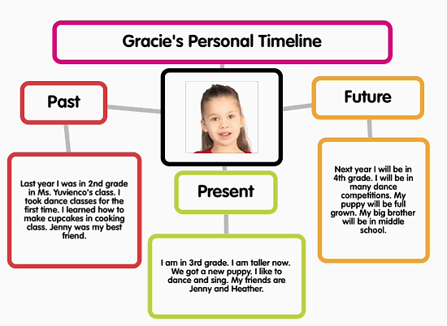
Example:

