


Certificate of Recognition
May it be known that this Certificate is presented to
Mike Miller

2014 Milwaukee Section
Scholarship Recipient
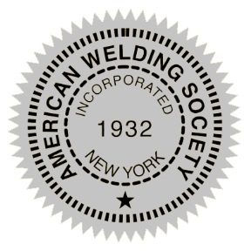


__________________________________ __________________________________ Section Chairman Date

