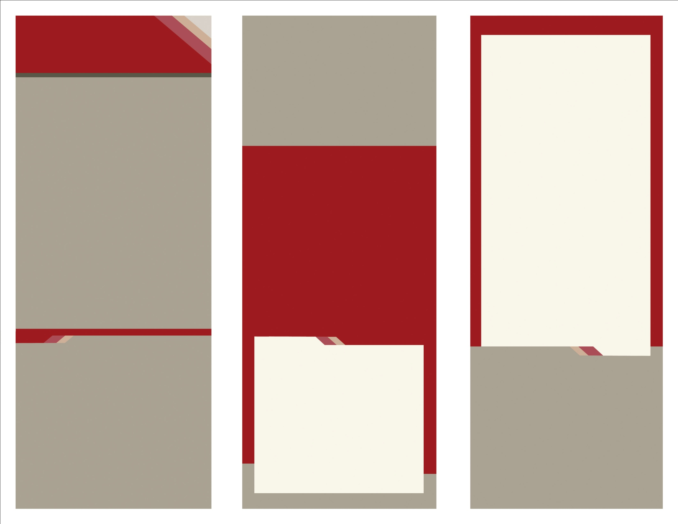

call out text from brochure here.

When you’re writing a newsletter, write it so that someone who has never heard of your company can understand what you’re offering as quickly as possible. Stay away from using jargon, acronyms, or complicated terms.

If you’re not sure what to write, make a list of “what we do” and then a list of “why our products or services are the best.” Use that information to create your brochure. Continue brochure text here.

If you’re not sure what to write, make a list of “what we do” and then a list of “why our products or services are the best.” Use that information tcreate your brochure. Continue brochure text here. Use that information to create your brochure. Continue brochure text here.

HEADER

SUBHEAD HERE

Delete this

box or enter

a quote or

to callout

text from

the brochure.

Enter Contact information

555 Street Address

City, State 55555

Phone | 555.555.5555

Fax | 555.555.5555

www.website.com

Delete text and place photo here.

Delete text and place photo here.

Enter Contact Information Here | 1127 Lombard Blvd. San Francisco, CA 59802 | phone 555.555.5555 | fax 555.555.5555

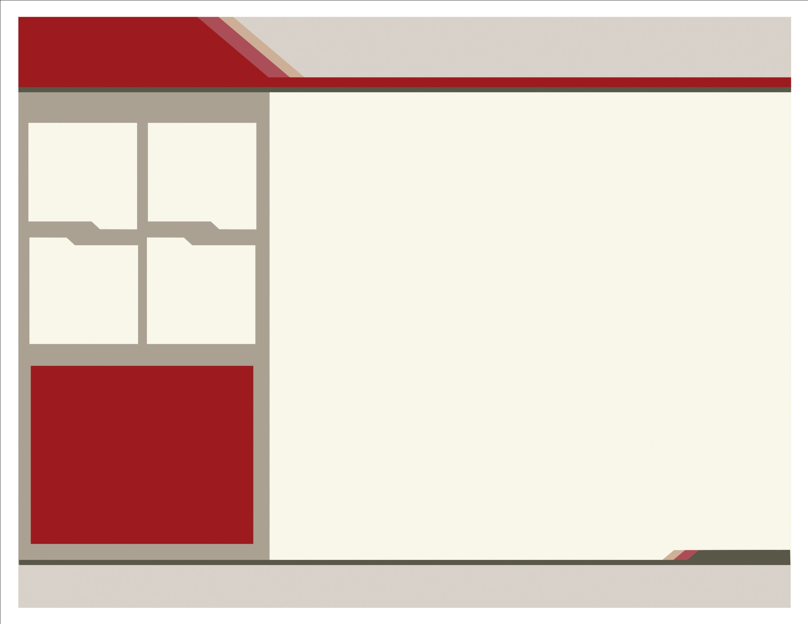

DELETE THIS BOX OR Call attention   
to specific points HERE.

* Enter bullet text here.
* Enter bullet text here.
* Enter bullet text here.
* Enter bullet text here.
* Enter bullet text here.

Delete box or continue brochure text here.  
Brief words or customer testimony. Delete   
box or continue brochure text here. Brief   
words or customer testimony.

Delete this

box or enter

a quote or

to callout

text from

the brochure.

Delete box or continue brochure text here. Brief words or customer testimony. Delete box or continue brochure text here. Brief words or customer testimony. Delete box or continue brochure text here.

Delete box or continue brochure text here. Brief words or customer testimony. Delete box or continue brochure text here. Brief words or customer testimony.

When you’re writing a brochure, write it so that someone who has never heard of your company can understand what you’re offering as quickly as possible. Stay away from using jargon, acronyms, or complicated terms.

If you’re not sure what to write, make a list of “what we do” and then a list of “why our products or services are the best.” Use that information   
to create your brochure. When you’re writing a brochure, write it so that someone who has   
never heard of your company can understand what you’re offering as quickly as possible. Stay away from using jargon or complicated terms.

If you’re not sure what to write, make a list of “what we do” and then a list of “why our products or services are the best.” Use that information to create your brochure. If you’re not sure what to write, make a list of “what we do” and then a list of “why our products or services are the best.” Use that information to create your brochure. Stay away from using jargon, acronyms, or complicated terms. Continue brochure text here. Continue brochure text here. Continue brochure text here. Continue brochure text here.

caption

caption

caption

caption

Delete text and place picture here.

Delete text and place picture here.

Delete text and place picture here.

When you’re writing a brochure, write it so that someone who has never heard of your company can understand what you’re offering as quickly as possible. Stay away from using jargon, acronyms, or complicated terms.

If you’re not sure what to write, make a list of “what we do” and then a list of “why our products or services are the best.” Use that information to create your brochure. If you’re not sure what to write, make a list of “what we do” and then a list of “why our products or services are the best.” Use that information to create your brochure. Iyou’re not sure what to write, make a list of “what we do” and then a list of “why our products or services are the best.”

Delete box or enter subhead here.

HEADER

SUBHEAD HERE

When you’re writing a brochure, write it so that someone who has never heard of your company can understand what you’re offering as quickly as possible. Stay away from using jargon, acronyms, or complicated terms.

If you’re not sure what to write, make a list of “what we do” and then a list of “why our products or services are the best.” Use that information to create your brochure.

Delete box or enter subhead here.

www.website.com

Delete this box or

ENTER Headline HERE.

Delete text and place picture here.