COMPLETE ITINERARY

MSU-BILLINGS STUDY TRIP TO JAPAN

and the

PREFECTURAL UNIVERSITY OF KUMAMOTO

May 14, 2009 through June 9, 2009

IMPORTANT:
SOME ASPECTS OF THIS TRAVEL SCHEDULE ARE PRELIMINARY: Exact times of air and rail travel may be changed. The airline schedules are current but the airlines sometimes make slight schedule changes. The train schedules contained in this version of the document are proposed for this trip (2009), but may be altered if some trains are booked up by the time we arrive in Japan and get the tickets. (Since we are using the JR-Pass for rail transportation, we cannot reserve tickets before arriving in Japan.)

The Hotel Reservations shown in this document are confirmed for the 2009 trip.

Please Note: This document, except for the train schedules contained and referred to herein, is © 2009 by R. Scott Harris. The train timetables in this document contain copyrighted material © 2009 by Kotsushinbunsha and © 1997-2009 Hitachi Information Systems, Ltd. Therefore, this document is for the use of students going on this trip to Japan, their immediate family, and faculty and staff of the sponsoring institutions: Montana State University-Billings and the Prefectural University of Kumamoto. Any use of this material in a commercial context without the permission of all copyright holders is strictly prohibited.
Table of Contents

Master Calendar and Map 3

Prepare for Trip 4
Packing and Understanding Japanese Customs Requirements 4
Documents 7
Money 7
Understanding US Customs Requirements for our Return 9
Understanding Jet Lag 10
Trip Project 11
Deciding What You Want to See 12
Think About Your Health 13

Departure and Arrival Days Flight/Train Schedule 14
Entry Procedures into Japan 15
Filling Out the Disembarkation/Embarkation Card 16
Customs Declarations for Japan 17
Customs Declarations for the US 18

Contact Information 19
Japan-Montana Time Differences 20
Hotels (when we are not in Kumamoto) 21
Kumamoto: PUK and Host Families 23

Chronological Itinerary 25
May 14-15: Billings to Tokyo 25
May 15-19: Tokyo 26
May 19-21: Hakuba 35
May 21-24: Hiroshima / Miyajima 36
May 24-June 6: Kumamoto 39
June 3-7: Kyoto 43
June 7-9: Tokyo 47
June 9: Tokyo to Billings 47

Detailed Train Schedules 49
May 15: Narita to Tokyo 49
May 19: Tokyo to Hakuba 50
May 21: Hakuba to Hiroshima (2 possible routes) 51
May 22/23: Hiroshima to Miyajimaguchi 57
May 24: Hiroshima to Kumamoto 58
June 3: Kumamoto to Kyoto 59
June 7: Kyoto to Tokyo 61
June 19: Tokyo to Narita 62
Master Calendar

Sunday | Monday | Tuesday | Wednesday | Thursday | Friday | Saturday
May 10 | May 11 | May 12  Meeting:  7:00 | May 13 | May 14  Leave  Billings | May 15  Arrive Tokyo | May 16  Tokyo
May 17 Tokyo | May 18 Tokyo | May 19 Tokyo → Hakuba | May 20  Hakuba | May 21  Hakuba → Hiroshima | May 22  Hiroshima/ Miyajima | May 23 Hiroshima/ Miyajima
May 24 Hiroshima → Kumamoto | May 25  Kumamoto | May 26 Kumamoto | May 27 Kumamoto | May28 Kumamoto | May 29 Kumamoto | May 30 Kumamoto
May 31 Kumamoto | June 1 Kumamoto | June 2 Kumamoto | June 3 Kumamoto → Kyoto | June 4 Kyoto | June 5 Kyoto | June 6 Kyoto
June 7 Kyoto → Tokyo | June 8  Tokyo | June 9 Tokyo → Billings | June 10 | June 11 | June 12 | June 13

Map
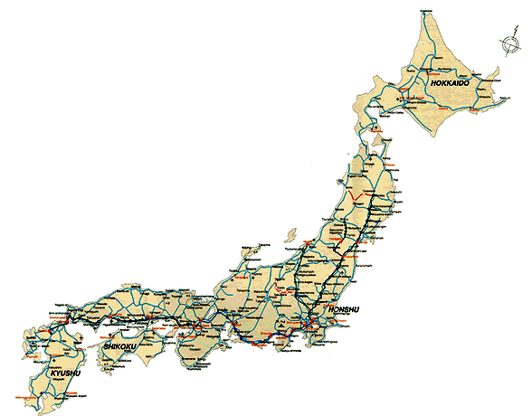
Tokyo
Narita Airport
Hakuba
Kyoto
Hiroshima
Kumamoto
x
x
x
x
x
x
Approximate Distances & Travel time:
(rail miles unless noted)

Billings–Narita (air miles) 6,417 miles 20.5 hrs
Narita–Tokyo 49 miles 1.0 hrs
Tokyo–Nagano 138 miles 1.7 hrs
Hakuba–Hiroshima 491 miles 8.6 hrs
Hiroshima–Kumamoto 248 miles 2.7 hrs
Kumamoto-Kyoto 484 miles 5.2 hrs
Kyoto-Tokyo 319 miles 2.6 hrs
Tokyo-Narita 49 miles 0.9 hrs
Narita-Billings (air miles) 6,417 miles 17.2 hrs
Preparing for the Trip.

There are a number of things you must do before we leave…and several that you should do if you are going to get the maximum benefit from the trip.

The “must do” things are:
- Pack for the trip
- Have your documents ready
- Have money

The “should do” things are:
- Prepare for going through U.S. Customs upon your return.
- Understand that you may be jet-lagged upon your return and make appropriate allowances before going.
- Acquaint yourself with where we are going and what will be available for you to see and do.
- Start your “course project” by setting up a trip log.

Packing for the Trip.

You have heard this over and over again, but the number one admonition for you when packing is to think “light.” There are two reasons for this: (a) You will have to carry your luggage up and down stairs, on and off trains, subways and busses, and load it into and out of taxicabs. There will be places where you will be toting your luggage for a few blocks or more. Sidewalks are not always smooth and, even with wheels or rollers, dealing with large luggage pieces under those circumstances will become frustrating. Even subconsciously you will be under stress; don’t make your luggage add to that! (b) Some of the trains (most notably the Shinkansens—bullet trains) will not have storage places that will accommodate large pieces of luggage. (The Shinkansens have open overhead racks and some space at the ends of the cars.) It will be rude to your fellow passengers (both your trip-mates and Japanese folks who will be traveling on the trains) to stack luggage in places not designed to accommodate it. Since train employees traverse cars with vending carts, you will not be allowed to put anything in the aisle.

Each place we go will have someplace where you can access laundry facilities—either in the hotel or nearby at a laundromat. You will be able to hand wash some things in your bathroom sink (but make sure they can drip dry quickly). Basic toiletries will be provided in the hotels. Hotels will have hairdryers. If you are going to bring stuff like toothpaste, antiperspirant/deodorant, etc., you should consider going to the store and buying the miniature “sample sizes”—which will be just about right for the trip. Women should bring sufficient feminine hygiene products for the first few days, but you can purchase additional amounts in Japan if you need to.

Your host family probably will have laundry facilities for you to use. Excluding what you will wear on the airplane, the longest stretch we will have if you want to do laundry only in Kumamoto will be 9 days. If you want a spare day, plan on bringing underwear/lingerie for 10-11 days. That can usually be compacted into fairly small luggage space. A couple of pairs of trousers (and/or skirts for the women) and sufficient shirts/blouses should be enough clothes for you. Plan on dressing casual for comfort, but NOT “grubby.” You should bring in that mix one outfit or ensemble that would be considered “business casual.” Also, bring 2 or 3 handkerchiefs for drying your hands in public washrooms.

One or two pairs of shoes (total) should suffice. Your shoes should be good for walking in (lots of walking). If bringing sneakers as your walking shoes, bring one pair for semi-formal situations. If you are bringing new shoes, break them in before we travel! You will have to slip in and out of your shoes a lot, so slip-on shoes might be a great idea. Also, make sure your socks don’t embarrass you since you will be walking in stocking feet a lot (especially in Kumamoto).

Expected temperatures in Tokyo when we arrive will range in the 60’s and 70’s (with evenings about 10° cooler.) Hakuba will be a little cooler and the other locales generally will be slightly warmer. Since it may (will) rain, you will probably be best served by bringing a light windbreaker and a sweater that you can layer. You should also bring a small folding umbrella (think T.J. Maxx, Ross, Target, etc.). If you forget something critical, you CAN buy it in Japan.

The foregoing should constitute a MAXIMUM amount of clothes. If they do not fit into a small suitcase, then bring less. You can purchase special zip-lock type bags for travelers that allow you to compress your clothes by squeezing the air out of the bag. There are two types of these bags—one is for travelers where you physically squeeze the air out by rolling the bag like a sleeping bag—and the other is for storing clothes and requires a vacuum cleaner to suck the air out. Make sure you buy the one that does NOT require a vacuum cleaner.

You should bring a camera and sufficient memory to last a few days. You will be able to download photo files to Scott Harris’s computer for storage, but make sure to bring the peripheral connection devices that you will need to do the download. You can bring MP3 or portable CD players if you wish. If you do so, please make sure to keep the volume at a level that is respectful of traveling companions (in other words, the volume must be low enough that nobody else can hear what you are listening to.) It will be very rude to “share” your music with others. Indeed, you are urged to NOT even think about using them on the subways and busses, and to be very cognizant of volume when on the trains. Do NOT bring your cell phone unless you are going to use it for other functions (e.g., alarms).

Make sure to leave room in your suitcase or carry-on items for gifts for your host family.

Bring any prescription medications and allowable over-the-counter medications you might need. Make sure that you limit the doses of prescription medicine to one-month’s supply and the number of over-the counter doses to 24. Since we will be in Japan a little less than a month, you should be okay for prescription drugs provided you bring a full month’s medication with you. You should bring all physicians’ prescriptions with you in case of the very unlikely event that you are delayed in your return to the U.S. need to get your prescription refilled in Japan.

The following is a list of U.S. over-the-counter medications that are considered “controlled substances” in Japan and are illegal. Some items not on the list may also be illegal. As a rule, anything containing pseudoephedrine or similar stimulants probably will be an illegal substance. Basically, if you have a question, don’t bring it unless it is a physician prescribed medication for which you have prescription documentation.
  - Tylenol Cold medications
  - Nyquil
  - Nyquil Liquicaps
  - Actifed
  - Sudafed
  - Advil Cold & Sinus medications
  - Dristan Cold “No Drowsiness” medications
  - Dristan Sinus medication
  - Drixoral Sinus medication
  - Vicks Inhaler
  - Lomotil

Technically, there are limits on the amount of cosmetics you can take as well as other things you should be aware of. Please visit these two Japanese Government’s websites for the most common import restrictions that could pertain to you: http://www.customs.go.jp/english/summary/passenger.htm
http://www.mhlw.go.jp/english/topics/import/index.html

It is your responsibility to make sure you do not bring banned substances into the country.

In addition to the above, since we are traveling in a group and an extended customs examination of one person’s luggage could delay our ability to get to the hotel or obtain our rail passes before the JR Office closes, you should understand the customs procedure at Narita.

Before we land at Narita, the cabin attendants will give you a customs declaration form. After we land and pick up our luggage, you will then have the option of going through the red or the green channel at customs depending on what you declared on the customs form. The green channel is for passengers who have no goods subject to duty and/or tax and goods not prohibited or restricted. If you choose that channel (line), the chances are excellent that you will be waived through customs without having your belongings checked. The red channel is for anyone who is carrying items that may be restricted or subject to import duties. If you indicate the latter, you WILL be delayed while your bags are inspected and decisions are made regarding whether you can bring the items into the country or what the appropriate duty will be. Since the number one imperative is that you are absolutely TRUTHFUL about what you are declaring, it is just a good idea to make sure you do NOT bring items that will necessitate your detour through the red channel. A copy of the Japanese Customs Declaration form is on page 17.

Documents.

You MUST bring your Passport. Without it, you will not get on the plane in Billings. Keep it in a safe, but accessible place. Keep track of your passport; know where it is at all times. Losing a passport can become a source of major disruption for both you and others on the trip. In 2005, a student lost her passport and JR Railpass. She was lucky to get a new passport. It “only” cost her $500 in added expenses. It could have easily run her into thousands of dollars if there had been any delay in issuing her the “emergency” passport. Beware that your travel insurance may not cover you for extra expenses incurred because of a lost passport. The insurance is generally for events that are beyond your control.

You should bring with you any documents you could need for insurance purposes. While we will have travel insurance with medical coverage, it is secondary coverage. Your primary health insurance at home is still your primary insurer in Japan and you need to bring with you any information that they would require you to carry.

You should keep a list of your credit cards and contact numbers in case you lose them. If you have any other important documents, (e.g., Drivers License) you should note the identifying numbers and other important information. Keep these notes in a separate location, not in your wallet or purse!

Suggestion: Before we leave, go through your wallet or purse and remove anything that you will not need on this trip. You probably ought to bring your driver’s license for additional identification (but do NOT even think about driving in Japan since your Montana license is not valid for driving there).

In addition to you keeping a copy of your passport, the Office of International Studies at MSU-Billings must be provided a copy of the main identification page of your passport BEFORE we leave for Japan. Scott Harris will carry a copy of that information as well as a copy of the medical/health information you submitted when you enrolled in the trip.

Money (This section may be revised somewhat prior to our departure)

Japan does have ATM machines, but they should be relied upon only as a backup in case you run out of money. You are urged to bring with you all of the money you anticipate needing. You basically have 4 categories in which you need to estimate expenses:

- Food that is not covered under the trip costs.
- Local transportation (subways, taxicab, local busses, etc) and admissions (e.g., Tokyo Tower, Temples, Events, etc.)
- Shopping
- Emergency

Food: You will be responsible for the following meals:
Tokyo: 5 lunches and 6 dinners plus breakfasts not eaten at the hotel.
Hakuba: 2 lunches (these may be provided at a nominal additional cost by the hosts at the Pension.)
Hiroshima: 4 lunches and 3 dinners.
Kumamoto: lunches (if box lunch is not provided by your host family) and anytime you go out on your own or with a group of students and are not with your host family.
Kyoto: 4 breakfasts, 5 lunches, 4 dinners

Meals not listed here are either included in the trip cost or are during the time you will be with your host family.

If one uses a rule of thumb that breakfasts will cost $7, lunches $10 and dinners $15 on the average when we are in Tokyo, Hiroshima, and Kyoto and add an allowance for Hakuba and Kumamoto (lunches only), the food allowance would be $405. That is a “high end” estimate, but really depends on what you will choose to eat. You can get by with a lot less (and still eat well!) and you can certainly spend a lot more! Scott Harris is estimating about $330 for himself.

Local Transportation and Admissions: Plan on about $100-$125. If you plan on using taxicabs a lot, budget more. If you plan on going to Tokyo Disneyland, Disney Sea World, Universal Studios or other high-admission places, budget a lot more (e.g., $60-$80 extra for Disneyland.)

Shopping, Souvenirs, etc.: This is totally up to you. Some stores take credit cards, so you might be able to fudge on this, but do not count on using plastic everywhere.

Emergency: This should be money that you bring or can access quickly in case you have an unexpected expense. You should budget the other categories so that this is NOT a slush fund that will merely allow you to spend the other funds faster. Plan on bringing it back home with you unless you run into some unforeseen expense. $200-$300 ought to be a good cushion—unless you lose your passport.

Remember, you will be gone for almost a month…put your budget in that perspective.

Traveler’s Cheques will be the best way to carry money to Japan. The exchange rate is better than on currency and most banks and post offices will readily perform money exchange services for you. In Tokyo, you will be able to exchange money at the hotel. The only caution for you is to make sure you have enough money in yen to see you through the weekend if the hotel does not exchange money.

Suggestion: For personal use, take money in $100 traveler’s cheques. Do not use $20 cheques; they will take too long to sign both when you purchase them and when you exchange them.

Credit Cards can be used at many places, but their acceptance rate is not as high in Japan as it is in the US. Japan is primarily a cash society. Be aware that your credit card company may charge you a fee or bump the exchange rate against you when they convert yen back to dollars on your bill. You might want to check with your credit card issuer before you go to see what their exchange rate policy is.

ATM Cards: Most Post Offices have ATM machines in Japan, and their use and placement in other locations is continually expanding. HOWEVER, you need to understand that ATMs are not used by the Japanese nearly as much as by folks in the US or Europe. Therefore, ATMs will not be as ubiquitous as they are in the US. You may have to go hunting to find one…and once found, remember that you are in Japan and there is some chance (especially with older ATMs) that instructions and writing will be in Japanese. Most new ATMs will allow you to set the display to English. You will have the highest likelihood of finding and using ATMs in the large cities (Tokyo and Kyoto), medium cities generally lag behind in their use and rural areas…well…good luck!

Know what to expect at U.S. Customs when we return.

Before you go abroad, you should understand that you will have to go through US Customs inspection upon your return to the US. You will have to “declare” in writing what you are bringing back into the United States that you acquired abroad—both items you purchased and those you received as gifts. Knowing this ahead of time will help you keep track of the receipts you will need to make your customs declaration.

On the flight from Japan to Los Angeles, you will have to fill out a declaration form and list items that you either purchased or received as gifts in Japan. Basically, the first $800 worth of goods brought back from Japan will be exempt from duties (import taxes). If you are bringing more that $800 worth of goods back (even those things given to you as gifts!), you may be subject to paying duty on the part in excess of $800. You should keep sales receipts of anything that is a major purchase and have it ready to show to customs inspectors if requested. If you do not have a receipt, then you should honestly declare to the best of your memory what you paid for it. This will also require a little calculation of conversion from yen to dollars. If you are well short of maxing out the $800 exemption, then precision in conversion of money is not too important. Past experience has been that the customs inspectors will ask a few questions and waive student groups on through. BUT, there always is the possibility that you may be selected for a thorough search of your luggage, so you should be prepared.

Additional notes:
- You will be allowed to bring in one liter of alcoholic beverages duty free (you must be 21 year old to do so.)
- Some things are flat out prohibited for you to bring into the country and they will be confiscated. These include anything from Cuba, prescription drugs that did not originate in the US, and anything that is illegal to possess in the US (even if it was not illegal in Japan).
- You may be able to ship items from Japan. Each package carries a duty exemption of $200. (This is in addition to the $800 exemption for things you personally bring into the country.) If you are shipping stuff from Japan, you must declare the contents and the value of the contents. Keep it under $200 or you may have to pay duty when it is delivered! (NOTE: You CANNOT ship or mail alcohol to the USA. Don’t even think about it.)
- If you are planning to take with you to Japan any expensive items (e.g., computer, fancy camera, etc.) that were not made in the USA and which are less than 6 month old, you could be subject to duty on them if you cannot prove that you bought them in the USA before you went to Japan. If you are planning to take any items that fall into this category, you can protect yourself by obtaining a “Certificate of Registration” for those items before leaving the US at http://forms.cbp.gov/pdf/CBP_Form_4457.pdf . Follow the directions starting on page 14 of the “Know Before You Go” booklet that is available online: http://www.cbp.gov/xp/cgov/travel/vacation/kbyg/
- You would be wise to peruse the entire “Know Before You Go” booklet referenced above. Much of it will not apply to you, but enough will to make it worth your while to understand it.
- Understand that you will have to declare anything purchased at “Duty Free” shops in Japan. “Duty Free” in this context just means that the goods were not subject to Japanese Import Duties or Taxes and, therefore, can be sold to you there cheaper than otherwise. These items must be declared for US customs in the same manner as anything else.
- Duties on the aggregate of goods valued in excess of $800 will generally be 3% of the first $1,000 of excess value. You will have to pay that on the spot.
- Alcohol in excess of 1 liter (33.8 fluid ounces) may be brought into the country (provided you are 21 years old), BUT anything in excess of 1 liter will be subject to the 3% duty PLUS applicable Internal Revenue Service taxes on alcohol.

Jet Lag

Jet lag is usually fairly severe for people returning from Japan. It is not well explained, but traveling from West (Japan) to East (USA) is often harder on people than going the other way. It also could be accentuated because you will be somewhat fatigued from all of the traveling we will have done. While many of you will barely feel any affects of jet lag during your first days in Tokyo, it is likely (not guaranteed) that you will feel out of sorts for a few days upon our return. Sleep habits could be dislocated (you will want to sleep during the day and will be unable to sleep at night), and when you are awake, you will feel logy and lethargic. Though unusual, those effects can last as long as a week. It is often suggested that quick recovery from jet lag occurs when you force yourself to follow your new routine as quickly as possible. Getting out in the sunshine (and thereby telling your biological clock to reset itself to Mountain Daylight Time) is also a recommended tactic. Drinking lots of water also is suggested.

Singapore Airlines offers this advice to minimize the effects of Jet Lag:

When you travel across time zones, your biological clock becomes desynchronized, which causes jet lag. Jet lag is hard to avoid, but one tip is to get some shut-eye during the flight -- dim the lights and drop your seat back. Refrain from beverages that interfere with your sleep patterns, such as alcohol and caffeine (coffee, tea, soft drinks.) Once you land, adopt local time immediately. If possible, avoid any commitments in the first couple of days -- admittedly not always easy if you are traveling on business

The foregoing admonition—along with the fact that you will have been traveling for over 24 hours—is the reason you are asked to refrain from drinking alcohol the first night we are in Tokyo…no matter how tempting it may be to sit back and down a beer , martini, gin and tonic or margarita! We will be traveling as a group the first few days in Tokyo and while you will most likely be able to get acclimated to the new time zone, the effects of jet-lag and alcohol create a strange brew in your body that will be no fun for you and will slow down the group. That will not be an auspicious beginning to your trip! (More on this topic appears later…it IS serious.)

Regardless of how fit you are or how good you think you will feel, when we return to the U.S., it probably would be a very good idea to plan on having a couple of days to “recover” before going back to work or having to fulfill other obligations. Plan to give yourself a few days to recover.

Trip Project: Keeping a journal of the trip.

You have all been apprised of the course requirements for this program. You have committed to attend all of the functions put on by the Prefectural University of Kumamoto and to submit a journal of memoirs from the trip that will be published on the MSU-B web page.

You should bring with you a notebook and pen or pencil so you can commit thoughts, ideas, and observations to paper…especially on some of the traveling days we will have.

You should consider making the first entry one that outlines a little of what you hope to achieve on the trip and well as some of the questions (or even fears) that you have about going to Japan. While on the trip, you should jot things down that you want to remember. It will not take long to do so every night or so, but it will really help you when you are trying to remember too many things. When you return to Billings, you must submit a trip memoir in the form of journal entries. We encourage you to edit your trip journal entries to tell the story of your trip to Japan and include pictures from the trip. The memoir should be more of a reflection of what you did and saw rather than a straightforward (and boring) travelogue. What was different, strange, weird, magical etc. about things you did or witnessed? What did you bring away from the trip, not only about a different land and culture, but also about yourself? You do not have to write about everything you did. Pick and choose the most meaningful things. If any of you are bloggers, just think of this as a “trip blog.”

You should submit the journals with “dated” entries electronically to Scott Harris in Word (*.doc) or Rich Text Format (*.rtf). Please do NOT try to provide any fancy layouts. Indicate in the document where you want pictures embedded in the following manner: [Insert Picture XYZ] where XYZ is the file name of the picture. It is usually best to provide this on a CD, but you can try e-mailing all of the files if you wish. Scott Harris will put the journals into web page format and post them on the MSU-Billings website. These memoirs will then be available for the faculty at PUK to review as part of your grade for the course. Examples of last trip’s MSU-B journals and those from another college are provided:

MSU-B Japan 2005 journals: http://www.msubillings.edu/BusinessFaculty/Harris/Japan%202005/Journals/Journal%20Index.htm

Centre College International Program Journals:
http://www.centre.edu/web/admission/traveljournals/

DUE DATE: Will be determined upon consultation with the PUK faculty. The best guess is that you will have until the end of second summer session (mid July) to do this.

Decide what you want to do and see before we go.

There will be way more to see and do than you will have time for on this trip. You are urged to look over the material that Scott Harris has assembled for this trip and posted on the web:

http://www.msubillings.edu/BusinessFaculty/Harris/Japan%20Webpage/Japanlinks.htm

Dr. Harris will work with the group to identify certain destinations that we can see as a group. But, during our time in Tokyo, Hakuba, Hiroshima, and Kyoto, you will be free to go to other places that hold special interest to you. We request that you travel in groups of at least two and check with Scott Harris before going. Taking full advantage of your limited time requires that you acquaint yourself with the options you have before we leave on the trip. Feel free to consult with Dr. Harris about your ideas; he may have some suggestions that will help you out.

The daily itinerary that starts on page 25 also will have ideas and suggestions for you. This itinerary includes a few enhancements that are not on the web page. In particular, a great preview of many of the places we will be is afforded through Google Earth—an amazing photo-mapping system you can download to your computer from http://earth.google.com/download-earth.html . The itinerary provides coordinates that you can use in Google Earth to see satellite photos of the places we will visit. For example, Narita airport’s coordinates are: 35° 45’ 52.27” N, 140° 23’ 02.68” E. As you zoom in on the airport, remember that virtually all of the planes in the picture are Jumbo Jets (i.e., Boeing 747’s or similar) for the long international flights.

The easiest way to find places using these coordinates is to orient your map so that “North” is pointing straight up. The coordinates of your cursor are in the lower left corner of the map. Note that the first set coordinates change most when you move the cursor up and down while the second set will change most when you move the cursor left and right. Since almost all of these coordinates are for Japan, you need to find Japan first. Once done, it is easiest to get into the neighborhood of the coordinates by zooming out and bringing the general area of the coordinate point to the center of the map screen. The coordinates that are supplied in this document exhibit more precision than you will need. Coordinates are given in degrees (°), minutes ('), and seconds (") and you can easily round coordinates to within a several seconds of those given. Then start to zoom in and keep refining your search by grabbing the coordinate point with your cursor and bringing it to the center of the screen. You will get fairly adept at the process after a few tries. Note that there are settings you can check to have the map show photos that have been taken of the view from the marked point (though some of the marks are not quite accurate). Have fun; this is a great program.

Think about your health.

On May 14th, you will be at the Billings Airport at 6:00 a.m. About 24 hours later, at about 5:40 a.m. Billings time, we should arrive at the hotel in Tokyo. The time zone you will be in is 15 hours ahead of Billings and your body will be wondering what happened to it. You will be in a country that is a long ways from Montana and the immunity that you built up to the little viruses and other maladies you were exposed to in Montana may not be able to do specific battle with the new things you will be exposed to. You will have traveled for hours in a hermetically sealed tube called an airplane, cooped up with 300-400 other people from all over. You will be “on the go” for 27 days. All of these add up to one thing: you will be more susceptible than usual to catch some sort of bug. Know this ahead of time and plan to take precautions that minimize your risk of coming down with a nasty cold (or worse). Be well rested before we leave. Plan to sleep on the plane. Wash your hands thoroughly frequently, especially before eating and before rubbing your eyes. If you feel tired during the trip, excuse yourself from some of the activities and rest.

When we get to the hotel in Tokyo, have a snack or a light meal and go to bed. Eight years ago, a young woman on the trip decided to go out with other members of the group to a club in Roppongi. To this day, she does not remember what happened that night or how she got back to a hotel room (not hers!). Though there was not evidence of foul play, something like that can be a very scary beginning to your trip. You will be much more tired than you think. Go to bed; do NOT go out that night and do NOT drink alcohol.

There are over-the-counter medicines that you can take that (supposedly) address the issues of increased exposure and susceptibility to various “bugs” when you travel. You may want to consider bringing some of that along. Regardless, be aware of your body and do what you have to do to stay healthy. Despite all precautionary efforts, there still is a chance that somebody will catch a cold. If that happens to you, take it easy and monitor yourself to decrease exposure to others and to hasten your own recovery.
Departure and Arrival Days Flight/Train Schedule

Local Time Distance* Montana Time
May 14, 2009:
Arrive at Billings Logan International Airport 5:30 am 5:30 am
Depart BIL: Delta 4379 to Salt Lake City 7:35am (387 mi) 7:35 am
Arrive SLC: (flight time: 1:16) 8:51 am 387 mi 8:51 am

Depart SLC: Delta 4701 to Los Angeles 9:45 am (590 mi) 9:45 am
Arrive LAX: (flight time: 1:54) 10:39 pm 977 mi 11:39 pm

Depart LAX: Singapore 11 to Narita 2:45 pm (5,440 mi) 3:45 pm
May 15, 2009:
Arrive NRT: (flight time: 11:25) 6:10 pm 6,417 mi 3:10 am

Depart Narita: JR Narita Exp #42 (time approx)** 7:13 pm (49 mi) 4:13 am
Arrive Tokyo Sta.: (time approximate)** 8:13 pm 6,466 mi 5:13 am

Arrive Asia Center Hotel (time approximate)** 8:40 pm 6,470 mi 5:40 am

June 9, 2007:
Leave Asia Center Hotel: (Taxis to Tokyo Sta) 2:15 pm (4 mi) 11:15 pm (6/08)

Depart Tokyo Sta: JR Narita Exp. 33 to Narita 3:03 pm (49 mi) 12:03 am Arrive Narita: 3:59 pm 53 mi 12:57 am

Depart NRT: Singapore 12 to Los Angeles 6:45 pm (5440 mi) 3:45 am
Arrive LAX: (flight time: 10:15) 1:00 pm 5,493 mi 2:00 pm

Depart LAX: Delta 1182 to Salt Lake City 3:50 pm (590 mi) 4:50 pm
Arrive SLC: (flight time: 1:45) 6:35 pm 6,083 mi 6:35 pm

Depart SLC: Delta 4691 to Billings 7:40 pm (387 mi) 7:40 pm
Arrive BIL: (flight time: 1:21) 9:01 pm 6,470 mi 9:01 pm

* Distances for a given leg of travel are shown in parenthesis with cumulative distance shown without parenthesis.
** Trains run every half hour between Narita and Tokyo Station. These times assume we will all get through Quarantine, Immigration and Customs, and exchange money and obtain our JR Passes and tickets in a timely manner.

Please note that your checked luggage cannot weigh more than 50 lbs. apiece. If it weighs more, you may be subject to additional charges. In no case can a single piece of luggage weigh more than 70 lbs. This is another reason to PACK LIGHT!!

Websites: Delta Airlines: http://www.delta.com/home/index.jsp
Singapore Air: http://www.singaporeair.com/saa/en_UK/index.jsp
Understanding the Procedure for Landing (Being Admitted into the Country) in Japan.

After we physically land, gather our carry-on items, and deplane, we will go through several check points as we are processed for formal landing (admittance) into Japan. These processes are generally quite simple provided that you have filled out the forms correctly (directions are provided below).

Step 1: Go through Quarantine Screening. There will be signs indicating that you should stop and see a public health official if you are not feeling well. Unless you are looking for it, you will probably miss the official standing with a small machine that is taking your temperature as you pass by. If all is well, you will not slow down in this area as you are screened.
Step 2: Go through Immigration Control. This is where you present your passport and the Disembarkation/Embarkation card that you filled out on the airplane. Your picture will be taken (so smile!) and you will be electronically fingerprinted by the Immigration Officer. This will just take a few seconds, though there will be a waiting line to get through Immigration
Step 3: Pick up your luggage at the luggage carousel.
Step 4: Go through Customs Control. This is where you present the customs form that you also filled out on the plane before landing. In the past, an oral customs declaration was acceptable, but recently they generally require a copy of the written form.
Step 5: Exit. Once you pass through customs, you must exit the area immediately. Wait for the other group members just outside the exit passage.

Once you are outside the exit, several things should happen quickly. There will be nearby money exchange counters. This is where you should exchange at least a few hundred dollars. Since the JR Office closes at 7:00, we will definitely want to get our JR Passes before they close if at all possible. Unfortunately both the money exchange booths and the JR Office will require your passport so we cannot platoon you between these two places. The JR Office will take 15-20 minutes to process our Rail Passes, but we will be fine as long as we get there before 7:00.

Some currency exchange windows also close at 7:00, but others will remain open so we may have to come back after obtaining the Rail Passes and find an open exchange window before leaving the airport. You will be tired and a little cranky, but it will free up a lot of time for everyone over the next few days if we can get the JR Passes at the airport. As an alternative, we will ask the Asia Center Hotel if they can reserve $300 worth of yen for each of us to see us through the weekend. In the past, the hotel has been able to exchange money at the front desk, but last trip they ran out. Since we are arriving late on Friday, we will have to have enough to see us through the weekend. Stay tuned!
Filling out the Disembarkation/Embarkation card.

During the flight from LAX to Narita you will be asked to fill out a “Disembarkation/ Embarkation Card” to present to Immigration at Narita

The Disembarkation/Embarkation card.

The card that will be given to you on the airplane looks somewhat like this:

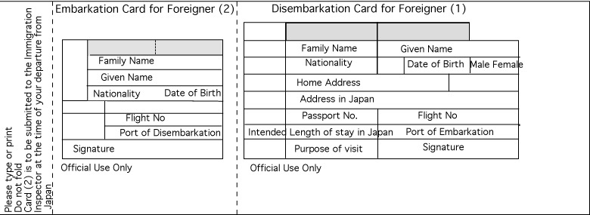

“Embarkation” refers to the act of boarding a vessel or airplane; “disembarkation” is the act of getting off the vessel or airplane at your destination. Part (1), the “Disembarkation Card for Foreigner” will be retained by the immigration officials when you enter Japan. They will put a sticker in your passport and staple part 2 – the “Embarkation Card for Foreigner” – to the page in your passport that has the sticker. When you leave Japan, the immigration officials will place an exit sticker in your passport and remove part 2, the “Embarkation Card for Foreigner.”

On the Disembarkation Card, most is self explanatory, but make sure you put the following in the respective boxes:
- Your nationality is: USA
- Address in Japan: Asia Center Hotel, Tokyo (It causes confusion to put multiple addresses, but it is worse to leave it blank. I will leave an itinerary at the Asia Center Hotel.)
- Intended Length of Stay in Japan: 26 days
- The Flight Number: SQ11 (double check this against your boarding pass and airline itinerary since it may have changed).
- Port of Embarkation: LAX (or Los Angeles)
- Purpose of Visit: School Tour, Sightseeing.

On the Embarkation Card, the following is what they are seeking:
- The Flight Number: SQ12 (again, double check your itinerary).
- Port of Disembarkation: LAX (or Los Angeles)

Customs Declarations

Upon landing at Narita.

There will be an easy form for you to fill out to go through customs at Narita. Basically, you only have “personal belongings” that your are bringing and “gifts” for your host family. Declare these along with the estimated value of the gifts. Fill in the first part using the same information that you put on the Disembarkation/Embarkation Card. The phone number for the Asia Center Hotel is: (81-3) 3402-6111

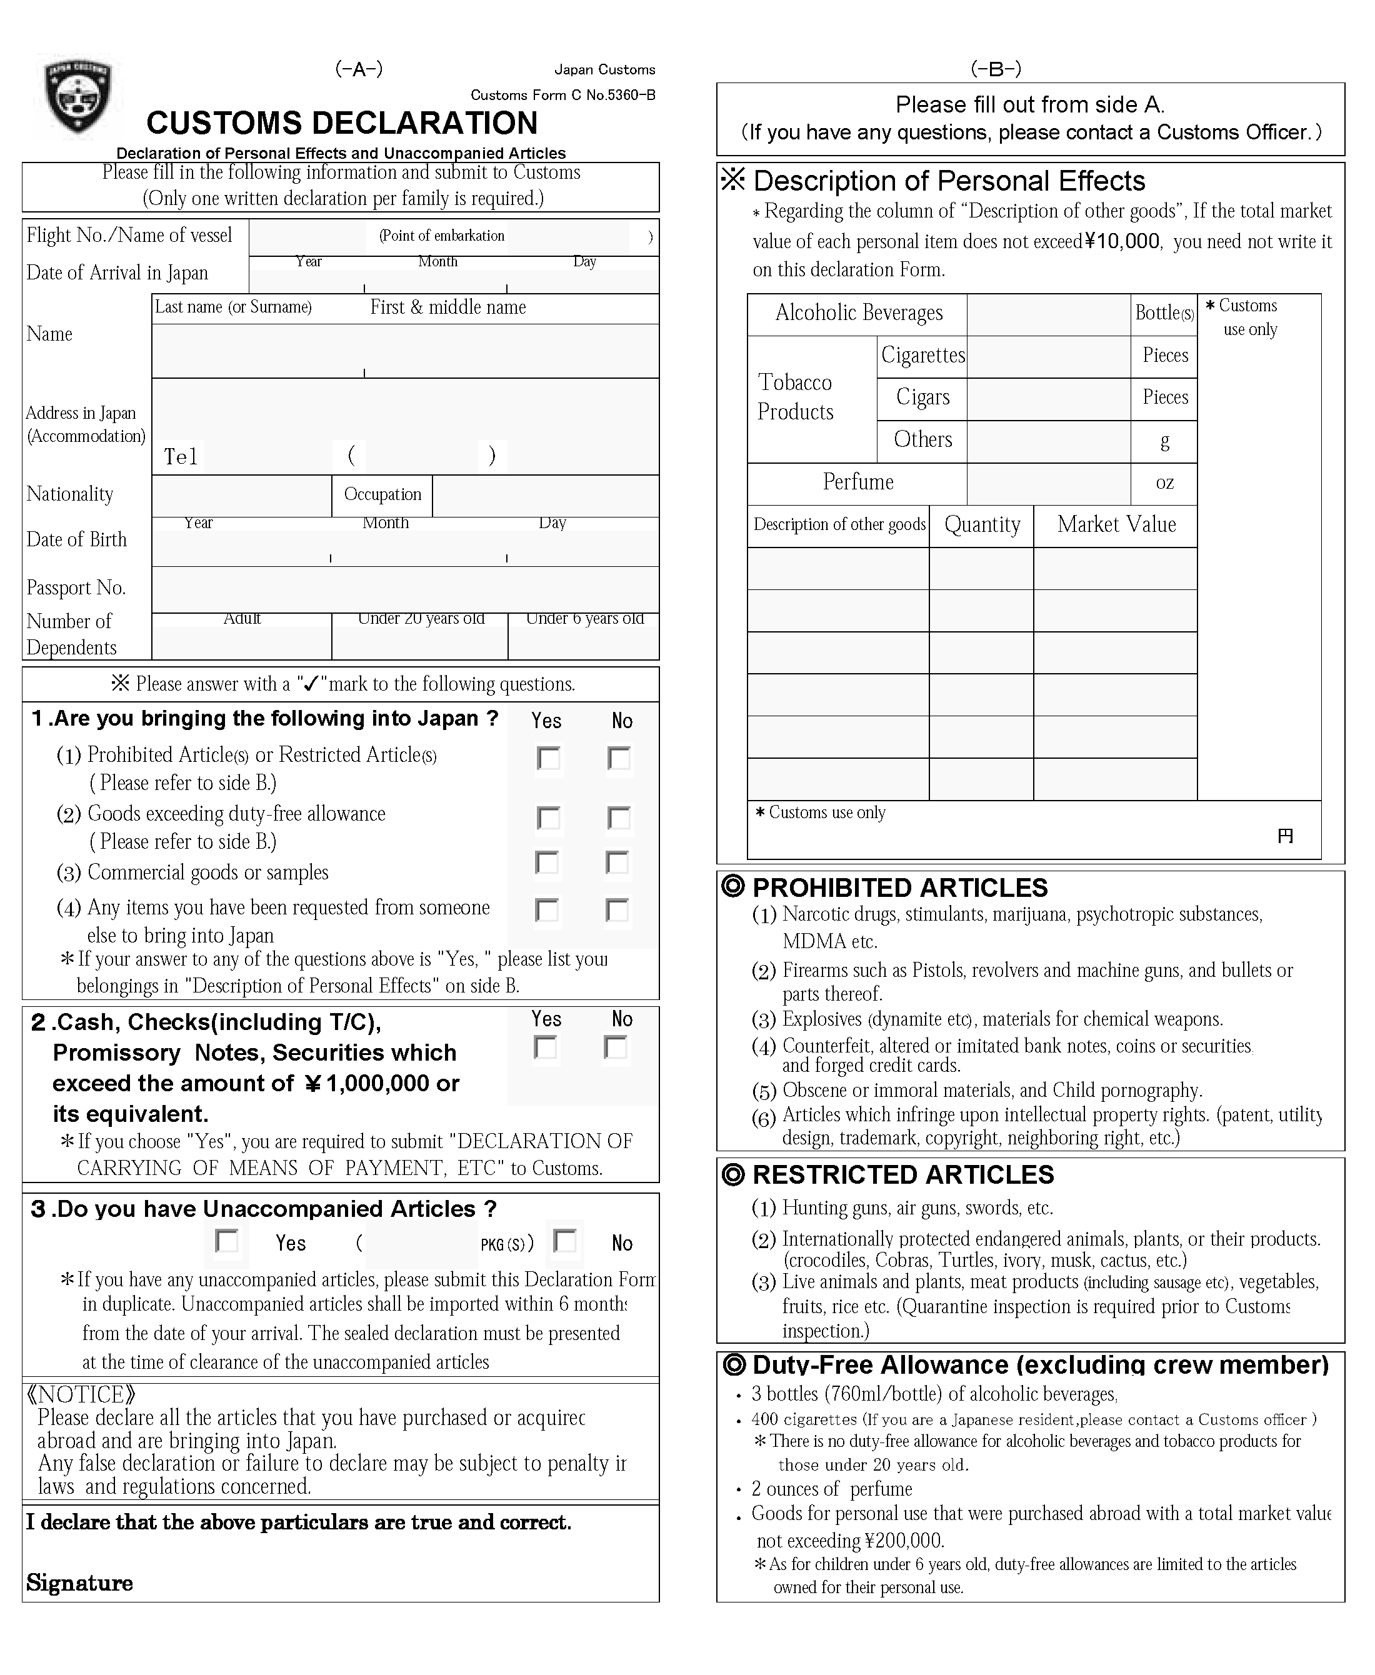

Upon returning to the United States in Los Angeles.

On the flight back to Los Angeles from Narita, you will be given a form that looks like the sample reproduced here (only it will be readable). Since you have read the section of this itinerary that pertains to the customs declaration, you should not have any trouble filling out this form. Just make sure that if you visited a farm, you have kicked all the dirt—and other “stuff”—off your feet (you will see what we mean).
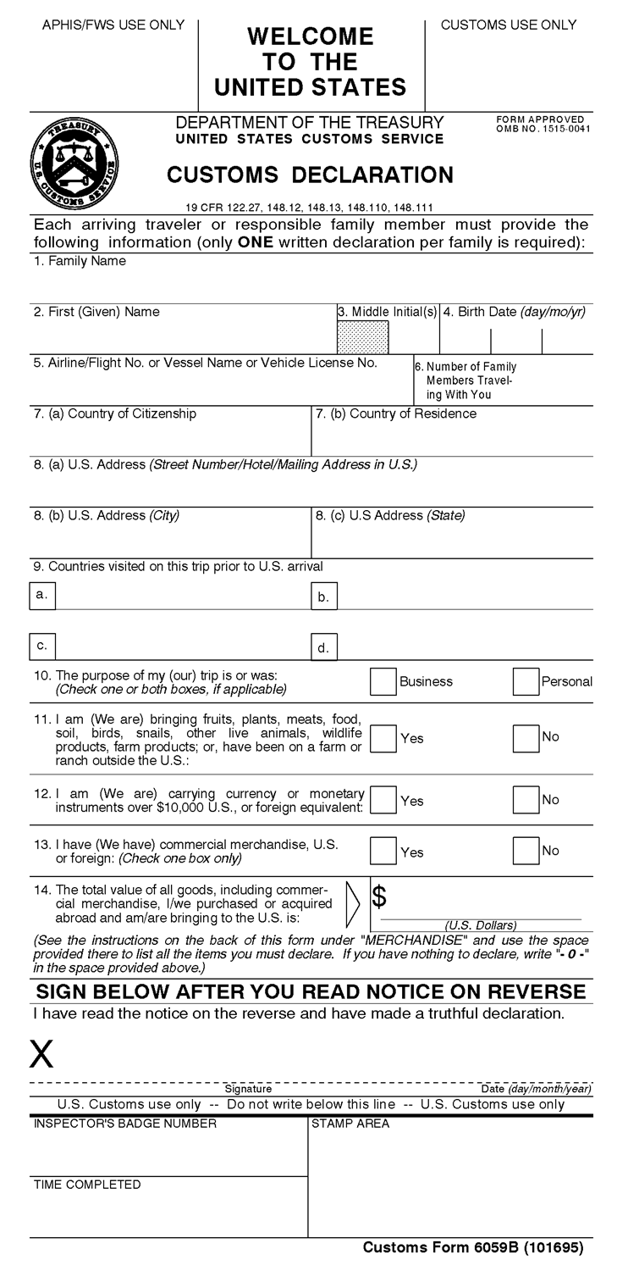
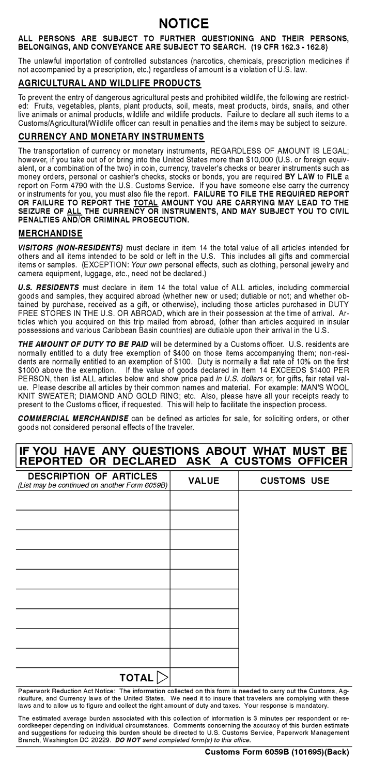

Contact Information

Emergency Contacts

The following pages list the hotel names, addresses, and telephone numbers where we will be staying. While we are in Kumamoto, you are provided the contact information at the Prefectural University of Kumamoto and a list of names and contact information for host families.

Please observe the two conditions under which this information is provided:

- These phone numbers are for emergency contacts only. The chances are that anyone who calls will first speak with someone whose main language is Japanese. But even those fluent in English likely will construe any call from someone in the United States as constituting an emergency. As such they will do whatever they can to track down the person who is being called. So, unless there is an emergency, please refrain from calling. (A great way to get non-emergency messages to students is explained below)

- Japan is 15 hours ahead of Montana. While the hotels generally will man their front desk on a 24-hour basis, the folks at the Pension in Hakuba and the host families in Kumamoto usually will be sleeping right when it is convenient for folks in the US to call. Unless there is a dire emergency, please time any calls to occur no earlier than 7:00 am and no later than 10:00 pm in Japan while we are in Hakuba and Kumamoto. The table on the next page gives you the concurrent times in Montana and Japan.

Non-Emergency Contacts.

Generally, it will be easiest if a trip participant calls home rather than vice versa. You can obtain international calling cards (from Costco?) before leaving Billings, but students have had trouble using them on past trips. It probably will be better to purchase them in Japan. On past trips, the Asia Center Hotel in Tokyo has sold phone cards for a very good price. Students will have access to the Internet in most cities we will visit. They will have access to the computer lab at the Prefectural University of Kumamoto and can check e-mail then on a daily basis. We can also explore using Skype as an alternative to using phones.

If parents want to get in touch with students, they can send a message to the trip chaperone, Dr. Scott Harris. His e-mail address is sharris@msubillings.edu. He will be glad to pass along information or alert a student to call home. Note: Though he will have a computer with him on the trip, there possibly will be times and locations when Dr. Harris cannot access the Internet. Also (especially on the weekend of May 30-31) the student may be traveling with their host family and not be easily contacted for a few days.

Japan-Montana Time Differences

The entire country of Japan is on one time zone. Use the following chart to convert between Montana (Mountain Daylight Savings Time) and Japan (always on Standard Time).

Montana | Japan
12:00 AM | 3:00 PM | Same day in Montana  and Japan
1:00 AM | 4:00 PM | Same day in Montana  and Japan
2:00 AM | 5:00 PM | Same day in Montana  and Japan
3:00 AM | 6:00 PM | Same day in Montana  and Japan
4:00 AM | 7:00 PM | Same day in Montana  and Japan
5:00 AM | 8:00 PM | Same day in Montana  and Japan
6:00 AM | 9:00 PM | Same day in Montana  and Japan
7:00 AM | 10:00 PM | Same day in Montana  and Japan
8:00 AM | 11:00 PM | Same day in Montana  and Japan
9:00 AM | 12:00 AM | Japan is one day ahead of Montana  (e.g. Monday in Montana = Tuesday in Japan.)
10:00 AM | 1:00 AM
11:00 AM | 2:00 AM
12:00 PM | 3:00 AM
1:00 PM | 4:00 AM
2:00 PM | 5:00 AM
3:00 PM | 6:00 AM
4:00 PM | 7:00 AM
5:00 PM | 8:00 AM
6:00 PM | 9:00 AM
7:00 PM | 10:00 AM
8:00 PM | 11:00 AM
9:00 PM | 12:00 PM
10:00 PM | 1:00 PM
11:00 PM | 2:00 PM

Unless otherwise noted, all references in this document are given based on the day and time in Japan.

Hotel Addresses and Phone Numbers

May 15th (evening) through May 19th (morning): Tokyo.

ASIA CENTER OF JAPAN HOTEL

The phone numbers, address, and website for the Asia Center of Japan Hotel are:

Phone: +81-3-3402-6111
Fax: +81-3-3402-0738
(If dialing from the US, the foreign access code for Japan, 011, should be dialed before this number. That is what the “+” in front of the number signifies)

Address: 10-32, Akasaka 8-chome
Minato-ku
Tokyo, Japan 107-0052

Web site: http://www.asiacenter.or.jp/eng/index.html
Most of the hotel was completely rebuilt a few years ago. We will be staying in the older section of the hotel (not shown in the pictures…it is older—and a little cheaper—but quite clean.).

May 19th (afternoon) through May 21st (morning): Hakuba.

PENSION LOCATION (yes, that is the name of the hotel)

The phone numbers, address, and website for Pension Location are:

Phone: + 81-261-72-5216
Fax: + 81-261-72-5682
(If dialing from the US, the foreign access code for Japan, 011, should be dialed before this number. That is what the “+” in front of the number signifies)

Address: 399-9301 長野県北安曇郡白馬村みそら野 2443-1
(This basically means that we have no clue what the address is in English, but here it is just in case somebody really wants it!)

Web site: http://web.hakuba.ne.jp/location/ This website is in Japanese. Google has a translation service that at least makes the words into English, but does not translate the syntax well. You can try it if you want.

May 21st (evening) through May 24th (morning): Hiroshima.

HIROSHIMA HOTEL CENTRAL

The phone numbers, address, and website for the Hiroshima Hotel Central are:

Phone: +81-82-243-2222
Fax: +81-82-243-9001
(If dialing from the US, the foreign access code for Japan, 011, should be dialed before this number. That is what the “+” in front of the number signifies)

Address: 1-8 Kanayamacho,
Naka-ku, Hiroshima-shi,
Hiroshima-ken, Japan 730-0022

Website: http://www.central-hotel.to/english/english.htm

May 24th (mid-afternoon) through June 3rd (early morning): Kumamoto.

Students will be in residence in Kumamoto with host families. (See next section for contact information)

June 3rd (mid-afternoon) through June 7th (morning): Kyoto.

THE PALACE SIDE HOTEL

The phone numbers, address, and website for the Palace Side Hotel are:

Phone: +81-75-415-8887
Fax: +81-75-415-8889
(If dialing from the US, the foreign access code for Japan, 011, should be dialed before this number. That is what the “+” in front of the number signifies)

Address: Karasuma Shimodachiuri Agaru
Kamigyo-ku
Kyoto 602-8011, Japan

Website: http://www.palacesidehotel.co.jp/english/fr-top-en.html

June 7th (afternoon) through June 9th (early afternoon): Tokyo.

ASIA CENTER OF JAPAN HOTEL

See contact information on page 21.

Kumamoto Contact Information

May 24th (mid-afternoon) through June 3rd (early morning): Kumamoto.

PREFECTURAL UNIVERSITY OF KUMAMOTO (PUK)

During weekdays (in Japan), students will be at PUK. Contact is to the Office of Student Affairs:

Mr. Akihiro Higashi
Administrative Staff
Students Affairs Division
Prefectural University of Kumamoto
3-1-100, Tsukide, Kumamoto City,
Kumamoto Japan 862-8502
TEL +81-96-383-7896 (US callers use the 011 prefix)
FAX +81-96-383-2364 (US callers use the 011 prefix)
e-mail: higashi@pu-kumamoto.ac.jp

This is NOT confirmed yet for 2009: The Student Affairs Division will provide Scott Harris a cell phone during this time. He will carry that phone 24 hours a day and will be able to be an emergency contact. That phone number will be:

Scott Harris
Cell phone +81-90-3075-9302 (US callers use the 011 prefix)

Please note that this cell phone will be useful ONLY during the time we are in Kumamoto; it will be turned back to the PUK Student Affairs Division when we leave Kumamoto.

Host Family names and contacts are on the table on the following page.
Host Family Contact Information:

MSU-B Student/  Faculty | Host's Name | Address | Postal Code | e-mail* | Phone Number** | Mobile Number**
HARRIS, Scott | OTANI, Yumi  OTANI, Eimi | 6-26-23, Ohe, Kumamoto-city | 862-0971 | sharris  @msubillings.edu | 096-363-0086 | 080-1796-9319
HARRIS, Emily | NAKAMURA, Ayano | 1635-137, Suya,  Koshi-city | 861-1102 | mama-s @amber.plala.or.jp | 096-242-7450 | 080-1732-2050
MOORE, John | MIYAMOTO, Naoya | 3726-16, Tsukure, Kikuchi-town,  Kikuchi-gun, Kumamoto | 869-1101 | takekisaitou @yahoo.co.jp | 096-339-1256 | 090-6899-1692
FEHLMANN, Tiffani | URAMOTO, Momoe | 5-2-5, Kusunoki, Kumamoto-city | 861-8003 | mtywm471148 @yahoo.co.jp | 096-338-3728 | 090-8767-2592
LEON, Sonya | KAWANAMI, Madoka | 1-15-1, Hikarinomori, Kikuyo-town,  Kikuchi-gun, Kumamoto | 869-1108 | madoka1208 @gmail.com | 096-233-1255 | 090-4983-5245
RODEGHIERO, Jennalee | MATSUDA, Naoko | ７-３-９, Tsukide, Kumamoto-city | 862-0920 | sym22753 @yahoo.co.jp | 096-381-2375 | 090-8624-1236
ALLEN, Ryan | KATAYAMA, Kyoko | 17-62, Kengun-honmachi,  Kumamoto-city | 862-0910 | katayama_kyoko @hotmail.com | 096-284-3200
ARMSTRONG, Michael | OKABE, Yoshitsugu | 2-5-8, Suizenji, Kumamoto-city | 862-0950 | y-okabe  @s5.kcn-tv.ne.jp | 096-383-8133 | 090-8761-9023
PETERSON, Ashley | MISHIMA, Yukihiro | 1-1-98, Goryo, Kumamoto-city | 869-4223 | satomi450202 @yahoo.co.jp | 0965-53-9715 | 090-8831-3394
HOWE, Sarah | MISHIMA, Yukihiro | 1-1-98, Goryo, Kumamoto-city | 869-4223 | satomi450202 @yahoo.co.jp | 0965-53-9715 | 090-8831-3394
WILBURN, Maureen | SUGA, Toyoko | 262, Toyoaki,  Mifune-town, Kamimashiki-gun, Kumamoto | 861-3131 | tsugamifuneo @mx7.tiki.ne.jp | 096-282-6278
VALLE, Ellen | FURUKAWA, Hiroko | 3-20-12, Tatsuda-jinnai, Kumamoto-city | 862-8005 | roma  @jc4.so-net.ne.jp | 097-338-2652 | 090-3738-3621
STURM, Christine | SHUTO, Yukuo | 3-10-2, Sakuragi, Kumamoto-city | 861-2101 | dengys0345  @s1.kcn-tv.ne.jp | 096-369-5703

* E-mail addresses have been split into two lines to fit them on the table. There should be no line breaks or spaces when you enter these into your e-mail program.

**The above phone numbers are for people who are calling from Japan. If you are calling from the USA, drop the initial “0” and add the following country and area codes: 011+81. Example: A local call to 096-363-0086 becomes the following when calling from the USA: 011-81-96-363-0086
Chronological Itinerary

Thursday and Friday, May 14-15, 2009: Billings, MT to Tokyo, Japan

We will travel from Billings to Narita (New Tokyo International Airport) via Salt Lake City and Los Angeles (LAX). Flight schedules may change from those contained in this itinerary. We will keep you apprised of any changes. We are currently scheduled to leave Billings at 7:40 am on May 14 and return to Billings at 10:36 pm on June 9.

On Thursday, May 14th, our departure day, you should be at the airport by 6:00 am. It will take longer to check in for an international flight and we want to make sure everybody clears security in plenty of time. We will have almost a 4-hour layover in Los Angeles on the outbound trip. This will give us time to change terminals and check in with Singapore Airlines before lunch at the food court in the Bradley International Terminal. The plane leaves for Tokyo at 2:40 pm and it will be a good idea for you to start through security by around 1:20 (depending on how long the line is) so you can be at the gate about an hour before departure.

During the flight from LAX to Narita you will be asked to fill out a “Disembarkation/ Embarkation Card” to present to Immigration at Narita as well as a Japanese Customs form. (See pages 16-17 for instructions.)

We are scheduled to land at Narita at 6:10 pm on May 15th.

Narita Airport (New Tokyo International Airport)

Two of the busiest airports in the world serve Tokyo. Tokyo International Airport (Haneda) is adjacent to Tokyo Bay and serves most domestic Japanese flights and some nearby foreign destinations. Most international flights, however, fly in and out of the New Tokyo International Airport in Narita, about 50 miles outside of Tokyo. It is also the entry/exit point for most of the airfreight traffic in and out of Japan.

Google Earth coordinates for Narita Airport: 35° 45’ 52.27” N, 140° 23’ 02.68” E

Upon arrival at Narita, we will have to go through Quarantine (health inspection), Immigration, and Customs. This will probably take about ½ hour. We will change some of our dollars to yen in Narita. Wait to exchange money in Japan since we will get a much better exchange rate there than will be available in Billings or LAX. As explained earlier, we also will try to obtain our JR Passes and pick up our train tickets for the rest of the trip at Narita since it will be much less convenient to make a special trip to Tokyo Station on another day. We will catch the next available Narita Express Train for the 50-mile trip to Tokyo Station. It will take about an hour to get there. The train schedule is on page 49.

When we arrive at Tokyo Station, we will have a choice of taking a taxi or the subway to the hotel. Each will be about as fast as the other, but the costs will be quite different.

Travel by taxi to the Asia Center of Japan Hotel: estimated cost per cab: ¥1500—¥2000. Cabs will hold between 2 and 3 people. Most cabs are about the size of a Honda Accord or Toyota Corolla and trunk space is limited. The fare is the same regardless of number of passengers and you will pay what is shown on the meter; there is no tipping.

Travel by subway to Asia Center of Japan Hotel: ¥190 per person. The subway station is in Tokyo Station, and we will have to make one transfer. The Aoyama Itchome subway station is about a 6-minute walk from the hotel. If we try to take the subways, we may get to the transfer point at the Akasaka-Mitsuke Station and find that the Ginza Subway Trains for the last leg are too crowded to accommodate luggage because of the Friday night crowds going to Shibuya. In that event, we can take cabs from there to the hotel.

Estimated travel time from Tokyo Station to Asia Center Hotel: 20-25 minutes (or less)

Evening of Friday May 15th until Tuesday morning May 19th: Tokyo

We will stay at the Asia Center of Japan Hotel in the Akasaka district of Tokyo (Full contact information for the hotel is on page 21.)

The staff at the Asia Center of Japan is fluent in English and will be able to assist you in any way they can. You will have a phone in your room to receive calls. You should make international calls at a phone using an international phone card in the lobby. The front desk is manned 24 hours a day. Leave your room key at the front desk whenever you leave the building.

You can exchange money (including traveler’s cheques) at the front desk. There will probably be a $300/day limit; if you want to exchange more, there is a bank down the street. Sometimes the front desk runs out of money they have for exchange, so it is not totally reliable.

You will be given tickets for the breakfast buffet when we check in. There is complimentary bottled water in a cooler in the lobby.

While we are in Tokyo, it is strongly recommended that you keep a copy of the following map with you at all times. Single-sheet copies are available at the front desk. If you get tired or lost, just flag down a cab and show the driver the map with directions to the hotel. Most will be able to use that to get you back to the hotel.

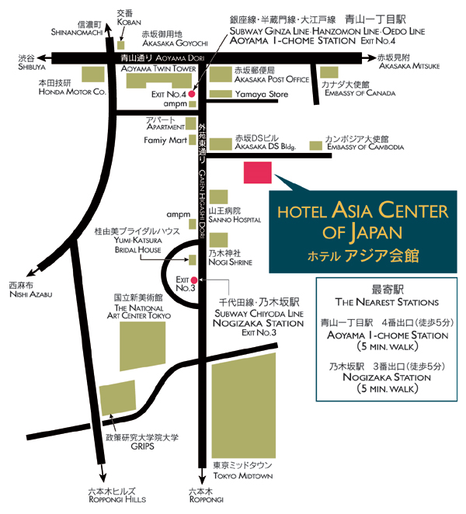

The Google Earth coordinates for the Asia Center of Japan Hotel are:
35° 40’ 13.47” N, 139° 43’ 40.92” E.

Tokyo Sightseeing

Tour and shop in Tokyo. Visit Tsukiji Fish Market and other places that interest you. We will plan on doing some things as a group (e.g., Tokyo Tower, Tsukiji, or other things that seem to elicit common interest), but you also will be free to visit places of particular interest on your own. We request that you go in groups of at least two people unless you have cleared it with the trip chaperone.

Your first morning will involve an orientation on buying and using tickets on the Tokyo Metro. There are many subway companies and even more subway lines. Fortunately there is a group of subway lines that are operated by one company that will take you almost anyplace you want to go. You can buy a one-day pass to for unlimited travel on those subway lines for ¥710. Most of the standard sights are accessible using the Ginza Line, Tokyo’s oldest subway line. The Aoyama-Ichome Station is about a 5-minute walk from the hotel. Trains run every 3-5 minutes.

Google Earth coordinates for a few of Tokyo’s attractions:

Tokyo Tower: 35° 39’ 30.76” N, 139° 44’ 43.91” E
Tsukiji Fish Market: 35° 39’ 44.12” N, 139° 46’ 10.79” E
Tokyo Station: 35° 40’ 51.92” N, 139° 46’ 01.20” E
Kabuki-za (Ginza District): 35° 40’ 09.63” N, 139° 46’ 04.15” E
Ueno Park (National Museums, zoo): 35° 42’ 56.00” N, 139° 46’ 25.14” E
Asakusa (Senso-ji Temple): 35° 42’ 51.37” N, 139° 47’ 48.56” E
Meiji Shrine: 35° 40’ 34.00” N, 139° 41’ 57.88” E
Tokyo Disneyland and Disney Sea Park 35° 37’ 45.00” N, 139° 53’ 03.00” E

Addresses in Japan

If you look on the Asia Center of Japan’s card (previous page), you will see only the names of the major streets on the map; the others are nameless. This is because street names are not used in Japanese addresses.

Japanese addresses are based on a “block” system rather than a linear “street” system. To see how it works, think of a house in a city. It is on a block in a neighborhood in a district within a city, which is in a county that is in a state that is in a country. One could find the house by identifying the block, neighborhood, district, city, county, state, and country. The house number would be the number for that house on the block. So, when you see the address for the Asia Center: 10-32, 8chome, Akasaka, Minato-ku, Tokyo 107-0052, you can interpret it as the 10th building in the 32nd block of the 8th section of the Akasaka area in the Minato district of Tokyo with “zip code” of 107-0052.

While this system works for Post Office employees, one would have to know the block numbers and other geographic specifics to navigate using this type of address. Therefore, it is quite common for Japanese folks to get to an area and ask further directions of locals who will be more familiar with the layout. For you, it basically means that addresses are useless. If you can navigate using maps, you will be in better shape than most. If you get lost or turned around, stop and ask someone for directions. Every 5th or 6th person may understand enough English to assist you.

Maps

The following pages have maps of some (not all!!) of the major shopping areas in Tokyo that are near the Asia Center Hotel or are easily accessible via subway. Additional area maps of Tokyo are found here: http://superfuture.com/city/city/city.cfm?city=1
Harajuku: Trendy shopping area.

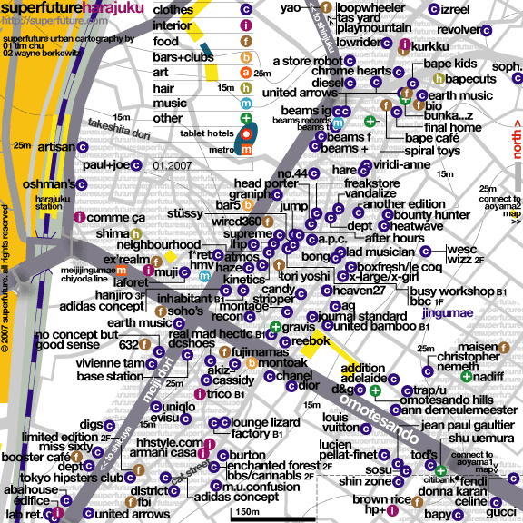

The Google Earth coordinates for the intersection of Meiji Dori and Omotesando are: 35° 40’ 06.74” N, 139° 42’ 19.73” E

The Aoyama 1 map that connects to the lower right of this map is on the next page.

Aoyama 1: this is a continuation of the Harajuku map (on the previous page)

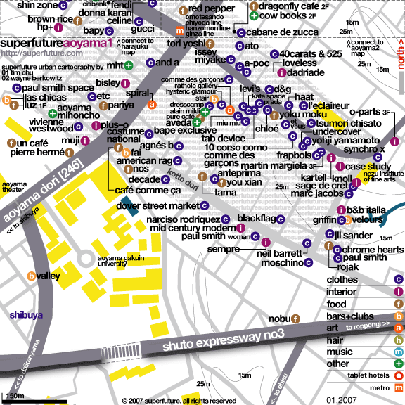

This area is quite close to where we will be staying at the Asia Center—one or two subway stops away.

Shibuya: The night lights at Shibuya Crossing (bottom center of the map) are spectacular and have been featured in many movies. The Google Earth coordinates for Shibuya Crossing are: 35° 39’ 33.92” N, 139° 42’ 02.40” E

Shibuya is at the end of the Ginza subway line, 3 stops from our hotel. (It is due to the popularity of the Harajuku and Shibuya areas for weekend nightlife that likely will have the Ginza subway packed when we first arrive in Tokyo on Saturday night.)

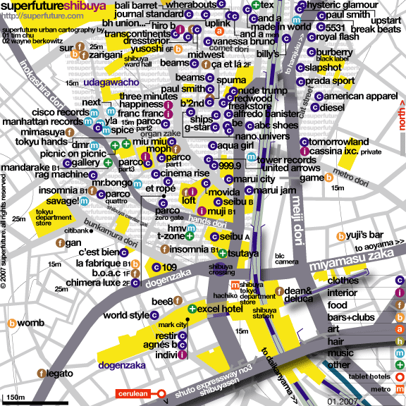

Roppongi: This is another restaurant and famous night club area—less than a mile from the Asia Center Hotel. Tokyo Midtown (just off the upper border of the map) is a major urban renewal project that was just completed. It is between “Roppongi Corner” (the intersection of Roppongi Dori and Gaien Higashi Dori in the upper center of the map) and the Asia Center Hotel. Roppongi Corner is on Google Earth at
35° 39’ 47.79” N, 139° 43’ 56.12” E. (The Tokyo Midtown area is shown as a large brown bare area in the Google Earth image.) Nearby is the very new Tokyo Art Center.

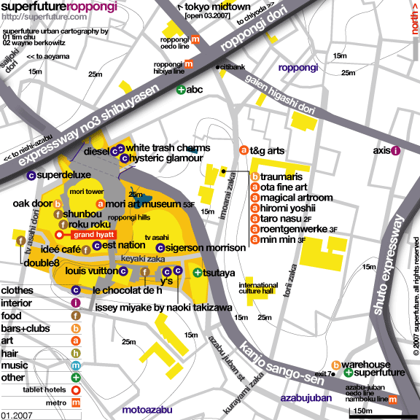

Ginza: This is the old famous shopping area of Tokyo where the old line department stores have their flagship stores. Also here are the Kabuki-za theater (to see Kabuki performances) and the headquarters for Sony Corporation (the spiraling showroom has the latest techno-gizzies). Sometimes in the evenings, Japanese “Gypsy” Fortunetellers set up tables and street vendors sell fresh steamed yams or sweet potatoes along the streets of Ginza.

Google Earth coordinates for the Kabuki Theater are:
35° 40’ 09.63” N, 139° 46’ 04.15” E.

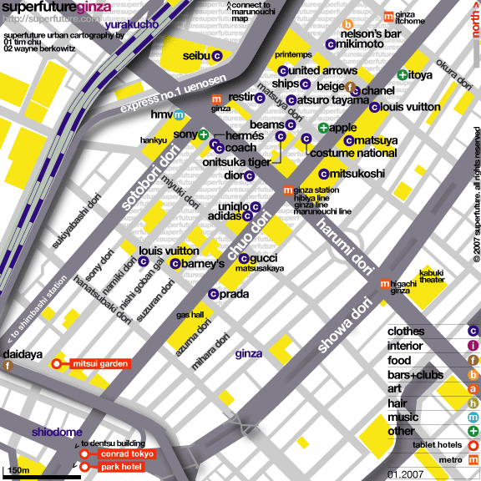

Tuesday, May 19th (Morning to Early Afternoon): Tokyo to Hakuba.

This is a travel day. Early risers will be able to grab a quick bite at the Hotel before we have to leave for the station. Our travel itinerary is: Tokyo to Hakuba in the Japanese Alps.

Transfer | Arrival  &  Depature | Required | Station name  &  Route and Train name
 | 08:40 |  | TOKYO
 |  | 100min | SHINKANSEN ASAMA 509
 | 10:20 |  | NAGANO

As of February 20, we are awaiting word from our host in Hakuba to find out if he will be able to meet us in Nagano with a bus to take us to Hakuba. If he cannot arrange for the bus, we will have to travel to Matsumoto and then up to Hakuba by train. If that becomes the case, we might consider taking an earlier train from Tokyo to Nagano.

Note on Train Travel Arrangements: Since we are using the JR RailPass for our train travel, we cannot make specific train reservations until we get to Japan. If all goes well, we will be able to get both the rail passes and reserved seat tickets when we arrive at Narita. Otherwise, that will be done in Tokyo on one of the following days. Therefore, the train itineraries in this document must be understood to be “preliminary” in that they are the trains we will try to get passage on. The chances are pretty good that we will succeed with most or even all of these. But there could be instances where a particular train is “full” and we will have to book ourselves onto another one. This could change our train schedules by an hour or two, but we will know that when we are able to get the tickets and can adjust our itinerary accordingly.

Note on Punctuality: Trains in Japan run on time 99.9% of the time (the 0.1% when they do not run on time is usually due to “acts of nature”—typhoons, earthquakes, snowstorms, etc.). So, do not be late…or you will have a solo adventure.

Tuesday Afternoon Through Wednesday Night, May 19th and 20th: Hakuba.

We will stay in the Hakuba area of Nagano Prefecture for two nights. You will be free to explore on your own. There probably will be an opportunity for you to visit your first onsen as there are several hot springs nearby. One attraction that you may want to visit is the Olympic Ski Jump Stadium. You can take a chair lift to the top of the facility and stand at the gates used by the ski jumpers. Besides seeing some beautiful country, a reason for visiting Hakuba is to allow you to decompress a little after Tokyo and rest up for the trip that will shortly take us to the southwestern tip of the country were Kumamoto is.

Trivia: “Hakuba” means “White Horse” in Japanese (“Haku” = “white” and “ba” = “horse”).

We will stay at the Pension Location, a “western style” inn that is similar to a “Bed and Breakfast” establishment in the US. It is likely that our group will occupy the entire inn, but there may be one or two other couples booked. Hakuba is a major ski area and summer resort, but we will be there in the off-season, so it likely will be quiet and fairly tranquil. Your host and hostess at the Pension Location will be Yoshiyuki and Kazuko Nagata.

Google Earth Coordinates: 36° 41’ 27.32” N, 137° 50’ 55.54” E. (Map resolution is poor). These coordinates are for the Pension Location, but if you look around nearby areas, you can see pictures of the mountains and valley.

Thursday, May 21st: Hakuba to Hiroshima.

We will leave Hakuba after breakfast and travel the longest single leg of the tour—to Hiroshima. We will leave Hakuba fairly early. We will have two choices of routes.

Route Choice 1: We will take the local (puddle jumper) train north to the coast on the Sea of Japan and catch a westbound Limited Express Train to Kanazawa. There will be a 45-50 minute layover in Kanazawa that coincides with lunchtime. You should be able to find food in or around the station. Then we will catch another Limited Express Train that will continue along the coast for before turning south to Kyoto and Shinosaka. The route will take us along the edge of Japan’s largest fresh water lake, Lake Biwa. In Shinosaka, we will have 43 minutes to make our way to the Shinkansen track area to catch the Hikari Rail Star Shinkansen (bullet train) to Hiroshima. We will arrive in Hiroshima at 5:52.

Route Choice 2: We take the local train south to Matsumoto and catch a Limited Express Train to Nagoya. In Nagoya, we catch a Shinkansen to Shinosaka where we switch trains to another Shinkansen to Hiroshima. The route from Matsumoto winds through the mountains on a very scenic route to the Pacific Coast (Nagoya). This route will take less time but there will be no breaks long enough to allow you to take a lunch break. You will either have to buy your lunch on the train or bring something from Hakuba.

Detailed train itinerary for these schedules starts on page 51.

Regardless of what route we take, this will be the longest travel day in Japan. On route 1, the total distance traveled for the day will be 490.6 miles (about the same distance from Plentywood to Missoula or from Billings to Coeur d’Alene, Idaho) in about 9 hours. Average speeds (including stops) on the different legs will vary from a little over 20 mph when we first leave Hakuba to a bit more than 131 mph over the last leg. The average speed for the day—including all stops and 2 hours and 1 minute in accumulated layovers—will be 54.7 mph.

Route 2 covers a distance of 482.2 miles in about 7 hours. Average speeds (including stops) on the different legs will vary from a little over 20 mph when we first leave Hakuba to almost 137 mph over the last leg. Because there will be just 50 minutes total in layovers, the average speed for the trip will be 69 mph. (including stops and layovers).

Though we will try to travel the route that the group chooses, it may depend on availability of seats on the trains.

Note on Names: You will often see Japanese words that start with “Shin” as in “Shinosaka” mentioned above. “Shin” means “new” and in the context of train stations, Shinosaka is the new train station in Osaka that was built for the bullet trains…which are called “Shinkansen”—meaning literally “new trunk rail lines.” Shinosaka station is different from the Osaka train station, which is closer to downtown Osaka.

Thursday Evening Through Sunday Morning, May 21st to the 24th : Hiroshima and Miyajima Island

When we arrive in Hiroshima, we can either take the streetcar or walk to the hotel. We will stay at the Hiroshima Hotel Central (see page 22 for contact details). The hotel is situated on one of Hiroshima’s many “rivers” that make up the Ota River delta. You can clearly see this on Google Earth by looking at the city from about 20 miles in space. (General coordinates are: 34° 23’ 36.05” N, 132° 27’ 06.72” E )

After checking into the hotel, you will be free to explore a Thursday evening in Hiroshima. It is suggested that you try the cuisine for which Hiroshima is particularly famous: Okonomiyaki. It is a uniquely Japanese food that has been described as a cross between pizza and pancakes, but made with noodles. Like pizza, you can get it in many different flavors and some places even have “grill your own” set-ups.

Several companies offer river tours of Hiroshima. If it is a nice night, this might be an option worth considering.

Since we will be in the Hiroshima area two full days (Friday and Saturday) and part of the morning Sunday, you should consider how you will spend that time. There are basically two “must visit” places in the Hiroshima area: The Peace Park and A-Bomb Museum, and the island of Miyajima. The grounds of the Peace Park are accessible during all hours and the museum hours are 8:30 am to 6:00 pm. Museum admission is a very reasonable ¥50.

As you walk around Hiroshima, realize that a little more than 60 years ago everything in the city was totally devastated. There were no trees or buildings to speak of. Everything you see has been rebuilt from the ashes. Though some predicted that it would take decades before anything could grow, the trees and gardens demonstrate the remarkable recovery capabilities of nature. Indeed, within a few days of the bombing, green sprouts pushed up through the devastated soil. The local transportation around Hiroshima centers on the city’s famous streetcars. After the bomb destroyed the city, the local government worked very hard to get the streetcars back up and running. When they did so, the streetcars became a symbol of hope and resiliency for the residents to rally around.

Note: There is virtually no residual radiation or fallout in the city today; it is considered completely safe. You will get more radiation exposure from the sun.

The other destination is Miyajima Island. Trains for Miyajima leave about every 10-15 minutes from platform 1 in Hiroshima Station (a few trains leave from platform 2, see detailed train schedule on page 54.). Take the Sanyo Line to Miyajimaguchi Station (about 25 minutes—the detailed schedule lists stations on the Sanyo Line to aid you in keeping track of where you are). When you exit the Miyajimaguchi Station, walk about a block and a half to the waterfront and catch the JR Ferry to Miyajima (note that the first intersection does not have crosswalks; you are supposed to take an elevator to an underground walkway and cross under the intersection). The JR ferry is free if you use your JR Rail Pass. (If you get mixed up and board the wrong ferry, you will have to pay around ¥110 for passage.)

Miyajima is a sacred island in Japan and everyone we know who has visited wants to go back to spend more time. The village and waterfront shops are fairly traditional. The shrines and views on Miyajima are world famous (including the “floating” Torii Gate in the tidal flats). The “Momiji” pastries produced here are famous throughout Japan and a little box of them would be a splendid little gift to take to your host family (Momiji = Japanese Maple). There is a tram (“ropeway”) that takes you to the top of the Mt. Misen where you can walk back down to the village through the Momiji-dani section of the National Park. The woods at the top of the mountain are home for monkeys and other interesting creatures. The tame deer that you will see everywhere in the village are considered sacred and will pester you for anything edible (including your clothes!!). The aquarium is okay but is nothing special; there are several others in Japan that are quite nice if that is an interest for you (the aquarium in Osaka is quite famous—you can possibly visit it when we are in Kyoto.) There is a speedboat (hydrofoil) that you can use to take back to Hiroshima. It drops you off at the Port of Hiroshima and you will have to find your way from there to the hotel. The cost one way is approximately ¥1,500. Alternatively, you can retrace your steps back to the ferry and take the train back to Hiroshima Station for free with the JR Pass.

Google Earth coordinates for Hiroshima and Miyajima:

Hiroshima Station: 34° 23’ 51.65” N, 132° 28’ 32.41” E
Hiroshima Peace Park: 34° 23’ 36.05” N, 132° 27’ 06.72” E
Hiroshima Central Hotel: 34° 23’ 32.52” N, 132° 28’ 06.94” E
Miyajimaguchi Train Station: 34° 18’ 43.30” N, 132° 18’ 10.73” E
Miyajimaguchi JR Ferry Terminal: 34° 18’ 39.98” N, 132° 18’ 18.80” E
Miyajima Island Ferry Terminal: 34° 18’ 08.33” N, 132° 19’ 20.05” E

Sunday, May 24th: Hiroshima to Kumamoto.

We have been asked to arrive in Kumamoto in the early to mid-afternoon so you can meet your host families and spend the late afternoon and evening getting acquainted. Therefore, we will leave Hiroshima mid to late morning.

Transfer | Arrival  &  Departure | Required | Station name  &  Route and Train name
 | 10:40 |  | HIROSHIMA
 |  | 70min | SHINKANSEN HIKARI RailStar 453
24min | 11:50  12:14 |  | HAKATA
 |  | 75min | LTD.EXP RELAY TSUBAME 11
 | 13:29 |  | KUMAMOTO

When we arrive in Hakata, we must walk from the Shinkansen area in the station to the regular train tracks to catch the Limited Express train to Kumamoto. You will have to haul your luggage down some stairs, so you will especially appreciate traveling light.

Shinkansen tracks are being constructed across Kyushu Island from Hakata through Kumamoto to Kagoshima. The portion from just east of Kumamoto to Kagoshima is complete, but we will have to take a “relay” train from Hakata to Kumamoto. The name of the train, Tsubame, means “swallow” (the bird) in Japanese.

Arrival in Kumamoto: what to expect.

It is likely that we will be met at the train station by a few students and delegates from the Prefectural University of Kumamoto. The university is several miles from the train station, so we probably will take cabs to the university. There, most (if not all) of you will meet your host family and receive a brief welcome and instructions for the following day. You then will depart with your host family for the remainder of the day.

Sunday, May 24th (evening) through Wednesday, June 3rd (early morning): Kumamoto

Your host is the Prefectural University of Kumamoto (PUK). During this time, you will be both under their aegis and obligated to meet the requirements for the exchange program as determined by PUK. This program is unique among the short-term MSU-B travel abroad trips in that the credit you receive actually originates with PUK and is transferred to MSU-B. Therefore, to put it succinctly, during the time we are in Kumamoto, PUK is calling the shots and trip participants are expected to respond accordingly by attending and participating in all scheduled lectures and events that the staff at PUK have planned.

The 2007 class schedule is shown on the next few pages as an example of what to expect.. The 2009 schedule will be included in a later version of this document. Even then, the schedule may be changed slightly by the time we arrive in Kumamoto. You will be provided with a final schedule when we arrive in Kumamoto.

PUK specializes in teaching “Japanese as a Second Language.” Single special topics lectures generally will follow the “JSL” class. Lunch will be on your own if it has not been packed for you by your host family. Afternoons generally will involve cultural activities or sports activities with PUK students but there will be a few “lectures” on specific afternoons There will be field trips as well. You usually will be picked up by your host family around 4:00. Evenings and weekends will be open to be with your host family or to attend ad hoc student functions and get-togethers.

Tentative Class List:

- Elementary Japanese (60 minutes x 6 sessions): You will learn survival Japanese: everyday greetings, basic numbers, etc. The course is not grammatical but practical to learn mainly pronouncing and hearing. You will also learn a little bit about Japanese hiragana and katakana characters. Professor Ryoji Baba.

- Living in Japan (90 minutes). Participants in this session will have an opportunity to ask and answer questions about their stay in Japan. All members are expected to become involved and share their experiences. Participation is limited to students from Montana and their escort. Assoc. Professor Jay Melton (Note: Prof. Melton is from San Diego and has visited MSU-Billings).

- Japan-U.S. Relations in the 21st Century (90 minutes). This lecture tries to give you some new idea on understanding Japan and its relations with the United States in the context of recent developments in Asia. Not only in economic, but in political, social and even cultural aspects, Japan's future lies in Asia, and so does the relationship between Japan and the U.S. Professor Takeshi Takano

- Functional Food – Food Processing and Food Technology (90 minutes). Nowadays, foods containing ingredient with functions for health are in the spotlight. In this lecture, I will introduce the food processing technology or biotechnology related to the manufacturing ‘foods for specified health uses (FOSHU)’ with the functions for the maintenance / promotion of health or special health uses. Associate Professor Hideki Shirasuchi

- Modern English Language Seminar (90 minutes). This class looks at the theories of foreign language learning and the process of language acquisition and the factors involved in the learning processes. In the class, students will interview each other in pairs about their experiences of learning foreign languages and discuss the issues involved in language learning. Professor Makoto Yoshii

- Oral English Expression (90 minutes): This class intends to help students develop their presentation skills. In the class, students will discuss a certain topic in pairs or in small groups. If time allows, students may have an informal debate in small groups. Professor Makoto Yoshii

An all-day field trip to Kumamoto Castle and a confectionary business is planned.

Your schedule as of May 13, 2009 is on the next page. There may be some additions or changes, but this will be the basic schedule.

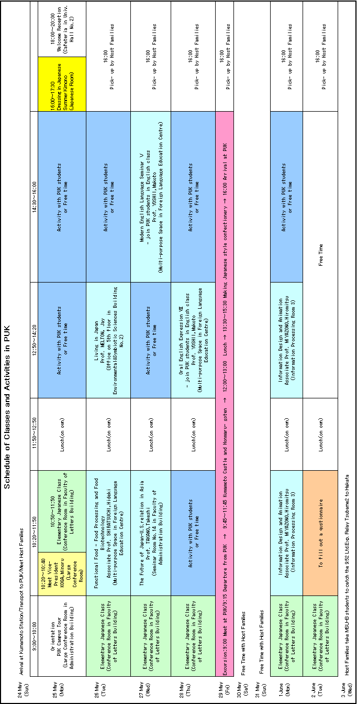

There are many things to do and see while you are in Kumamoto in addition to those scheduled by the university: visit Suizenji Park, see fireflies, shop, eat, karaoke, hang out, etc., etc.

Here are some Google Earth coordinates:

Kumamoto Station: 32° 47’ 24.52” N, 130° 41’ 21.73” E
PUK: 32° 48’ 23.00” N, 130° 45’ 54.13” E
Kumamoto Castle: 32° 48’ 22.12” N, 130° 42’ 20.99” E
Downtown Kumamoto: 32° 48’ 09.40” N, 130° 42’ 33.73” E
Suizen-ji Park 32° 47’ 25.86” N, 130° 44’ 04.63” E
Mt. Aso National Park: 32° 53’ 05.60” N, 131° 05’ 07.08” E
Amakusa National Park: 32° 32’ 24.44” N, 130° 25’ 24.61” E

Wednesday, June 3rd (morning): Kumamoto to Kyoto

We will leave Kumamoto and take many memories and newfound friendships with us as we start our trip back to Tokyo. However, a trip to Japan is incomplete without spending some time in the cultural and spiritual center of the nation, Kyoto. We will meet at Kumamoto Station to say our goodbyes early in the morning. Following group pictures (and some tears), we will head off to Kyoto.

Transfer | Arrival  &  Departure | Required | Station name  &  Route and Train name
 | 09:52 |  | KUMAMOTO
 | # | 79min | LTD.EXP RELAY TSUBAME 2
28min | 11:11  11:39 |  | HAKATA
 | # | 165min | SHINKANSEN HIKARI RailStar 460
16min | 14:24  14:40 |  | SHINOSAKA
 | # | 14min | SHINKANSEN HIKARI 376
 | 14:54 |  | KYOTO

(Detailed train schedule starts on page 59.)
Wednesday, June 3rd to Sunday, June 7th (morning): Kyoto

Upon arrival in Kyoto, you are urged to notice the stark architecture of the atrium of Kyoto Station. There are many eating establishments in the upper levels of the station as well as in the “Porta” and “Cube” shopping malls that are underground adjacent to the station.

We will take the Karasuma subway from Kyoto Station to the Marutamachi Subway Station and walk a block and a half to the Palace Side Hotel. (See page 22 for contact information.)

Interesting note: The Japanese syllables in Kyoto and Tokyo (“kyo” and “to”) are the same—just in different order. Kyoto was the old imperial capital of the nation; Tokyo is the modern era capital.

What To Do in Kyoto and the Surrounding Area.

We could easily spend a couple of weeks in Kyoto and not see everything. Not only is the city literally dotted and surrounded by temples and shrines (many of which are United Nations Cultural Heritage sites), it is the home of the old Imperial Palace (the grounds of which are directly across the street from our hotel), world-class museums, and is one of the few remaining places where geisha can be seen on a regular basis. Kyoto is also a center of artisans who work in wood, pottery, textiles, kimonos, etc. Osaka, the second largest city in Japan, is just a 25-minute train ride away. Often overlooked in favor of Tokyo and Kyoto, Osaka has a lot of attractions—from a world-class aquarium to some of the most interesting architecture in Japan to Universal Studios-Japan. The ancient capital of Japan (before Kyoto), Nara, is a “must-see” place with the Todai-ji Temple, the largest wooden structure in the world that houses Japan’s largest statue of Buddha. Around Osaka and Nara are some of the largest burial mounds in the world, some of which dwarf the pyramids of Egypt and the Yucatan. Many are “key-hole” shaped in the middle of lakes and are best identified from the air using Google Earth (see page 43 for coordinates of the largest Burial Mound—in Osaka). Nara is an easy 30-45 minute train ride from Kyoto. Himeji is a one-hour trip from Kyoto and is the home of the Great White Heron Castle, the largest original castle in Japan. On the way back from Himeji, you might want to stop in Kobe with its interesting waterfront and famous “Chinatown.” This is already too much to do in the time we will have, yet it barely scratches the surface of opportunities.

Here are some suggestions: There are so many temples to choose from in Kyoto that you can quickly become “templed out” if you try to do too many. Select a couple of temples to see. I have compiled a list that has some of the more unusual and diverse temples. I suggest that you start with that list and pare or expand your plans from there. You should also consider making reservations to visit the Imperial Palace (if it is open). Admission is free, but reservations are required. We should plan a one-day trip to Nara (with optional stops at the Byodo-in Temple and/or the Fushimi-Inari Shrine)

Temples and Shrines in Kyoto and surrounding areas

Northwest Kyoto has two famous temples that are fairly close to each other:
- Kinkaku-ji Temple is also known as the “Golden Pavilion” (admission: ¥400)
- Ryoan-ji Temple has one of the most famous “zen gardens” in the world. The plant and water gardens on the temple grounds are also quite interesting. (admission: ¥500)

East of Kyoto Station (take a bus from Kyoto Station):
- Sanjusangen-do Temple: A very long building that houses about 1,001 carved images of Kannon, a Buddhist diety. (admission: ¥600)
- Kiyomisu-dera Temple: Temple complex on the side of a hill. Walk through the cemetery to get there from the bus stop. After visiting, wander through ancient narrow streets and make your way to the Gion district, the famous center of the geisha and teahouse culture.

South of Kyoto Station (take the JR Nara line for a few stops)
- Fushimi-inari Shrine: The hills on the grounds of the shrine have miles of paths that are covered with thousands of Torii gates. (Free admission; Get off at the Inari stop on the JR Nara Line. Make sure you are on a local train since the express trains do not stop here.)

Nara and Uji (Take the JR Nara line)
- Byodo-in Temple in Uji. This is the Famous “Phoenix” temple featured on the ¥10 coin. There is also a museum on the temple grounds that features ancient carvings of Bosatsu (Buddhist divas) on clouds. (Admission: ¥500) [Get off the Nara train in Uji and walk about a half-mile to the temple. It is about a 1-2 hour side trip on the way to or from Nara.]
- Todai-ji Temple in Nara. This is where the big, big Buddha is (admission: ¥500). Situated in Nara Park a little more than a mile or so from the train station. Walking through downtown takes you past other temples, including a famous 5-storied Pagoda and some ponds that are loaded with turtles. After visiting the Todai-ji temple, you might want to go up the hill past the large bell. There are interesting temple grounds up there from which you can get a good view of the surrounding area. Back down in Nara Park is the National Museum of Nara.
- Isuien Garden. This is near the Todai-ji Temple and is reputed to be one of the three most exquisite ancient Japanese gardens in the country. It is tucked away on a side street and is not very large, but if you are into gardens, this one may be worth seeing. (Admission: ¥600)

There are many, many other temples and shrines you can visit. Each has its own personality and features. Scott Harris can suggest many other options if you want to see more.

Other Attractions:

- Gion district of Kyoto. This is a major center of the geisha culture with narrow streets and teahouses. The best time to see geisha is around dusk when they are starting to make their rounds to the teahouses. They usually arrive and depart in black cabs. If you see a cab arrive at a teahouse waiting for a fare, the chances are it has been summoned to take a maiko or geiko to their next appointment. The word “geisha” is a general term for the young women who practice this art; in Kyoto they are better called “maiko” (apprentice geisha) and “geiko” (veteran geisha). There is an excellent website that can answer most questions about this unique occupation. See: http://www.immortalgeisha.com/

- Flea Market: Kyoto Flea Markets rival those anywhere else in the world. We will miss the biggest one, but I will post a schedule of smaller ones (if there are any) that coincide with our visit.

- Himeji Castle. This is a large authentic castle (not rebuilt like so many in the country—including the one in Kumamoto). It has been featured in many movies. You generally will be free to explore the castle on your own. There are signs that will explain features. Website: http://www.himeji-castle.gr.jp/index/English/index.html

- Osaka Aquarium. This is one of the largest aquariums in the world. It is built around the theme of different ocean biomes that exist around the Pacific Rim (“Ring of Fire”). Their website: http://www.kaiyukan.com/eng/index.htm

- Universal Studios—Japan. A little pricey, but if you are looking for something American with a Japanese flavor… http://www.usj.co.jp/e_top.html Fairly close to the aquarium.

- For other places, review the links at http://www.msubillings.edu/BusinessFaculty/Harris/Japan%20Webpage/Japanlinks.htm

Google Earth Coordinates for attractions in Kyoto and the Kansai Region

- Kyoto Station: 34° 59’ 07.68” N, 135° 45’ 30.97” E
- Palace Side Hotel: 35° 01’ 14.01” N, 135° 45’ 32.52” E
- Gion: 35° 00’ 10.72” N, 135° 46’ 29.70” E
- Kinkaku-ji Temple: 35° 02’ 22.48” N, 135° 43’ 42.53” E
- Ryoan-ji Temple: 35° 02’ 04.37” N, 135° 43’ 05.65” E
- Sanjusangen-do Temple: 34° 59’ 18.94” N, 135° 46’ 18.26” E
- Kiyomizu-dera Temple: 34° 59’ 41.64” N, 135° 47’ 06.20” E
- Fushimi-Inari Shrine: 34° 58’ 02.20” N, 135° 46’ 21.81” E
- Byodo-in Temple (Uji): 34° 53’ 21.22” N, 135° 48’ 27.78” E
- Todai-ji Temple (Nara): 34° 41’ 20.84” N, 135° 50’ 23.70” E
- Burial Mound (Osaka): 34° 33’ 49.47” N, 135° 29’ 14.48” E
- Himeji Castle: 34° 50’ 22.08” N, 134° 41’ 37.84” E
- Osaka Aquarium: 34° 39’ 16.13” N, 135° 25’ 44.98” E
- Universal Studios-Japan: 34° 39’ 54.00” N, 135° 25’ 55.00” E

Sunday, June 7th (morning): Kyoto to Tokyo.

We will leave Kyoto mid-morning and catch the Shinkansen for a 2¾-hour ride to Tokyo.

Transfer | Arrival  &  Departure | Required | Station name  &  Route and Train name
 | 9:56 |  | KYOTO
 |  | 164min | SHINKANSEN HIKARI 366
 | 12:40 |  | TOKYO

(Detailed train schedule is on page 61)

Sunday, June 7th (afternoon) through Tuesday, June 9th (afternoon): Tokyo

We will be in Tokyo for two nights before taking off to go home. We will return to the Asia Center Hotel of Japan (see p.21 for contact details). You will be free to do last minute shopping, packing (mailing?) or to take in parts of the city and area that you missed when we first arrived. There are two additional possible destinations that we didn’t visit in our previous stay in Tokyo that might be of interest. Either would consume virtually the entire day on Monday, June 8th:

- Tokyo Disneyland or Tokyo Disney Sea. These are two theme parks adjacent to each other. Separate admission is required for each one, but each is an all-day visit. Believe it or not, the admission fees are considerable cheaper than their counterparts in Anaheim or Orlando, but they are still a little pricey. See for details: http://www.tokyodisneyresort.co.jp/index_e.html

Google Earth coordinates: 35° 37’ 45.00” N, 139° 53’ 03.00” E

- Nikko. This is a destination about 150 km (93 mi) north of Tokyo. Travel time each way is around 2 hours. Nikko is famous because the Toshogu Shrine there is the mausoleum for Ieyasu Tokugawa, one of the major founding fathers (shogun) that united Japan. A famous feature of the shrine is the lacquer work on the carvings which add vibrant colors to the buildings and setting. Nikko is also the seat of a national park with three major waterfalls and ancient cedar trees. A website to consult on Nikko is: http://www.nikko-jp.org/english/index.html

Google Earth coordinates: 36° 45’ 25.00” N, 139° 35’ 56.00” E

Tuesday, June 9th (afternoon…then morning, afternoon and evening): Tokyo to Billings

You will have the morning to do last minute shopping and packing. Please make sure you check out of your room by the deadline. You can store your luggage at the main desk if you want to leave the hotel for a while. We will meet in the lobby of the hotel at 2:00 pm and plan to take cabs to Tokyo Station. Our train to Narita Airport leaves at around 3:00 and arrives at Terminal 1 around 4:00 (see schedule on page 59). We should proceed to check in at the Singapore Airline counter immediately. After checking in, you may do some last minute shopping in the airport shopping arcade or grab a bite to eat in the same area. You can also exchange yen notes (not coins!!) at the currency exchange counters at the airport. So, either plan on spending your coins or bringing them home as souvenirs.

Our plane is scheduled to take off at 6:45 pm. You should plan to be at the gate by 5:45 at the latest. You will be able to gauge the time you will need to get through security by checking the lines (if there are any). But, beware that the real potential for delay is AFTER you get through security and need to go through passport control at the immigration station. This can delay getting to the gate by anywhere from 15 to 30 minutes. Unfortunately, you will be unable to tell how long the delay will be until you get there. After you clear passport control, proceed to the departure gate. If you have a little extra time, there are some duty-free shops in this part of the airport.

The flight schedule is on page 14 of this trip itinerary. When we land in Los Angeles, we will have to go through immigration and customs (just as we did entering Japan). On the flight from Japan to Los Angeles, you will have to fill out a declaration form and list items that you either purchased or received as gifts in Japan (see pages 9-10 and 18 for details on US Customs and the Customs Declaration Form.)

The average time necessary to clear immigration and customs where we will be returning is about 40 minutes. As occurred in Narita when we entered Japan, we will first go through passport control with the immigration officers. We will then pick up our checked luggage and proceed through customs. After clearing customs, you will be able to put your checked luggage back on a conveyor belt and it automatically will be forwarded to our Billings bound flights. The recheck station will be inside the security zone for the airport. If you accidentally take your luggage with you as you exit the secure area, you will not be allowed to bring your luggage back in and you must recheck it with Delta before proceeding to the domestic flight gates.

If flights are on time, we will have almost 3½ hours to make our next flight. Immigration and customs could take nearly an hour. Since we have to change terminals and LAX does not have a way to do this and remain inside the secure area, we will have to go through security again to get to our Delta gate. There are places to eat inside the secure gate areas and I would strongly urge you to get through security in the Delta terminal before trying to get some lunch. Pay attention to the time as it will pass faster than you may expect. We will have a bit more than a 1½ - 2 hour layover in Salt Lake City before flying on to Billings. We should arrive right around 10:40 pm.

Tuesday, June 9 will have been the longest day of your life. From the time the day broke in Japan at 12:01 am until midnight in Billings, 39 hours will have passed.

Welcome home. Now you can rest.

Detailed Train Schedules.

As stated on page 34, these train schedules are subject to change. (Note: all distances in Japan are given in kilometers (0.6214 miles); the mile distances have been added for your reference.)

Friday, May 15th: Narita to Tokyo Station.

We will try to catch one of the following:

LTD.EXP NARITA EXPRESS 46

Train number | 2046M
Reservation number | 57046

Station | Arrival time | Departure time | Platform | Distance
NARITA AIRPORT |  | 19:13
AIRPORT TERMINAL 2 | 19:14 | 19:16 |  | 1.0 km | 0.6 mi
TOKYO | 20:13 |  | 2 | 79.2 km | 48.6 mi

LTD.EXP NARITA EXPRESS 48

Train number | 2048M
Reservation number | 57048

Station | Arrival time | Departure time | Platform | Distance
NARITA AIRPORT |  | 19:45
AIRPORT TERMINAL 2 | 19:47 | 19:49 |  | 1.0km | 0.6 mi
TOKYO | 20:51 |  | 1 | 79.2km | 48.6 mi

Tuesday, May 19th: Tokyo to Hakuba (Tokyo to Nagano by train and possibly bus to Hakuba) arrangements pending:

Transfer | Arrival  &  Departure | Required | Station name  &  Route and Train name
 | 08:40 |  | TOKYO
 |  | 100min | SHINKANSEN ASAMA 509
 | 10:20 |  | NAGANO

SHINKANSEN ASAMA 509

Train number | 509E
Reservation number | 10509

Station | Arrival time | Departure time | Platform | Distance
TOKYO |  | 08:40 | 20
UENO | 08:45 | 08:46 | 19 | 3.6 km | 2.2 mi
OMIYA(SAITAMA) | 09:05 | 09:06 |  | 30.3 km | 18.8 mi
TAKASAKI | 09:30 | 09:31 | 11 | 105.0 km | 65.2 mi
KARUIZAWA | 09:47 | 09:48 |  | 146.8 km | 91.2 mi
SAKUDAIRA | 09:56 | 09:57 |  | 164.4 km | 102.2 mi
UEDA(NAGANO) | 10:07 | 10:07 |  | 189.2 km | 117.6 mi
NAGANO | 10:20 |  | 13 | 222.4 km | 138.2 mi
Average speed (including stops) will be 82.9 mph

Thursday, May 21st: Hakuba to Hiroshima: Route Choice 1

Transfer | Arrival  &  Departure | Required | Station name  &  Route and Train name
 | 08:54 |  | HAKUBA
 |  | 18min | JR Oito Line
12min | 09:12  09:24 |  | MINAMIOTARI
 |  | 55min | JR Oito Line
13min | 10:19  10:32 |  | ITOIGAWA
 |  | 88min | LTD.EXP HAKUTAKA 4
53min | 12:00  12:53 |  | KANAZAWA
 |  | 159min | LTD.EXP THUNDERBIRD 26
43min | 15:32  16:15 |  | SHINOSAKA
 |  | 97min | SHINKANSEN HIKARI RailStar 469
 | 17:52 |  | HIROSHIMA

Detailed Schedules:
JR Oito Line

Train number | 323M

Station | Arrival time | Departure time | Platform | Distance
HAKUBA |  | 08:54
SHINANOMORIUE | 08:56 | 08:57 |  | 1.9 km | 1.2 mi
HAKUBAOIKE | 09:02 | 09:02 |  | 5.7 km | 3.5 mi
CHIKUNI | 09:07 | 09:08 |  | 9.0 km | 5.6 mi
MINAMIOTARI | 09:12 |  |  | 10.4 km | 6.5 mi
(Zipping right along at 21.7 mph)

There will be a short 12-minute wait for a train change to go the rest of the way down the hill.
JR Oito Line

Train number | 425D

Station | Arrival time | Departure time | Platform | Distance
MINAMIOTARI |  | 09:24
NAKATSUCHI | 09:30 | 09:30 |  | 4.0 km | 2.5 mi
KITAOTARI | 09:36 | 09:37 |  | 8.4 km | 5.2 mi
HIRAIWA | 09:45 | 09:45 |  | 14.9 km | 9.3 mi
KOTAKI | 09:59 | 09:59 |  | 21.7 km | 13.5 mi
NECHI | 10:05 | 10:05 |  | 25.3 km | 15.7 mi
KUBIKIONO | 10:11 | 10:11 |  | 30.2 km | 18.8 mi
HIMEKAWA(NIIGATA) | 10:14 | 10:15 |  | 32.1 km | 20.0 mi
ITOIGAWA | 10:19 |  |  | 35.3 km | 21.9 mi
(Going a bit faster at an average speed of 23.9 mph—perhaps because it is downhill.)

We will have a short stop here to change trains: 13 minutes.

LTD.EXP HAKUTAKA 4

Train number | 1004M
Reservation number | 37804

Station | Arrival time | Departure time | Platform | Distance
ITOIGAWA | 10:31 | 10:32
NYUZEN | 10:52 | 10:52 |  | 35.1 km | 21.8 mi
KUROBE | 11:00 | 11:01 |  | 47.2 km | 29.3 mi
UOZU | 11:05 | 11:06 |  | 53.5 km | 33.2 mi
TOYAMA | 11:21 | 11:22 | 2 | 79.0 km | 49.1 mi
TAKAOKA (TOYAMA) | 11:33 | 11:34 |  | 97.8 km | 60.8 mi
KANAZAWA | 12:00 |  | 2 | 138.4 km | 86.0 mi
(Average speed—including stops—is 58.6 mph.)

LUNCH TIME: The next train will arrive in 45 minutes but will be in the station for about 7 minutes before departing. It will come in at the same platform so we will not have to cart luggage.
LTD.EXP THUNDERBIRD 26

Train number | 4026M
Reservation number | 86026

Station | Arrival time | Departure time | Platform | Distance
KANAZAWA | 12:45 | 12:53 | 2
KOMATSU | 13:10 | 13:11 |  | 28.4 km | 17.6 mi
KAGAONSEN | 13:19 | 13:20 |  | 42.3 km | 26.3 mi
AWARAONSEN | 13:30 | 13:31 |  | 59.0 km | 36.7 mi
FUKUI(FUKUI) | 13:41 | 13:43 | 5 | 76.7 km | 47.7 mi
SABAE | 13:50 | 13:51 |  | 90.4 km | 56.2 mi
TAKEFU | 13:55 | 13:56 |  | 95.6 km | 59.4 mi
TSURUGA | 14:15 | 14:16 |  | 130.7 km | 81.2 mi
KYOTO | 15:09 | 15:11 | 7 | 224.8 km | 139.7 mi
SHINOSAKA | 15:32 | (train departs at 15:33) | 17 | 263.8 km | 163.9 mi
(Average speed—including stops—is 61.9 mph.)

There will be a 43-minute layover—during which we will have to move from the regular part of the station to the Shinkansen track area. Since this train originates in Shinosaka, we probably will be able to board the train several minutes before departure.

SHINKANSEN HIKARI RailStar 473

Train number | 473A
Reservation number | 01469

Station | Arrival time | Departure time | Platform | Distance
SHINOSAKA |  | 16:15 | 20
SHINKOBE | 16:29 | 16:30 |  | 36.9km | 22.9 mi
HIMEJI | 16:49 | 16:49 |  | 91.7km | 57.0 mi
OKAYAMA | 17:10 | 17:11 | 2 | 180.3km | 112.0 mi
FUKUYAMA | 17:27 | 17:28 |  | 238.6km | 148.3 mi
HIROSHIMA | 17:52 |  | 12 | 341.6km | 212.3 mi
(Average speed—including stops—is 131.3 mph.)

Thursday, May 21st: Hakuba to Hiroshima: Route Choice 2

Transfer | Arrival  &  Departure | Required | Station name  &  Route and Train name
 | 08:53 |  | HAKUBA
 | % | 39min | JR Oito Line
6min | 09:32  09:38 |  | SHINANOOMACHI
 | % | 58min | JR Oito Line
16min | 10:36  10:52 |  | MATSUMOTO
 | # | 127min | LTD.EXP (WIDEVIEW)SHINANO 8
12min | 12:59  13:11 |  | NAGOYA
 | # | 52min | SHINKANSEN HIKARI 369
16min | 14:03  14:19 |  | SHINOSAKA
 | # | 93min | SHINKANSEN HIKARI RailStar 469
 | 15:52 |  | HIROSHIMA

Detailed Schedules:

JR Oito Line

Train number | 1336M

Station/Airport | Arrival time | Departure time | Platform | Distance
HAKUBA | 08:51 | 08:53
IIMORI | 08:57 | 08:57 |  | 3.0 km | 1.9 mi
KAMISHIRO | 09:00 | 09:00 |  | 4.5 km | 2.8 mi
MINAMIKAMISHIRO | 09:03 | 09:04 |  | 6.9 km | 4.3 mi
YANABASKIJOMAE | 09:10 | 09:10 |  | 11.8 km | 7.3 mi
YANABA | 09:13 | 09:13 |  | 13.4 km | 8.3 mi
UMINOKUCHI | 09:17 | 09:18 |  | 16.8 km | 10.4 mi
INAO | 09:20 | 09:21 |  | 18.1 km | 11.2 mi
SHINANOKIZAKI | 09:24 | 09:25 |  | 20.3 km | 12.6 mi
KITAOMACHI | 09:27 | 09:28 |  | 22.5 km | 14.0 mi
SHINANOOMACHI | 09:32 |  |  | 24.6 km | 15.3 mi

There will be a brief 6-minute stop to change trains in Shinanoomachi

JR Oito Line

Train number | 4230M

Station | Arrival time | Departure time | Platform | Distance
SHINANOOMACHI |  | 09:38
MINAMIOMACHI | 09:40 | 09:40 |  | 1.1 km | 0.7 mi
SHINANOTOKIWA | 09:44 | 09:44 |  | 4.2 km | 2.6 mi
AZUMIKUTSUKAKE | 09:47 | 09:47 |  | 6.5 km | 4.0 mi
SHINANOMATSUKAWA | 09:50 | 09:53 |  | 9.1 km | 5.7 mi
KITAHOSONO | 09:55 | 09:56 |  | 11.3 km | 7.0 mi
HOSONO(NAGANO) | 09:57 | 09:58 |  | 12.3 km | 7.6 mi
AZUMIOIWAKE | 10:01 | 10:01 |  | 15.2 km | 9.4 mi
ARIAKE(NAGANO) | 10:03 | 10:03 |  | 16.7 km | 10.4 mi
HOTAKA | 10:06 | 10:06 |  | 18.9 km | 11.4 mi
HAKUYACHO | 10:09 | 10:09 |  | 20.9 km | 13.0 mi
TOYOSHINA | 10:12 | 10:12 |  | 23.7 km | 14.7 mi
MINAMITOYOSHINA | 10:14 | 10:14 |  | 24.7 km | 15.3 mi
NAKAGAYA | 10:17 | 10:17 |  | 26.7 km | 16.6 mi
HITOICHIBA | 10:19 | 10:22 |  | 28.3 km | 17.6 mi
AZUSABASHI | 10:24 | 10:24 |  | 29.9 km | 18.6 mi
SHIMATAKAMATSU | 10:26 | 10:27 |  | 31.3 km | 19.4 mi
SHIMAUCHI | 10:29 | 10:31 |  | 32.5 km | 20.2 mi
KITAMATSUMOTO | 10:34 | 10:34 |  | 34.4 km | 21.4 mi
MATSUMOTO | 10:36 |  | 6 | 35.1 km | 21.8 mi
Average speed from Hakuba to Matsumoto (including stops and layover): 21.6 mph.
We will have 16 minutes to get from platform 6 to platform 1 in Matsumoto. Maybe that’s enough for a bathroom break, but not for food.

LTD.EXP (WIDEVIEW)SHINANO 8

Train number | 1008M
Reservation number | 38808

Station | Arrival time | Departure time | Platform | Distance
MATSUMOTO | 10:51 | 10:52 | 1
SHIOJIRI | 11:00 | 11:01 |  | 13.3 km | 8.3
KISOFUKUSHIMA | 11:29 | 11:31 |  | 55.0 km | 34.2
NAKATSUGAWA | 12:06 | 12:08 |  | 108.2 km | 67.2
TAJIMI | 12:34 | 12:35 |  | 151.9 km | 94.4
CHIKUSA | 12:52 | 12:52 |  | 181.0 km | 112.5
NAGOYA | 12:59 |  | 11 | 188.1 km | 116.9

Average speed down the mountain: 55.2 mph.
We will have a tight 12 minutes to get to the Shinkansen section of the station.

SHINKANSEN HIKARI 369

Train number | 369A
Reservation number | 01369

Station | Arrival time | Departure time | Platform | Distance
NAGOYA | 13:10 | 13:11 | 16
KYOTO | 13:48 | 13:49 | 13 | 147.6 km | 91.7 mi
SHINOSAKA | 14:03 | 14:05 | 21 | 186.6 km | 116.0 mi

Now, we’re starting to move: average speed is 133.8 mph

At Shinosaka station, we will switch from a 16-car train to an 8-car train that is exclusive to the Western Japan Rail Company. The Shinkansen Hikari RailStar rivals the fastest Nozomi trains and has the most comfortable seating arrangements. In the stretch before Hiroshima, this train will be sailing along at 177 mph

SHINKANSEN HIKARI RailStar 469

Train number | 469A
Reservation number | 01469

Station | Arrival time | Departure time | Platform | Distance
SHINOSAKA |  | 14:19 | 20
SHINKOBE | 14:32 | 14:33 |  | 36.9 km | 22.9 mi
HIMEJI | 14:49 | 14:49 |  | 91.7 km | 57.0 mi
OKAYAMA | 15:10 | 15:11 | 22 | 180.3 km | 112.0 mi
FUKUYAMA | 15:27 | 15:28 |  | 238.6 km | 148.3 mi
HIROSHIMA | 15:52 | 15:53 | 12 | 341.6 km | 212.3 mi

Average speed from Shinosaka, including stops is 136.9 mph.

Friday or Saturday, May 22/23: Hiroshima to Miyajimaguchi.

This schedule is a “typical” schedule for the run from Hiroshima to Miyajimaguchi. Some trains will not stop at all of these stations, so keep track of the station names.
You do not need reservations, and trains run at least every 15 minutes during the day, usually departing from platform 1 (but not always…so check before boarding!)
If you come back on the same train, just reverse the order of stations.

JR Sanyo Line

Train number | 541M

Station/Airport | Arrival time | Departure time | Platform | Distance
HIROSHIMA |  | 09:20 | 1
YOKOGAWA | 09:23 | 09:24 |  | 3.0 km | 1.9 mi
NISHIHIROSHIMA | 09:26 | 09:26 |  | 5.5 km | 3.4 mi
SHININOKUCHI | 09:30 | 09:30 |  | 9.7 km | 6.0 mi
ITSUKAICHI | 09:33 | 09:34 |  | 12.1 km | 7.5 mi
HATSUKAICHI | 09:37 | 09:37 |  | 15.5 km | 9.6 mi
MIYAUCHIKUSHIDO | 09:39 | 09:39 |  | 17.1 km | 10.6 mi
AJINA(JR) | 09:42 | 09:43 |  | 20.1 km | 12.5 mi
MIYAJIMAGUCHI | 09:45 | 09:45 |  | 21.8 km | 13.5 mi

Sunday, May 24th: Hiroshima to Kumamoto.

Transfer | Arrival  &  Departure | Required | Station name  &  Route and Train name
 | 10:40 |  | HIROSHIMA
 |  | 70min | SHINKANSEN HIKARI RailStar 453
24min | 11:50  12:14 |  | HAKATA
 |  | 75min | LTD.EXP RELAY TSUBAME 11
 | 13:29 |  | KUMAMOTO

Travel Details:

SHINKANSEN HIKARI RailStar 453

Train number | 453A
Reservation number | 01453

Station | Arrival time | Departure time | Platform | Distance
HIROSHIMA | 10:39 | 10:40 | 12
TOKUYAMA | 11:03 | 11:03 |  | 88.5 km | 55.0 mi
KOKURA | 11:32 | 11:33 | 12 | 213.5 km | 132.7 mi
HAKATA | 11:50 |  | 14 | 280.7 km | 174.4 mi
Average speed—including stops—is 149.5 mph; between Hiroshima and Tokuyama, the train will reach speeds of 177 mph. Note: Just before we arrive in Kokura, the train will pass beneath the sea, going under the strait that separates the main island Honshu from Kyushu, where Kumamoto is.

We will have 24 minutes to get from the Shinkansen tracks to the regular train tracks to catch the Limited Express train to Kumamoto. You will have to haul your luggage down some stairs, so you will especially appreciate traveling light.

LTD.EXP RELAY TSUBAME 11

Train number | 11M
Reservation number | 89011

Station | Arrival time | Departure time | Platform | Distance
HAKATA |  | 12:14 | 6
TOSU | 12:34 | 12:35 |  | 28.6 km | 17.8 mi
KURUME | 12:40 | 12:40 |  | 35.7 km | 22.2 mi
OMUTA | 12:59 | 13:00 |  | 69.3 km | 43.1 mi
KUMAMOTO | 13:29 | 13:31 |  | 118.4 km | 73.6 mi
Average speed—including stops—is 58.9 mph.

Wednesday, June 3rd: Kumamoto to Kyoto.

Arrive at Kumamoto Station between 9:00 and 9:15 for group pictures with host families

Transfer | Arrival  &  Departure | Required | Station name  &  Route and Train name
 | 09:52 |  | KUMAMOTO
 | # | 79min | LTD.EXP RELAY TSUBAME 2
28min | 11:11  11:39 |  | HAKATA
 | # | 165min | SHINKANSEN HIKARI RailStar 460
16min | 14:24  14:40 |  | SHINOSAKA
 | # | 14min | SHINKANSEN HIKARI 376
 | 14:54 |  | KYOTO

Travel Details:
LTD.EXP RELAY TSUBAME 2

Train number | 2M
Reservation number | 89002

Station | Arrival time | Departure time | Platform | Distance
KUMAMOTO | 09:48 | 09:52
OMUTA | 10:21 | 10:21 |  | 49.1 km | 30.5 mi
KURUME | 10:40 | 10:40 |  | 82.7 km | 51.4 mi
TOSU | 10:46 | 10:47 |  | 89.8 km | 55.8 mi
HAKATA | 11:11 |  | 1 | 118.4 km | 73.4 mi
Average speed—including stops—is 55.7 mph

There will be a 28-minute layover during which we will have to move to the Shinkansen part of the station.

SHINKANSEN HIKARI RailStar 460

Train number | 460A
Reservation number | 01460

Station | Arrival time | Departure time | Platform | Distance
HAKATA |  | 11:39 | 12
KOKURA | 11:56 | 11:17 | 13 | 67.2 km | 41.8 mi
SHINYAMAGUCHI | 12:16 | 12:16 |  | 147.9 km | 91.9 mi
HIROSHIMA | 12:49 | 12:50 | 14 | 280.7 km | 174.4 mi
FUKUYAMA | 13:14 | 13:15 |  | 383.7 km | 238.4 mi
OKAYAMA | 13:32 | 13:33 | 23 | 442.0 km | 274.7 mi
HIMEJI | 13:53 | 13:54 |  | 530.6 km | 329.7 mi
SHINKOBE | 14:10 | 14:11 |  | 585.4 km | 363.8 mi
SHINOSAKA | 14:24 |  | 25 | 622.3 km | 386.7 mi
Average speed from Hakata to Shinosaka: 386.7 miles in 2 hours 45 minutes: 140.6 mph.

We will have a 16-minute layover. We will not change platforms.

SHINKANSEN HIKARI 376

Train number | 376A
Reservation number | 01376

Station | Arrival time | Departure time | Platform | Distance
SHINOSAKA | 14:38 | 14:40 | 25
KYOTO | 14:54 | 14:56 | 12 | 39.0 km | 24.2 mi
Average speed: 103.7 mph.

Sunday, June 7th: Kyoto to Tokyo.

Transfer | Arrival  &  Departure | Required | Station name  &  Route and Train name
 | 9:56 |  | KYOTO
 |  | 164min | SHINKANSEN HIKARI 366
 | 12:40 |  | TOKYO

Travel Details:
SHINKANSEN HIKARI 366

Train number | 366A
Reservation number | 01366

Station | Arrival time | Departure time | Platform | Distance
KYOTO | 09:54 | 09:56 | 12
NAGOYA | 10:32 | 10:33 | 15 | 147.6 km | 91.7 mi
HAMAMATSU | 11:07 | 11:09 |  | 256.5 km | 159.4 mi
SHIZUOKA | 11:30 | 11:36 |  | 333.4 km | 207.2 mi
MISHIMA | 11:54 | 11:55 |  | 392.9 km | 244.1 mi
SHINYOKOHAMA | 12:21 | 12:22 |  | 484.8 km | 301.3 mi
SHINAGAWA | 12:33 | 12:34 |  | 506.8 km | 314.9 mi
TOKYO | 12:40 |  | 19 | 513.6 km | 319.2 mi
Average speed—including stops—is 116.8 mph. The longer stop in Shizuoka is to allow a Nozomi Shinkansen to pass us.

Tuesday, June 9th: Tokyo to Narita Airport.

LTD.EXP NARITA EXPRESS 33

Train number | 2133M
Reservation number | 57333

Station/Airport | Arrival time | Departure time | Platform | Distance
TOKYO | 14:57 | 15:03 | 4
AIRPORT TERMINAL 2 | 15:54 | 15:57 |  | 78.2 km | 48.6 mi
NARITA AIRPORT | 15:59 |  |  | 79.2 km | 49.2 mi

